**INDIAN COIN SEPARATOR AND COUNTING MACHINE USING EDGE DETECTION TECHNIQUE**

**Amith Salehittal1, Vijay D Shetti2, Medha M Naik3, Vartur Sreekumar Sharanya4​**

[**amithsalehittal999@gmail.com**](mailto:amithsalehittal999@gmail.com)**1**

[**vijayshetti4@gmail.com**](mailto:vijayshetti4@gmail.com)**2**

[**medhanaik0225@gmail.com**](mailto:medhanaik0225@gmail.com)**3**

[**sharanyasr6@gmail.com**](mailto:sharanyasr6@gmail.com)**4**

*Department of Information Science and Engineering, Canara Engineering College*

**ABSTRACT:** *The project focuses on the segregation and calculation of Indian currency. Almost all temples in India have a donation box. The separation of such coins requires more human intervention and can therefore be automated and as a result improves efficiency and reduces time consumption in the process. The project adopts automation for this time-consuming process. This includes the use of digital image processing technology that helps detect and separate coins; Thus, making the process more rapid and accurate. The purpose of this system is to identify and match Indian coins, finally counting the number of one rupee, two rupees, five rupees and ten rupee coins. There are various techniques for matching coins. The proposed system uses a digital image processing template matching algorithm, by which the value of the coin is identified and edge detection technique is also used to detect the edge of the coin. That is to read the computer's image and match the coins. Finally count the total value of the coins and display it on a digital monitor.*

**KEYWORDS: *Internet of Things, Metal Sensors, Server Motors***

1. **INTRODUCTION**

In our country, there are temples which have many donation boxes. Many people use them and include coins and currency notes as their religious donation. More human intervention is required to separate currency coins falling into the currency box (hundi). It is not reliable for today's fast world. Therefore, we have to take corrective action against this process. Sorting coins is a very time-consuming and boring task. There is no recording device for future use in the manual method of counting coins. This is not only happening in temples but also in banks which deal in large number of coins and currency every day. Banks use bill counting machines to count money. But when the customer wants to pay a large amount of cash in the bank, the bank employees can make mistakes to calculate the total value and the number of coins of one rupee, two rupees, five rupees and ten rupees. Some coins of different foreign currency look similar. So it is sometimes difficult to distinguish them using the human eye, especially for large quantities of coins. Furthermore, due to globalization, banks often receive foreign currency that employees cannot recognize. Donors face the same situation as the bank, as donors come from all over the world. It is therefore necessary to develop a system that can help them identify and calculate the money they receive. Also, the process will also require automation at this time. Automation with flexibility provides a good result. Automation provides efficiency and accuracy. No human intervention is needed for this. Coins and currencies vary at the time of donation entry. This is reducing the time to separate coins and currency. With the help of a blower, it separates the postures which are inserted into the donation box. The coins are then ranked according to their diameter. Counters are used for counting purposes. Counted values ​​are displayed on a digital display for recording purpose. An electronic controller serves as the brain of the system that controls the sequence of operations. Separating and counting coins and currency is a time-consuming process that requires more manpower.

* 1. **PROBLEM STATEMENT**

The aim of this system is to identify and matches the Indian coins, finally count the number of one rupee, two rupees, five rupees, and ten rupee coins are used.

Most of the conventional identification methods used in slot machines, work by testing physical properties of coins such as size, weight and materials. However, if physical similarities exist between coins of different currencies, then the traditional coin testers would fail to distinguish the different coins.

**1.2 OBJECTIVE**

* To segregate coins and currency notes.
* To count each coin and display the total sum of it.
* To reduce man power and increase the level of accuracy.

**1.3 SCOPE OF THE PROJECT**

* To provide a user friendly application for Separation and Counting of Indian currency and coins.
* To identify and matches the Indian coins, finally count the number of one rupee, two rupees, five rupees, and ten rupee coins are used
* To decrease human inefficiencies by creating an automated system.
* To count each coin and display the total sum of every denomination.
* Low cost automation and Less time consumption
  1. **PURPOSE**
* The purpose of this project is to automatethe manual method of counting the coins
* This system will help them to recognize and calculate the money that they receive.
* Coins and currencies are separated at the time of insertion of donation itself.
* The proposed system utilizes the digital image processing which will speed up the process of separation.

1. **LITERATURE SURVEY**

There are several techniques used to distinguish such coins from different denominations. Parameters such as parameters, size, weight, and material have been used to analyze and identify the value of the coin. Various programming languages ​​such as C, C ++, C #, Java, Python etc. are also used.

*Rotational invariant neural pattern recognition system for coin recognition*. [1] In this work they have created a multilevel neural network and the preprocessor consists of several slabs of neurons. This preprocessor was used to obtain rotational inductive inputs for multilevel neural networks. For the weight of neurons in the preprocessor, the concept of circular array was used instead of square array. In 1993 tried to achieve 100% accuracy for coins. In this work he has used back propagation and genetic algorithms to design neural networks for coin recognition. Back propagation is used to train the network.

*To classify Indian coins of different denominations recently issued and to count the total value of coins in terms of Indian national rupees* [2] The purpose of this work is to separate recently issued Indian coins. It is to classify into denominations and calculate the total value. Coin with reference to Indian National Rupee (INR) [1, 2]. Systems include Robert's edge detection method (93% accuracy), Gaussian edge detection method (94% accuracy), canny edge detection method (97.5% accuracy) and multi-level counter progression neural network (ML-CPNN) based approach (99.5% accuracy) ). Parameters such as size, shape, surface, weight etc. are considered and Matlab is used as a medium for simulation and obtaining results. Comparisons between existing techniques were summarized by Modi et al., Specifically using image processing techniques and found that a maximum accuracy of 99.7% was obtained for Canadian coins using decision trees in 1996 .

*Indian currency recognition and coin fall* [3] The system used the FLA (Field Processed Gate Array) controller which together with MATLAB detects currency notes to check for incorrect and counterfeit notes. If the notes are real, the value of the currency is counted using artificial neural networks. There is a DC gun for the sorting process.

*Indian coin detection and sorting using the SIFT algorithm* [4] The proposed system using the SIFT algorithm in addition to the MATLAB tool for coin detection. It uses feature extraction techniques to differentiate between coins. Similarly, he used edge detection algorithms to detect coins.

*Coin classification using a novel technique to learn characteristic decision trees by controlling the degree of normalization [5]* In this work, controlling the degree of normalization introduced an approach to coin classification using specific decision trees. Algorithms such as ID3 were unable to detect instances of the categories present in the set of decision tree training examples. Instead of being rejected, such examples are actually assigned to one of the classes present in the training set. Get 100% recognition accuracy rate. In the pre-processing stage, they have used a Gaussian filter to smooth the image and then gray level thresholding is performed to obtain a binary image. To extract the features, they have used a Harris-Hassian detector. Next, the limit value of the characteristic points of the coin is calculated. The Circle Hof transform is used for circle detection. After circle detection the coins are classified according to the radius and threshold value

*Three color selective stereo gradient method for rapid topography recognition of metal surfaces.* [6] Similar to our approach, translational invariance is achieved through transfection, whereas rotational invariance is a consequence of a polar coordinate representation and correlation. Their system uses a special hardware to ensure that no fraudulent coins are accepted by the system. In our case there is no risk that fraudulent photographs of coins will be presented to the system. Therefore, the use of color seems to unnecessarily increase computational costs. The basic idea of ​​a straight line detection method is discussed in the coin's image. The criteria for coin classification based on gray-level, color, texture, shape, model, etc., are discussed. Method that specifically addresses coin segmentation based on color or gray value. Many serious problems such as the size of the coin, the peak in the surface of the coins are attempted to be detected but, it does not produce much results.

*Pattern matching using a rotation invariant coin identification system with a neural network.* [7] This system is capable of collecting data and extracting coin characteristics. In the first stage the RGB coin image is acquired. The RGB image is then converted into a grayscale image. They have used the Sobel filter to detect edges from the image and to detect radius and center. In the next step they have generated a feature vector. This feature vector is then extended to trained neural networks. The neural network then classifies the coins.

*Using the Indian coin recognition image subtraction technique* [8] this system checks the radius and centroid of the coin's image and then applies coarse and fine subtraction to the input image. A subtraction is performed between the object image and the database coin image which provides rapid recognition and good accuracy.

*In the Harris-Hessian algorithm* [9] pre-processing step for coin anticipation, they have used a Gaussian filter to smooth the image and then gray level thresholding is performed to obtain a binary image. To extract the features, they have used a Harris-Hassian detector. Next, the limit value of the characteristic points of the coin is calculated. The Circle Hof

transform is used for circle detection. After circle detection the coins are classified according to the radius and threshold value.

*Coin recognition using artificial neural networks* [10] They have used Sobel edge detection to detect the circular boundary. He has used the circular huff transform to remove shadows from the coin image. They applied discrete cosine transforms and discrete wavelet transforms to divide the image into smaller segments. The pattern average image is then generated. In the final stage vectors are generated and given as input to the neural network.

1. **SYSTEM REQUIREMENT SPECIFICATION**

**3.1 Definitions, Acronyms & Abbreviations**

* + - PHP - PHP: Hypertext

Preprocessor

* + - HTML - Hyper Text Markup

Language

* + - CSS - Cascading Style

**3.2 OVERALL DESCRIPTION**

**3.2.1 Product Functions**

The application varies with user using it .It has three main functionalities.

Temple Admin:

* + - On clicking the website, a login screen is displayed and the temple admin will login.
    - The admin can view the number of coins of every denomination or currencies entered into the hundi.
    - The admin can also view the total amount of money in the hundi.
    - The admin is also provided with a logout option.

Testing:

* + - It consists of all the steps the mention in the training phase but one to one mapping is done here using machine learning algorithm.

Training:

* + - The captured image using Raspberry pi camera is taken as a input in testing phase
    - Converting input image into grey scale image
    - Extractin Features such as histogram, color feature and shape of the coin.
    - Performing normalization.
    - Applying machine learning algorithm.
    - Performing class detection.
    - Updating the coin count in server.

**3.2.2 Design & Implementation Constraints**

The components required, and the technologies adapted for the project are available in ease. Sufficient technology is available to carry out this project. Globally available software packages fulfil the requirements adapted for developing the project into product. The design which has to be implemented can be simulated through the available software and prototype can be developed according to the concept. After attaining the results of prototype, the concept which has been designed can be fabricated into a product.

* Mainly this project works on separation of Indian coins but not with the foreign currency.
* The admin need to have the basic knowledge of the database to check the final count of the coin in the server because only admin can view the webpage.
* In this proposed system machine will be mainly trained with the one rupee, two rupee, five rupee coins other than this it will not count.

**3.3 External Interface Requirements**

**3.3.1 User Interfaces**

The user interface consists of a webpage where the temple admin can login. Once logged in, the admin can view the number. of coins collected, total number of coins of every denomination, total amount collected etc.

**3.3.2 Hardware Components**

The hardware components used are

* Processor: Intel or AMD
* RAM: 4GB and above
* Raspberry pi
* Raspberry pi camera
* Server Motor
* Coin Dispensary Kit

**3.3.3 Software Interfaces**

**Software Description**

Operating System : Windows

Language : HTML, PhP, CSS, Python 3

Database : MySQL,

1. **SYSTEM DESIGN**

The purpose of the design phase is to plan a solution of the problem specified by the requirement document. The design of a system is perhaps the most critical factor affecting the quality of the software, and has a major impact on the later phases, particularly testing and maintenance. The output of this phase is the design document. The design activity is often divided into two separate phases. They are system design and detailed design

**4.1 ARCHITECTURAL DESIGN**

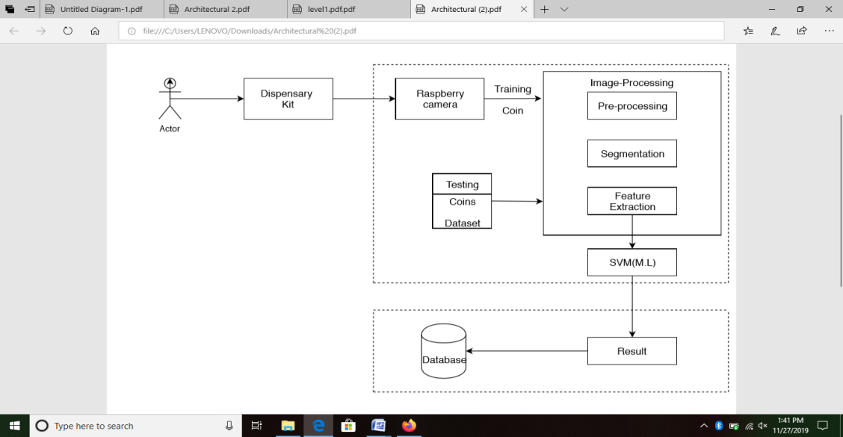

Figure: 4.1 Architectural Designs

In this proposed system a raspberry pi cam captures the image and camera is fixed at a constant height. This information passed to raspberry pi segregate coins of one, two and five by extracting features like its size and shape. Output for coin dispensary kit is separated coins and counts are updated.

**4.2 BLOCK DIAGRAM OF ENTIRE SYSTEM**

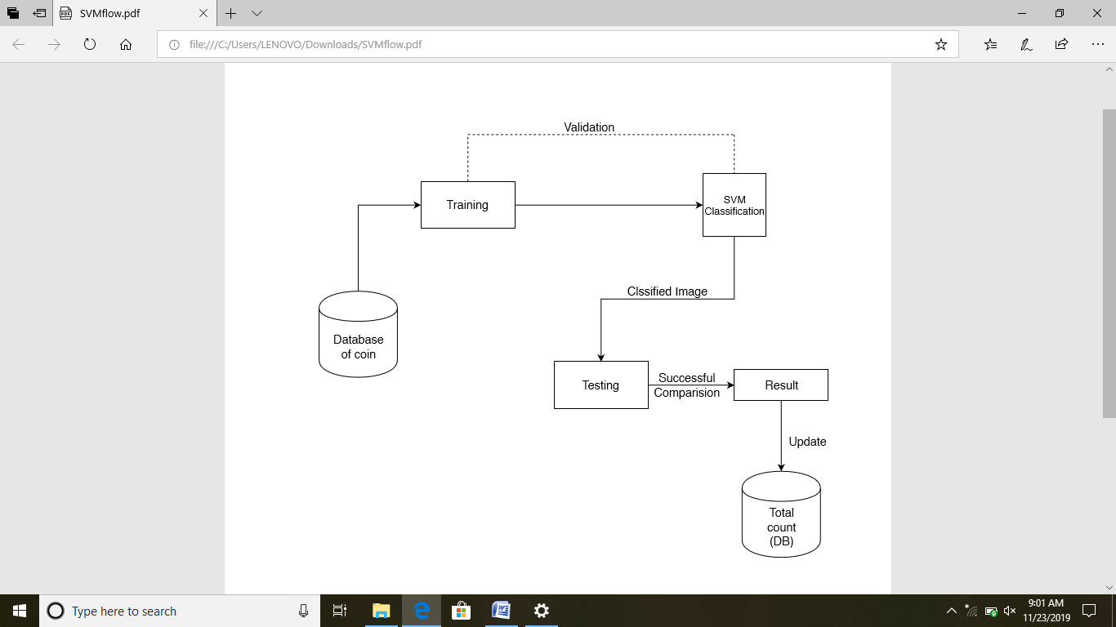

Figure: 4.2 Block Diagram for Entire System

It is a Machine Learning algorithm that analyzes data for classification and regression analysis. It compares the test image feature and coin image with the trained dataset. Test image feature is a process which is having single image and that is obtained from training phase and coin image is obtained from trained database .Here 1:1 mapping is done between these two processes.

1. **PROPOSED APPROACH**

The intent of this paper is to identify and match Indian coins, finally counting the number of one rupee, two rupees, five rupees and ten rupee coins. There are various techniques for matching coins. Edge detection technology was used in this system. That is to read the computer's image and match the coins. Finally count the total value of the coins. Techniques involved are image color segmentation, edge enhancement, edge detection, blob measurement, huef transformation. The proposed system uses digital image processing template matching algorithm, by which the value of the coin is identified. It also uses an edge detection algorithm to detect the edges of coins and count them if the coin goes up and down and is displayed on a digital monitor. It also matches the color of the coin to separate the coins, as the new 1 rupee and 5 rupee coins are more or less the same. Coins are ranked according to their diameter. Counters are used for counting purposes. Counted values ​​are displayed on a digital display for recording purpose. This reduces man power and increases the level of accuracy.

1. **ARCHITECTURE**

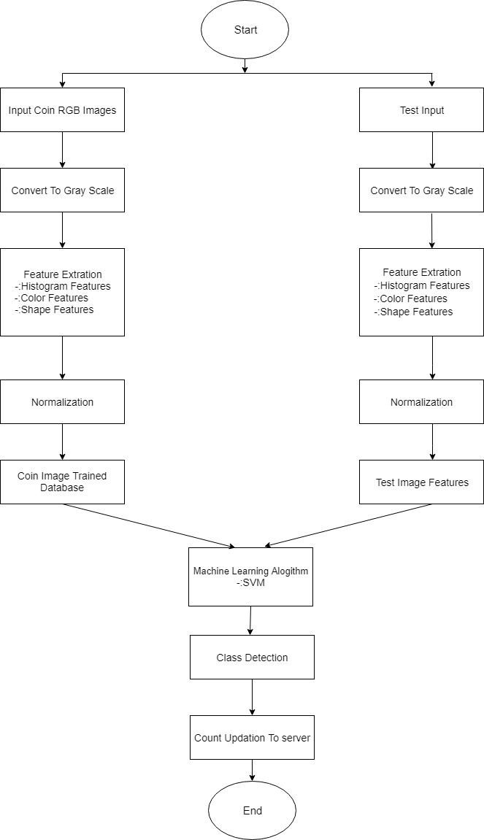

Figure 6: Training and Testing phase of coin detection

The proposed system consists following 7 steps as follows:

**Step 1:** **Read input image**

The captured image using Raspberry pi camera is taken as an input in testing phase.

**Step 2:** **Convert input image into grey scale image**

If there are color image then convert it into grayscale using weighted method.

The new equation that form is:

New grayscale image = ((0.3 * R) + (0.59 * G) + (0.11 * B))

According to this equation, Red has contributed 30%, Green has contributed 59% which is greater in all three colors and Blue has contributed 11%.

**Step 3:** **Extract Features such as histogram, color feature and shape of the coin.**

[[counts](https://in.mathworks.com/help/images/ref/imhist.html#buo3qek-1-counts),[binLocations](https://in.mathworks.com/help/images/ref/imhist.html#buo3qek-1-binLocations)] = imhist([I](https://in.mathworks.com/help/images/ref/imhist.html#buo3qek-1-I)) calculates the histogram for the grayscale image I. The imhist function returns the histogram counts in counts and the bin locations in binLocations. The number of bins in the histogram is determined by the image type. Optionally can compute the histogram counts and bin locations using a GPU (requires Parallel Computing Toolbox™). For more information, see [Image Processing on a GPU](https://in.mathworks.com/help/images/image-processing-on-a-gpu.html).

**Step 4:** **Perform normalization**

After feature extraction, as it is the random process it create data redundancy. This can be overcome by normalization and this process also performs data integration of the coin and that data is sent to coin image feature trained database.

**Step 5:** **Apply machine learning algorithm**

Comparing the image features with the obtained coin image. Test image feature is a process which is having single image and that is obtained from training phase and coin image is obtained from trained database .Here 1:1 mapping is done between these two process using machine learning algorithm named SVM (Support Vector Machine) which is mainly used to solve classification or regression challenges.

**Step 6:** **Perform class detection**

Detecting the instance of a coin from a particular class .For example consider 3 classes, class1 ,class 2,class3 detecting for which class the particular coin belongs to and segregating the coins according to their respective class.

**Step 7:** **Update count in server** Updating the coin count of particular class. For example if 1 rupee is in class 1 then total count of class 1 is updated to the server.

1. **RESULTS**



Figure: 7.1 Login page of Admin

In above figure the user mainly refers to the admin or the person who monitors the whole system .He can view the count of the coin and the updates of coin count. The user makes use of his mail id as a username and his password to login and view the details.



Figure: 7.2 Verification of user through OTP

The logged in user gets OTP to their registered user id via mail. The user needs to verify the OTP with the web page to view the coin details.

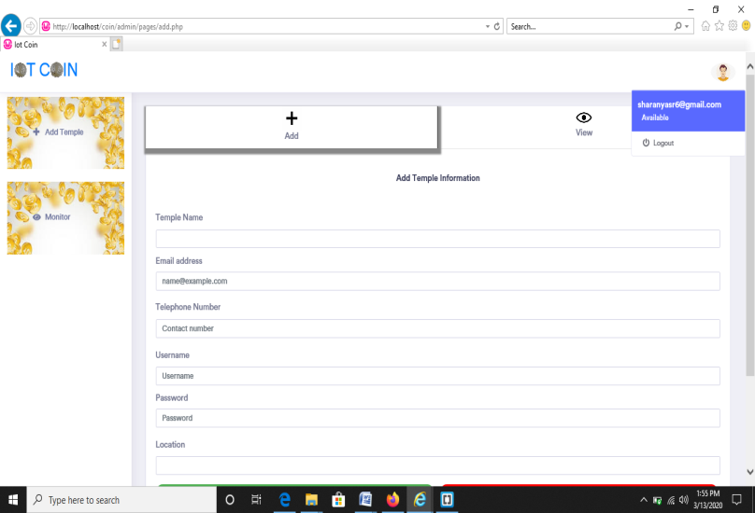

Figure: 7.3 Add the temple details

In above figure the user can and the temple details for monitoring the count of the coin

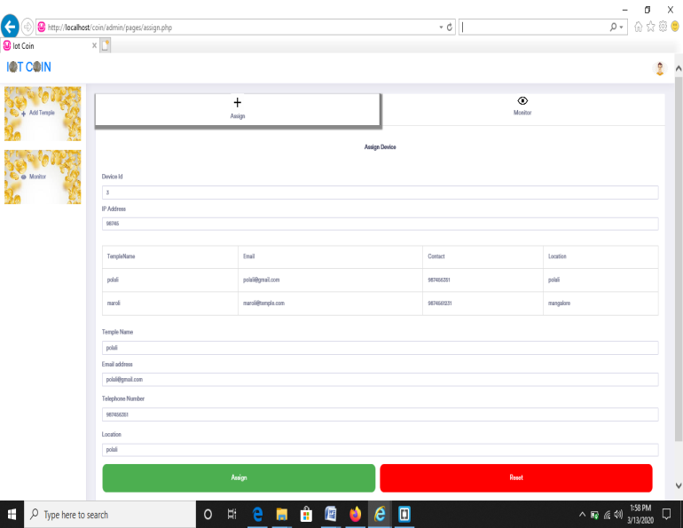

Figure: 7.4 Add the temple details

Here the admin assigns the temple to a particular IP address and to monitor

1. **FUTURE SCOPE**

Implementation is done only for coins. Integration of both coins and notes can be done by implementing principles of Machine Learning Algorithm. Database can be created for each notes and coins .Automated system can be developed which is able to distinguish between coins and notes in and around the acrylic box, segregate them and put them in respective slot. Finally outputting the total sum of coins and separately.

1. **CONCLUSION**

Coin recognition using morphological operations shows positive signs for coin identification. Image segmentation used as the first step reduces total time requires executing the program. Machine Learning algorithm provides the clear edges of the coins to improve accuracy for coin detection. Different features such as histogram, color and shape are determined. Also blob measurements and normalization are performed which are used to provide and give precise results.

**REFERENCES**

1. Minoru Fukumi, Sigeru Omatu, Fumiaki Takeda, and Toshihisa Kosaka,” *Rotation invariant neural pattern recognition system with application to coin recognition”*, IEEE Transactions on Neural Networks 3 (1992), no. 2, 272–279
2. Velu CM, P.Vivekanadan , Kashwan K R, “*Indian Coin Recognition and Sum Counting System of Image Data Mining Using Artificial Neural Networks*”. International Journal of Advanced Science and Technology. Jun 2011; 31, 67–80p.
3. Anija KP, Afna mamu, Aisha Chandhni, Kavya Madhusoodhanan, “*Recognition of Indian Currency and Denomination of Coin*”. International Journal for Scientific Research & Development. 2016; 4(1): 843–846p.
4. Rohan S, Akshat G Poi, Sahil G Khorjuvekar, Vaibhav Naik, “*Indian Coin Detection and Sorting using SIFT algorithm*”. International Journal of Science Technology & Engineering. Apr 2016; 2(10): 601–603p.
5. Paul Davidsson, “*Coin classification using a novel technique for learning characteristic decision trees by controlling the degree of generalization”*, Ninth International Conference on Industrial & Engineering Applications of Artificial Intelligence & Expert Systems (IEA/AIE-96), Gordon and Breach Science Publishers, 1996, pp. 403–412.
6. M. Adameck, M. Hossfeld, and M. Eich, “*Three color selective stereo gradient method for fast topography recognition of metallic surfaces”*, Proceedings of Electronic Imaging, Science and Technology *(*Martin A. Hunt and Jeffery R. Price, eds.), Machine Vision Applications in Industrial Inspection XI, vol. SPIE 5011, January 2003, pp. 128–139.
7. Sabita Pal, Gaurav Kumar and Sovan Raj Meher, “*Indian Coin Recognition using Image Subtraction Technique*”, IJCAES 2014
8. Harveen Kaur and Neetu Sharma, “*Modified coin identification using Neural Network*”, IJETAE 2014
9. Saranya das.Y. M and R.Pugazhenthi, *“Harris-Hessian Algorithm for coin Apprehension”*, IJARCET 2013
10. Tushar N.Nimbhorkar and M.M.Bartere, “Coin Recognition by using Artificial Neural Network”, IJCITB 2013