Integrated Farming System Using IoT and Bluetooth

Chethan G Naik1,Aneesh Krishna2, Srinitha3, Samyuktha Shenoy4, Narayan Naik5

*UG Students 1234 Department of Information Science and Engineering*

*Associate prof5, Department of Information Science and Engineering*

*Canara Engineering College, Benjanapadavu (India)*

*chethangnaik09@gmail.com1, aneeshkrishna4739@gmail.com2, srinitha1704@gmail.com3, samyukthashenoy1998@gmail.com4, naik.mtech09@gmail.com5*

**Abstract—This paper is focused on developing an automatic irrigation system using an esp32 board with internet as well as Bluetooth remotely controlled by any android OS cellphone. So the agricultural lands are irrigated automatically without physical presence of farmer. As technology is advancing so irrigation are also getting smarter. Modern irrigation pumps are gradually shifting from conventional features switches to centralized control system, involving remote controlled switches. Presently, conventional pump switches located in different part of the agricultural land are makes it difficult for the user to go near them to operate and physically present on those areas. Even more it becomes more difficult for the elderly or physically handicapped people to do so. Remote controlled irrigation automation system provides a most modern solution with cellphone for those person who want to do agriculture without physically present on the place. Along with this automated irrigation facility, our project also provides buzzer triggered alarm system for fences rather than electric fences to ensure the safety of animals as well as crops. The intruder alert notification is sent through mobile application to alert the user, hence ensuring the safety of crops.**

***Keywords*- Irrigation, Fence, Relay, Buzzer, Ubidots cloud, Firebase, ESP32, HC12 module.**

## **INTRODUCTION**

Water is a vital resource for living creatures, each living creature uses water per its desires, because of this importance of water in our lives, it is highly necessary to use this resource as effectively and optimal as possible. There are several sectors that come under water consumption; the biggest sector is the agricultural sector which amounts to about 70% of the water consumption.

Climate change is a major factor for the unpredictable weather and rainfall patterns. As many of the farmers depend on the monsoons which occur for about four months of the year, changes due to this unpredictable nature of weather harm the crop yield and tend to incur losses. Farmers have stated several times that the monsoon rains have become increasingly unpredictable over the past twenty years, both in the timing of the rainfall and the total amount of rainfall per year. [1] Unfortunately, many farmers still use the traditional methods of farming which results in low yielding of crops and fruits. Thus in order to improve the yield, it’s beneficial to make use of the automatic machineries rather than the current traditional approach and thereby depend less on manpower.

Here our project is introduced to eliminate all the problems the farmers face in the traditional methods in various ways. Our project has introduced an irrigation system where the water can be supplied to the large area of plantations easily through mobile application which can trigger water pump as well as gatevalves. Another application of our project is that we can determine water level of the tank and hence measure the quantity of water and fertilizer to be supplied to the crop. We have also installed alarm trigger sensors to the fence rather than using electrical fence, which as an extra feature of sending notifications giving the intruder alert to the user.

1. **EXISTING SYSTEM**

## **IoT based crop field monitoring and irrigation automation.**

In this work, a system is developed to monitor crop-field using sensors (soil moisture, temperature, humidity, Light) and automate the irrigation system. The data from sensors are sent to web server database using wireless transmission. In server database the data are encoded in JSON format. The irrigation is automated if the moisture and temperature of the field falls below the brink. In greenhouses light intensity control can also be automated in addition to irrigation. The notifications are sent to farmers’ mobile periodically. The farmers’ can able to monitor the field conditions from anywhere. This system will be more useful in areas where water is in scarce. This system is 92% more efficient than the conventional approach. They developed a system using sensors to monitor the crops. The use of wireless transmission of sensor data from the field and storing it on a database along with control through mobile application proposed a proof of concept to automate the irrigation system.

In their system the use of NRF24L01 for wireless transfer of data is different from our system where data is transferred through our Wi-Fi module ESP32, Hc12 and then uploaded to cloud.

## **2.2 Automated irrigation system using a wireless sensor network and GPRS module**

[4]An automated irrigation system was developed to optimize water use for agricultural crops. The system has a distributed wireless network of soil- moisture and temperature sensors placed in the root zone of the plants. In addition, a gateway unit handles sensor information, triggers actuators, and transmits data to a web application. An algorithm was developed with threshold values of temperature and soil moisture that was programmed into a microcontroller-based gateway to control water quantity. The system was powered by photovoltaic panels and had a duplex communication link based on a cellular-Internet interface that allowed for data inspection and irrigation scheduling to be programmed through a web page. The automated system was tested in a sage crop field for 136 days and water savings of up to 90% compared with traditional irrigation practices of the agricultural zone were achieved. They developed an automated irrigation using solar power for organic that are geographically isolated. Their work on internet controlled duplex communication system holds a good decision making concept for adaptation to several different scenarios. The internet link is provided where access through mobile devices are established.

## **GSM based automated irrigation control using Raingun irrigation system**

## [6]proposed a system for automatic Irrigation prototype where in the sensor nodes sends sensed values to the microcontroller that operates the solenoid valve. This microcontroller is interfaced to a mobile phone that is in auto answering mode to activate the buzzer that then switches off the motor by sending this activation signal to the microcontroller. This system is based on microcontroller application that results in lower power consumption. This system supports aggressive water management for the agricultural land. This architecture is based on the capabilities of current and next-generation microcontrollers and their application requirements. Microcontroller used for the system is promising that it can increase system life by reducing the power consumption resulting from lower power consumption.

## **Solar Fencing Unit and Alarm for Animal Entry Prevention**

[8] propose a method to protect farms from wild animals Operational amplifier circuits are utilized mainly for the detection of animal intrusion from the outside of farms. The proposed monitoring scheme is to provide an early warning about possible intrusion and damage by wild animals. The Solar Electric Fence system is a modern day alternative to conventional methods of fencing to protect your crops & property. Electric Fence is an effective way to reducing losses caused by animals. The progress in science & technology is a non-stop process. As the technology grows day by day, we can imagine about the future in which thing we may occupy every place. The proposed system based on Atmel microcontroller is found to be more compact, user friendly and less complex, which can readily be used in order to perform. Several tedious and repetitive tasks. Though it is designed keeping in mind about the need for industry, it can extended for other purposes such as commercial & research applications. Due to the probability of high technology (Atmel microcontroller) used this“solar fencing unit and alarm for animal entry prevention” is fully software controlled with less hardware circuit.

# **proposed system**

Our system consists of effective application that helps the farmers in their agriculture practice. In traditional agriculture practice we have few major disadvantages. For instance, timer which will pump water when it is raining which results in wastage of water. Another disadvantage is dry run factor that happens in motor due to insufficient quantity of water in the reservoir. Suppose, we have large area of land, manually operated gatevalves are time consuming and also, wastage of energy. The safety of animals as well as farm is one of the most pressing issue due to the usage of electricfence.

1. **IMPLEMENTATION**

An architecture description is a formal description and representation of a system, organized in a way that supports reasoning and behavior of the system.

**4.1 Architectural design**

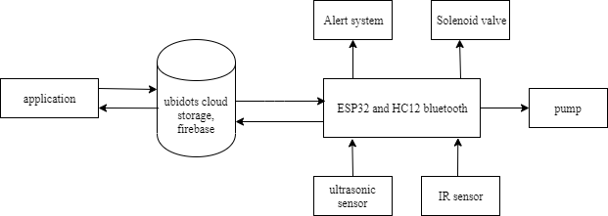

**Figure4.1. Represents the Architectural Design**

Figure4.1 represents the architectural design of the system where the mobile application is connected to IR and ultrasonic sensors through ESP12 and HC12 Bluetooth module to control the solenoid valve, pump, and alert system. The data is transferred through ubidots cloud and firebase.

**4.2 Modular Design**

The below diagram represents the modular design or “modularity in design” is a design approach that subdivides a system into smaller parts called modules that can be independently created and then used in different systems.

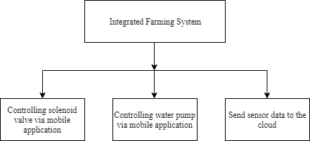

**Figure4.2. Diagram Representing Modular Design**

* The solenoid valve which directly controls the irrigation system is connected to the mobile application through ESP can be controlled by the farmer.
* The water level status in the tank is displayed in the mobile application. Thus farmers can avoid wastage of water by irrigating when the tank is already filled with water.
* The data regarding water level in the tank, as well as the security status of the crop, is uploaded to the cloud from the sensors. The cloud platform provides information in real-time.

1. **RESULTS**

**5.1 Home Page**

The home page allows the user to control the pump and gatevalves through IoT and Bluetooth.

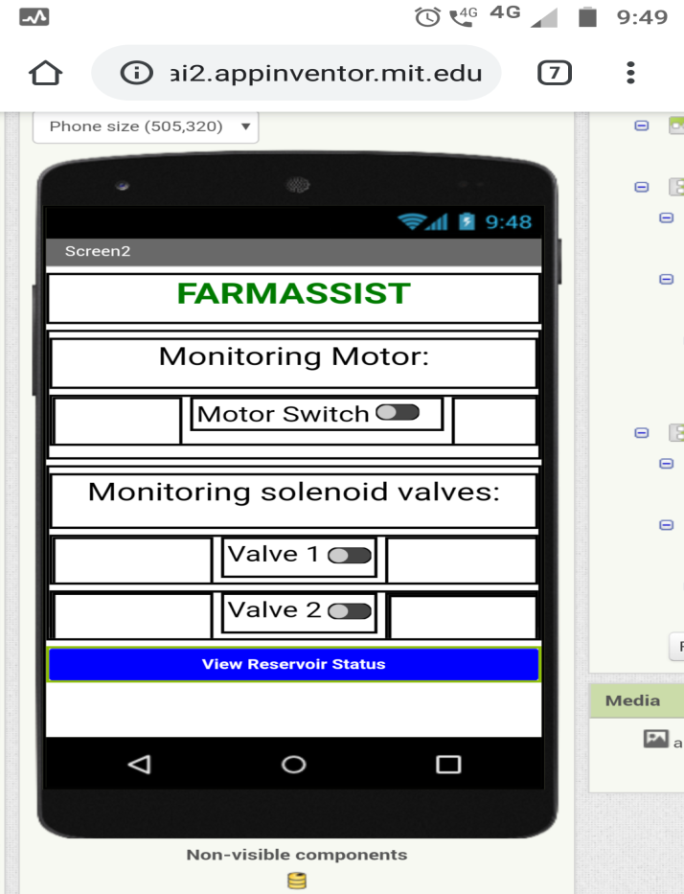

**Figure 5.1 Home Page**

**5.2 Tank Details**

View reservoir status will show the level of water in the tank .

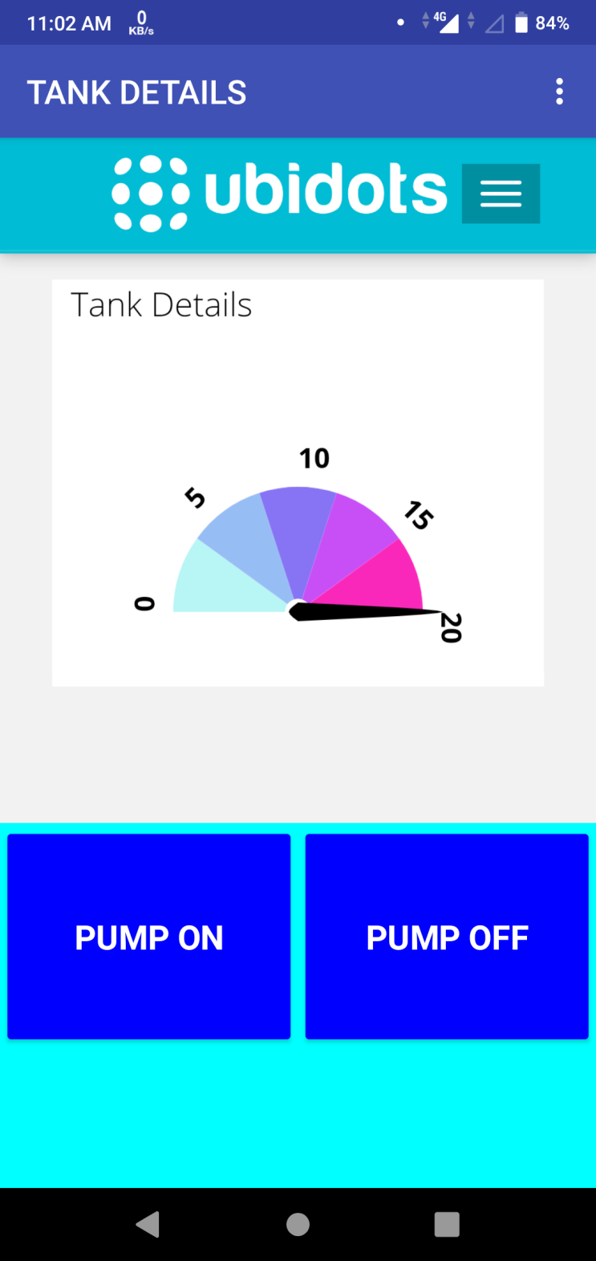

**Figure 5.2 Tank Detail**

**5.3 Intruder notification and Bluetooth connectivity**

Here we can see the notification from the sensors during the detection of intruder.

Select BT module button will enable us to connect mobile device to the control system.

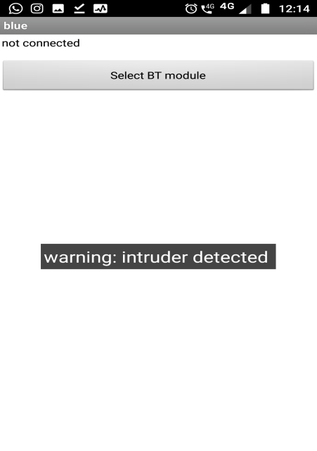

**Figure 5.3 Intruder notification and Bluetooth connectivity**

1. **CONCLUSION**

The irrigation system on automation uses optimal resources to improve the efficiency of the irrigation. This system can be implemented in places that face water shortage to improve agricultural sustainability. This system enables the farmer to control the irrigation system in the whole crop through a mobile application without even having to visit the farm. The system also ensures the safety of the crop by facilitating anti- trespassing system in fencing. This fencing system sends intruder alert to the farmer via mobile application as well as buzzer system. The farmer can also be aware of the water level in the tank by just looking at the application which displays the amount of water filled in the tank. Apart from water supply through application, the system also includes supplying fertilizers to the crops through irrigation system. This system also addresses the problem of unstable network by introducing Bluetooth connectivity to control irrigation via mobile application. Thus this system integrates modern technology with the farming practice to improve time and resource efficiency which later provides better outcome.

##### **references**

* 1. Indian Farmers Cope With Climate Change and Falling Water Tables by MehaJain,National Geographic Explorer
  2. R. Suresh, S. Gopinath, K.Govindaraju, T.Devika, N. SuthanthiraVanitha, “GSM based Automated Irrigation Control using Raingun Irrigation System”, International Journal of Advanced Research in Computer and Communication Engineering Vol. 3, Issue 2, February2014.
  3. P. Rajalakshmi and S Devi Mahalakshmi “IOT Based Crop- Field Monitoring And Irrigation Automation” Intelligent Systems and Control (ISCO), 2016 10th International conference
  4. Joaquín Gutiérrez, Juan Francisco Villa- Medina, Alejandra Nieto-Garibay, and Miguel Ángel Porta-Gándara “Automated Irrigation System Using a Wireless Sensor Network and GPRS Module” IEEE TRANSACTIONS ON INSTRUMENTATION AND MEASUREMENT,VOL.63,NO.1,JANUARY2014
  5. Jia Uddin , S.M. Taslim Reza , QaderNewaz, Jamal Uddin2 , Touhidul Islam , and Jong- Myon Kim “Automated Irrigation System Using Solar Power” 2012 7th International Conference on Electrical and Computer Engineering 20-22 December, 2012, Dhaka,Bangladesh.
  6. R.suresh1 , S.Gopinath2 , K.Govindaraju3 , T.Devika4 , N.SuthanthiraVanitha5 “GSM based Automated Irrigation Control using Raingun Irrigation System” International Journal of Advanced Research in Computer and Communication Engineering Vol. 3,Issue 2, February2014
  7. Review Paper based on automatic irrigation system IJAICT Volume 1, Issue 9, January 2015, Doi:01.0401/ijaict.2015.09.01 Published on 05 (02)2015
  8. Krishnamurthy B, Divya M, Abhishek S, Shashank H A “Solar Fencing Unit and Alarm for Animal Entry Prevention” International Journal of Latest Engineering Research and Applications (IJLERA) ISSN: 2455-7137 Volume – 02, Issue – 05, May – 2017, PP – 128-135
  9. SanketSalvi, PramodJainS.A, SanjayH.A, Harshita T.K, M. Farhana, Naveen Jain, Suhas M V “Cloud Based Data Analysis and Monitoring of Smart Multi-level Irrigation System Using IoT” International conference on I-SMAC, 978-1-5090-3243-3/17/$31.00 ©2017 IEEE