Unmanned Aerial Vehicle based Weeds Detection using Deep Neural Networks

Mohithraj B J1, B Srividhya Pai2, Mohini3, Chaitra H4, Dr. Sumathi Pawar5

*UG Students1,2,3,4 Department of Information Science and Engineering*

*H.O.D5 Department of ISE*

*Canara Engineering College, Benjanapadavu*

*mail2mohithraj@gmail.com1, paisrividhya@gmail.com2,*

*mohinikini2298@gmail.com3, hchaitra95@gmail.com4, pawarsumathi@gmail.com5*

***Abstract -* This paper is focused on detection of weeds in the crop through UAV. Weed control usually consists of spraying herbicides in the agricultural sector. This practice entails major waste and herbicide costs for farmers, and contamination of the environment. One way to minimize costs and the effects on the environment is to allocate the right herbicide doses in the right place and at the right time (Precision Agriculture). Unmanned Aerial Vehicles (UAVs) are now becoming an important collection method for the localization and management of weeds due to their ability to capture images of the whole agricultural field with very high spatial resolution and at low cost. Following major advancements in UAV acquisition systems, automatic weed detection remains a challenging problem due to its close resemblance to the crops. In this paper we propose a deep learning approach, Convolutional Neural Networks (CNNs) with an unsupervised training dataset collection for weeds detection from UAV images. The proposed method comprises three main phases. First, capture an image of the field using UAV. In the second phase, processing the image with CNN. Finally, to show the results using Web Application.**

***Index Terms:* Convolutional Neural Networks, Deep learning, Quadcopter, UAV, Weed detection.**

**I. INTRODUCTION**

Automation of agricultural food processing is gaining prominence in the scientific community and industry. The main objective of the automation is to achieve a growth in agricultural food demand, which is currently lower than the growth of agricultural food production. Automation in agriculture could be increased by the introduction of unmanned aerial vehicles (UAVs) and unmanned ground vehicles (UGVs) which can track crop growth and respond automatically if certain factors, such as water scarcity, weeds or insects, infestation or plant disease, are detected.

The implementation of robotic systems in agricultural food or resource production has been shown to increase the yield of crops per unit of land. There are still a few problems that need to be solved in order to provide a completely integrated system that can be used in the agriculture. One of the challenges is the detection of weeds in the fields. Weeds are present in different forms of plants; it is very difficult to identify these weeds and to take necessary measures to remove them.

Can we distinguish weeds from a crop seedling? Many weeds and crop seedlings look similar, so sometimes it can be hard to differentiate the two. Although they look alike when they are young, they will eventually grow into totally different plants. This challenge presents itself in many real-world situations. For example, Charlock is an agricultural weed and an invasive species in some areas outside its native range, while Shepherd's Purse, considered an herbal medicine, has seedlings of very similar shape to Charlock. Thus, farmers need to differentiate each type of seedling to successfully cultivate without damaging their plants. The dataset contains 4,750 training images and 794 test images, each of which belongs to one of twelve species at several different growth stages. The goal of this project is to build an effective system that identifies weeds present in fields along with the crops using UAV and deep neural networks. The drone-mounted camera captures field images and the resulting image is validated with a qualified deep learning model using the Convolution Neural Networks (CNN) and the results are plotted on a canvas depicting a weeded land with a detailed description.

*A. Problem Statement*

The aim of Unmanned Aerial Vehicle based Weeds Detection using Deep Neural Networks is to detect unwanted growth of weeds along with other crops and to draw a map of the field indicating the presence of weeds with the help of Unmanned Aerial Vehicle and Deep Neural Networks.

Usually in farming when farmers grow crops additional growth of weeds will arise, which will spoil the actual outcome of farming as they affect the growth of planted plants in terms yield and quality. Weeds detection is the major problem when it comes to large areas of cultivation and due to the similarity of weeds and crops which can cause problems in identifying the presence of weeds. Deep Neural Networks approaches could be applied to solve this problem to detect the weeds and to classify them based on computer vision techniques.

**II. LITERATURE SURVEY**

Unmanned Aerial Vehicle (UAV) is becoming an interesting acquisition system for weeds localization and management. Recently the Deep Learning approach has shown impressive results in different complex classiﬁcation problems. In this paper, we propose a novel fully automatic learning method using Convolutional Neural Networks (CNNs) with unsupervised training dataset collection for weeds detection from UAV images. [3] The proposed method consists in three main phases. First, we automatically detect the crop lines and use them to identify the interline weeds. In the second phase, interline weeds are used to constitute the training dataset. Finally, we performed CNNs on this dataset to build a model able to detect the crop and weeds in the images. In modern agriculture, most crops are grown in regular rows separated by a defined space that depends on the type of the crop. Generally, plants that grow out of the rows are considered as weeds commonly referred as inter-line weeds. The main common point between the supervised machine learning algorithms is the need of training data. For a good optimization of deep learning models, it is necessary to have a certain amount of labeled data. But as mentioned before creating large agricultural datasets with pixel-level annotations is an extremely time-consuming task.

Little attempts have been made to develop a fully automatic system for training and identification of weeds in agricultural fields. The main advantage of such technique is that it is unsupervised and does not depend on the training data. Indeed, based on the hypothesis. Intra and inter line vegetation are then used to constitute our training database which is categorized into two classes crop and weed. Thereafter, we performed CNNs on this database to build a model able to detect the crop and weeds in the images. The results obtained are comparable to the traditional supervised training data-labelling.

Another approach is the weed mapping for precision agriculture using Unmanned Aerial Vehicles (UAVs) imagery precision agriculture. Post emergence site specific control treatment is mainly referred to control the weed that can occur in precision agriculture. To identify the difference between the weed and the actual crop and getting it in pixels in early growth stages was very difficult. Differentiating the weed and crop and getting into the imagery pixels is very difficult. Like considering the thickly spread crop identifying in image is very complicated. This makes the major problem of the context of object-based image analysis (OBIA) by means of the supervised machine learning methods combining the feature and with pattern selection techniques, by inventing the system the strategy for data alleviating the user intervention while not compromising the accuracy of the imagery.

For the classification method the training patterns via clustering techniques are to consider a representative set of the whole field crop data image spectrum which is the first proposed method [2]. To obtain the best discriminating functionality from a set of various statistics and measures of different nature are the feature selection methods. After all the research outcomes show that the system method for the selection of patterns is suitable and constructing of sets of data. The information concerned with the image processing which achieves the data acquisition in the 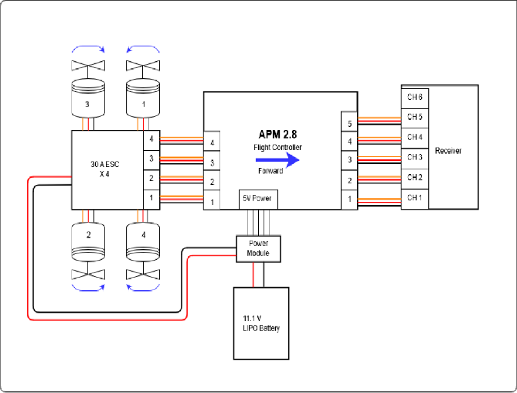steps. The main characteristics is to get the image from the UAV, while considering the image mosaicking process. The huge potential between UAV imagery and crop row weed mapping give some good complemented with the ODIA. Finally, there are some great influences to measure the weed mapping in crops.

**III. METHODOLOGY**

Architectural design is a concept that focuses on components or elements of a structure and unifies them into a coherent and functional whole, according to a particular approach in achieving the objective(s) under the given constraints or limitations.

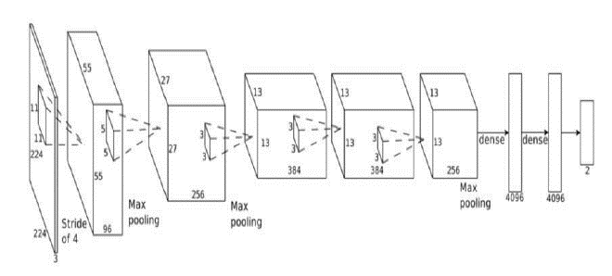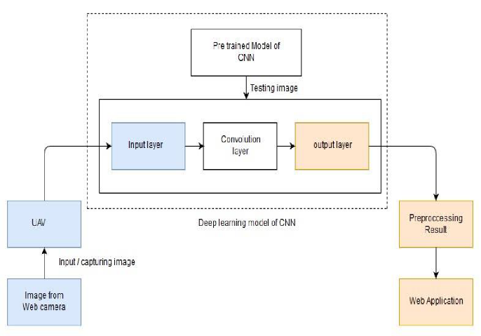

Fig 1: Architectural design for Weeds Detection

First the images of various weeds are acquired using a high-resolution camera so as to get better results & efficiency. Then deep learning techniques are applied to these images to extract useful features which will be required for further analysis.

Unmanned Aerial Vehicle (UAV) mainly comprises APM 2.8 flight controller. The UAV is operated using a Radio Controller. The diagram below describes the components of UAV.

Fig 2: UAV architecture diagram for Weeds Detection

Deep Learning Architecture diagram describes a lot of the computer vision community to take a serious look at deep learning for computer vision tasks. Convolutional layers use a subset of the previous layer’s channels for each filter to reduce computation and force a break of symmetry in the network. The subsampling layers use a form of average pooling.

Fig 3: Deep learning architecture for Weeds detection

The diagram describes the flow of feature extraction for Weeds detection using CNN. The data is loaded from the prepared dataset for testing the samples obtained from UAV and also for training samples.

Fig 4: Flow Design for Feature Extraction

**IV. IMPLEMENTATION**

The goal of our project is to implement an effective weed detection system using UAV. The implementation of the system has mainly 3 parts; (1) Building a UAV; (2) Building a CNN model; (3) Building a web application.

*A. Unmanned Aerial Vehicle (UAV)*

UAV is built using following components: (1) APM 2.8 Flight Controller; (2) Brushless DC Motors; (3) Electronic Speed Controllers; (4) Frame; (5) Battery; (6) Transmitter and Receiver.

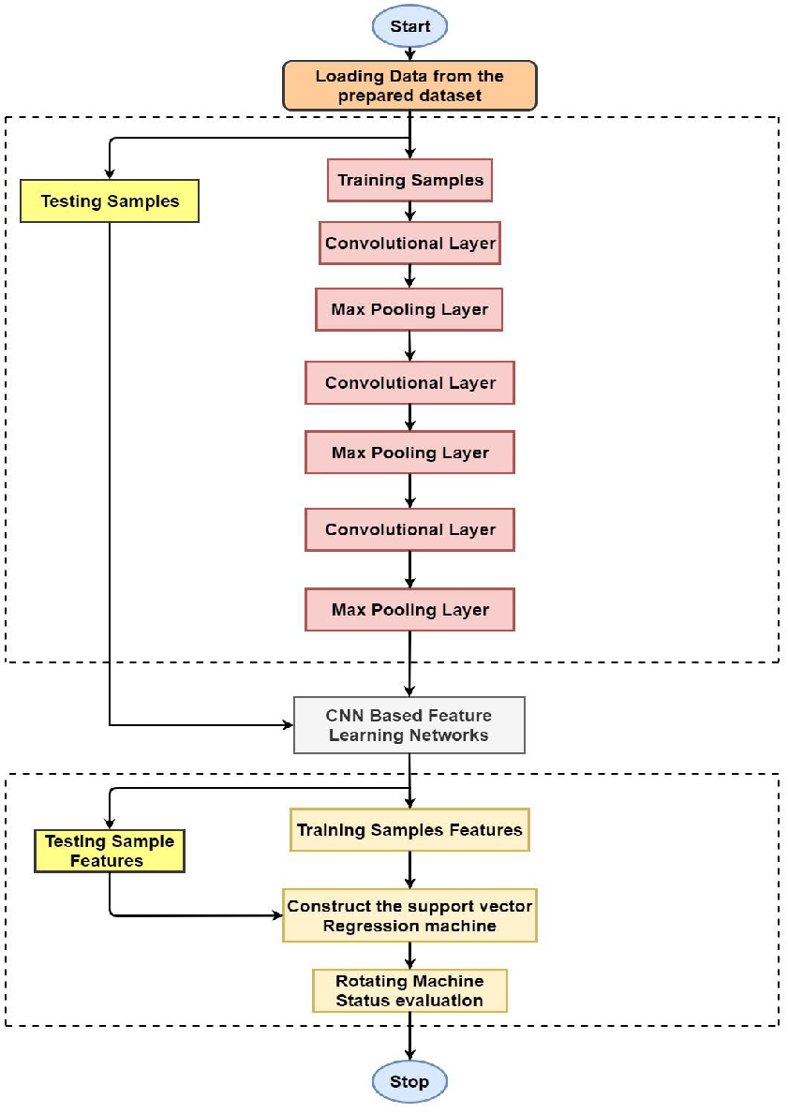**APM 2.8 Flight Controller:** The APM 2.8 is a complete open source autopilot system and the bestselling technology on the prestigious 2012 outback Challenge UAV competition. It allows the user to turn any fixed, rotary wing or multi rotor vehicle (even cars and boats) into a fully autonomous vehicle; capable of performing programmed GPS missions with waypoints.

**Brushless DC Motor:** Brushless motors rotate at very higher speeds and consume very less power compared to the other types of DC motors. It is very energy efficient and also it does not need much energy to run like DC motors. KV rating on the BLDC motors indicates how many rotations the motor can rotate for a given number of volts. The motors (iPOWER) used for this project have a higher power system. Each motor has poles, good quality parts, very well for smooth running and it is designed in such a way to provide a better performance.

**Electronic Speed Controllers:** Normally all Brushless DC motors are three-phased, so it won’t run in a direct power supply with DC connections. In this case, the electronic speed controllers come into the picture. These are connected with the motors which create three high frequencies with continuously controllable phases. These controllable phases are entirely different for each frequency. This enables the motors to rotate. The pulse width modulation signal generated by the microcontroller which is present in the multi-copter flight controller board is fetched directly to the ESC which is used to rotate the motors.

**Frame:** The frame is the one which contains all the things together. Frames are available in different shapes and materials. The frame material should possess very good characteristics physically. It should be very strong enough to bear the vibrations coming from motors. Carbon fiber is one of the best material options for the frame since it is very expensive, we chose glass fiber. F450 is the frame we used for this project. This frame is built from good quality materials, the main frame is made of glass fiber and the arms are made of polyamide nylon. This frame has integrated PCB connections for direct soldering of ESCs and battery. Assembly was very easy and it is provided with one size bolts which makes the things very easy to keep in order and safe.

**Battery:** The battery is one of the main sources for this project. Lithium Polymer (Li-Po) is considered because it is very light in weight. Its current rating should meet the motor power requirements. Turnigy 3300mAh is the battery we used for our project. The battery comes with 3 cell configuration and it is having a discharge rate at 25C

**Transmitter and Receiver:** The FlySky FS-i6 is a great entry level 6-channel telemetry 2.4 GHz computer transmitter that uses solid and reliable Automatic Frequency Hopping Digital System (AFHDS) spread spectrum technology. Radio receiver receives 2.4GHz signals coming from the transmitter side. It has got 6 independent channels to receive the signal from the transmitter and then sends the signal to the microcontroller for further processing. Its current consumption is less than 40 mA and works on 5volt power supply.

All these components are assembled together to form a UAV and a camera is mounted on the UAV. An image is captured on flight and then it is forwarded for Deep learning processing.

*B. Convolutional Neural Network (CNN)*

Our CNN model consists of convolutional layers (CNV) and one fully connected (FC) layers. The size of the input images is *Wt × Ht* pixels. Each convolutional layer consists of (1) Convolution layer; (2) Max-pooling layer; and (3) Nonlinearity layer.

**Convolution layer:** The input to the convolutional layer is an image or a feature map *X* of size *Wt ×Ht ×D* with the trainable *K* kernels, each of size *w × h × D* also called the filter bank *W*. The output feature map Fmap can be computed as:

 (1)

where * is a two-dimensional discrete convolution operator and b is a trainable bias parameter.

**Non-linearity layer:** In the traditional CNN architecture, this layer consists of a pointwise nonlinearity function, which is applied to each component in a feature map. The non-linearity layer computes the output feature map as:

*FNL = f(Fmap)* (2)

where f(.) is commonly chosen as a rectified linear unit (*ReLU*), i.e. *f(x) = max(0,x).*

**Pooling layer:** The pooling layer reduces the resolution of the feature map. It makes the features reliable against the noise and distortion. The pooling layer involves executing a max operation over the activations within a small spatial region G of each feature map:

*FPL = maxi∈G FNLi* (3)

The CNN model is trained with the dataset and the image obtained from UAV is tested to detect the presence of weeds.

*C. Web Application*

Web applications are built using tools like: (1) Angular JS; (2) Django.

**Angular JS:** AngularJS is a JavaScript-based open-source front-end web framework mainly maintained by Google and by a community of individuals and corporations to address many of the challenges encountered in developing single-page applications.

**Django:** Django is a Python-based free and open-source web framework, which follows the model-template-view architectural pattern. It is maintained by the Django Software Foundation, an independent organization established as a 501 non-profit. Django's primary goal is to ease the creation of complex, database-driven websites.

The results obtained from CNN are processed then a canvas is shown using a web application with the presence of weeds.

**V. RESULTS**

This method can be used in all situations, especially in the places where laborers are hard to find. It has many advantages that include very fast detection of weeds, identifying the classes of weeds etc. Some weeds cannot be distinguished by naked eye, so our system will solve the issue in an effective manner. The use of flight controller results in an easy control of UAV. The web application shows the area in the agriculture field where a greater number of weeds are present, thereby farmers can take up certain measures to remove the weeds. Our system can be combined with the pesticide spraying system where detection and spraying can be done using the same UAV. This results in a target based spraying system, which will reduce environmental pollution and use of less pesticides to the field.

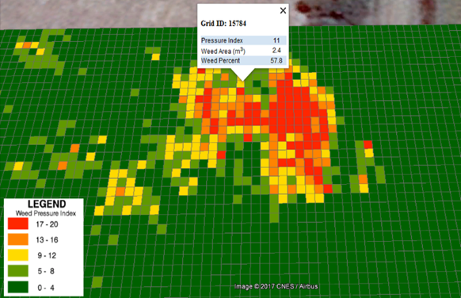 Fig 5: Web application showing the presence of weeds.

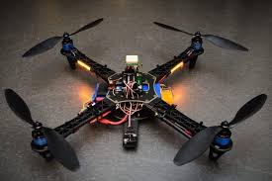

Fig 6: UAV based weeds detection system.

**VI. ANALYSIS**

Comparing the existing systems and the methods used, advantages and disadvantages is listed below in the tabular form. The methodology/algorithm used in the proposed system is more efficient, compared to the existing system.

Table 1. Analysis Table

|  |  |  |  |
| --- | --- | --- | --- |
| **Name of the Paper** | **Methodology/ Algorithm** | **Advantages** | **Disadvantages** |
| [1]. Machine vision system for weed detection using image filtering in vegetables crops. | Image filtering technique for extraction and base line method for binary classification. | Additional computational cost will be reduced compared to the algorithms that require high training of datasets. | Image acquisition is more difficult in different lighting conditions and crops images should be in perpendicular lines. |
| [2]. Selecting patterns and features for between and within crop row weed mapping using UAV imagery | Precision agriculture using UAV, pattern and feature selection techniques. | There are features of great influence for the classification of both crops and weeds. | The model requires few user information to generalize to new areas. |
| [3]. Deep Learning with unsupervised data labelling for weeds detection on UAV images. | Automatic learning technique using CNN. Concept of intra and inter line is used. | It uses an unsupervised learning method and does not depend on training dataset. | Difficult to use multispectral images because in some conditions visible spectral cannot be differentiated. |
| [4]. Identification of weeds in sugarcane fields through images taken by UAV Random Forest Classifier. | Image patterning recognition with the help of RGB cameras and UAV.  It uses the Random Forest Classifier. | RF classifiers have high accuracy and broad use by remote sensing communities. UAV captures high resolution pictures. | Success rate of identification of narrow leaf weed is very less. |
| [5]. Efficient Weed Detection Procedure Using Low-Cost UAV Imagery System for Precision Agriculture Applications | This method is divided into two classification: weed patches and non-weed patches. | This uses a low-cost UAV to collect the RGB images from the agricultural fields. Can detect large and small amounts of weeds. | Cannot detect all weed patches, due to the low quality of the binary image generated from the UAV camera and vegetation segmentation process. |

**VI. CONCLUSION**

In this paper, UAV imagery was collected over a field, and then the CNN method was proposed for weeds detection and weed mapping of the imagery. The collected images are subjected to deep learning techniques. In deep learning, we propose Convolutional a neural network which produces high accuracy. After that, the CNN results are shown in a web application indicating the presence of weeds in the field. Especially for the recognition of weeds, CNN's approach achieved the highest accuracy compared with other methods.

However, this concept helps in only detection of weeds rather than removal or eradication of weeds. This requirement limits the application of this method. So, in the future of this work, we plan to introduce the detection and also removal system like pesticides spraying, laser guided removal technique to reduce the manual work and enhance the ease of application.

**REFERENCES**

[1] Camilo Andrés Pulido-Rojas, Manuel Alejandro Molina-Villa, Leonardo Enrique Solaque-Guzmán; “Machine vision system for weed detection using image filtering in vegetables crops” funded by the research vice rectory of the Nueva Granada Military University in Bogotá, Colombia.-2016

[2] Maria Perez Ortiza, Jose Manuel Penaa, Pedro Antonio Gutierrezb, Jorge Torres Sancheza, Cesar Hervas Martinezb; “Selecting patterns and features for between and within crop row weed mapping using UAV imagery.” Department of Computer Science and Numerical Analysis, University of Cordoba, Department of Mathematics and Engineering, Universidad Loyola Andalucia.

[3] M.Dian. Bah, Adel Haﬁane, Raphael Canals; “Deep Learning with unsupervised data labelling for weeds detection on UAV images”; IEEE, 2018.

[4] Inacio H. Yano, Jose R. Alves, Welsey E. Santiago; “Identification of weeds in sugarcane fields through images taken by UAV and Random Forest Classifier.” ; University state of Campinas, Pontifical Catholic University, Brazil.

[5] M. Hassanein, N.El-Sheimy; AN “Efficient Weed Detection Procedure Using Low-Cost UAV Imagery System for Precision Agriculture Applications”; Department of Geometrics Engineering, University of Calgary,-2018

[6] Dr.V.S. Malemath, Mrs Sharanamma M. Hugar; “A new approach for weed detection in agriculture using image processing techniques”; International Journal of Advanced Scientific and Technical Research, 2016.

[7] Alessandro dos Santos Ferreiraa, Daniel Matte Freitasa, Gercina Gonçalves da Silvaa, Hemerson Pistorib, Marcelo Theophilo Folhesc; “Weed detection in soybean crops using ConvNets” Federal University of Mato Grosso do Sul, Brazil, Dom Bosco Catholic University, Brazil, IbiGeo Geociência Aplicada, Brazil

[8] J. M. Guerrero, G. Pajares, M. Montalvo, J. Romeo, and M. Guijarro. “Support vector machines for crop/weeds identification in maize fields” .Expert Systems with Applications, 39(12):11149 – 11155, 2012

[9] J. Geipel, J. Link, and W. Claupein. “Combined spectral and spatial modeling of corn yield based on aerial images and crop surface models acquired with an unmanned aircraft system” .Remote Sensing,6(11):10335, 2014

[10] P. Tokekar, J. V. Hook, D. Mulla, and V. Isler. “Sensor planning for a symbiotic UAV and UGV system for precision agriculture”, pages 5321–5326. 2013.