An Integrated User Interface as Farmer’s Assistant System

Shwetha, Sangeetha P Nayak, Prathiksha P Shenoy, Shreya Rajesh, Priyanka

Department of Computer Science and Engineering

Shri Madhwa Vadiraja Institute of Technology and Management, Bantakal, Udupi

***Abstract* — Agriculture is the science or an art of cultivating the soil, raising livestock, crops growing and harvesting. Agriculture is also a technique of producing land with higher productivity which is being utilized throughout the globe using many procedures with the help of some science and technology which is highly produced in daily life. Despite the fact that the mobile phones are being made use by individuals who are living in certain rural areas, nevertheless there are barely any similar applications for them to account their affairs to the government during the times when they face any problems or any several obstacles. There are many existing applications related to agriculture. These applications are used to solve problems of farmers such as finding the exact location, area of their land and to know further details about their land. After seeing all these applications our survey revealed that there is no such feature which provides farmers to lodge their agricultural issues and request funds from the government. Here the concept of geo tagging is used for capturing the exact location of destructed land. In this proposed methodology, the problems faced by the farmers during destruction of agricultural field are solved in an unique way. According to this methodology, the farmers can lodge their issues in this web application and they can request fund from the government whenever they face agricultural loss due to natural calamity.**

**Keywords – Geotag, Web Application System.**

# INTRODUCTION

In recent days, the technologies are developing such as the use of electronic devices and information transmission. This has introduced radical transmutation to the agricultural working environment. The world is becoming more compound in these years due to increase in population and its demand for more food, water, and energy and increasing pressures on various natural resources. Many efforts have been made to improve farmer's living standards, and to overcome the farmer’s poverty and food insecurity that are still prevalent across large portions of our country. There are many technologies currently used in agriculture. Agriculture using IOT is an application for the implementation of connected devices and also a unique or alternative method of technologies which is very useful for agriculture. Using IOT it is able to know the real time weather conditions. In Precision Farming or precision agriculture, the name precision itself says the exactness which is the most trending application of IOT in Agriculture. Nowadays by the advance technology in the agricultural operations IOT has introduced agricultural drones which have the highest impact on agriculture and it is also a trending method. For the purpose of the greenhouses, smart IOT now has enabled some of the weather stations so that it will automatically adjust the conditions of the climate accordingly for their specific set of the instructions. Machine learning is one of the new technologies which is very much trending nowadays. This type of technology is been implemented as the modern form of agriculture. This method has a very good advantage as it helps in growing healthy seeds.

In our proposed application it is been tried to solve the problems of farmer whenever they face agricultural land destruction due to natural calamity. Here a farmer can request fund from the government whenever he faces agricultural loss due to natural calamity. The main advantage is that, this is a user friendly application which can be used by farmer. Another advantage is that since this project follows a bottom up approach, there is not much need for the higher officials to verify the documents of farmers because the documents will already be verified by the officers at lower level. Hence it is cost effective since farmers need not visit the place to lodge their issues with village accountant. Since the information related to the farmer will be saved with village accountant, there is no much need to refer the documents again. Hence farmer’s time will be saved.

# BACKGROUND

Agriculture is a technique of producing land with higher productivity which is been utilized throughout the globe using several few procedures with the help of science and technology which is highly produced in daily life. Agriculture is the science or an art of cultivating the soil, raising livestock, crops growing and harvesting. Agricultural science is nothing but transacting with the production in farm. In addition to this some other tasks are cultivating crops in the fertile soil, and also control over the water, the products which are processed by either plants or animals and also growing or harvesting the crops, and other such reliable tasks. Web-based agricultural support system (WASS) has been put forward to carry out the agriculture related activities in several areas as it combines with some of the web technologies and other agricultural system. It’s been analyzed with some of the fundamental nature in web-based agricultural support system and also to describe some of the functionalities present in the system [1]. The Web also provides some of the details regarding the process which is supported by the systems, such as Decision Support System (DSS).

We know that the agriculture is one of the oldest, traditional methods and also the most important activities of the man. This type of agriculture is been carried out under the control of the natural environment as agriculture is an important source of food. Instead of growing or building industrialization and urbanization in the world or global we can have a good practice of cultivating the land which is more beneficial for the daily living basis. In some of the developing countries agriculture is considered as a major sector because it has been providing major sources of employment as well as the income. We know the fact that the agriculture is the backbone of the Indian economy. In this economy, India is nearly about 64 % of the total population and 90 % of the rural populations are engaged as well as indulged in the activity called agriculture. Socio-economic factors will also be supporting for the growth of some of the basis of agriculture. Therefore it is very important to focus on the physical as well as the socio-economic factors which deals with the agricultural study and also some of the region intended to understand the agricultural scenarios of the particular region [2].

The main aim is to reach the farmers for the awareness of agricultural facilities, also the usage and the perception in Agriculture. The statistical survey for the design techniques is used to collect all the data from the farmers in order to reach them the awareness in e-Commerce. It is necessary to provide a clear interpretation as well as implications for common people [3]. Suppose if status of any complaint is given to farmers mobile then it would be useful for him to keep track of his complaint status. Hence the farmer is benefitted. By using modern technology such as internet in agriculture, we can stop the process of taking bribe in government offices.

The demand for digital phones among the farmers is increased due to the advancement in the knowledge of technology. Hence this is an opportunity for researchers to build up mobile based information dispersion among them. In some cases, the knowledge regarding cultivation of crops has been communicated successfully to the interested stakeholders by using cell phone based on Short Message Service (SMS) systems and Interactive Voice Response (IVR) systems [4].

Mobile devices are broadly used by the individual person for the purpose of communication, music, usage of web and other social networking sites. Despite the fact that the mobile phones are being made use by individuals who are living in certain rural areas, nevertheless there are barely any similar applications for them to account their affairs to the government during the times when they face any problems or any obstacles. Here the whole project illustrates the particular authentic user where in the government will see farmer lodge complaint and updates respective data, government gets to know about this and post the status to his mobile as complaint accept, complaint reject or complaint withhold request status[5].

In the rural areas, the internet facility will not be able to give the required market information because in such areas internet cannot be availed. Hence SMS facility provides required information to the farmers [6]. Farming is considered as the prime occupation in India, but now the problem is that human beings engage in farming which will be belonging to the low level class and will be in poverty very deeply. It is also necessary to use some of the techniques which will be guiding the farmers in all the aspects such as some of the different schemes available to farmers, and the total sale as well as the gain for every selling products, accessing for new techniques in farming into the e-learning methods and centralizing approaches to display the several government’s agricultural scheme. One such technique used is called as E farming.

The issues and survey of E-agriculture in cultivation and development with respect to India is given prime consideration. The data inequality between farmers and farmer, village and village, region and region are the real challenge for the Agriculture in India. E-Agriculture is a crop up field which focuses on the development of agriculture through improved processing of data which is being collected. In E-agriculture, innovative way to concentrate on cultivation of crops and development of rural people by involving the application of knowledge and communication technologies (ICTs) is practiced. Precision Agriculture is basically the progressive e-agriculture application; it is used for cultured technologies in the agriculture to develop the quality and the capacity of production. Improving the yields and protecting the environment, cutting crops is done by utilizing precision agriculture. It uses 5 major components namely, for searching, managing, mapping the spatial information Geographical Information Systems (GIS) is used, to identify Remote Sensing (RS) is used and  for locating and defining the spatial features Global Positioning Systems (GPS) is used or for the actions that contributes to the quality of site clear cut practices, for recording crop productivity which is used as an historical directory for managing the crops by monitoring, allowing the target and giving the specific input, Variable Rate Technology (VRT) is used [7].

The main vision is to establish fair estimates to the cultivation society by formulating new approaches and use of online method for some agricultural process. This web application will provide benefits for farmers during destruction of crops due to natural calamity. Hence it is necessary to implement an idea which cuts off the involvement of the middleman and the concept of giving and taking bribes can be completely eliminated. Many small croppers still depend on the local broker and put high rate of interest whenever farmers need money and face loss due to natural calamity. The benefits were eliminated which the farmers were supposed to get. Some of the technologies have improved, it is restricted to urban areas but it has not gone to the rural areas [8].

The growth of smart technology and the recent addition of information services provided by the mobile is a way to overcome the actual information asymmetry, which helps in removing the gap between the availability and rendering of agriculture inputs and infrastructure. The usage of mobile networks and handsets in India has been increased therefore it makes the information more widely available. It could help the agronomical markets operate more efficiently, and the challenges faced in rural sector can be overthrown. The recent technology of mobile permit the services of information which suggest that it is time to mark the transformation of mobile phones and their impact on agronomy in India [9]. These services will provide huge information to farmers. Smart phones are becoming a fundamental device for different types of users irrespective of the age group. In India, smart phones technology has witnessed a paradigm shift in the transmission medium to reach large number of people. The services like SMS which is based on information services can be provided using new application implemented using web technology. The server can send the request and to parse the received data can be done by Hyper Text Transfer Protocol (HTTP) Connection.

# IMPLEMENTATION

The detailed description of the system overview, tools and technologies being used, web design, methodology used in implementation, simulation, security and performance is explained in this section.

# OVERVIEW

Development of computer technologies has mostly influenced the use of computer support in different agricultural activities. Web application plays a major role in agricultural life of farmers. Solution to one of the agricultural problems faced by the farmers during agricultural disasters is by using the web application. In the proposed methodology, the brief explanation of how the lodged complaints are processed from lower level officers to higher level officers is provided. When the farmer is about to upload his documents pertaining to his complaint, the concept of geotagging comes into picture. Geo-tagging is the method of enclosing the information of the location in the form of converting the geographical metadata to digital media (such as websites, videos, and photographs). Geotagging provides the authentication of location and assures that the picture taken by the farmer is the valid image of the destroyed field. SMS is sent timely to the farmers mobile phones in order for the farmers to keep track of their complaint status. Concept of SMS facility is introduced because in rural areas availability of internet connection might be disrupted and farmers cannot check their complaint status all the time.

# TOOLS AND TECHNOLOGIES USED

In order to create a web application, a front end and a backend is essential. The front end usually interacts with the end users. The backend usually has database. A database is the data structure that stores and manages all the organized information properly. A DBMS is a software application which normally cooperates with end users, and database as well as applications, in order to analyze the data for other purposes.

The Structured Query Language (SQL) commands are nothing but instructions. It is generally used to communicate with database. It is also used to perform specific tasks and functions, queries of data. Its task is to create a table, add data into the table, drop the table, modifying the existing data present in the table and to set different permission for user. Every database object has an owner. The Permissions in SQL are the various rights to approach the database objects and the approval can be accepted to the user to allow that user to perform operations such as selection, insertion or modification of data rows. There are five types of SQL Commands: DDL, DML, DCL, TCL and DQL. DDL(Data Definition Language): It changes the structure of the table like creating a table, deleting a table, altering a table etc. DML(Data Manipulation Language): These commands are used to modify the existing database. DCL(Data Control Language): These commands are used to grant authority and to take back authority from any database user. TCL(Transaction Control Language): These commands are used with the DML commands like INSERT, DELETE and UPDATE. DQL(Data Query Language) is used to fetch the data from the database.

XAMPP(Cross Platform Apache MariaDB PHP Perl) is a open source and free software platform for web server that is developed by Apache. HTML stands for Hyper Text Markup Language and it is a standard markup language for web pages.

XAMPP(Cross Platform Apache MariaDB PHP Perl) is a open source and free software platform for web server that is developed by Apache.

PHP is a general purpose programming which is originally designed for the development of web. PHP codes can be also used in command line interface for the execution.

HTML stands for Hyper Text Markup Language and it is a standard markup language for web pages. This markup language can be used to show and compose text, images, and other material into audible and visual web pages. CSS which stands for Cascading Style Sheets is a method to beautify html pages. CSS will add the various styles of backgrounds, dimensions, colors, text-styling, opacity, font-size, position, font-family. HTML is used to create only a basic design but CSS will add life to it. JavaScript is the client-side scripting language, used to include the dynamic behavior to the static web pages. JS is used to provide basic structure to the designed web page and beautify it.

# WEB DESIGN

Web design will include disciplines and skills in the production and maintenance of web sites. Web design is generally used in order to describe the design process which is related to the front end or client side design of a website. Web designers are usually expected to have an alertness of usability. Web designers use different types of tools based on which part of the process of production they are involved in.

The most frequently used programming language for the Front-End design is HTML5. In past days, CSS was used as the designing technology for web site development. But in the recent days Bootstrap is used for designing. Using Bootstrap the look, feel and compatibility of the website design will be improved. Bootstrap provides faster access to web pages due to the technology used in bootstrap framework.

1. **Client Script Execution:**

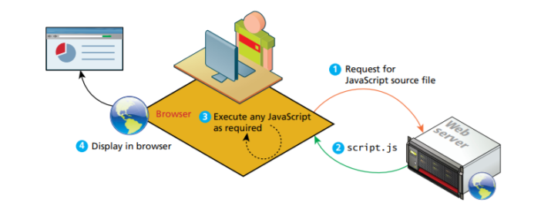

Fig.1 Client script execution [11]

In client side script execution these steps are taken place:

Step 1: Client will send request to the web server for the javascript source file.

Step 2: From the web server it will send the script by adding .js extension.

Step 3: Any javascript which is required will be executed.

Step 4: The executed script will be displayed in the browser.

1. **Server script execution:**

A server-side script can access any resources made available to it by the server.

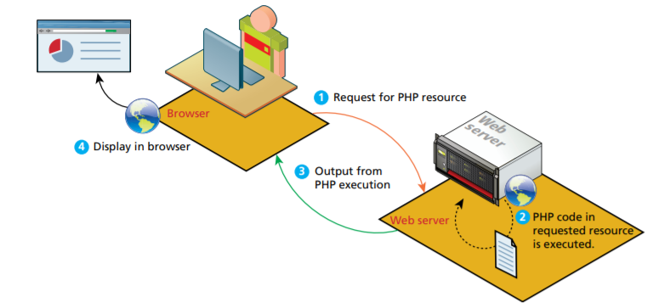

Fig.2 Server script execution [11]

In server side script execution these steps are taken place:

Step 1: Client will send for the php resources to the web server.

Step 2: In the web server the php code in the requested source will be executed.

Step 3: Web server will send output from the php execution to the browser.

Step 4: At the browser the output will be displayed.

# METHODOLOGY

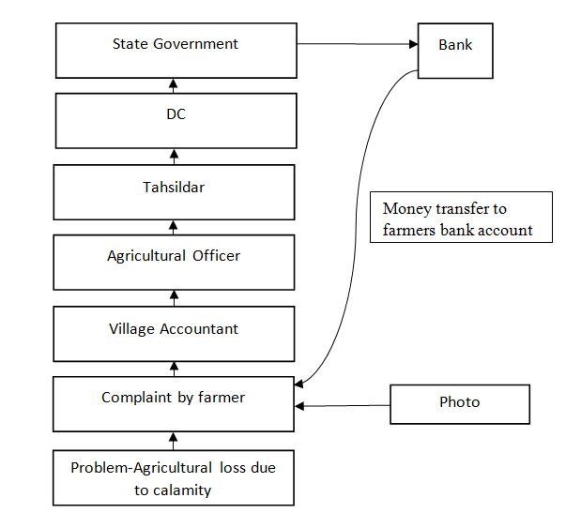

Fig. 3 Block diagram of the system

Fig. 3 depicts the overall flow of documents submitted by farmers in our web application. In our proposed method, farmers can request funds from the government whenever they face agricultural loss due to natural calamity. The issues submitted by the farmer will be received by the Village Accountant. Once the documents are verified by the Village Accountant, the concerned documents will be sent to the agricultural officer to verify the exact cause of the destruction. The agricultural officer also verifies some documents. Later these documents are sent to the Tahsildar. Tahsildar will allot the amount for sanction of the fund. After the verification he will allot the appropriate amount. Tahsildar approves the documents for further process. Later, the documents will be sent to the District Commissioner. The District Commissioner will sign the documents and approve the amount allotted for sanction of funds. Finally the documents will move to the State Government for fund allotment. The State Government will sanction the amount by signing the concerned documents. After this process the funds will be sent to the bank account of the farmer. Farmers can keep track of his complaint status.

# SIMULATION

The data collection allows farmers to approach conservation of data at a land-scape scale, versus at the farm or even the country level. The more information that the cultivators have about the crops, the better the opportunities would the farmers to increase their yield. Proper co-ordination between the interface and the database is necessary to ensure that application is responsive. Web based simulation is the appeal of the services of computer simulation typically through a web browser over World Wide Web(WWW).

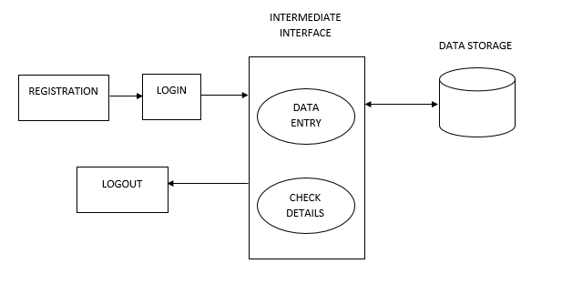

Fig. 4 Overall System Design

Fig. 4 illustrates the brief overview of the design of Farmers Assistant System. Step 1, requires that the registration of the farmer should be complete before logging in to the system. Step 2, indicates the intermediate interaction between user (farmer and officer) and the database. This step includes two modules. First module is “data entry” with respect to farmers. The farmer must provide all his personal details along with complaint details. Complaint details include bank details and land details. Second module is “check details”. If the user is a farmer then he can check the status of his complaint. If the user is a officer then he/she must check the details of complaint lodged by farmers of his/her village. Step 3, includes the storage done in the database. All the data entered by the farmer will be stored in the database. This helps the officers to access the details of the farmers as and when needed.

# SECURITY

Security is the most important concern to any web application because the sensitive data should be stored in a safe manner. Web application security will include security of websites, web services as well as web application itself. The web application security is specifically applied on internet and also web system.

The main area where the security is to be provided is authentication and authorization of websites. Authentication means the process of validating the users who they claimed to be. The most common factor of authentication is the usage of password i.e., if the password entered by the user is correct then the system will consider the identity of user as valid and it will grant the user with access to the web application. Some sort of security must be provided whenever the data is stored in the backend of the web application. One of the way is to encrypt the private data before storing that particular data in backend. In order to access this data it is necessary to decrypt the private data. The process of providing permission to the user in order to have access over a specific function or resource is known as authorization in the system security. Examples include granting permission to the user to download a specific file on the server.

Confidentiality (also known as privacy) is the process of ensuing that data remains confidential and private. The data should not be viewed by eavesdroppers or unauthorized users who control the flow of traffic across the entire network. To enforce confidentiality Encryption is frequently used. When the data is passed through the network, Integrity becomes a key concern just like privacy. The process which guarantees that the data is to be protected from sudden or malicious modification is known as Integrity. Hashing techniques along with message authentication code will provide Integrity in the data.

# PERFORMANCE

The software quality is affected by quality attributes such as implementation approach used, designing approach used, the tools used for development of software, Web Application Servers, the hardware environment etc [10]. This paper focuses on attempt to develop web application based on scalability and performance.As more and more web applications are built up, it is necessary to focus on the performance of the web application and scalability of the web application. Performance of an application is termed as the time interval between the submission of the request from a user and the completion of the response for the submitted request.

Consider a web application system expressed as

w = {p1, p2 ,…, ps}

where pj given by 1 < j < s, is a page of the system.

Hence the response time that user *i* acquires the data of a web page by accessing a web application randomly for a single request is given by [10]:

ti= { ti1 , ti2 ,…..,tis }

For any particular web application, every page will have a different type of influence on the response time. So, we will define an influence factor for response time for each page as the following [10]:

γ = { γ1, γ2, γ3,…, γs }

where γj is the influence factor of page j , 1 ≤ j ≤ s.

given j = 1

During a single request condition, when the user *i* accesses a web application, the response time of a particular web page is given by [10]:

TRi = j.tij = γ.ti (3.1)

We assume that the client access event is a uniform distribution and the number of the random access users is n*.* The performance RT of web application system is given as [10]:

R = ( TR1+ TR2 +…..+ TRn) / n (3.2)

For some of the web applications, the value of R in Equation 3.2 is a fixed value. The lesser the value of R, the shorter is the mean response time for a single request. So better is the performance of the web application.

The practical application is that, if response time of the web page exceeds 8 seconds, users tend to terminate the session and they will leave the website (eight-second rule).

R 4 sec, the performance of WAS is better.

4 sec < R  ≤ 6 sec, the % of WAS users lost are 60%.

6 sec < R < 8 sec, the % of WAS users lost are 95%.

R  ≥ 8 sec, the indicator of poor performance of the system, and it will not only cause systems to fail, but also drive the users away.

# SCALABILITY

Scalability of web application means compatibility of application to adapt itself to changes in design. The designed web application is highly scalable. This is because for an existing application new features can be added or removed at any time. When a new comer starts to build his/her first website, at that particular moment he/she may not know the disadvantages that may arise in the future. So in order to overcome this in the future, web application should be highly adaptable to the changing features. Hence scalability plays an important role in the web development. But frequent changes in the code structure may result in increasing complexity and it will be complicated to understand the code structure. Website scalability means the ability of the system, process or the network to cope up with the increase in workload when the resources are added. Scalability may also mean the ability to add additional resources while keeping central node structure intact. Scalability also depends on the ratio of increase in systems performance.

# CONCLUSION

It is revealed that farmers have started with the adoption of advanced technologies. An Integrated User Interface as Farmers Assistant System simulation helps to study the intricacies of the dependences between farmers and the nature. In this paper, typical applications of the information technology in agriculture were introduced. This application shows the combination of traditional agriculture practices with modern information technology. Further researches will be focused on how to improve the facility and real-time simulation. The combination of the information technology and agricultural technology represents the development direction of the future agricultural technology. The problem faced by the farmer can be solved with the proposed methodology in a cost effective way. The government should try to create awareness for the farmers on how best they can use modern inventions using technology in agriculture. The farmers will thus be able to use the application in a convenient manner.

REFERENCES

[1] Yuegao Hu ZhiQuan, Y.Y. Yao, J.T. Yao, V.V. Raghvan, G.Y. Wang(Eds.): *WSS’04, pp.75-80*, 2004.

[2] Brett Drury, Robson Fernandes, Maria-Fernanda Moura, Alneu de Andrade Lopes, “ A survey of semantic web technology for agriculture” , *Information Processing in Agriculture*, 26 February 2019.

[3] Sumitha Thankachan, Dr. S. Kirubakaran, “E-Agriculture Information Management System”, *in Proceeding of International Journal of Computer Science and Mobile Computing, IJCSMC*, Vol. 3, Issue. 5, May 2014, pg.599-607.

[4] Uvasara Dissanayake, Ashintha Perera, K.P. Hewagamage, G.N. Wikramanayake, “Mobile Based Collaborative Learning Tool to Facilitate Instructor-mediated Informal Learning in Agriculture”, *in Proceeding of International Conference on Advances in ICT for Emerging Regions(ICTer): 099-105*, 2015.

[5] Manisha Bhende, Mohini S. Avatade, SuvarnaPatil, Pooja Mishra, Pooja Prasad, Shubham Shewalkar, “Digital: E-Commerce Application For Farmers”.

[6] Sindhu M R ,Aditya Pabshettiwar, Ketan K. Ghumatkar, Pravin H. Budhehalkar, Paresh. V Jaju, *in Proceeding of I(IJCSIT) International Journal of Computer Science and Information Technologies*, Vol. 3(2), 2012, 3479-3482.

[7] Deka Ganesh Chandra, Dutta Borah Malaya, “Role of e-Agriculture in Rural Development in Indian Context”.

[8] Abhishek A.G., Bharathwaj M., Bhagyalakshmi L., “Agriculture Marketing Using Web and Mobile Based Technologies”, *in Proceeding of IEEE International Conference on Technological Innovations in ICT For Agriculture and Rural Development (TIAR 2016),* 2016.

[9] Manav Singhal, Kshitij Verma, Anupam Shukla, ABV-Indian Institute of Information Technology and Management, “Krishi Ville - Android based Solution for Indian Agriculture”.

[10] Zao-Bin GAN and Deng-Wen WEI, Vijay VARADHARAJAN, *Proceedings of the Third International Conference on Information Technology and Applications (ICITA’05)*, Evaluating the Performance and Scalability of Web Application systems.

[11] Randy Connoly and Ricardo Hoar, *“Fundamentals of Web Development”*, First Edition, Pearson Education India (ISBN:978-9332575271).