**SURVEY ON PADDY LEAF DISEASE DETECTION AND CLASSIFICATION USING DEEP LEARNING TECHNIQUES**

Ajay1 Amod Shetty1 Nisha J1 Nishmitha Shetty1 Manoj T*

Shri Madhwa Vadiraja Institute of Technology and Management, Bantakal, Udupi, India

***Abstract*— India’s agriculture has a proven history of growing a plethora of crops, with the foremost food staples being rice. Agriculture has been the backbone of the Indian economy and it will still stay therefore for an extended time. Paddy is one of the most important and widely cultivated crops in the Asian continent. It accounts for marketable production. Unfortunately, paddy cultivation is facing numerous challenges these days because of the infestation and different factors on paddy leaf inflicting rice leaf diseases. The diseases are mainly classified into Rice blast, Brown spot, and Bacterial leaf blight. These diseases have a great impact on both the quality of the rice crop and its yield. This ends up in a huge loss for the farmers, which leads to reduced interest in cultivating the paddy crop and eventually suicide. In this survey paper we present a different deep learning approach which can be used for paddy leaf detection and classification from their images.**

# **Introduction**

Agriculture invariably bears a main role within the Indian economy. Paddy cultivation is the second largest revenue generator in the agricultural sector of our country. In India, rice is the most preferred staple food to 70% of the total population. Among the rice-growing countries within the world, India has the most important space for the cultivation of paddy crop and ranks second in position.

The natural calamities like drought or flood are very frequently observed in many places of India. Because of these natural disasters, there's an enormous loss to crop cultivation and ultimately to the farmers. Due to such loss, several farmers are committing suicide. If natural calamities aren't present then there could also be sudden pest attacks destroying all the crops. In most of these cases, farmers as well as crops are always at the sting of risk. The policies and schemes framed by the government are also not so encouraging in terms of heavy loss incurred by the farming community.

There are several factors for the reduced production of paddy crop. One among the numerous factors is paddy leaf disease. Paddy leaves are most stricken by totally different styles of diseases like Rice blast, Brown spot, and bacterial leaf blight. Detection and classification of diseases are necessary tasks to extend productivity. The task of detection of the disease through naked eyes is long and generally causes error in distinguishing the correct variety of diseases. There's a desire for an automatic disease system for correct and quick disease detection and recognition. Deep learning techniques are most popular because of its performance in image classification. Deep learning techniques avoid the extraction of advanced hand-crafted options in contrast to ancient machine learning techniques and supply end-to-end learning.

The remainder of the paper is organized as follows. Section II introduces some of the popularly used deep learning approaches for image classification. Section III gives a brief description about Bacterial Leaf Blight, Brown Spot and Rice Blast Diseases. Sections IV presents different deep learning approaches to classify rice leaf diseases and in Section V concludes the paper.

# **Deep Learning approaches**

Neural Network is a machine learning technique that mimics the human nervous system and also the structure of the brain. Processing units in neural networks are organized in input, hidden and output layers. The units in each layer are connected to a different unit in adjacent layers. Each connection contains a weight value. Applications of Neural Networks include pattern recognition, classification, clustering, dimensionality reduction, computer vision, natural language processing (NLP), regression, predictive analysis, etc.

Deep Neural Network (DNN) is a kind of neural network that is trained to learn representations from data sets without any manual design of feature extractors. Deep Learning consists of an outsized number of processing layers, which contrasts with a shallow learning model with fewer layers of units. The transformation from shallow to deep learning has allowed for more complex and nonlinear functions to be mapped, as they can't be efficiently mapped with shallow architectures. Here are some deep learning approaches,

1. **Convolutional Neural Network (CNN):**

Each layer consists of groups of 2D neurons called filters or kernels. Moving from input to output layers there are multiple convolution layers that perform refined feature extraction at every layer. Sub-sampling and pooling layers are often inserted between each convolution layer. Convolution layers are followed by fully connected layers which perform classification. CNN takes a 2D n × n pixelated image as an input. In CNN, neurons in each feature extraction layer are only connected to the spatially mapped fixed-sized and partially overlapping neurons within the previous layer’s input image or feature map [1]. This region within the input is named the local receptive field. The smaller number of connections reduces training time and chances of overfitting. All neurons in a filter are connected to an equivalent number of neurons in the previous input layer with a constraint to have an equivalent sequence of weights and biases. These factors will increase the learning ability and reduce the memory requirements for the network. Thus, each neuron during a specific filter looks for an equivalent pattern but in several parts of the input image. Sub-sampling layers reduce the dimensions of the network. Max/mean pooling or local averaging filters are different techniques to attain sub-sampling. The final layers of CNN are responsible for the particular classifications, where neurons between the layers are fully connected. Deep CNN is often implemented with multiple series of weight-sharing convolution layers and sub-sampling layers. The deep nature of the CNN leads to high-quality representations while maintaining locality, reduced parameters, and invariance to minor variations in the input image.

Different models of CNN for Image Classification: LeNet-5, AlexNet, ZFNet, VGGNet, GoogLeNet, ResNet, DenseNet, CapsNet, SENet. AlexNet, ZFNet, and VGGNet followed the architecture of the traditional CNN model like LeNet-5 [2]. By combining the inception module and residual blocks with the traditional CNN model, GoogLeNet and ResNet gained better accuracy than stacking equivalent building blocks again and again. DenseNet focused on feature reusing to strengthen the feature propagation.

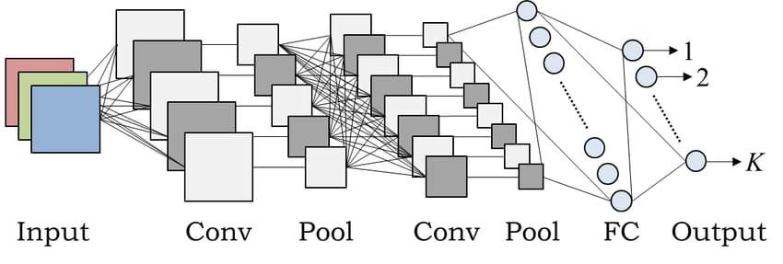

Figure 1. CNN Architecture [3]

1. **Recurrent Neural Network (RNN):**

RNN is a neural network where the output from the previous stage is fed as input to the present stage. This enables us to find out sequences and information to continue the network. RNN is efficient in modelling sequential data, speech or text [4]. RNN is applied to non sequential data to train in a very non-sequential manner. RNN is often used for image, video captioning, word prediction, word translation, image processing, speech recognition, speech processing, natural language processing, music processing applications, etc. A recurrent neural network has a greater capability of deep learning.

Different types of RNN architectures are: Fully Recurrent Neural Network, Recursive Neural network, Hopfield Network, Elman networks and Jordan networks or Simple Recurrent Network, Echo State Network, Neural history compressor, Long STM, Gated Recurrent Units, Bi-directional RNN, Continuous-time RNN, Hierarchical RNN, Recurrent Multilayer Perceptron, Multiple Timescales Model, Neural Turing Machines, Differentiable Neural Computer and Neural Network push down Automata. Changes in needs can change the architecture of RNN. With the enhancement and addition of the latest features, the new architecture of RNN is often developed.

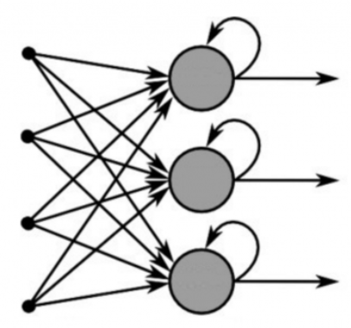

Figure 2. RNN Architecture [5]

1. **Long Short-Term Memory (LSTM):**

In 1997 Hochreiter et al., [1] first proposed LSTM. It consists of blocks of memory cells through which signal ﬂows while being controlled by input, forget and output gates. These gates control what is stored, read and written on the cell. LSTM is used by Google, Apple, and Amazon in its voice recognition platforms. A smaller variation of LSTM is understood as gated recurrent units (GRU). GRUs are smaller in size as compared to LSTM because of the absence of output gate, and can perform better than LSTM on only some simpler datasets. LSTMs recurrent neural networks keep track of long-term dependencies. LSTM is often efficiently used for learning from the sequence input file and can build models that consider context and earlier states. The cell block of LSTM retains pertinent information from previous states. The input, forget and output gates control new data going into the cell, what remains within the cell and the cell values are utilized by the output of the LSTM block for the calculation respectively.

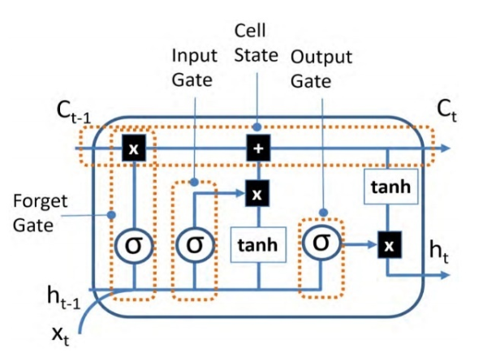

Figure 3. LSTM Architecture[1]

1. **Restricted Boltzmann machines (RBM)**

Restricted Boltzmann machines (RBM) are probabilistic graphical models that are described as random neural networks that learn a probability distribution over its set of input. Due to the rise in computational capacity and the development of faster learning algorithms, RBM became more helpful for several machine learning problems. RBM is the variation of Boltzmann Machines (BM) To represent sophisticated distribution hidden nodes are often introduced to make them powerful. The capacity of the BM is increased by introducing tons of hidden variables. The name is Restricted because RBM is BMs without visible-visible and hidden-hidden connections [6]. In RBMs, the set of visible and hidden units is conditionally independent. RBMs are the building blocks of the various deep multilayer architectures like Deep Belief networks (DBN) and Deep Boltzmann Machines(DBM). 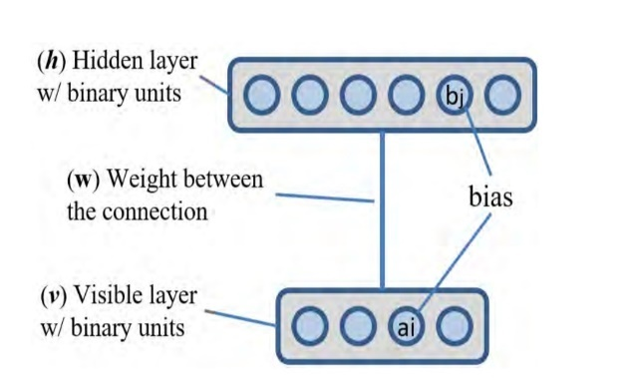

Figure 4. RBM Architecture [1]

DBN by Hinton is obtained by training and stacking many layers of Restricted Boltzmann Machines (RBM) in a greedy manner. After training the stacks of RBM, it can be used to initialize a multi-layer neural network for classification. A DBM is a network of symmetrically coupled random binary units. It contains a bunch of visible units and a sequence of layers of hidden units. Connections exist only between hidden units in adjacent layers, as well as between the visible units and the hidden units within the first hidden layer.

# **Rice leaf disease**

1. **Bacterial Leaf Blight:**

Bacterial leaf blight in rice is caused by Xanthomonas Oryzae. It’s one of the well-known rice leaf diseases. This disease was 1st discovered by the farmers of Japan in 1884 [7]. Bacterial leaf blight is characteristic of yellow lesions with wavy margins on leaf blades which will reach the sheath.The occurrence of microorganism ooze from infected leaves has been discovered in warm and wet climates that contributes to the spread of this disease. The disease is favored by warm temperatures, high humidness, rain, and deep water. The disease is more prevalent in soily areas wherever these conditions occur.Crop losses of 10-20 percent in moderate conditions or severe losses of up to 50 percent in extremely contributing conditions are recorded in many Asian countries.Globally, bacterial leaf blight incidence has been reported from completely different parts of Asia, Australia, Africa, and also the U.S. In India, bacterial leaf blight disease has been discovered in most vital rice-growing states like Punjab, Orissa, Haryana, Uttar Pradesh, Bihar, Andhra Pradesh, and Kerala [7]. Symptoms are discovered at the tillering stage, disease incidence will rapidly increase with plant growth.

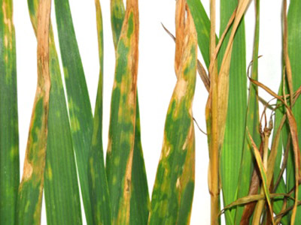

Figure 5. Bacterial Leaf Blight [7]

1. **Brown Spot:**

Brown Spot in paddy leaf is caused by Bipolarisoryzae [8]. It causes substantial quantitative and qualitative losses in a paddy field.This disease is particularly observed in an atmosphere wherever water supply is short combined with nutritional imbalance significantly lack of nitrogen. The infectious agent produces circular to oval, brown spots on the leaves are typically surrounded by a yellow halo and black or dark brown spot on glumes. Heavy infection considerably reduces the number of tillers & grains and lower the quality and weight of individual grains leading to a loss of 30-43% whereas it had been only 12% under moderate and non-significant at lower infection ratings. This disease has been reported to appear in all the rice-growing countries as well as China, Japan, Burma, Iran, Bangladesh, Sri Lanka, Africa, South America, Saudi Arabia, North America, Philippines, Russia, Australia, and Thailand.

In India, it's known to occur in all the rice-growing states since its initial report from Tamil Nadu. The disease is more severe in dry-seeded rice within the states of Chhattisgarh, Bihar, West Bengal, Jharkhand, Assam, Orissa, and Madhya Pradesh. The infectious agent attacks the crop from the seedling to the milk stage. The symptoms appear as minute spots on the coleoptile, leaf sheath, leaf blade and glume, being most distinguished on glumes and leaf blades. On leaves, typical spots are brown in color with grey or white center, and it is oval in form resembling sesame seeds typically with yellow halo whereas young

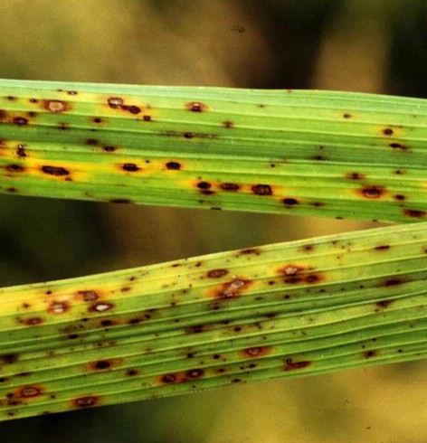

Figure 6. Brown Spot [8]

spots are small, circular and will appear as dark brown or purplish brown dots. Many spots unite and also the leaf dries up. The affected crop will usually be recognized from a distance by scorched appearance due to the death of the seedlings. On vulnerable cultivar, the spots are much larger and will reach up to one cm or more. The symptoms on leaf sheaths and coleoptiles are like those on the leaves.

1. **Rice Blast:**

Rice blast in rice is caused by Pyriculariaoryzae [9]. This disease can infect surface tissues of paddy plants at any growth stage and cause total crop failure. The infective agent produces bruises on leaves, culm nodes, leaf collars, panicles, and panicle neck nodes that vary in color depending on environmental conditions, and age. In favorable conditions, this disease will destroy entire paddy crops within fifteen to twenty days and cause yield losses of up to 100 percent. Pyricularia Oryzae is a threadlike, ascomycete fungus and is reported from more than eighty-five countries of the world [10].

The Rice blast disease was first observed in India as a devastating epidemic that occurred in Tamil Nadu. Seven epidemics of rice blast occurred between 1980 and 1987 in four states, two each in Andhra Pradesh, Himachal Pradesh, one in and Haryana Tamil Nadu, causing serious yield losses. Rice blast disease typically causes an outbreak in February, because of low night temperatures of 22 to 23ºC and long condensate appearance throughout the day. In August, heavy damage of rice blast disease is because of light falling for several days in most of the areas. Rice Blast disease attacks nearly all the above-ground parts of the paddy plants at all the crop growth stages.

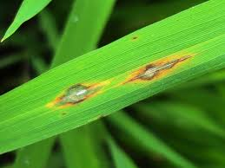

Figure 7. Rice Blast [9]

# **Classification of Rice Leaf Diseases using Deep Learning Techniques**

Yang Lu *et al.*  [11] proposed a model for the rice disease identification method based on deep convolution neural network techniques. Their main goal in this proposed model was to construct a deep convolution network model to achieve fast and accurate automated recognition by using rice disease images.  They used a dataset of 500 natural images of diseased and healthy rice leaves captured from the rice experimental field, CNNs are trained to identify 10 common rice diseases. In their proposed model images are given directly into the model. The proposed model consists of three convolution layers in which the first layer is used to extract the low-level features like edges lines edges lines and corners and the remaining two layers are used to extract the other high-level features.  They used sparse-auto encoding to learn the features from images. In order to classify the images from a reduced data set a layer of convolution and pooling was used. They applied a stochastic pooling method to randomly select elements in feature maps according to their probability values. The stochastic pooling layer also prevents over-fitting. They also compared the recognition accuracy of stochastic pooling with mean-pooling and max-pooling in which accuracy of stochastic pooling is 95.48% and the remaining two are 92.11% and 93.24% respectively. A softmax regression learning algorithm to solve multi-classification problems and gradient descent algorithm to train the CNN. Finally they classified the 10 common different rice diseases. The two main contributions of their proposed model are i) it is able to recognize 10 common rice diseases effectively and correctly and ii) able to obtain a recognition accuracy better than other models. They achieved an accuracy of 95.48%. This accuracy is much higher than the conventional machine learning model. The result showed the feasibility and effectiveness of the proposed method. They also compared the simulation result with the other models such as Back Propagation (BP), Support Vector Machine (SVM) and Practical Swarm Optimization (PSO) in which the accuracy rate of CNN is more.

Vimal K.Srivastava *et al.,* [12] proposed a model for rice disease classification using transfer learning of deep CNN to overcome the problem of consumption of time to get the result. They observed that the performance of transfer learning is better as compared to training the network from scratch on the small dataset. They mainly focused on the images of the diseased symptoms in leaves and stems which are captured from the field. Transfer learning technique which helped them to get good accuracy even in the limited number of images in the dataset. They used AlexNet which is a deep CNN model pre-trained on a large ImageNet dataset for extraction of features and SVM for classification. Since they used AlexNet as the feature extractor, they removed the final layer of the AlexNet which is the classification layer. Then the extracted image features are fed to the SVM. They used a pre-trained deep convolution neural network (CNN) as a feature extractor. Since RGB color images provide a simple and reliable way to detect and classify the rice diseases they used RGB color images. They collected 619 images which belonged to four classes: Rice blast, Bacterial leaf blight, sheath blight, Healthy leaves. They partitioned these datasets into training and testing sets with a different ratio. They carried out their experiment for 10 trails by choosing samples randomly for each partition from the whole dataset and calculated the classification accuracy by averaging the accuracy of 10 trails. The proposed model succeeded to classify rice disease with a classification accuracy of 91.37%, 90.39% and 89.45% for the training-testing division of 80-20, 70-30 and 60-40 respectively.

V. Vanitha *et al.* [13] discussed an automatic plant disease identification approach using a deep convolution network. The degree of harm caused has increased due to the variation in pathogen varieties, changes in cultivation methods and inadequate plant protection techniques. They observed that the loss of rice crops due to pathogens varies from 26% to 52%. They discussed mainly three rice diseases i.e., bacterial leaf blight, sheath rot, and rice blast. There are various machine learning algorithms including Support Vector Machine (SVM), Artificial Neural Network (ANN) on various crops like wheat, maize, and cotton. But there is a fundamental difference regarding the pattern of disease between rice plants and the above-mentioned plants. Since rice leaves are narrow in width and diseases can occur in any part of the leaves. So they experimented with the convolution networks to improve the accuracy of the identification of rice diseases. There are mainly three stages that are involved. They are i) Data Preparation ii) Training and iii) Disease Detection. In Data Preparation collection of data is done. After the process of data preparation, proposed CNN models are trained using a back gradient algorithm. This algorithm minimized the total error of the model on the training test. The final step is that they identified the disease of the rice plant. The result of their model effectively detected and recognized three classes of rice diseases with the best accuracy of 99.53% on the test set.

Ahmad Arib alfarisy *et al.,* [14] proposed a model to detect both paddy pests and diseases using deep learning trained and fine-tuned to fit accurately on the dataset. They started their model with data acquisition required to train a deep learning model. In this proposed model they used a dataset having 4,511 images for 13 classes in which 9 class paddy pests and 4 class paddy diseases. They collected the required dataset from the internet using a query of pests and disease name of paddy in different languages. After the collection of the dataset, they separated these images into trained and test datasets. They also added an extra one class for the background image to get a more accurate classification. Total images with the class background are 5,226 datasets they used for their proposed model. Then they augmented the dataset to overfit the problem caused by a small dataset to train a deep learning model. They augmented the images with these properties: i) rotated with 90 degrees ii) rotated270 degree iii) flipped horizontally iv) flipped vertically. They augmented the dataset using augmentor. They used Caffe which is an open-source deep learning framework and pre-trained CaffeNet model. They partitioned their dataset 70:30 i.e., 70%for training and 30% for tests. After fine-tuning of the CaffeNet model, 80% accuracy is achieved in 5000 iterations and accuracy is increased to 87% up to 30,000 iterations. The developed model is able to classify 13 classes of paddy pests and diseases with an accuracy of 87%.

S. Ramesh *et al.,* [15] proposed the model for recognition and classification of paddy leaf diseases using an optimized deep neural network with Jaya algorithm [16]. The proposed model consists of five steps and they are: i) Image acquisition ii) Pre-processing iii) Segmentation iv) Feature extraction v) Classification. They started their model by collecting the dataset from the farm field which is having four types of diseases: bacterial blight, brown spot, sheath rot, and rice blast. The total dataset contains 650 images in which 95 normal, 125 bacterial blight, 170 blast, 110 sheath rot, and 150 brown spot images. Then these images are passed to the computer for pre-processing of the images. In pre-processing, they eliminated the image background by applying hue values that are selected based on several trails. After preprocessing they used k-means clustering for the segmentation by which they extracted diseased portion from the leaf image. The unwanted green part in the diseased image is also removed. After that, they extracted both texture and color features. After extracting the features they classified the diseased images by using an optimized deep neural network with Jaya optimization algorithm (JOA). There are three primary layers in the DNN framework. But they constructed two hidden layers to increase the training speed and classification accuracy. They used the JOA algorithm to improve the fitness value of every solution so that it provides the best solution. The comparison of the best solution and the old solution is done and this process is repeated until then until the termination criteria are achieved. They achieved an accuracy of 90.57%, 95.78%, 98.9%, 94% and 92% for bacterial blight, rice blast, brown spot, and sheath rot respectively.

Eusebio L *et al.* [17] proposed the model for detecting rice insect pests and diseases using convolutional neural network and image processing. They collected the images from the regional crop protection center and all images were pre-processed. These datasets are divided into three parts: training set, validation set, and test set. They used transfer learning to develop the model. They retrained Google’s inception-v3 using python and TensorFlow in order to predict different classes of rice pests and diseases and the final layer retrained from scratch. The pre-processed image is fed to the classifier. Down sampling operation is performed in the pooling layer until the image reaches the final layer. The computations of the scores of different classes of diseases which are required to make the prediction are made in the final layer. In order to obtain effective documentation and also to describe the model, they used agile modeling. To respond to the customer requirements they used extreme programming. They also developed the android application which helped them to check whether the developed application can detect and classify the rice pests and diseases accurately or not. By this, they achieved an accuracy of 90.9%.

R.Rajmohan, *et al.,* [18] proposed a model of sensor-based mobile app framework for determining the accuracy which gives the agriculturists valuable information about the paddy yield and its condition and also to detect various crop diseases which include diseases like rice blast, brown spot, bacterial leaf blight, sheath blight, false smut, root-knot nematode, and white tip nematode. They choose 250 images in which 200 infected images are used by them to train with deep CNN and SVM classifiers and the remaining 50 images are used for testing. They developed a mobile app with ML algorithms for the identification of paddy diseases. Their main objectives are to construct a database to store information about paddy disease and their treatment possibilities. Their proposed model includes two models: i) disease identification ii) disease management. Disease identification includes four steps: i) image capture and selection, ii) image zoom and crop, iii) Upload image and iv) receive a notification. They collected clear images through the camera by taking several snapshots. They selected the earlier collected images from the database if there is the same crop problem. They applied the pattern matching algorithm for those cropped images of the best portion of the disease which are uploaded to the remote server in order to perform pattern matching. They removed the noise images using a deep convolution network algorithm. During classification, they classified the image into two sets i.e., training dataset and testing dataset. They analyzed training datasets using deep CNN and testing datasets using the SVM classifier which classifies based on the comparison with the training database. For the classified disease, the precaution is sent to the farmer via a mobile app. By this, they achieved an accuracy of 87.50%.

Wan-Jie Liang *et al.* [19] proposed a model for the recognition of rice blast disease based on CNN. They also showed that CNN is more effective than the other two traditional handcrafted features such as LBPH (local binary pattern histogram) and Haar-WT (wavelet transform). They considered both 2906 positive samples and 2902 negative samples for training and testing the CNN model. They collected the diseased images from the institute of plant protection Jiangsu Academy of Agricultural Sciences, Nanjing, China. They considered two network structures and implemented these two by using Torch7 which is a scientific computing framework. They used a stochastic gradient descent for training purposes. For both CNN models, comparative experiments are done by them and accuracy is calculated. They obtained with the result that both are having low bias and variance and good convergence and high accuracy and also there is no overfitting. Since the first structure has a more fully connected layer and fewer samples than the second network structure, they considered the second CNN model. They performed Haar-WT decomposition of the rice blast and performed up to level five and obtained better accuracy in the fourth level with 83.8%. So they considered the fourth level and compared that with CNN. They performed LBPH in which images divided into m*m local blocks and classification accuracy is calculated using the SVM classifier of those blocks. By this division, they obtained higher accuracy of 83.7% and this division is considered to be compared with the CNN model. They obtained the result for both accuracy and area under the curve (AUC). The combination of SVM+CNN resulted in very good accuracy and the AUC i.e., about 95.82% and 0.99 respectively which is more than that of the combination of LBPH+SVM and the Haar-WT+SVM.

John William Orillo *et al.* [20] proposed a model for the identification of diseases in the plant using image processing. They also used the Back Propagation Neural Network to enhance accuracy. In their proposed model identified three common rice diseases: Bacterial leaf blight, Brown spot, and Rice blast. Theirs proposed model includes the following process: i) Image acquisition, ii) Image enhancement, iii) Image segmentation, iv) Feature extraction and v) Backpropagation neural network. They collected 134 images from Greenhouse of the international rice research institute using a controlled light module box. Out of 134 images, 70% of those images are used for training and 15% for validation and 15% for testing. After collecting the images they reduced the noise in those images. They also used HSV color space. They converted the processed image to the binary image using the process of thresholding by applying Otsu’s method during the segmentation of the images. Then they removed the healthy part of the leaves and left disease images to be fed to the neural network. By applying the Backpropagation neural network they classified those three common diseases of the rice plant. The training of those images stop after the neural network meets the following criteria: i) Maximum iteration is reached; ii) Maximum gradient is reached and iii) Maximum validation checks. By this they achieved the accuracy of 100% for the disease identification and presented those classified images in the user interface window.

Harshadkumar B *et al.,* [21] proposed a system for the detection and classification of diseased rice plants using the concepts of machine learning and image processing. The proposed model follows steps: i) Image acquisition, ii) Image pre-processing, iii) Disease segmentation, iv) Feature extraction and v) Disease classification. They considered three types of images i.e., bacterial leaf blight, brown spot, and leaf smut and these are captured from the farm field. After collecting the images they pre-processed the images to remove the background of the image by applying four techniques. They converted the diseased leaf to the HSV color space and extracted the saturation component and applied the mask in RGB space to remove the background and they left with only the leaf portion including diseased spots. They used K-means clustering for the image segmentation and they applied these techniques for segmentation i.e., LAB color space, Otsu’s segmentation and HSV color space based K-means clustering. They used thresholding to remove the unnecessary green portion which is the result of K-means clustering. They differentiated the three diseased leaves based on color, texture, and shape. They classified those three diseased leaf images by using the SVM machine learning model. By this, they achieved 93.33% as training accuracy and 73.33% as testing accuracy.

S.Ramesh *et al.* [22] proposed a model to detect rice blast disease using ANN (Artificial Neural Network) and KNN (K-Nearest Neighbor). The proposed system consists of the following steps: i) Image acquisition, ii) Image pre-processing, iii) Image segmentation, iv) Feature extraction and v) Classification. They collected the images by capturing the photos in the farm field using a high-resolution digital camera. They resized the original image for further processing. Then they converted resized images to grayscale images and further conversion takes place from RGB image to HSV during pre-processing of the image. They applied the K-means clustering for the segmentation of the images and obtained the K values and selected K value as K=3 since it produces a more accurate image. They extracted eight features to differentiate the healthy and diseased image of the rice leaves. After that extracted features are applied to the classifier for the classification of the infected and uninfected image. They used two classifiers: KNN and CNN. KNN used K=3 as the parameter value since it provided them both background and leaf part of the image. Since they got 85% accuracy by using the KNN classifier they again applied the extracted features to the ANN classifier. ANN classifier consisted of one hidden layer with five neurons which provided them the more accurate results. By this, they got 100% accuracy for the blasted image using ANN.

K.Jagan Mohan *et al.* [23] proposed a model to identify and classify the various diseases of the rice plant. They mainly focused on three diseases namely brown spot, leaf blast, and bacterial blight. Their proposed system consists of two parts: Detection and Recognition. They used Haar-features and AdaBoost classifier for detection of rice plant disease and Scale Invariant Feature Transform (SIFT) feature and k-Nearest Neighbor and SVM as the classifier for the recognition of the diseased rice plant. They considered 60 diseased images out of which 50 images are detected by them using the AdaBoost classifier. By this, they obtained 83.33% accuracy. During the recognition of the diseased rice plant, they used k-NN and SVM classifiers. Seven features that are extracted using SIFT are fed to the SVM model. The average distance is calculated between the features vector and provided better results. K-NN divided the dataset into training and test dataset. Out of 120 diseased images 90 images are training set and 30 images are tested set. K-NN recognized the diseases based on the minimum distance value and compared the test features with train features. By this, they obtained an accuracy of 91.10% and 93.33% using SVM and k-NN respectively.

Guoxiong Zhou *et al.* [24] proposed a model to identify three diseases of rice leaves using FCM-KM and R-CNN fusion. They considered rice blast, bacterial blight and sheath blight as the three diseases that must be identified by their proposed model. They used 3010 images for the classification. They collected diseased images and removed low brightness and blurred images. They also reduced the noise by applying a 2-D filtering mask combined with a weighted multilevel media filter (2DFM-AMMF). After denoising the images, they segmented those images by using faster 2D-otsu for the separation of targeted rice leaves from the background. They segmented the images by taking optimal threshold value after segmentation they extracted the features using FCM-KM and R-CNN fusion. Finally, they obtained an accuracy of 97.2% by the combination of FCM-KM and R-CNN.

T. Gayathri Devi *et al.* [25] proposed a model for the identification and detection of the rice leaf disease using SVM with the radial basis neural networks (RBFN). The proposed system consists of two stages namely testing and training stage. During the training stage, they collected the images from the rice knowledge bank and preprocessing is done by them with the help of cropping, clipping and images are further enhanced with the help of histogram equalization process. They feed the enhanced images to the segmentation process. They segmented the images by using Otsu with K-means clustering to segment the similar attributes into images based on the threshold values. They extracted the features and fed those features for further training using SVM. During the training stage they followed the same steps as that of the training stage. But the feature testing is done by using a radial basis neural network. By this they obtained the classification accuracy of 98.3% with the combination of SVM-RBFN.

# **Conclusion**

Rice leaf disease is one of the main problems faced by the farmer. Rice blast, Brown spot and Bacterial blight are the main diseases found in rice leaves. So as to avoid this problem, a proper system should be built so that the farmer can identify the disease easily. In this paper, deep learning methods were explored in order to automatically classify and detect rice plant diseases from leaf images. The study on some recent approaches shows the nearly optimal disease classifying techniques with the help of various algorithms. These deep learning techniques will automatically extract lower level features to higher level features hierarchically due to which it yields good results.

**References**

1. Ajay Shrestha and Ausif Mahmood, “Review of Deep Learning Algorithms and Architecture”, IEEE Access, Volume 7, May 2019, DOI: doi.org/ 10.1109/ACCESS.2019.2912200
2. Farhana Sultana, Abu Sufian, A Paramartha Dutta, “Advancements in Image Classification using Convolutional Neural Network”, [International Conference on Research in Computational Intelligence and Communication Networks](https://ieeexplore.ieee.org/xpl/conhome/8716487/proceeding), May 2019, DOI: doi.org/10.1109/ICRCICN.2018.8718718
3. Akinori Hidaka, Takiokurita,”Consecutive Dimensionality Reduction by Canonical Correlation Analysis for Visualization of Convolutional Neural Networks”, Research Gate, December 2017, DOI: 0.5687/sss.2017.160
4. Trupti Katte, “Recurrent Neural Network and its Various Architecture Types”, International Journal of Research and Scientific Innovation, Volume V, Issue III, March 2018, ISSN 2321–2705.
5. Nikals Donges, “Recurrent Neural Network: Understanding the basics of RNNS and LSTM”, Builtin, September 2019
6. Neelam Agarwalla, Debashis Panda, Mahendra Kumar Modi, “ Deep Learning using Restricted Boltzmann Machines”, International Journal of Computer Science and Information Technologies, Volume 7, 2016, ISSN:0975-9646
7. Pranamika Sharma, L.C. Bora, K.C. Puzari, A.M. Baruah, R. Baruah, K.Talukdar, L. Kataky, A. Phukan, “Review on Bacterial Blight of Rice Caused by Xanthomonas oryzaepv. oryzae: Different Management Approaches and Role of Pseudomonas fluorescens As A Potential Biocontrol Agent”, Excellent Publishers, Volume 6, No.3, pp.982-1005, March 2017, DOI: doi.org/10.20546/ijcmas.2017.603.117.
8. S. Sunder, Ram Singh, Rashmi Agarwal, “Brown spot of rice: an overview”, Research Gate, pp.201-215, January 2014.
9. Aziiba Emmanuel Asibi, Qiang Chai, Jeffrey A. Coulter “Rice Blast: A Disease with Implications for Global Food Security”, Agronomy, volume 9, Issue 8, August 2019, DOI: Doi: 10.3390/agronomy9080451.
10. Ch. Yashaswini, P. Narayan Reddy, B. Pushpavati, Ch. Srinivasa Rao, M. Seshu Madhav, “Prevalence of Rice blast (Magnaportheoryzae) incidence in South India", [International Journal of Pharma and Bio Sciences](https://www.researchgate.net/journal/0975-6299_International_Journal_of_Pharma_and_Bio_Sciences), Volume 6, Issue 1, August 2017, ISSN 2277-1808.
11. Yang Lu, Shujan Yi, NianyinZeng, YurongLiu, Yong Zhang, “Identification of rice diseases using deep convolution neural networks”, ELSEVIER, July 2017, DOI: dx.doi.org/10.1016/j.neucom.2017.06.023.
12. Vimal K.Shrivastava, Monoj K. Pradhan, SonajhariaMinz, Mahesh P. Thakur, “Rice Plant Disease Classification Using Transfer Learning of Deep Convolution Neural Network”, Research gate, Volume XLII-3/W6, February 2019, DOI: doi.org/10.5194/isprs-archives-XLII-3-W6-631-2019.
13. V.Vanitha, ”Rice Disease Detection Using Deep Learning”, International Journal of Recent technology and Engineering, Volume-7, Issue-5S3, February 2019, ISSN: 2277-3878,
14. Ahmad Aribalfarisy, Quuuan Chen, Minyi Guo, “Deep Learning Based Classification for Paddy Pests and Disease Recognition”, [International Conference on Mathematics and Artificial Intelligence](https://dl.acm.org/doi/proceedings/10.1145/3208788), April 2018, DOI: doi.org/10.1145/3208788.3208795.
15. S. Ramesh, D. Vydeki, “Recognition and Classification of paddy Leaf Diseases Using Optimized Deep Neural Network with Jaya Algorithm”, Science Direct, September 2019, DOI: doi.org/10.1016/j.inpa.2019.09.002.
16. Hari Mohan Pandey, “Jaya a Novel Optimization Algorithm: What, How and Why?”, [International Conference - Cloud System and Big Data Engineering](https://ieeexplore.ieee.org/xpl/conhome/7503213/proceeding), July 2016, DOI: doi.org/10.1109/CONFLUENCE.2016.7508215
17. Eusebio L. Mique, Thelma D. Palaoag, “Rice Pests and Diseases Using Convolutional Neural Network”, International Journal of Recent Technology and Engineering, April 2018, DOI: doi.org/10.1145/3209914.3209945.
18. R.Rajmohan, M.Pajany, R.Rajesh, D.Raghu Raman, U.Prabhu, “Smart Paddy Crop Disease Identification and Management Using Deep Convolution Neural Network and SVM Classifier”, Research Gate, Volume 118, No. 15, pp.255-264, 2018, ISSN: 1314-3395.
19. Wan-jie Liang, Hong Zhang, Gu-feng Zhang, Hong-xin Cao, “Rice Blast Disease Recognition Using a Deep Convolution Neural Network”, Research Gate, February, 2019, DOI: doi.org/10.1038/s41598-019-38966-0.
20. John William orillo, Jennifer dela cruz, Leobelle agapito, Paul Jensen satimbre Ira valenzuela, “Identification of Disease in Rice Plant Using Back Propagation Artificial Neural Network”, [International Conference on Humanoid, Nanotechnology, Information Technology, Communication and Control, Environment and Management](https://ieeexplore.ieee.org/xpl/conhome/6999008/proceeding), November 2014, DOI: doi.org/10.1109/HNICEM.2014.7016248.
21. Harshadkumar B. Rajaathi,Jitesh .Shah, Viul K. Dabhi, “Detection and Classification of Rice Plant Disease”, Research Gate, July 2017, DOI: 10.3233/IDT-170301.
22. S.Ramesh, D.Vydeki,”Application of Machine Learning in Detection of Blast Disease in South Indian Rice Crops”, Journal of Phytology, Volume 11, April 2019, DOI: 10.25081/jp.2019.v11.5476.
23. K.Jagan Mohan, M.Balasubramanian, S.Planivel, "Detection and Recognition from Paddy Plant Leaf Images", Research Gate, Volume 144, No.12, June 2016, DOI: 10.5120/ijca2016910505.
24. Guoxiong Zhou, Wenzhuo Zhang, Aibin Chen Mingfang he, Xueshuo Ma, "Rapid Detecton of Rice Disease Based on FCM-KM and Faster R-CNN Fusion", IEEE Access, Volume 7, October 2019, DOI: doi.org/10.1109/ACCESS.2019.2943454.
25. T. Gayathri Devi, P.Neelamegam, "Paddy Leaf Disease Detection using SVM with RBFN classifier", International Journal of Pure and Applied Mathematics, Volume 117, No.15, pp. 699-710, 2017, ISSN: 1314-3395.