A New Design System of Quadcopter with Autonomous Flight Control

Y Suhas Kumar1, Darshan G Shetty2, Yajnesh Anchan3, Shreyas4, and Rajashree Nambiar P5

*Shri Madhwa Vadiraja Institute of Technology and Management, Bantakal, India.*

**Abstract - An Uninhabited or unmanned Aircraft System (UAS) is composed of four main components: the air vehicle, the payload, the control station and the data link. The operators interact with the UAS through the data link and are usually located in the control station. The focus of this project is on the vehicle itself (UAV) and more precisely on rotorcraft. Indeed, rotary wing aircraft have a very wide range of applications, thanks to their Vertical Take-Off and Landing (VTOL), hover and low speed capabilities. In addition, since they do not require a runway or any heavy facilities, they are more often used than fixed wing aircraft for research in aerial robotics. Therefore, a very wide variety of rotorcraft concepts have been invented. This creativity has been reinforced by the blossoming and rapid expansion of UAS projects, due to their reduced cost and risk of development, compared with inhabited aircraft. From the past 10 years most of the drones created are RC-controlled and the design of quadcopters haven’t changed. The only changes that are taking place is the variety of devices or sensors mounted on the drone. So, we are creating an entirely new design. Its built in such a way that it offers much more stability (co-axial rotors with two axis rotation), can lift higher payload and includes tight manoeuvrability. It includes obstacle detection and avoidance system, Advanced GPS location tracking and survey, it also provides protection against natural aerial threats using zoned frequency emitter.**

Keywords- UAV, Drones, Quadcopter, Ergonomic Flight Design, Co-Axial Motors, 2 Axis Rotation, Autonomous Flight Control, Zoned frequency emitter circuit, Payload, Pixhawk, Telemetry, QGC, Mission planner, CATIA V5.

1. INTRODUCTION

Normally drones require a controller, which is used remotely by an operator to launch, navigate and land it. Controllers can communicate with the drone using radio waves, including Wi-Fi.The drone we are designing is completely autonomous. With the issue of few initial commands the drone is ready to take off. The initial commands that is necessary is given by data telemetry system which provides us with more variety of commands that is needed for the function of autonomous drones.Navigational systems, such as GPS, are typically housed in the nose of the drone. The GPS on the drone communicates its precise location with the controller. An onboard altimeter can communicate altitude information. The altimeter also helps keep the drone at a specific altitude, if commanded.The drone can be equipped with a number of sensors, including distance sensors (ultrasonic, laser, lidar), time-of-flight sensors, chemical sensors, and stabilization and orientation sensors, among others. Visual sensors offer still or video data, with RGB sensors collecting standard visual red, green and blue wavelengths, and multispectral sensors collecting visible and non-visible wavelengths, such as infrared and ultraviolet. Accelerometers, gyroscopes, magnetometers, barometers and GPS are also placed according to requirement.Our drone employs obstacle detection and collision avoidance sensors. Initially, the sensors were designed to detect objects in front of the drone. But we plan to provide obstacle detection in all six directions: front, back, below, above and side to side.

1. *Ergonomic Flight Design* **–**

Coaxial rotors or "coax rotors" are a pair of helicopter rotors mounted one above the other on concentric shafts, with the same axis of rotation, but turning in opposite directions (contra-rotating). The main benefit arising from a coaxial design is increased payload for the same engine power. Reduced noise is a second advantage of the configuration. Typically drones, to be exact quadcopters employ fixed rotors that barely move. To increase the manoeuvrability of our drone we use 2-axis flexibility rotation of the coaxial rotors employed. This increases our obstacle manoeuvrability and single rotor failure recovery by a huge factor which in turn increases the safety and fuel efficiency of the drone.

The communications protocols have a 3-layer encryption and decryption. The drone has got advanced GPS location tracking and surveillance. Collision detection is integrated into the drone with the help of LIDAR sensors. Zoned frequency emitters are housed in the drone to avoid natural aerial threats.

1. DESIGN SPECIFICATIONS
2. *Co-axial Rotors*

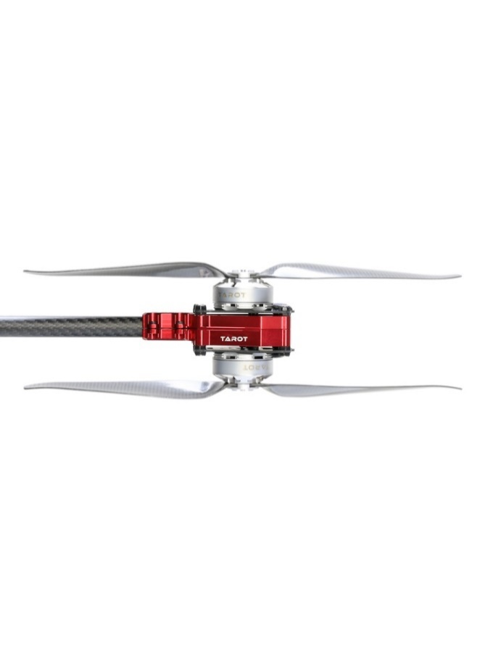

Fig. 1. Co-axial Rotors

Fig. 1 illustrate the idea of co-axial motors. It consists of two motors, one on top and one on the bottom, both rotate in opposite direction with different speed. The top motor will rotate slowly compared to bottom motor and push the air downward. The bottom motor will have higher speed and push the air downwards with more speed which produce more thrust and stability as compared to conventional single motors.

1. *Inner and Outer Ring Design*

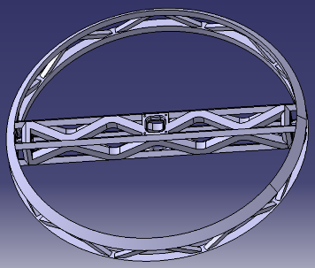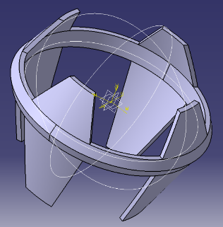Fig. 2. Ring Designs

Fig. 2 describes about designs of inner and outer ring. The design was done using the CATIA V5 software, these two rings helps us in two axis rotation of the motors. The inner ring will rotate in one axis and it’s also used in housing the motors. The outer ring rotates in another direction, it’s used as a duct which will help us in directing the air and create more thrust and it’s also used as a stand while landing the drone.

1. *Two axis rotation system*

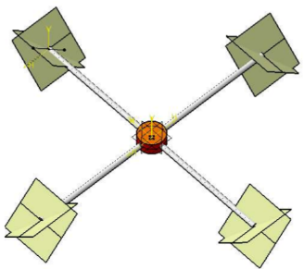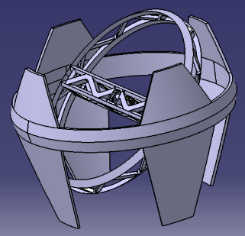

Fig. 3. Two Axis Rotation of the Motors

Fig. 3 gives us the idea of rotation of the motors in two axes, the main objective of the drone is to move the drone in any direction or in any angle, by using the above system we will be able to achieve it. The drone can be tilted according to the requirement, it can also be tilted to 90o and moved accordingly. This system helps the drone to move in congested areas where conventional drones cannot be moved since it can fly in any tilt angle and in any direction without changing the orientation of the body of the drone.

1. *Drone flight control using keyboards*



Fig. 4. Keys (Highlighted) Used to Control

Fig 4 highlights the keys which are used to control the drone. Instead of using the RC Transmitter we are using the keys of keyboard to control the drone flight as shown in the table 1. It helps us to include large number of functions since it contains a greater number of keys than the RC Transmitter.

TABLE 1

KEYS USED

|  |  |  |
| --- | --- | --- |
| W - Forward | Up Arrow – move upwards | T – Takeoff |
| A – Left | Left Arrow – Rotate Left | L - Land |
| S – Backwards | Down Arrow – move downwards | R – Return to home |
| D – Right | Right Arrow – rotate right |  |

1. *Advanced GPS Location Tracking System*



Fig. 5. Drone Moving Towards the Destination

Fig. 5 describes about the location tracking system programmed by us. In auto mode, once the GPS co-ordinate is provided to the drone, it will calculate a straight-line equation from the take off point and destinations, takes all the points on the curve as way points and move accordingly. If the location is lost by the GPS of the drone it will move backwards considering the last way point and from that point it will move in a circle of specified radius. If the GPS is still not available it will increase the radius and perform the same action, the procedure is repeated until the GPS location are available. Once the location is available it will once again calculate the straight line and do all the necessary things and move towards the destination.

Once the destination is reached it flies in a circular manner considering a circle of specified radius, conducts a survey and sends the data to the cloud using the WI-FI. The users can get those data from anywhere around the world just by entering to the cloud and retrieve the data.

This system provides us an opportunity to fly the drone anywhere around the globe by sitting in a remote location. It also includes obstacle detection and avoidance system which will help us in safeguarding the drone from obstacles.

1. *Zoned Frequency Emitter Circuit (ZFEC)*

Since we all know that drones will have major impact on aerial species, we have come with an idea of a frequency emitter circuit which will disturb the birds flying very near to it so that it moves away from the drone and reduce the threats to their life. In some of the countries the eagle or the hawks are trained to destroy the drones by using this system we can avoid that also. When a bird flies near to the drone the frequency emitted will have some impacts on the brains of the birds hence it tends to move away from the drone by this, we can safeguard both the drone and the life of the Aerial species.

1. METHODOLOGY

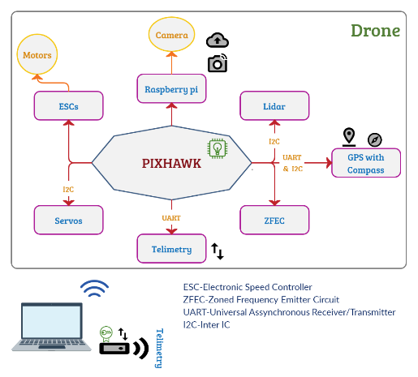

Fig. 6. Block diagram of the complete system

We are using Pixhawk as the main controller which consists of 32-bit ARM CortexM4 high-performance processors can run NuttX RTOS real-time operating system, along with accelerometer, barometer, gyro sensors. GPS is used for the location tracking, Zoned frequency emitter is used to avoid natural aerial threats, telemetry is used for the communication between the ground station and the drone (with 3 layers of encryption and decryption), Lidar sensors are used for obstacle detection, Raspberry pi and camera is used for surveillance with live stream or cloud update capabilities.

1. *Flowchart*:

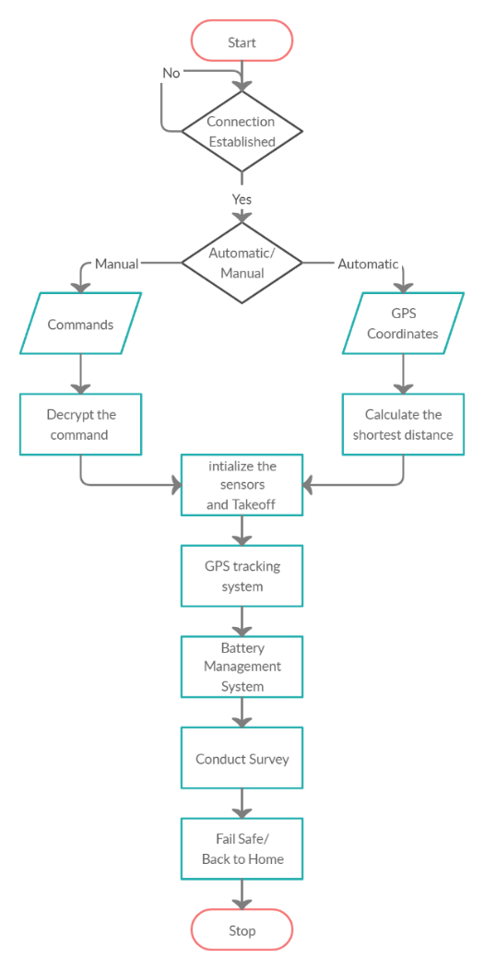

Fig. 7. Flow of working of the Drone

Initially the drone is connected to the ground module using telemetry devices, then it has two modes, manual and automatic. In automatic we need to give the GPS location of the destination it will calculate the shortest distance from the takeoff point and the destination. In manual mode we need to give commands to the drone which is encrypted in 3 layers during transmission and decrypted in the receiving end.

The drone will interpret the input and initializes the sensors connected to it, and it will take off. While flying it will keep a track of the GPS coordinates, if GPS Signal is lost it will undergo an AI process which will help us to get back the location and move towards destination. We have a battery management system to maintain the battery voltage between the feasible range. Once the destination is reached the drone will conduct the survey. We have two emergency function, if connection is lost the drone will return to the initial take off point which is known as back to home function, if the battery is drained we have fail safe function so that the drone will safe land without harming the surroundings, the drone will automatically adjust its orientation if it is varied by air pressure.

1. RESULTS AND CONCLUSSION

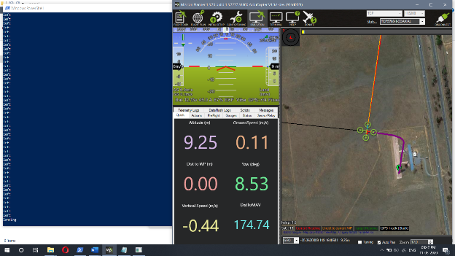

Fig. 7. Simulation Using Mission Planner

Fig. 7 is an image which shows the simulation of the drone using the Mission planner. The simulation contains a drone which is designed by us where we need to design the body of the drone, and include all the parameters like frame type, sensors used and their calibration setup, flight modes which include Return to Launch, Stabilize, Guided modes etc., Radio setup, battery monitor system, fail safe operations, obstacle detection and avoidance system, camera and its gimbal control. Once the parameters are fed into the system the drone is ready to fly in the simulation. Once the drone is ready, we add our custom-built drone to the repository of the mission planer and start the simulation, if there is no error the simulation profile will start, after that we run a python script in order to control the drone. The script and mission planner software are connected over TCP ports, once the communication is established the drone is ready to simulate ad it will perform all the operations specified by the user.

There are two modes in the flight control, i.e. Auto and Manual mode. In Auto mode we need to enter the GPS Co-ordinates of the destination, the drone will move towards the destination using the Advanced GPS location tracking system as discussed in the fig, 5, once reached it will make a survey and sends the data. In Manual mode the drone will be in control of the user and it is controlled by using the keys as discussed in the fig. 4. Every command used in the communication will undergo 3 layers of encryption and decryption at both drone and ground station side to make it more secure while Flying the drone.

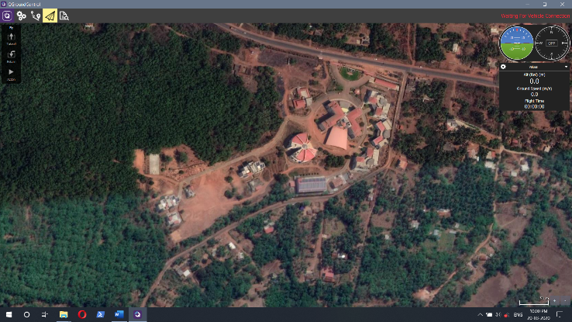

Fig. 8. QGroundControl Software

Fig. 8 describes about the QGroundControl software which is used to program and build the drone, it’s also used to control the drone where it works as a Ground station software. It provides various functions and features which will be helpful while building and using the drone, it has features to keep a track of health of drone which include GPS satellite count, Battery voltages, sensor readings, orientation and height of the drone from the ground level it also gives an idea of where the drone headed. We use telemetry devices to communicate between the drone and the ground station, the communication is secured with 3 layers of encryption and decryption as discussed earlier.

REFERENCES

1. G. Colombatti, A. Aboudan, C. Bettanini, L. Magini, C. Bettineschi, G. Deotto, L. Toninello, S. Dehei, A. Deguio, P. Zunovello, A. Manesanzi, and the Horus Team, "Horus - A Drone Project for Visual and IR Imaging", : 978-1-5090-4234-0, 2017, IEEE
2. Fernando J. Velez, Alejandra Nadziejko, " Wireless Sensor and Networking Technologies for Swarms of Aquatic Surface Drones", : 979-1-4799-8991-8, 2015, IEEE
3. Juan A. Besada, Ana M. Bernardos, Luca Bergesio,Diego Vaquero, Ivan Comparia, Jose R. Casar, "Drones-as- a- Service: A Management Architecture to Provide Mission Planning Resource Brokerage and Operation Support for Fleets of Drones", :978-1-538-9151-91/19, 2019, IEEE.
4. LudovicAprille**,** YvesRoudierand TullioJoseph Tanzi**,** "Autonomous Drones for Disaster Management: Safety and Security Verification"**,** 9789090086286**,** 2015**,** URSI**.**
5. Seon Kim Jin, Gino J.Lim, "Drone Aided Border Surveillance with an Electrification Line Battery and Charging Systems",:92**:**657**-**670, 2018, Journal of IntelligenceandRoboticSystems**.**
6. Rajath U Joshi, Shashank TS, "A New Approach For An Intelligent Swarm Robotic System"**,:** 2319**-**1163**/** 2321**-**7308, 2015, IJRT.
7. Huang Shen, F.Y.C. Albert, CK Ang, Dwee Jin Teck, K.P Chan, “Theoretical Development and Study of Takeoff Constraint Thrust Equation for A Drone”, : 978-1-5386-2126-2017, IEEE.

# M. F. A. Rahman, S. M. Radzuan, Z. Hussain, M. F. Khyasudeen, K. A. Ahmad, F. Ahmad, A. I. C. Ani, “Performance of Loiter and Auto Navigation for Quadcopter in Mission Planning Application Using Open Source Platform”, :978-1-5386-3897-2017 IEEE.

AUTHORS PROFILE

|  |  |
| --- | --- |
|  | **Y Suhas Kumar**, Student, Dept. of Electronics and Communication, Shri Madhwa Vadiraja Institute of Technology and Management, Bantakal. |
|  | **Darshan G Shetty**, Student, Dept. of Electronics and Communication, Shri Madhwa Vadiraja Institute of Technology and Management, Bantakal. |
|  | **Yajnesh Anchan**, Student, Dept. of Electronics and Communication, Shri Madhwa Vadiraja Institute of Technology and Management, Bantakal. |
|  | **Shreyas**, Student, Dept. of Electronics and Communication, Shri Madhwa Vadiraja Institute of Technology and Management, Bantakal. |
| rajashree-ec | **Mrs. Rajashree Nambiar P,** Sen. Asst. Prof., Dept. of Electronics and Communication, Shri Madhwa Vadiraja Institute of Technology and Management, Bantakal. |