**MIRRO-COOL SMART MIRROR**

**Abstract: Most of the traditional product used in household appliances had become more familiar to the user, they have to use the repetitive device which they won’t get any interaction from it, make to feel loneliness and less secure in that environment. In this modern era the home appliances are become smarter than the past decades because of the remarkable growth in technology especially like IoT based platform where almost all the appliance are smarter than the previous generation ex: door lock, window, mirror refrigerator, fans etc. where the appliances are integrated on the single embedded system, Which had become smarter in order to give human interface easier. And provide more secure in order to use in the particular interval, which consumes less area, less power and highly reliable to the product in this paper represents about Mirro-cool smart mirror which used to display an information required for the user like time, event, calendar, newsfeed etc.**

**Keywords: Raspberry Pi, Display unit, Smart mirror, Cloud.**

I. INTRODUCTION

At present, more and more close to the life of intelligent products are emerging, Smart TV, smart watches to now appear again smart mirror. The smart mirror is designed to use a 21 inch diagonal display, positioned vertically, which will mounted behind a Two-way mirror allowing only elements lit on the screen to be seen by the user. The intelligent mirror is the principle of one-way perspective, the actual picture in the form of specular reflection transmitted to our vision. The picture displayed behind the mirror can also be transmitted to us through the mirror, so as to achieve the effect of showing the pattern on the mirror. It contains speakers that allow for application notification sounds and playback.

The smart mirror user interface has a set of 4 standard applications that provide important information to the user including weather, news feed, calendar schedule and clock. The smart mirror has voice control over a voice recognition system developed for the user interface. The voice control allows for interaction with the to-do list. The voice control has activated through a clause provided by the user.

**II. Proposed architecture**

**Power supply**

A power supply is a device that supplies electric power to the load. The primary function of a power supply is to convert electric current from a source to the suitable voltage, current at fixed frequency to power the load. The source power may be used from the electric power grid, such as an energy storage devices i.e. batteries or fuel

Adarsha Suvarna1, Vipul Kumar2, Heisarki Phawa3 and Akash S Shetty4

Yenepoya Institute of Technology, Thodar, Moodbidri

Department of Electronics and Communication Engineering, YIT Moodbidri

Cells, generators or alternators, solar power converters, or another power supply. DC supply use AC mains electricity as an energy source. Such power supply will have a transformer to convert the input voltage to a higher or lower AC voltage. A rectifier required to convert the transformer output voltage to a variable DC voltage, which is passed through an electronic filter to convert an unregulated DC voltage into fixed DC voltage.

Raspberry 3b+

The Raspberry Pi is a low cost, credit-card sized microcontroller that plugs into a computer monitor, which uses a standard keyboard and mouse. It is a capable little device that enables people of all ages to extend computing technology, and to learn how to program in languages like Scratch and Python. It’s capable of doing everything you’d expect a desktop computer to do, from browsing the internet and playing high-definition video, to making spreadsheets, word-processing, and playing games.

SD Card

An SD Card (Secure Digital Card) is a small flash memory card designed to provide high-capacity memory in a small size. SD cards are used in many small portable devices such as digital video camcorders, digital cameras, handheld computers, audio players and mobile phones. In use since 1999, SD Memory Cards are now available in capacities between 16 Megabytes and 1 Gigabyte. An SD card typically measures 32 x 24 x 2.1 mm and weighs approximately 2grams.

HDMI Cable

HDMI supports standard, enhanced, or high-definition video and standard to multi-channel surrounded audio. HDMI benefits include uncompressed digital video, a bandwidth of up to 5 gigabytes per second, one connector instead of several cables and connectors, and communication between the video source and the DTV. HDMI development is overseen by the HDMI Working Group that includes Sony, Hitachi, Silicon Image, Philips, and Toshiba as members.

LED Monitor Display

LED Display (Light Emitting Diode) is a screen display technology that uses a panel of LEDs as the light source. Currently, a large number of electronic devices, both small and large, use LED display as a screen and as an interaction medium between the user and the system. Modern electronic devices such as mobile phones, TVs, tablets, computer monitors, laptops screens, etc., use a LED display to display their output.

We use a led TV that is placed behind the mirror, this led TV is a 24 inch of size and it will display customizable module such as clock, newsfeed, calendar etc.

Microphone

A microphone is a sensor that translates sound vibrations in the air into electronic signals or scribes them to a recording medium. Microphones enable numerous types of audio recording devices for purposes of including communications of many kinds, as well as music and speech recording.

Speaker

A speaker is a term used to describe the user who is giving voice commands to a software program. A computer speaker is a hardware device that connects to a computer to generate sound. The signal is used to produce the sound that comes from a computer speaker is created by the computer's sound card.

Wooden Frames

Framing in construction is the fitting together of pieces to give a structure support and shape.[1] Framing materials are usually wood, engineered wood, or structural steel. The alternative to framed construction is generally called mass wall construction, where horizontal layers of stacked materials such as log building, masonry, rammed earth, adobe, etc. are used without framing.

Two Way Mirror

A Two-way mirror is a reciprocal mirror that is reflected on one side and transparent at the other. The recognition of one-way transmission is achieved when one side of the mirror is brightly lit and the other side is dark. This allows viewing from darkened side but not vice versa.

III. Implementation and Working:

Figure 1.1 explains about working of smart mirror. In this Raspberry pi acts as a CPU, which process the information fetched from the sensor and cloud, process, executed actions are performed by actuator. Cloud acts as a data center, where all the related information are fetched based on the IP address using HTTP protocol to the Raspberry pi. When the camera detect and recognize the person smart mirror initialize its working, which displays all the relevant information clock, calendar and events, newsfeeds, compliment, whether forecasting. Smart mirror can be interfaced through mic module to get the information from the cloud which is relevant for the user. When the user speak to the Google assistant connect to the cloud using ip address and give the information required to the person. The challenging task is to display the processed information from the cloud the the display unit is done by electron browser. Electron browser is a framework which is used for desktop application.

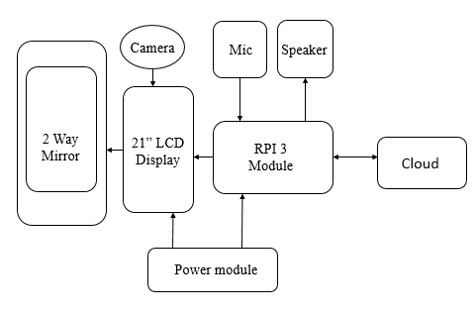Figure 1.1: Block diagram of Smart Mirror.

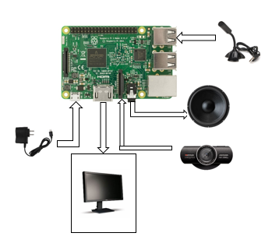Figure 1.2: Connection between Raspberry Pi and I/O Devices.

**IV. RESULT AND CONCLUSION:**

A futuristic smart mirror system that provides information like time, date, accurate temperature and humidity, and latest news while looking and grooming in front of mirror.

Smart mirrors have great potential to enhance user experience of accessing and interacting with information. Not only do they allow users to see relevant information effortlessly, they can also be integrated as a thief detection system. Our smart mirror saves time and makes it easier to access information. In today society security is of crucial importance

**V. REFERENCES**

[1] Kun Jin, Xibo Deng, Zhi Huang, Shaochang Chen “Design of the Smart Mirror Based on Raspberry” IEEE Advanced Information Management, Communicates, Electronic and Automation control Conference 2018.

[2] Piyush Maheshwari, Maninder Jeet Kaur, Sarthak Anand “Smart Mirror: A Reflective Interface to Maximize Productivity” International Journal of Computer Applications (0975 – 8887) Volume 16 No.9, May-2017.

[3] Vaibhav Khana, Yash Vardhan, Dhruv Nair, Preeti Pannu “Design and Devlopment of a Smart Mirror Using Raspberry Pi” International Journal of Electrical, Electronics And Data Communication, ISSN: 2320-2084 Volume-5, Issue-1, Jan-2017.

[4] Divyashree K J, Dr. P.A. Vijaya, Nitin Awasthi “Smart Mirror As A Personal Assistant Using Raspberry Pi” International Research Journal of Engineering and Technology (IRJET) Volume: 05 Issue: 05 May-2018.

[5] Dr. G. KarpagaRajesh, L. Antony Jasmine, S. Anusuya, Aswath Apshana, S. Asweni, R. Haritha Nambi “Voice Controlled Raspbrry Pi Basie Smart Mirror” International Research Journal of Engineering and Technology (IRJET) Volume: 06 Issue: 05 May-2019.