Smart Poultry Farm Monitoring System using IoT

**Sheethal1, Shraddha Shanbhag2, Vidit Sunil Bedramane3, Vineet Inas Gonsalves4, Shivakumar K. M5**

*1Information Science and Engineering, Canara Engineering College (India)*

*2Information Science and Engineering, Canara Engineering College (India)*

*3Information Science and Engineering, Canara Engineering College (India)*

*4Information Science and Engineering, Canara Engineering College (India)*

*5Associate prof., Department of Information Science and Engineering, Canara Engineering College. (India)*

## **Abstract—** **A combination of wireless sensors and database servers can be used for controlling and monitoring environmental parameters in a poultry farm. Various environmental parameters like temperature, humidity, ammonia gas have a big role in operations of Poultry. Operator can get updates regarding the internal environmental situation of poultry farm by accessing the data using a web page. A combination of hardware and software is used which will initiate the action automatically to control the environmental parameters according to present standards, if there are any changes in parameters which exceed the present system will act automatically and help to take actions to control the environmental parameters. Sensors are used to control temperature, water level, smoke, gas and food dispensing. All these sensors are connected with the Arduino uno which can control and monitor all data. The data is stored in the database servers, and detailed record of poultry farm with status of environmental conditions is maintained at a webpage. System thus focuses on maintaining best possible environmental conditions with minimal human effort.**

***Keywords—*****Iot*,* Poultry Automation, Sick detection, Smart poultry, Web application.**

# **Introduction**

In the new era of networking technology, we cannot deny the greatness of Internet of Thing (IoT). It has the ability to collect voluminous of data from anywhere at any time. The main idea of IoT is to detect and gather information from the surrounding area, then share the information over the Internet for different interesting purposes. Business uses the IoT innovation in a manufacturing field and it is not only restricted for mechanical applications. The IoT is actually being used widely around us. As the world trending into new technologies and implementation of IoT, research in agriculture field also take the IoT benefits in producing the best livestock. Most of the projects in this field manifest the use of a wireless sensor network (WSN) in collecting data from different sensors deployed at various nodes. The collected data contain information about the environmental states. For example, studies in poultry are being carried out in the controlled environment where the researchers need to concern with livestock feeding status at the animal reproduction lab. They need to monitor the poultry house by checking the electricity condition, the abnormality of temperature and humidity level. The problem may arise after working hours, where the researcher needs to return back the poultry house to check the lab condition, especially the temperature and humidity condition. If abnormality situation occurs, they need to inform the caretaker or the lab assistant about it. Moreover, there is no alarm system to alert the temperature or the humidity level in the poultry. Focus of this research is to use modern technologies for a poultry farming to monitor and control environmental parameters which play an important role in operations of a poultry farm. Parameters such as temperature, humidity, ammonia need to be controlled as extremely high or low levels of these parameters can have adverse effect on growth of hen. For proper growth of hen we need to maintain ideal environmental conditions along with food in the right quantities, if this is achieved hen’s will remain healthy and will gain desired weight. Health and adequate weight gain of hen are very important for a farm owner as these two factors play a decisive role in realization of profits from poultry business.

# **Existing System**

## **RFID for Poultry Traceability System at Animal Checkpoint**

[3] A combination of wireless sensors and GPRS network can be used for controlling and monitoring environmental parameters in a poultry farm. Various environmental parameters like temperature, humidity, ammonia gas have a big role in operations of Poultry. Operator can get updates regarding the internal environmental situation of poultry farm by accessing the data using a web page. A combination of hardware and software is used which will initiate the action automatically to control the environmental parameters according to preset standards, if there are any changes in parameters which exceed the presets system will act automatically and help to take actions to control the environmental parameters. Sensors are used to control temperature, water level, smoke, gas and food dispensing. All these sensors are connected with the raspberry pi which can control and monitor all data. The data is transmitted using GPRS, and detailed record of poultry farm with status of environmental conditions is maintained at a webpage.

## 2.2 **Human-Stimulated Intelligent Control Method of Fruit and Vegetable Cold Storage**

[4] The environmental problems and associated issues had been a source of worry for the world. Emergance of IoT (Internet of things) and the step towards the smart approach such as smart cities, smart buildings, and smart grid have really posed the successful implementation of IoT.The proposed software based hardware is capable of monitoring the environment related parameters such as air temperature, air humidity, O2, CO2 level of concentration and NH3 concentration. The experimental setup was found very effective and accurate. This scheme will earn a safe environment and profit to the poultry industry.

## **Internet based Smart Poultry Farm**

## [2] Extreme learning machine (ELM) and support vector ma- chine (SVM) classiﬁers are developed to detect rales (a gurgling sound that is a symptom of respiratory diseases in poultry). These classiﬁers operate on Mel-scaled spectral features calculated from recordings of healthy and sick chickens during a vaccine trial. Twenty minutes of labeled data were used to train and test the classiﬁers, then they were run on the full 25 days of continuous recordings from the healthy and sick chickens. The resulting detection rate follows the course of the disease and clearly distinguishes between the healthy and sick chickens. These results improve on our previous ﬁndings from the same data, and demonstrate the potential for automated acoustic monitoring of the health of commercial ﬂocks.

## **Band Selection of Hyperpectral Images for Automatic Detection of Poultry Skin Tumors**

## [1] Poultry is a largest source of human food, rapid increasing trend in human population and badly effect of newly seen poultry diseases (N1H1 bird-flue, highly pathogenic avian influenza HPAI) making it difficult to meet the daily increasing human poultry requirements. To improve the poultry growth by using most modern technology we are proposing a complete wireless sensor network solution for poultry farming. Poultry farming is mostly divided into two categories (1) Egg production poultry farms and (2) Meat production poultry farm. In this study we will propose Complete Wireless network solution for poultry farming (CWNS-PF) to establish an ideal poultry farm with maximum productivity and economy. This proposed CWNS-PF is equally useful for both types of poultry farms.Our proposed system mainly consists of 7 components, if these are followed and managed well, quality and quantity of chickens can be improved which will ultimately lead to improve the human health.

## **Smart Farm: Extending Automation to the Farm Level**

[6] Poultry Management is one major agriculture business. The big challenge in the poultry is to identify the disease in the early stage and avoid to spread the disease to another. Most of the cases it needs an intense labor and training. We propose an embedded system that can monitor the poultry and distinguish the affected ones from the group. This will allow the users to detect the sick units earlier and leads a cost effective solution for poultry industry. The initial target of this paper is to develop an embedded IOT system connected with the server that can monitor the poultry farms. The second target is to present the current work that has been done on sound analysis for poultry industry.

# **Proposed System**

Iot based poultry system proposes a new system that can monitor poultry and classify the normal and infected hens. The user can monitor this system from anywhere. This system has been enabled with IoTs, for monitoring, and accessing data from anywhere using cloud infrastructure. The procedures and algorithms are designed, developed, and tested to classify the infection with the help of various sensors. The proposed model is beneficial to poultry that vary in size from small scale to large scale production. This provides over all view of application architecture that can help to monitor the poultry health and diseases.

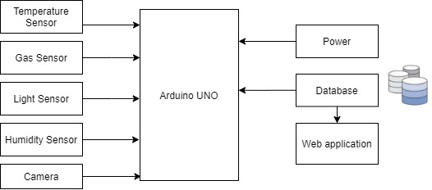

**Figure 1. Architectural diagram for Machine translation**

The proposed system has three layers such as (i) IoT sensors layer, (ii) processing and filtering layer, and (iii) cloud infrastructure. Sensor layer gathers all the input from the poultry. In the poultry the hens will be stored as a group. The plan is to identify the hen which is sick among the group. We can capture temperature, sound, video of the gauge for analysis. The noises of all hens has influence of recording the sound waves. But in contrast the other readings like temperature, RGB input may have less influence of other nearby gauges. We have done a comprehensive study about video and sound analysis for identifying the infected hen using IoT. The proposed model depicted in Fig. 1 shows the various sensors and the integration to the application. The sensors are connected to the Arduino UNO R3 (Atmega328 - assembled). Arduino gets the digital signal from various sensors and provides the input using the serial port (USB) to the system .

1. **IMPLEMENTATION**

An architecture description is a formal description and representation of a system, organized in a way that supports reasoning and behavior of the system.

4.1 **Architectural design**

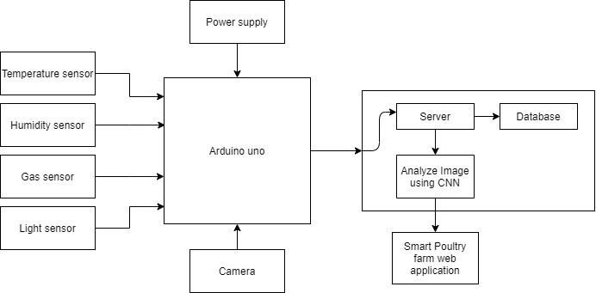

**Figure 2. Represents the Architectural Design**

Figure 2 represents the architectural design of the system. Architectural design is a concept that focuses on components or elements of a structure. They work with space and elements to create a coherent and functional structure. The first step of the design phase is the schematic design. It gives us the overall view of the different modules being involved in the system and the indication of the flow of the data. The architectural design indicates the overall sections in the system namely the different sensors that are being used to monitor the physical parameters of the poultry farm, Arduino uno used as a medium for transfer of data from sensor to the sensor, the hence collected is fed to the next block where it is processed and the finally is made available for view on the Web application.

4.2 **Modular Design**

Modular design is an approach (design theory and practice) that subdivides a system into smaller parts called modules or skids, that can be independently created and then used in different systems. A modular design can be characterized by functional partitioning into discrete scalable, reusable modules, rigorous use of well-defined modular interfaces and making use of industry standards for interfaces.

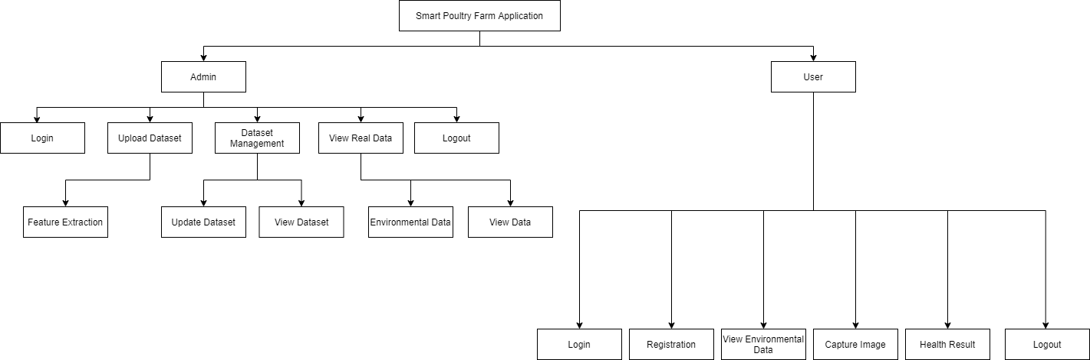

**Figure 3. Diagram Representing Modular Design**

4.3 **Algorithm For Logic Implementation**

Step 1: When the circuits turn on the sensors in the farm gets activated.

Step 2: Later the parameters being recognized by the sensors are sent to the Arduino uno which in turn forwards it to the server that is being connected using http.

Step 3: The Arduino uno collects the data from the sensors at the previously decided time slots and further forwards it to the server.

Step 4: The hen’s sent data is observed in the web application by the end user whenever he wants.

Step 5: The behavioral parameters of the poultry hen is observed by capturing timely images of the head and this is further processed using image processing.

Step 6: The image processing is done using the CNN algorithm on the data set.

Step 7: On applying CNN algorithm on the collected data set, further we classify the images captured into active and inactive states of the poultry hen.

Step 8: The hens observed active and inactive states are being forwarded to the web application.

1. **RESULTS**

**5.1 Login Page**

Login page allows the new user to register themselves to the web application allowing them to access the various analysis results of the poultry farm.



**Figure 4. Login Page**

**5.1 Home Page**

The home page allows the user to monitor the Temperature, gas level and the image of the hen. Further analyze image button indicates whether the selected hen is healthy or unhealthy.

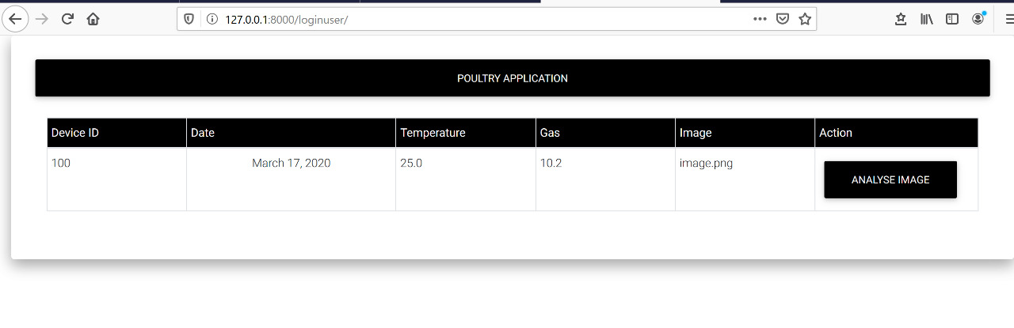

**Figure 5. Home Page**

1. **CONCLUSION**

The proposed framework can be used to monitor and identify the sick hens in the farm as soon as they get affected. Combining the Image analysis for motion pattern and thermal sensor analysis for temperature pattern of the sick and normal hens for the better prediction and classification. We can extend the image analysis for movement and behavior analysis also. Integration of the sensor results produces the hybrid and accurate results is our current ongoing research. The proposed system is mainly focused on automatic control of the environmental parameters and automatically detecting the sick hens in the farm. This can be extended to the automatic food control mechanism and automatic disposal of wastage.

##### **References**

* 1. Z. Du, M. K. Jeong and S. G. Kong, "Band Selection of Hyperspectral Images for Automatic Detection of Poultry Skin Tumors", In the journal of IEEE Transactions on Automation Science and Engineering, vol. 4, no. 3, pp. 332-339, July 2007. doi: 10.1109/TASE.2006.888048.
  2. K. SravanthGoud* and Abraham Sudharson, Internet based Smart Poultry Farm, Indian Journal of Science and Technology, Vol (19), IPL101, August 2015.
  3. W. Chansud, J. Wisanmongkol and U. Ketprom, "RFID for poultry traceability system at animal checkpoint," In 2008 5th International Conference on Electrical Engineering / Electronics,Computer,Telecommunications and Information Technology, Krabi, pp.753-756,2008.doi: 10.1109/ECTICON.2008.4600540.
  4. K. Zhang and J. Liu, Study on Human-simulated Intelligent Control Method of Fruit &Vegetable Cold Storage, 2009.
  5. Fangwu Dong, Naiqing Zhang, “Wireless Sensor Networks Applied on Environmental Monitoring in Fowl Farm,” HAL Id: hal-01055409 https://hal.inria.fr/hal-01055409 Submitted on 12 Aug 2014.
  6. Mathew, “ Smart Farm: Extending Automation To The Farm Level,” INTERNATIONAL JOURNAL OF SCIENTIFIC & TECHNOLOGY RESEARCH VOLUME 3, ISSUE 7, JULY 2014, ISSN 2277-8616.
  7. Junho Bang1, Injae Lee1, Myungjun Noh1, Jonggil Lim1 and Hun Oh2, “Design and Implementation of a Smart Control System for Poultry Breeding's Optimal LED Environment,” International Journal of Control and Automation Vol.7, No.2 (2014), pp.99-108.