**IOT Based Baby Monitoring System Using RaspberryPi**

**Hemant Prakash Shanbhag1, Rajat Vivekanand Gajinkar2, Vishal Vaman Kamat3, Anal Ballullaya 4**

*1Information Science and Engineering, Canara Engineering College (India)*

*2Information Science and Engineering, Canara Engineering College (India)*

*3Information Science and Engineering, Canara Engineering College (India)*

*4Associate prof, Department of Information Science and Engineering, Canara Engineering College.(India)*

**Abstract—**  **This project is focused on an idea to design a Smart Cradle System using IOT which will help the Parents to monitor their child even if they are far away from home & can detect every activity of the Baby from any distant corner of the world. It is an smart, innovative & protective Cradle System to nurture an infant in an efficient way. This system considers all the minute details that are required for the care & protection of the Baby in the cradle. The design of smartness & innovation comes with the use of technologies/methodologies which include Internet of Things (IOT) (Modules like Raspberry Pi, Humidity & Temperature sensing), Cry DetectingMechanism, Live Video Surveillance, Cloud Computing (Data Storage) & User Friendly Web application (for User Controls). In order to detect each & every activity of Baby, different Sensors/Modules are attached to the Cradle: Humidity & Temperature Sensing Module for detection of Wetness of the bed, A Camera on top of the Cradle for live video footage & Cry Detection Circuit to analyze Cry Patterns. All the data which is been taken from the sensors/modules will be stored in Cloud (Thing Speak) & analyzed at regular intervals. A Health Algorithm is applied to these datasets to get information about the body conditions which is helpful as any regular symptoms of a disease can be identified easily.**

***Keywords—*****Iot , Baby Monitoring, Cry detection, Sound Analysis and Humidity Sensor.**

# **INTRODUCTION**

As we are very well familiar with the hurdles faced by Parents to nurture their infant and especially in case if both the Parents are working. To give 24 hours of time in such cases is next to impossible. Thus, we should develop something unique that can help Parents to have a continuous surveillance/watch on the Baby/Infant and can notify about the same. Thus, we came up with an idea to design a Smart Cradle System using IOT which will help the Parents to monitor their child even if they are far away from home & can detect every activity of the Baby from any distant corner of the world. It is an innovative, smart & protective Cradle System to nurtue an infant in an efficient way. This system considers all the minute details that are required for the care & protection of the Baby in the cradle. The design of smartness & innovation comes with the use of technologies/methodologies which include Internet Of Things (IOT) (Modules like Raspberry Pi, Arduino, Humidity & Temperature sensing), Swing Automation, Cry Detecting Mechanism, Live Video Surveillance, Cloud Computing (Data Storage) & User Friendly Android Mobile Application (for User Controls). In order to detect each & every activities of the Baby, different Sensors/Modules are attached to the Cradle: Humidity & Temperature Sensing Module for detection of Wetness of the bed, A Camera on top of the Cradle for live video footage & Cry Detection Circuit to analyse Cry Patterns which eventually triggers the swinging mechanism (if required based on the range of frequency). All the data which is been taken from the sensors/modules will be stored in Cloud (Google Firebase) & analyzed at regular intervals. A Health Algorithm is applied to these datasets to get information about the body conditions which is helpful as any regular symptoms of a disease can be identified easily. An instant mobile notification that will be generated if any abnormal activity is detected (something unusual OR crying of baby OR wetness due to Baby Urine) in the Android Mobile Application which has been Developed. It has UI controls which include the feature of controlling the swinging mechanism of the cradle (can be turned on, turned off & can maintain the speed of swing), control for the switching on the camera live footage & controls for playing the toy/projector whenever the baby cries.

# **EXSISTING SYSTEM**

## **IoT Based Smart Cradle System with an Android App for Baby Monitoring**

[1] Availability of high speed internet and wide use of mobile phones leads to gain the popularity to IoT. One such important concept of the same is the use of mobile phones by working parents to watch the activities of baby while babysitting. This paper presents the design of Smart Cradle which supports video monitoring. Also it activates buzzer and gives alerts on phone if –first, baby cry continues till specific time which means now cradle cannot handle baby and baby needs personal attention and second, if the mattress in the cradle is wet. This cradle has an automatic rotating toy for baby’s entertainment which will reduce the baby cry possibility.

## 2.2 **Video-based IoT baby monitor for SIDS prevention**

[2] Availability of high speed internet and wide use of mobile phones leads to gain the popularity to IoT. One such important concept of the same is the use of mobile phones by working parents to watch the activities of baby while babysitting. This cradle swings automatically on detection of crying sound of the baby. Also it activates buzzer and gives alerts on phone if –first, baby cry continues till specific time which means now cradle cannot handle baby and baby needs personal attention and second, if the mattress in the cradle is wet. This cradle has an automatic rotating toy for baby’s entertainment which will reduce the baby cry possibility.

## **Sudden Unexpected Infant Death and Sudden Infant Death Syndrome**

[3] Availability of high speed internet and wide use of mobile phones leads to gain the popularity to IoT. One such important concept of the same is the use of mobile phones by working parents to watch the activities of baby while babysitting. This cradle swings automatically on detection of crying sound of the baby. Also it activates buzzer and gives alerts on phone if –first, baby cry continues till specific time which means now cradle cannot handle baby and baby needs personal attention and second, if the mattress in the cradle is wet. This cradle has an automatic rotating toy for baby’s entertainment which will reduce the baby cry possibility.

## **An Automatic Monitoring and Swing the Baby Cradle for Infant Care**

[4] This project presents a baby monitoring system for busy parents so that they can ensure the proper care and safety of their babies. This system can detect the baby’s motion and sound; especially crying and video output of baby’s present position can be displayed on a display monitor so that the mother or another responsible person can watch the baby while away from him or her. The Raspberry Pi B+ module is used to make the total control system of the hardware, condenser MIC is used to detect baby’s crying, PIR motion sensor is incorporated to detect baby’s movement and Pi camera is used to capture the baby’s motion.A display is used to have video output of sleeping baby. Finally, the developed hardware is tested to analysis the capability of detecting the motion and crying sound of baby as well as the video output. This proposed system can provide an easier and convenient way for busy parents in terms of taking care of their babies.

## **UWB Baby Monitor**

[6] As human beings, we begin interacting with the world by expressing our basic needs through crying. Parents strive to identify and timely address these needs before hysterical crying sets in. However, first-time parents usually fail, and this leads to frustration and feelings of helplessness. In this context, our work focuses on creating an automatic system able to distinguish between different infant needs based on crying. We extract various sets of paralinguistic features from the baby-cry audio signals and we train various rule-based or statistical classifiers.

# **PROPOSED SYSTEM**

**3.1 Proposed Diagram**

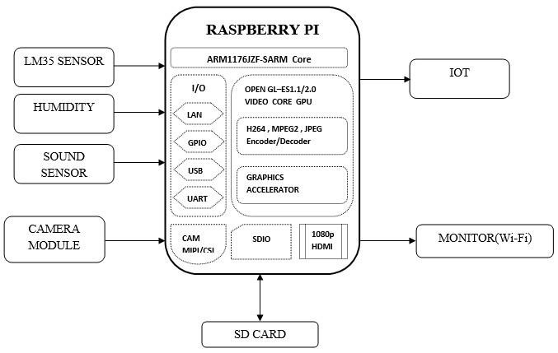.

**Figure 1. Architectural diagram**

In this proposed system, both sensors and forecasting cloud is used, so that resulting data having high accuracy about the children condition, also we are using surveillance of the children using camera from a Wide Area Network (WAN) which can be viewed in the Web Application and also can control the situationfrom a remote area anywhere from the world.In this project MCP3008 is used, so connect 3.3v pin from raspberry to all sensors Similarly MCP3008 and all sensor’s ground pins should be grounded Now connect sensor’s output pins to each channels of MCP3008 (ex: LM-35 to channel 0, HUMIDITY to channel 1 and SOUND sensor to channel 2 of MCP3008) Connect USB camera with raspberry pi Connect power supply for Raspberry pi Plug the HDMI cable in Raspberry pi from the monitor using VGA to HDMI converter cable Connect USB Mouse and USB keyboard to the Raspberry pi.

1. **IMPLEMENTATION**

An architecture description is a formal description and representation of a system, organized in a way that supports reasoning and behavior of the system.

4.1 **Architectural design**

An architecture description is a formal description and representation of a system, organized in a way that supports reasoning and behavior of the system.

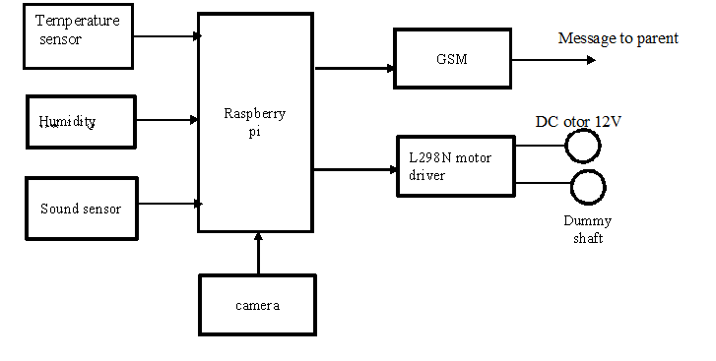

**Figure 2. Represents the Architectural Design**

Figure 2 The above figure represents the architecture design of the system where the temperature sensor, humidity, sound sensor and the camera are connected to the raspberry pi. The GSM will send the message to the parent and the L298N motor driver is used to move the dummy shaft using the dc motor.

4.2 **Modular Design**

The below diagram represents the modular design Modular design or “modularity in design” is a design approach that subdivides a system into smaller parts called modules that can be independently created and then used in different systems.

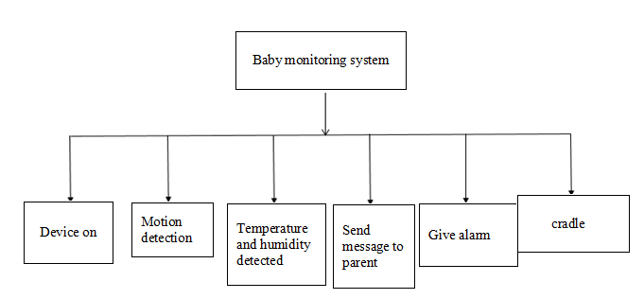

**Figure 3. Diagram Representing Modular Design**

Our proposed system aims at monitoring the vital signs of the baby such as heartbeats and body temperature using wireless technology and textile sensors which are comfortable for the baby to wear and also accurate and precise than other sensors. We also focus on increase the scope of transmitting the information over the internet in order to provide remote access. The camera module incorporated enables displaying the visual feeds of the whereabouts of the baby and keeping an eye over their movements in a finite area. This system overcomes the drawback of the existing systems which are clumsy, less user friendly and expensive.

4.3 **Algorithm For Logic Implementation**

In neural networks, Convolutional neural network (CNNs) is one of the main categories to do images recognition, images classifications. Objects detections, recognition faces etc., are some of the areas where CNNs are widely used. CNN image classifications takes an input image, process it and classify it under certain categories. Computers sees an input image as array of pixels and it depends on the image resolution. Based on the image resolution, it will see h x w x d Convolution is the first layer to extract features from an input image. Convolution preserves the relationship between pixels by learning image features using small squares of input data. It is a mathematical operation that takes two inputs such as image matrix and a filter or kernel.

1. **CONCLUSION**

Our proposed system aims at monitoring the vital signs of the baby such as heartbeats and body temperature using wireless technology and textile sensors which are comfortable for the baby to wear and also accurate and precise than other sensors. We also focus on increase the scope of transmitting the information over the internet in order to provide remote access. The camera module incorporated enables displaying the visual feeds of the whereabouts of the baby and keeping an eye over their movements in a finite area. This system overcomes the drawback of the existing systems which are clumsy, less user friendly and expensive.

##### **REFERENCES**

[1] “IoT Based Smart Cradle System with an Android App for Baby Monitoring”, [2017 International Conference on Computing, Communication, Control and Automation (ICCUBEA)](https://ieeexplore.ieee.org/xpl/mostRecentIssue.jsp?punumber=8443317).

[2] “Video-based IoT baby monitor for SIDS prevention” in [2017 IEEE Global Humanitarian Technology Conference (GHTC)](https://ieeexplore.ieee.org/xpl/mostRecentIssue.jsp?punumber=8215842)

[3] "Sudden Unexpected Infant Death and Sudden Infant Death Syndrome", Centers for Disease Control and Prevention. Centers for Disease Control and Prevention 17 Apr. 2017, May 2017   
  
[4.] R. Palaskar S. Pandey A. Telang A. Wagh R. Kagalkar "An Automatic Monitoring and Swing the Baby Cradle for Infant Care" International Journal of Advanced Research in Computer and Communication Engineering vol. 4 no. 12 pp. 187-189 2015.   
  
[5.] "Difference between Raspberry Pi and Arduino" Hardware Fun 2016 [online] Available: http://hardwarefun.com/tutorials/difference-between-raspberry-pi-and-arduino.   
  
  
[6.] E. Ziganshin M. Numerov S. Vygolov "UWB Baby Monitor" 2010 5th International Confernce on Ultrawideband and Ultrashort Impulse Signals pp. 159-161 2010.   
  
[7]. A. Industries "Raspberry Pi Model B+ 512MB RAM ID: 1914 - \$29.95: Adafruit Industries Unique & fun DIY electronics and kits" Adafruit.com 2016 [online] Available: https://www.adafruit.com/product/1914.   
   
[8]. A. Industries "Raspberry Pi Camera Board ID: 1367 - \$19.95: Adafruit Industries Unique & fun DIY electronics and kits" Adafruit.com 2016 [online] Available: https://www.adafruit.com/product/1367.   
  
[9]. "Camera Module - Raspberry Pi" Raspberry Pi 2016 [online] Available: https://www.raspberrypi.org/products/camera-module/.