Detection of Diabetic Retinopathy in Retinal Images using MLP classifier

*Deepthi E1, Gayathri P2, Pooja.K3 Prajna.B4,Sadhana B5*

*Students1,2,3 department of information science and engineering*

*Assistant Professor5 Department of ISE*

*Canara Engineering collge Bantwal*

*deepthikuloor98@gmail.com1* [*gayathrip738@gmail.com2*](mailto:gayathrip738@gmail.com2)

[*poojakanuvalli@gmail.com*](mailto:poojakanuvalli@gmail.com) *3* [*prajnag13@gmail.com,4*](mailto:prajnag13@gmail.com,4)*,sadhana26rai@gmail.com5*

***ABSTRACT: The MLPNN classifier is presented to classify retinal images as normal and abnormal the rising situation. In the developing world suggests diabetic retinopathy may soon be a major problem in the clinical world. Hence, the detection of diabetic retinopathy is important. To analyses and processes the retinal images for the detection of retinal image patterns, describing structural and disease patterns to appropriate elicitation of the image features, targeting diabetic retinopathy detection. Therefore, deploying suitable techniques to extract distinguishable features and application of relevant transformation and feature selection techniques to formulate an expressive feature vector and build efficient models to predict the patterns in retinal images using MLP classifier. The major objectives are Multi-Layer Perception Neural Network (MLPNN) is used to detect diabetic retinopathy in retinal Images. To classify retinal images as normal or abnormal. MLPNN classifier is used to find best feature subset. To obtain relatively high accuracy for training and cross validation datasets.***

**I.INTRODUCTION:**

Major causes of identification of diabetic retinopathy are restricted to detect diseases only for diabetic patients. Also to know the per cent of the diabetics and to provide privileges for doctors to update the details about the disease and its possible diagnose. The rising situation in the developing world suggests diabetic retinopathy may soon be a major problem in the clinical world. Hence, detection o diabetic retinopathy is important. This project focuses on Multi-Layer Perception Neural Network (MLPNN)to detect diabetic retinopathy in retinal images. In this project the MLPNN classifier is presented to classify retinal images as normal and abnormal. A feature vector is formed with 64-point Discrete Cosine Transform (DCT) with different 09 statistical parameters namely Entropy, mean, standard deviation, average, Euler number, contrast, correlation, energy and homogeneity. The Train N Times method was used to train the MLPNN to find best feature subset. The training and cross validation rates by the MLPNN are 100% for detection of normal and abnormal retinal images.

* 1. **PURPOSE**
* Reduces the time for detecting diabetes when compared to manual inspection.
* This System can be used as alternative for manually identifying diabetes and also minimize laboratory works.
* Detecting diabetes in a short span of time when compared to a manual inspection.
* Effective use of convolution neural networks in identifying different classes of retinal images
  1. **PROBLEM STATEMENT**

The aim of this project is to detect diabetes retinopathy in retina. In this project the MLPNN classifier is presented to classify retinal images as normal and abnormal the rising situation in the developing world suggests diabetic retinopathy may soon be a major problem in the clinical world.

Hence, the detection of diabetic retinopathy is important. To analyses and processes the retinal images for the detection of retinal image patterns, describing structural and disease patterns to appropriate elicitation of the image features, targeting diabetic retinopathy detection. Therefore, deploying suitable techniques to extract distinguishable features and application of relevant transformation and feature selection techniques to formulate an expressive feature vector and build efficient models to predict the patterns in retinal images using MLP classifier.

* 1. **SCOPE**
* It is restricted to detect diseases only for diabetic patients.
* To know the percent of the diabetics.
* To provide privileges for doctors to update the details about the disease and its possible diagnose.
  1. **OBJECTIVE**
* To detect diabetic retinopathy in retinal image using Multi-Layer Perception Neural Network (MLPNN)
* To classify retinal images as normal or abnormal.
  + - To MLPNN classifier is used to find best feature subset.
    - To obtain relatively high accuracy for training and cross validation datasets.

**S**

**II.LITERATURE SURVEY:**

The two types of image processing are Analog Image processing and Digital Image Processing Analog Image Processing can be used in hard copies, like printouts and photographs. Digital Image Processing helps to manipulate the digital images by using computers. To get the original information, it has to undergo various phases of processing like pre-processing, enhancement and display information extraction. Digital Image Processing has an advantage over Analog Image Processing. Medical image processing is the method that generates the images of the human body for medical purposes and it helps to easily identify the disease, observe and detect the disease. Symptoms of diabetic retinopathy are seeing spots or floaters in the field of vision, blurred vision, having a dark or empty spot in the canter of the vision and difficulty to see well at night. On detection of diabetic retinopathy from the digital fundus images, selected pre-processing methods are performed for the detection of diabetic, which is decisive in diabetic retinopathy grading. In all the recent works it has been assumed that Visual Dictionaries for Automatic Retinal Lesion Detection involves development of an automatic DR screening system that can detect the presence of many abnormalities related to DR.

An ensemble-based framework to improve multi-layer perception neural network detection. [1].The consistent MLP identification in digital fundus images concerned with the medical image processing is based on the collection framework that identifies the MLP. The collection framework is analyzed with the output of multiple classifiers and the combination of internal mechanism of MLP detectors.

**2.1Automatic Detection of Diabetic Retinopathy**

Diabetic retinopathy (DR) is the leading cause of blindness in the working-a asymptomatic stages, is effective for preventing visual loss and reducing costs for health systems [2]. Most screening digital color fundus cameras are used to acquire color photographs of the retina [3]. These photographs are then examined for the presence of lesions indicative of DR, including exudates (EXs) [4]. In any DR screening program, about two-third of patients have no retinopathy [2]. The application of automated image analysis to digital fundus images may reduce the workload and costs by minimizing the number of photographs that need to be manually graded [5]. Many studies can be found in the literature regarding digital image processing for DR. Most algorithms comprise several steps. First, a pre-processing step is carried out to attenuate image variation by normalizing the original retinal image [6]. Second, anatomical components such as the impurities are removed [7] by using histogram algorithm. Finally, only those remaining pathological features of DR are retained for subsequent classification. This review gives an overview of the available algorithms for DR feature extraction and the automatic retinal image analysis systems based on the above mentioned algorithms.

### Retinopathy Detection of Exudates in Diabetic

The proposed algorithm for detecting and localizing the occurrence of exudates from low contrast digital images collected from retinopathy patients [2]. Retinal fundus image is pre-processed and Histogram Algorithm method is used for segmenting the exudates in the retinal fundus images. This technique enables the ophthalmologists for detecting the appearance of exudates in less interval of time that helps in identifying the exudates location and there by confirms the disease. The present back propagation neural network is used to detect exudates. The Optic Disc is eliminated to prevent the occurrence of exudates [1]. In order for efficient detection of exudates and no exudates at the pixel level, decision Tree and equalization methods are used. This reduces the cost of the BPN class as well as the burden of the filtration of the normal images.

Detection of diabetic retinopathy involves medical identification of dilation of blood vessels, presence of exudates, lesions or any other abnormalities in the retinal images. Fundus retinal images not only provide anatomical information of the retina, but also the information of these pathological features. In a healthy retinal image, the features observed are network of blood vessels, macula and the optic disc. Any change due to diabetic retinopathy will cause variation in these salient features. Fig 1 shows a grey level fundus image while shows the retinal image affected with diabetic retinopathy. It explores MLPNN classifier system which can detect diabetic retinopathy by using several features of retinal images like 64-point Discrete Cosine Transform (DCT) along with [7].

* 1. **Algorithm used for Extracting Fundus:** After last step there are large intensity variations in the image and one can see that veins and other eye features are not clearly seen there. For making intensity variations uniform histogram equalization is used. Histogram equalization is technique which identifies various intensity variations in the given image and increases its global contrast. For equalization both Histogram Equalization and Contrast Limited Adaptive Histogram Equalization are used but Contrast Limited Adaptive Histogram Equalization giving a little better feature than simple one. So, in equalization purpose.
  2. **Feature Extraction of Fundus Image**

Detection of diabetic retinopathy involves medical identification of dilation of blood vessels, presence of exudates, lesions or any other abnormalities in the retinal images. Fundus retinal images not only provide anatomical information of the retina, but also the information of these pathological features. In a healthy retinal image, the features observed are network of blood vessels, macula and the optic disc. Any change due to diabetic retinopathy will cause variation in these salient features. Fig 1 shows a grey level fundus image while shows the retinal image affected with diabetic retinopathy. It explores MLPNN classifier system which can detect diabetic retinopathy by using several features of retinal images like 64-point Discrete Cosine Transform (DCT) along with [7].

* 1. **Algorithm used for Extracting Fundus**

After last step there are large intensity variations in the image and one can see that veins and other eye features are not clearly seen there. For making intensity variations uniform histogram equalization is used. Histogram equalization is technique which identifies various intensity variations in the given image and increases its global contrast. For equalization both Histogram Equalization and Contrast Limited Adaptive Histogram Equalization are used but Contrast Limited Adaptive Histogram Equalization giving a little better feature than simple one.

* 1. **Proposed System**

In this paper the generalized neural network for the detection of diabetic retinopathy using features extracted from the retinal images. The images were then analyzed using the algorithms described in the following section: The block diagram of the proposed system is shown in fig. It consists of different modules such as Retinal

Fundus Image input, Pre-processing (decolor, resize), Feature Extraction (64- point DCT with statistical parameters), formation of feature optimize vector, Multi-layer perception (MLP) Classifier, Design of optimal MLP classifier by selecting hidden layers, learning rule, transfer function and step size etc. and Testing of Cross validation/Test dataset. DIARETDB0 Database retinal images used as input for classifier system. For each image, features extracted like 64- point DCT and 09 statistical parameters. The extracted features data for all images first randomized and then fed to the MLP NN for training of neural network. The MLP NN is used to test the proposed feature vector of retinal images to classify as normal and abnormal image.

**SUMMARY OF LITERATURE SURVEY:**

Table 1: summary of literature survey

|  |  |  |  |
| --- | --- | --- | --- |
| **AUTHOR** | **TITLE** | **ALGORITHM/ METHOD** | **DRAWBACK** |
| [1]Amol Pratap Rao | FFT based Detection of diabetic retinopathy in Fundus retinal images | Fast Fourier Transform(FFT) | The presence of insignificant feature reduces the accuracy of the output |
| [2]Maria Garcia | Comparison of logistic regression and Neural network classifier in the detection of hard exudates in Retinal  images | Generalized Feed Forward Neural Network(GFFNN) | Native RBFs require as many hidden neurons as the available training points. |
| [3]Meindert Niemeijer | Retinopathy Online Challenge:  Automatic detection of Microaneuryms in Digital Color Fundus Photographs | ROC evaluation algorithm | Data used for the ROC was difficult due to the presence of noise, compression artifacts and the general image quality |
| [4]Michael Goldbaum | Automated Diagnosis and Image understanding with object extraction, object classification and inferencing in Retinal Images | STARE(Structured Analysis of the Retina),  ANN(Artificial Neural Netwok),  Bayesian networks | * Improving System Performance are arduous * Time consuming and skill intensive work |
| [5] Anil K Jain | Artificial Neural Network: A tutorial | ANN | * Need lots of data for architecture with many layers * Architecture have to be fine tuned to achieve the best performance |

**III SYSTEM REQIREMENT AND SPECIFICATION**

Major causes of identification of diabetic retinopathy are restricted to detect diseases only for diabetic patients. Also to know the per cent of the diabetics and to provide privileges for doctors to update the details about the disease and its possible diagnose.

**3.1 PRODUCT FUNCTIONS**

The project aims to detect the diabetic in retinal images and classify the diabetic classes using Multiple perception neural network algorithm. It has three functionalities.

**Admin**:

* On clicking the website, a login screen is displayed and the admin will login.
* The admin can view the no. of retinal
* images entered into the system.
* The admin can also view the final detection of diabetic.
* The admin is also provided with a

logout option.

**Training:**

* The captured image using Raspberry pi camera is taken as an input in testing phase
* Converting input image into grey scale image
* Extracting Features such as histogram, color feature and shape of the retina.
* Performing normalization.
* Applying machine learning algorithm.
* Performing class detection.
* Updating the image detection in the server.

**Testing:**

* It consists of all the steps mentioned in the training phase but one to one mapping is done here using machine learning algorithm. 2.2 Product Functions This system has following functionalities.
* Pre-Processing: Retinal Images are extracted and filtered using Histogram Equalization.
* Feature Extraction: Retinal images are derived from the Retinal image which is

given as input, whose are used to compare with data set.

* Classification: The contents from the image are selected and classified using the

MLPNN classifier system which can detect diabetic retinopathy.

**3.2 DESIGN & IMPLEMENTATION CONSTRAINTS**

System has the following design and implementation constraints

* System should communicate with user to get input in DCIM only.
* The system can be used by the people who has medical knowledge.
* Only the Administrator of the system has given the privilege to extract retinal images from data set and analyses it.
* User should have the minimum knowledge of using computers.
* System should be connected to the Internet to classify the retinal images.

**IV. DESIGN:**

Input retinal fundus image

Pre-processing

processing

Texture analysis

Normal

Feature Extraction

DRR

### Figure :architectural diagram

### Design

The below diagram represents the modular design Modular design or “modularity in design” is a design approach that subdivides a system into smaller parts called modules that can be independently created and then used in different systems.

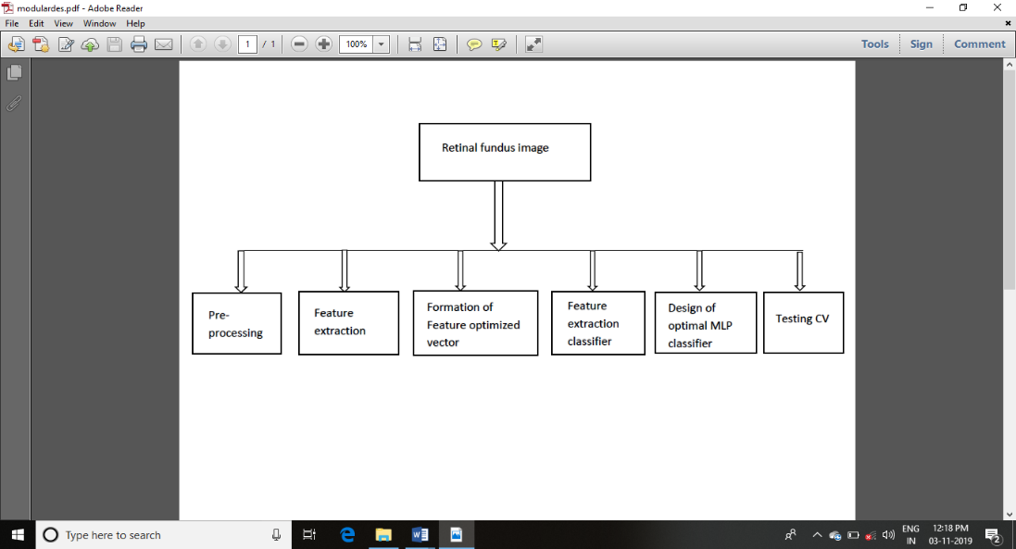

Fig. 4.2: Diagram Representing Modular Design

Initially Edge detection-based Image segmentation is done, and finally image analysis and classification of diseases. This work the input images using the RGB pixel counting values features used and identify disease wise and next using homogenization techniques Sobel and Canny using edge detection to identify the affected parts of the leaf spot to recognize the diseases boundary is white lighting and then result is recognition of the diseases as output

### Algorithm for Logic Implementation

* + - 1. RGB image acquisition.
      2. Apply Colour Median Filtering by Median filter.
      3. Noise removal and feature detection.
      4. Edge detection.
      5. Feature Extraction.
      6. Binary conversion.
      7. Level identification.

### Statistical validation

**V.RESULTS AND DISCUSSION**



FIG 5.1 Login page for the Admin

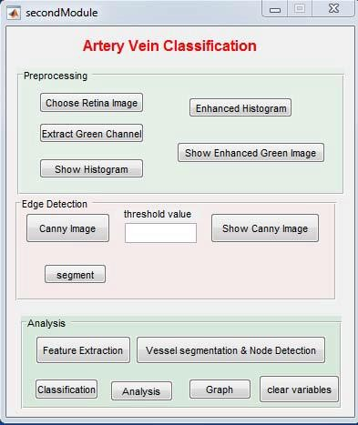

FIG 5.2 UI Page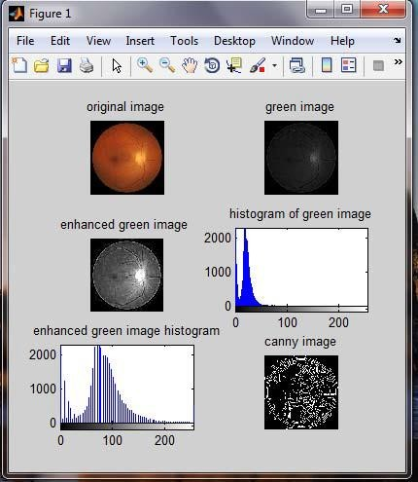

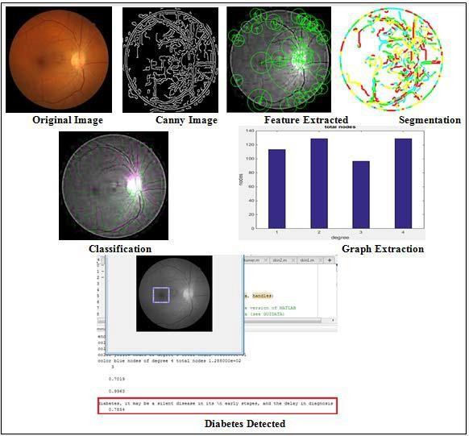FIG 5.3 Processing Page

FIG 5.4 Processing Page

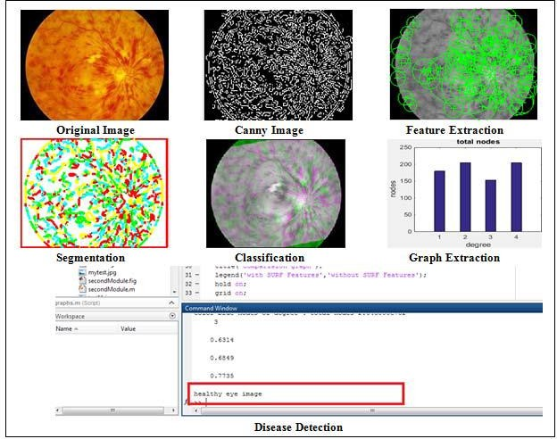FIG 5.5 Diabetic Retinopathy determination page

**VI. CONCLUSION**

This system enables the users to detect diabetes through desktop application. The system also ensures better accurate results when compared to other existing algorithms like ANN. This system also ensures time saving when compared to manual inspection. For future works a device can be developed which is used to capture the image.

**REFERENCES:**

1. Amol Pratap Rao Bhatkar*, “FFT based Detection of diabetic Retinopathy in Fundus Retinal Images”* Dr.G.U. Kharat 978-1-4673-9692-9/15$31.00-2019

2. A.P. Bhatkar & G.U. Kharat, *” Detection of Diabetic Retinopathy in Retinal Images using MLP classifier”*, 2015 IEEE International Symposium on Nanoelectronics and Information Systems, 978-1-4673-9692-9/15

3. María García, Carmen Valverde, *“Comparison of Lo 34gistic Regression and Neural Network Classifiers in the Detection of Hard Exudates in Retinal Images”*, 35th Annual International Conference of the IEEE EMBS Osaka, Japan, 3 - 7 July, 2013

4. Meindert Niemeyer*,” Retinopathy Online Challenge: Automatic Detection of Microaneurysms in Digital Color Fundus Photographs”*, IEEE Transactions on Medical Imaging vol.29, no.1, January 2010

5. S. JeraldJeba Kumar, Madheswaran*, “Extraction of Blood Vascular Network for Development of an Automated Diabetic Retinopathy Screening System”,* International Conference on Computer Technology and Development IEEE 10.1109/Icctd.2009.212, 2009.

6. Michael Goldbaum, Saied Moezzi, Adam Taylor, Shankar Chatterjee, Jeff Boyd,

Edward Hunter, and Ramesh Jain, *“Automated diagnosis and image with object*

*extraction, object classification and difference in retinal images”* ,Br. J Ophthalmol, vol 83, august 1999

7. C.Sinthanayothin, J. Boyce, H. Cook, and T. Williamson, *“Automated localisation of optic disc, fovea, and retinal blood vessels from digital color fundus images”*, Br. J Ophthalmol, vol. 83, august 1999.

8. Anil K. Jain Michigan State University, Jianchang Mao IBM Almaden Research Centre*.,” Artificial neural networks: A tutorial”,*1996.