[1]

SaviourDrone: An Autonomous Drone for Medical Emergencies

Rahul Adiga C1, Sameeksha U Raikar2, Suma S H3, Sumanth S4, and Dr. Balachandra Achar5

*Abstract*—Engineering and technology play an important role in the healthcare sector for the betterment of lives on earth. The project, SaviourDrone deals with the same, i.e., for the betterment of our society. The drone being developed will be completely driverless, equipped with a robotic arm and a two-way video communication feature. SaviourDrone will be interfaced with a fully customized mobile application for user benefits. The proposed robotic arm will be equipped with different sensors and nodes which can track the necessary vitals of a patient in need. The working of the project being built can be explained as follows, whenever a victim feels sick, the person himself / the people around can make use of the mobile application to inform the situation to the emergency services. The drone which is near to the patient receives the GPS coordinates of the patient and arrives at the spot in very less time. Even the ambulance nearby will receive the coordinates. Through the video communication feature, a doctor from the hospital can observe the condition of the patient. The mechanical arm measures the parameters like pulse rate, BP, emotional stress levels and these details are passed to the doctor. The doctor after examining the vitals can suggest the first aid to be done before the ambulance arrives. The basic first-aid will be available in the drone which can be used based on the instructions given by the doctor through video communication service.

*Index Terms*—Internet of Things, Aircraft navigation, Public healthcare, Telemetry, Global Positioning System, Image processing

**Manuscript received Mar, 2020**

*This work was guided by* ***Dr. Balachandra Achar (Professor and Head),*** *Depart­ment of Electronics and Communication, SMVITM Udupi, Karnataka, India.*

***Rahul Adiga C,*** *Depart­ment of Electronics and Communication, SMVITM Udupi, Karnataka, India.*

***Sameeksha U Raikar,****Depart­ment of Electronics and Communication, SMVITM Udupi, Karnataka, India.*

***Suma S H,****Depart­ment of Electronics and Communication, SMVITM Udupi, Karnataka, India.*

***Sumanth S,****Depart­ment of Electronics and Communication, SMVITM Udupi, Karnataka, India.*

# INTRODUCTION

Even though the world is developing rapidly, the reach of healthcare facilities is lacking in a major part of the population around the world. As per a survey, nearly 27% of the deaths in India happen with no medical attention at the time of death[1]. A majority of the patients who die without medical attention would have suffered a heart attack, cardiac arrest or stroke-related problems. Every second heart attack patient in India takes more than 400 minutes to reach a hospital, that too without any first aid being provided to the patient. So, there’s an urgent need to find a technique through which the needy gets the doctor’s attention as soon as possible and SaviourDrone addresses this issue. The project can be analyzed in two different stages, wherein the first stage is focused on the hexacopter and the second, being focused on the mechanical arm. The copter being developed will be completely autonomous and reaches a particular location when the coordinates are provided. The drone’s landing gear will be specifically designed to land in most of the conditions without any trouble. The mechanical arm is an integral part of the SaviourDrone, provides us the feature of two-way communication between the doctor and the person in need. The arm also has different sensors attached to measure various parameters such as the patient’s body temperature, pulse rate, and emotional stress levels and these details are passed to the doctor and the emergency services. SaviourDrone also carries the first-aid kit and some of the most commonly needed medicines which will be handy most of the time. Jet injector technology can be used to further develop the features of the project. In short, SaviourDrone is being built to have a positive impact on our society in the field of healthcare, keeping in mind that the combination of healthcare and engineering can do wonders.

## Abbreviations and Acronyms

GPS(Global Positioning System):

GPS is a satellite navigation system that provides the ground coordinates for tracking the location of an object.

.

# jet injector

Jet injector is a technology used to injectmedicine or a vaccine into the body without the use of a needle. The medicine is injected at very high pressure to make it penetrate the outer layer of the skin to deliver the medicine. Disposable-Cartridge jet injectors are used to prevent the spreading of diseases from one subject to another. Because of low-maintenance and low-risk while injection of medicines, jet injector technology is attached with the mechanical arm of SaviourDrone to inject the necessary medicines to the victim in case of emergency.

# galvanic skin response

Galvanic skin response is used to analyze the emotional status of a person by analyzing the sweat glands. Galvanic skin response data significantly varies depending on the emotional arousal one experiences and this data can be used to treat patients effectively by understanding the stress levels, drowsiness of the victim. The change in skin conductance depending on the emotional arousal is the basic principle of GSR, higher the emotional arousal, greater is the skin resistance. Two simple electrodes are used to measure the Galvanic skin resistance. As the effect of medicine and treatment changes completely depending on the stress level one is in, SaviourDrone makes use of the GSR sensor to analyze the stress levels of the patient, try to minimize the stress and emotional arousal and then treat the patient effectively.

# drone

Building a perfect drone is very important for the effectiveness of SaviourDrone. The drone in use should be able to fly to the coordinates provided with minimum or no assistance and land in almost any type of ground. Depending on the number of drones available and the range to be covered, the perfect battery should be selected. The two-way video-communication is established by using some of the already available video-communication platforms installed to the microcontroller which has an attached camera, microphone, and a display. The first-aid kit attached to the drone is temperature-controlled to maintain the perfect temperature for the medicines in it. The drone makes use of image processing and object detection to approach the patient. The drone can be manually controlled to guide it very near to the victim by following the video feed provided by the drone.

# proposed methodology

The project can be explained in three different phases.

Phase-1: Informing about the emergency

When a person needs medical expertise or has met with an accident, the situation can be reported to the medical authorities using the mobile application built. The focus is on building the application for android devices initially using the android studio. The application uses internet connectivity to send the data and an emergency number will be provided to report the situation in case internet connectivity is not available. The application uses Global Positioning System to get the exact location of the emergency. If the patient is in some other location, there will be an option to manually provide that particular location. If the person who is reporting the incident knows the condition of the patient, he can inform the authorities about that as well, along with a picture. All these details are now shared with the ground station which manages the drone facility and connects the patient with an expert.

Phase-2: Ground station and drone operation

The ground station manages the flight of the drone and acts as a mediator between the medical expert and the patient. When the ground station receives GPS coordinates of the emergency, depending on the condition of the patient as reported through the mobile application, arms the drone with certain medicines, first aid and commands it to fly. Telemetry is used to command the drone to follow certain flightpath in order to reach the final destination. The flight controller uses the coordinates of the ground station as the launch location and returns to launch location automatically if it encounters any difficulty in the flight like low battery.

The flight controller being used is Pixhawk PX4 2.4.8 which is one of the leading flight controllers for commercial drones and supports autopilot mode. GPS module and the compass attached to the flight controller is utilized to guide the drone to the emergency location using the flightpath provided earlier. Specific altitude will be set for the flight so that the drone can hold on to that particular altitude throughout its flight. Ultrasonic sensors are used to prevent collision during the automatic maneuver. After the drone nears the patient, it can be guided to the exact spot using the feed through the camera module and RC Transmitter and receiver. The camera module being used will be an action camera and makes use of RF signals to transmit the feed to the ground station. The drone on reaching the location generates a loud sound so that the people nearby can get to know about the situation and come for help. Coming to the mechanical arm attached to the drone, it will be equipped with different sensors like LM35 for temperature measurement, heartrate monitoring sensor, and galvanic skin response sensor to calculate the stress levels of the patient. Different parameters from these physiological sensors are sent to the ground station and the ambulance services so that they are well prepared to handle the situation. The same is shared with the medical expert who observes both the physiological parameters as well as the live footage to analyze the condition of the patient. On observing the physiological parameters and the live footage, the expert guides the patient or the people around the patient for first-aid. Since savior-drone supports two-way video communication, the doctor can explain about the first-aid procedure to be done effectively and monitor the situation. The doctor can suggest making use of the first-aid kit available with the drone if needed so that the situation is handled as much as possible before the arrival of an ambulance. If in case of a serious medical emergency and the medicine needs to be injected to the needy, jet injector technology will be used. Jet injector technology is capable of injecting the medicine without the needle. On the suggestion of medical expert, the people around the patient can load up the medicine into the jet injector and inject it directly into the skin in order to improve the patient’s condition. The medicines will be stored in a cold case in order to maintain them in a stable cold environment. The patient will be continuously monitored until the arrival of an ambulance.

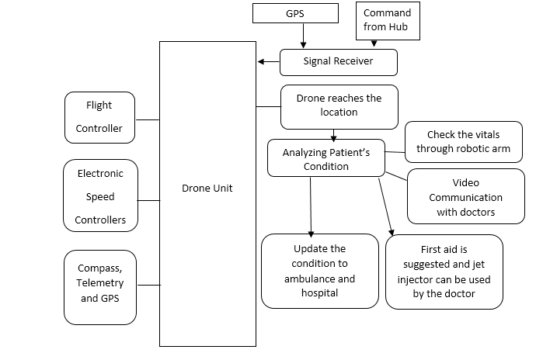

Fig: Block Diagram for SaviourDrone

Phase-3: Drone return to launch location

On the arrival of an ambulance, the drone gets commanded from the ground station to return to the launch location. Pixhawk contains the coordinates of the ground station as launch location and the return to launch command initiates the drone to take a flight towards it. Even during the flight, if the battery levels of the drone is below a set threshold, it returns back. When the drone returns back from an operation, its batteries gets replaced, the firstaid kit is filled up and it is completely ready for another operation within minutes to help save a precious life.

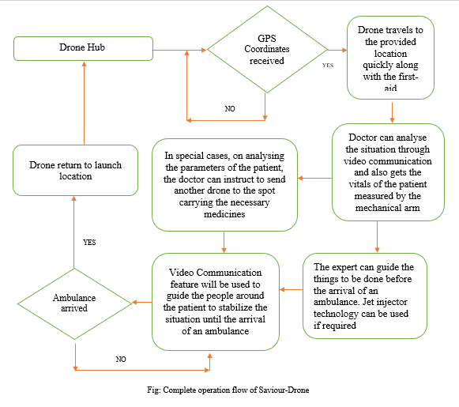

The above flow-chart represents the complete working methodology as explained in the previous sections of this paper.

# Conclusion

## SaviourDrone when implemented, solves some of the major problems faced by the health-care and medical emergency sector. Some of the important tasks like delivering first-aid to the needy as quickly as possible, establishing two-way communication with experts to deal with the emergency situation, analyzing patient’s vitals and use of jet-injector technology, SaviourDrone does it all. So, it’s no secret that the combination of engineering and healthcare can do wonders for society.

References

[1]. Sivakumar B, “27% of deaths in india for want of medical attention”,27/10/15, TOI

[2]. RameeshaTariq, Mahim Rahim, “DronAID – A Smart Human Detection Drone for Rescue”,: 978-1-5386-8354-5, IEEE, 2018

1. .