Experimental Characterisation of a McKibben-type Pneumatic Bending Actuator

Adithya R Upadhya1, Mohith S1, Navin Karanth P1

1Department of Mechanical Engineering, National Institute of Technology Karnataka, Surathkal, Mangalore – 575025

***Abstract -* Soft robotics is a growing, fresh area that relies on these mechanical characteristics and the inclusion of components, buildings and applications. Just as animal movements are based on the close inclusion of neural and mechanical controls, soft robotics aims to accomplish better and simpler processes by exploiting ‘mechanical intelligence’ of soft materials. One such soft pneumatic bending actuator is developed here. It is then fabricated using latex tube, braided sleeve and strain-restraining material. The McKibben Pneumatic Bending Actuator (MPBA) was characterized after several tests. The actuator tested here shows a bending angle of 130.8° for an air pressure of 2.5bar. It exerted a maximum force of 8.52N for the same air pressure.**

***Keywords* – McKibben Pneumatic Bending Actuator, MPBA, Pneumatic Actuator, Soft Robotics.**

# Introduction

Classical robots have rigid underlying frameworks which constrain their ability to communicate with their environment. Conventional robot manipulators, for instance, have rigid connections, and can move objects using their advanced end effectors only. However, these robots face difficulties working in unstructured and heavily congested conditions [1]. Animals use the fragile mechanisms of complex natural systems to maneuver efficiently. Such capabilities have encouraged robotic engineers to integrate soft technology into their projects [2]. This has inspired many robotics engineers and scientists to study and develop bioinspired robots. Innovative and creative outcomes from these works led to the development of a new robotics field known as ‘soft robotics’[3]. Robosoft community defines a soft robot as “devices that can actively interact with the environment and can undergo large deformations relying on inherent or structural compliance.”[4] A variety of actuators were developed in this area which includes Pneumatic Artificial Muscle(PMA), Pneumatic Bending Actuator(PBA), soft grippers and many more. It was Richard H Gaylord who first developed linear actuators in 1958. He described it as "an elongated, expandable tubular means surrounded by a woven sheath that forms an expandable chamber which contracts in length when circumferentially expanded"[5]. However then it was popularized by Joseph L McKibben in 1960 by using it to support his daughter with polio[6]. These actuators were also known as Pneumatic Muscle Actuators (PMA) as they resembled a human muscle when actuated and relaxed. It was considerably used in the exoskeleton and humanoid hand development [7]–[11] owing to its unique properties like low membrane material deformation, high tensile strength, uniform membrane loading, high contraction and more[12]. However, it is not convenient to generate bending motion using a linear actuator. This led to the development of Pneumatic Bending Actuators (PBA).

A PBA is a kind of an actuator which bends when sufficient amount of air is supplied. Soft PBA could simplify and enhance the transmission mechanism's performance, and have greater stability compared to their rigid mechanical counterparts. Many variants of bending actuators are developed during the course of time which includes PneuNets[13], granular jammed bending actuator[14], fiber-reinforced bending actuators[15] and multiple chambered bending actuators[16]. These bending actuators are mainly used in development of rehabilitation devices and gripper, where more human interaction is involved. PneuNets are primarily used where more deflection and less force are required, whereas fiber-reinforced or McKibben type actuators are commonly used for higher force applications.

All the actuators in the research mentioned above domains of use. They provide significant bending but fail to provide the bending force required. Here, a low-cost and easy to fabricate McKibben Pneumatic Bending Actuator (MPBA) is fabricated and tested in order to characterize. It generated a sufficient bending movement along with adequate force.

# Working Principle

To understand the working principle of the MPBA, it is necessary to know the working principle of a typical PMA. A PMA comprises of a rubber tube or bladder surrounded by a braided sleeve. It actuates on compressed air. When compressed air is supplied, the tube expands non-uniformly, like a balloon. The braided sleeve, which has a general application of electrical wire insulation, contracts axially when it is radially expanded and vice-versa. This phenomenon controls the expansion and shortens in length. Hence, a PMA shortens in length when compressed air is supplied as shown in Figure 1. Here, L is the length of the PMA and D is the diameter. Hence, L1 >L2 >L3 and D1 < D2 < D3 [17].

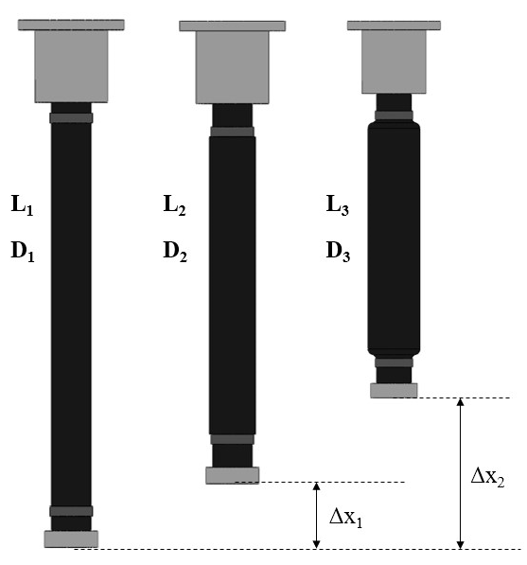

Figure 1: Different stages of actuation of a McKibben PMA

An MPBA works on the same principle. Only addition is the strain-restraining material affixed axially on the external surface of the actuator. Strain-restraining material can be any flexible material such as nylon fabric. It prevents a part of the actuator from shortening and hence bending takes place.

Figure 2 depicts the actuated and the relaxed states of the MPBA. It is noticeable that during bending, the strain-restraining material forms the top part of the actuator. This is because the part of the actuator without strain-restraining material shortens and hence it forms the inner surface.

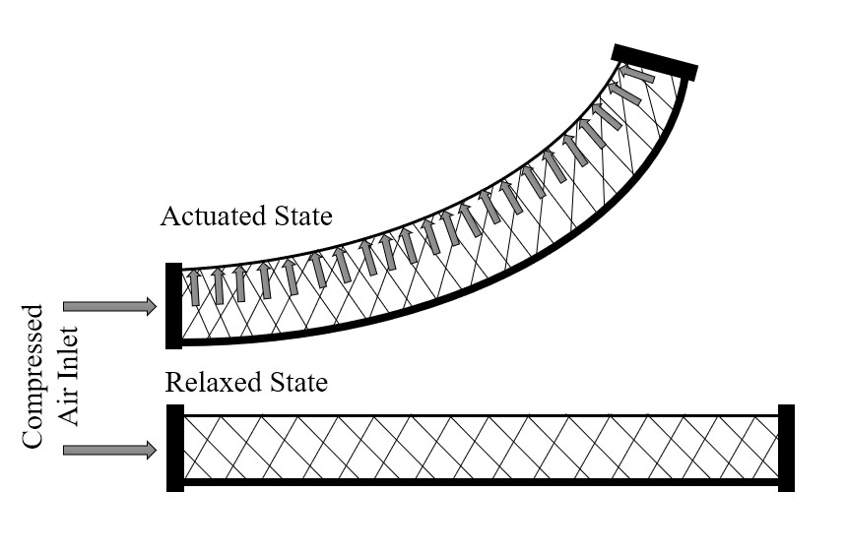

Figure 2: Schematic of the actuated and the relaxed state of the MPBA

This is similar to the working of a bimetallic strip [18], where two metal strips with different thermal coefficient is fixed to one another. It bends when heated due to difference in expansion rate.

# Fabrication Of The Actuators

The MPBA fabricated is made up of a latex tube, braided sleeve [19] and a strain-restraining material. The latex tube of inner diameter (ID) 8mm and outer diameter (OD) 12mm forms the inner part and the braided sleeving of 12.7mm surrounds it. Non-stretchable nylon fabric is used as the strain-restraining material. The width of the strain-restraining material is same as the diameter of the sleeve, i.e., 12.7mm. The length of the fabricated actuator is 100mm.

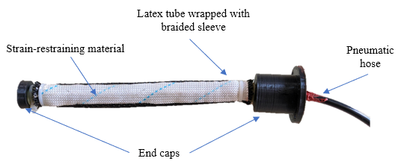

Figure 3: A fully fabricated MPBA

Figure 3 shows a fully fabricated MPBA. It also comprises of the end-caps which are 3D printed in our lab. One end is available for connecting to the pneumatic components and the other end is sealed.

# Experiments Conducted

The fabricated MPBA is tested for bending angle and the force exerted and characterized. The testing is carried out in a test-rig shown in Figure 4 which was developed in our lab. The test-rig is built using aluminium frames of dimensions 20x20mm. It has fixtures for holding the actuator in the horizontal direction, compressor and an FRL to supply clean air to the actuator. Here, the pressure range was maintained from 0-2.5bar as the end-caps were designed for that range.

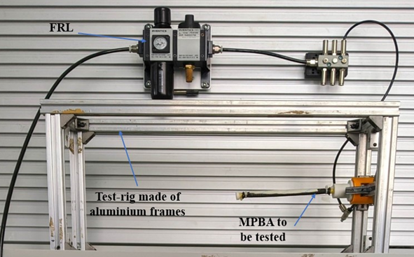

Figure 4: Test setup for MPBA characterization

Both bend angle and the force exerted is measured using the same rig with required modifications.

## Bending Test

This test is performed to evaluate the bending capability of the actuator. The compressed air is supplied and the pressure of which is controlled by the FRL. A digital camera (Nikon D5200) [20] is used to take images at regular intervals of 0.25bar pressure maintained in the actuator. These images are then processed using a the software IC Measure [21] to obtain the bend angle or the curvature angle of the actuator. Figure 5 shows the schematic of the test setup used for measuring bending angle of the MPBA.

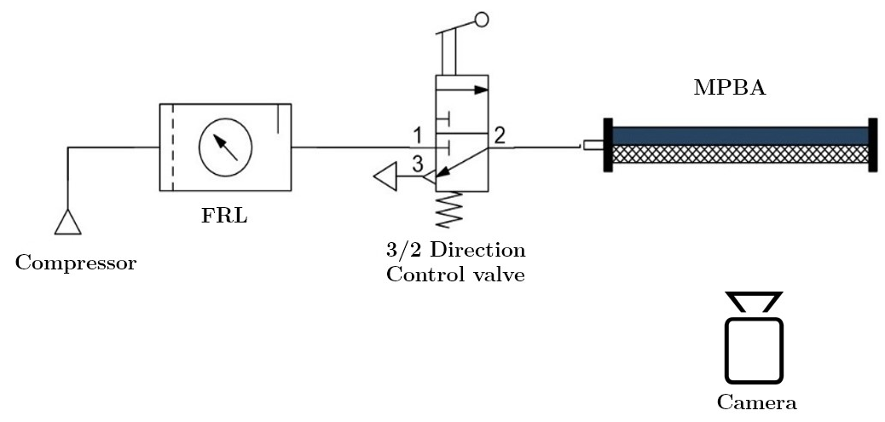

Figure 5: Schematic of the test setup for testing MPBA

The images captured during the bending test of the MPBA is shown in Figure 6.

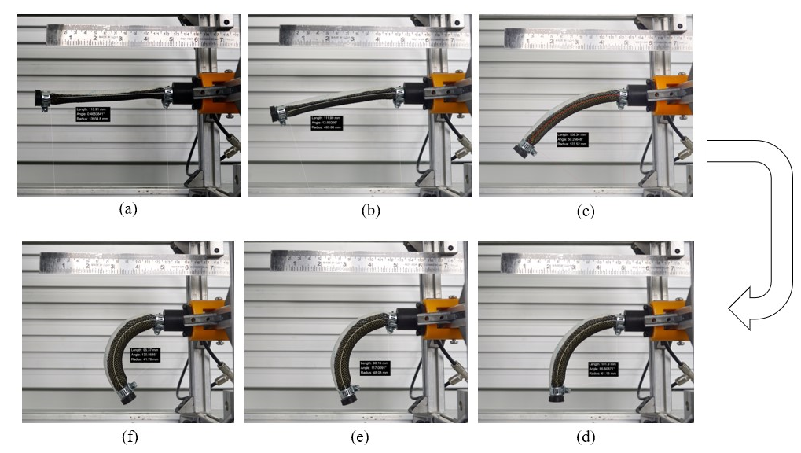

Figure 6: Images showing the bend positions of the MPBA at (a)0bar (b)0.5bar (c)1bar (d)1.5bar (e)2.0bar and (f)2.5bar

## Force Test

It is important to calculate the force produced by the actuator, since it is one of the key features of choosing the actuator for a specific application. Here, a spring is used to measure the force exerted by the actuator. The spring is made of spring steel and its spring constant is known. A hook is fixed to one of the end-cap of the MPBA and is connected to the spring. Force calculation is done as per Hooke’s Law equation for springs which is given by,

|  |  |  |
| --- | --- | --- |
|  | $$F_{s}=k x$$ | (1) |

In the above equation (1), $F_{s}$ is the spring force in Newtons, $k$ is the spring stiffness in N/mm and $x$ is the displacement of the spring caused by the actuator force. The displacement is measured using image processing.

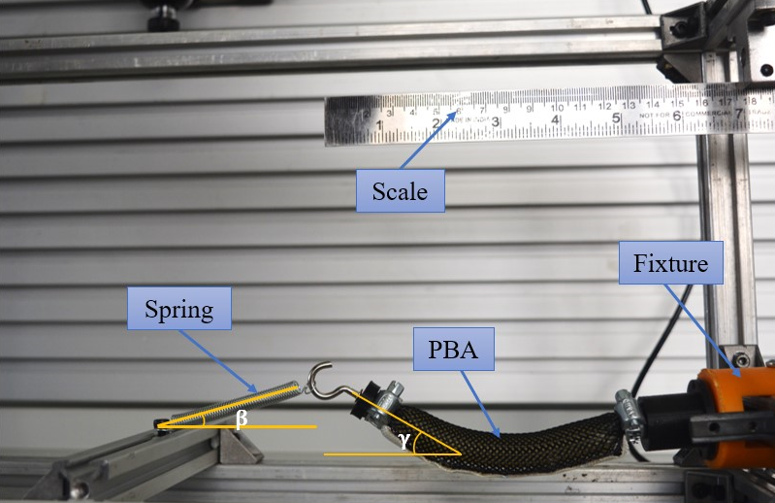

Figure 7: Test setup for force measurement

Figure 7 shows the setup for measuring the force exerted by the actuator. Here, actuator force $F_{m}$ and the spring force $F_{s}$ is non-colinear. Hence forces are resolved into its components and equated to obtain the force exerted by the actuator. The equation (2) gives the actuator force in terms of spring force $F_{s}$, the angle between the spring axis and the horizontal plane $β$, and the angle between the actuator axis and the horizontal plane $γ$. These angles are also determined by image processing method as shown in Figure 7.

|  |  |  |
| --- | --- | --- |
|  | $$F_{m}=F_{s} \left(\frac{cosβ}{cosγ}\right)$$ | (2) |

# Results And Discussion

The test results include the bend angle property, linear displacement property and the force exertion property. These parameters help in deciding the dimension for the actuator for a specific application.

Multiple trials were performed to minimize the experimental errors during characterization. The result obtained during bend test is shown in Figure 8. It can be observed that the maximum bending angle for an air pressure of 2.5bar is 130.85° from its initial position.

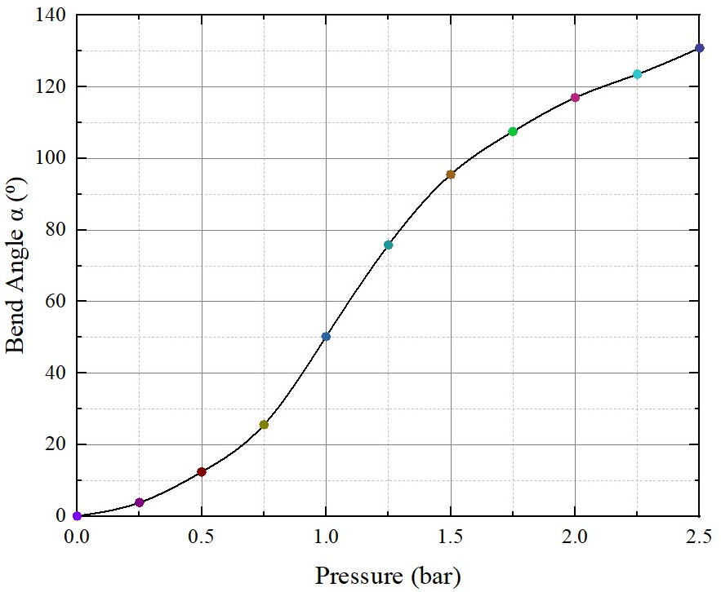

Figure 8: Bend Angle vs Pressure plot for the MPBA

The linear displacement in vertical direction is measured to provide an estimation of the actuator's space usage and to notice the pattern that the actuator adopts during the actuation process. Figure 9 shows the variations of the linear displacement of the MPBA for varying pressures. It can be noticed that the linear displacement increases almost linearly against the pressure up to the highest value. However, the displacement reduces after a certain point, which is due to the bending of the actuator by an angle greater than 90°.

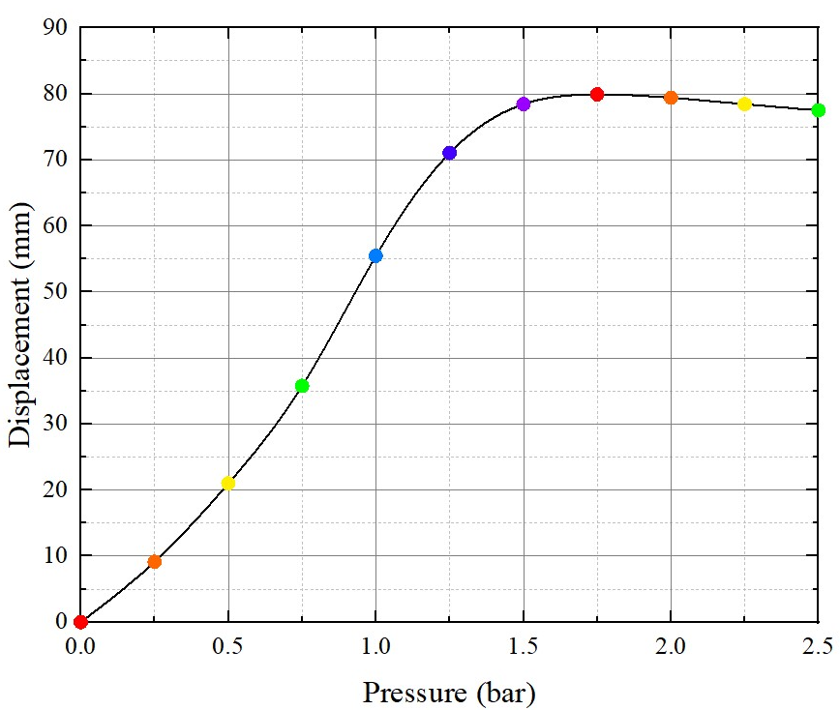

Figure 9: Linear Displacement vs Pressure plot for the MPBA

The force exerted by the MPBA while bending is measured using a spring of known stiffness. The plot of pressure $(P)$ and actuator force ${(F}_{m})$ is given in Figure 10. It can be noticed that the force increases linearly against the air pressure maintained inside the actuator. The actuator exerts a maximum force of 8.52N at 2.5bar pressure.

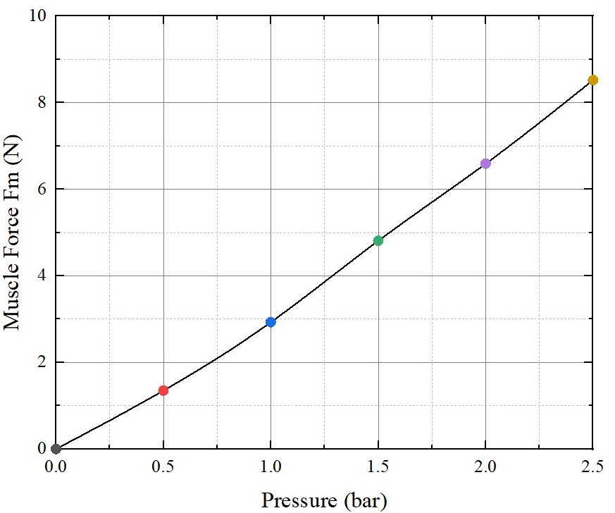

Figure 10: Muscle Force vs Pressure plot for the MPBA

# Conclusion

A McKibben Pneumatic Bending Actuator (MPBA) is developed from a McKibben type PMA and fabricated using latex tube, braided sleeve and a strain-restraining material. In order to characterize the actuator, various tests are performed on it. The bending capability of the actuator and the exerted force is quantified and plotted. It can be noticed that the bend angle of the MPBA increases as the pressure increases and it bends up to 130.85° from its initial position for a pressure of 2.5bar. The force exerted by the actuator rises linearly with the pressure and exerts a maximum force of 8.52N at an internal air pressure of 2.5bar. Further investigation is on process to fabricate MPBAs of different sizes and compare their characteristics.

Acknowledgement

This research work was carried out in the Automation Lab, NITK using the equipment funded by Fund for Improvement of S&T Infrastructure in Universities and Higher Educational Institutions (FIST) Program ([SR/FST/ETI/-399](http://mech.nitk.ac.in/sites/default/files/upload/sponsored_imprint_industry%20projects.pdf)), Govt. of India and the authors would like to acknowledge the same.

References

[1] D. Trivedi, C. D. Rahn, M. Kier, and I. D. Walker, “Soft robotics : Biological inspiration , state of the art , and future research,” *Appl. Bionics Biomech.*, vol. 5, no. 3, pp. 99–117, 2008, doi: 10.1080/11762320802557865.

[2] S. Kim, C. Laschi, and B. Trimmer, “Soft Robotics: A Bioinspired Evolution in Robotics,” *Trends Biotechnol.*, vol. 31, no. 5, pp. 287–294, 2013, doi: 10.1016/j.tibtech.2013.03.002.

[3] C. Lee *et al.*, “Soft Robot Review,” *Int. J. Control. Autom. Syst.*, vol. 15, no. 1, pp. 3–15, 2017, doi: 10.1007/s12555-016-0462-3.

[4] C. Laschi, B. Mazzolai, and M. Cianchetti, “Soft Robotics : Technologies and Systems Pushing the Boundaries of Robot Abilities,” *Sci. Robot.*, vol. 1, no. 1, p. 11, 2016, doi: 10.1126/scirobotics.aah3690.

[5] B. Tondu, “Modelling of the McKibben artificial muscle: A review,” *J. Intell. Mater. Syst. Struct.*, vol. 23, no. 3, pp. 225–253, 2012, doi: 10.1177/1045389X11435435.

[6] B. Tondu and P. Lopez, “Modeling and Control of McKibben Artificial Muscle Robot Actuator,” *IEEE Control Syst. Mag.*, vol. 20, no. 2, pp. 15–38, Apr. 2000, doi: 10.1109/37.833638.

[7] B. Tondu, S. Ippolito, J. Guiochet, and A. Daidie, “A Seven-degrees-of-freedom Robot-arm Driven by Pneumatic Artificial Muscles for Humanoid Robots,” *Int. J. Rob. Res.*, pp. 257–274, 2005, doi: 10.1177/0278364905052437.

[8] J. H. Lilly, “Adaptive Tracking for Pneumatic Muscle Actuators in Bicep and Tricep Configurations,” *IEEE Trans. NEURAL Syst. Rehabil. Eng.*, vol. 11, no. 3, pp. 333–339, 2003, doi: 10.1109/TNSRE.2003.816870.

[9] P. Scarfe and E. Lindsay, “Air Muscle Actuated Low Cost Humanoid Hand,” *Int. J. Adv. Robot. Syst.*, vol. 3, no. 1, pp. 139–146, 2006.

[10] L. Udawatta and S. Witharana, “Control of Pneumatic Artificial Muscle for Bicep Configuration Using IBC,” in *International Conference on Information and Automation for Sustainability*, 2008, no. September 2017, pp. 35–39, doi: 10.1109/ICIAFS.2007.4544777.

[11] Ž. Šitum and S. Herceg, “Design and Control of a Manipulator Arm Driven by Pneumatic Muscle Actuators,” in *16th Mediterranean Conference on Control and Automation Congress Centre, Ajaccio, France*, 2008, pp. 926–931.

[12] A. R. Upadhya, A. Rayan H, and Muralidhara, “Design, Fabrication and Testing of Pneumatic Muscle Actuator for Artificial Human Arm,” *J. Mech. Eng. Res. Dev.*, vol. 42, no. 5, pp. 115–118, 2019, doi: 10.26480/jmerd.05.2019.115.118.

[13] P. Polygerinos *et al.*, “Towards a Soft Pneumatic Glove for Hand Rehabilitation,” in *IEEE International Conference on Intelligent Robots and Systems*, 2013, pp. 1512–1517, doi: 10.1109/IROS.2013.6696549.

[14] L. Al Abeach, S. Nefti-Meziani, T. Theodoridis, and S. Davis, “A Variable Stiffness Soft Gripper Using Granular Jamming and Biologically Inspired Pneumatic Muscles,” *J. Bionic Eng.*, vol. 15, no. 2, pp. 236–246, 2018, doi: 10.1007/s42235-018-0018-8.

[15] B. Wang, K. C. Aw, M. Biglari-Abhari, and A. McDaid, “Design and Fabrication of a Fiber-Reinforced Pneumatic Bending Actuator,” in *IEEE/ASME International Conference on Advanced Intelligent Mechatronics, AIM*, 2016, pp. 83–88, doi: 10.1109/AIM.2016.7576747.

[16] M. R. M. Razif, A. A. M. Faudzi, M. Bavandi, N. A. M. Nordin, E. Natarajan, and O. Yaakob, “Two Chambers Soft Actuator Realizing Robotic Gymnotiform Swimmers Fin,” in *IEEE International Conference on Robotics and Biomimetics, IEEE ROBIO 2014*, 2014, pp. 15–20, doi: 10.1109/ROBIO.2014.7090300.

[17] E. Kelasidi, G. Andrikopoulos, G. Nikolakopoulos, and S. Manesis, “A Survey on Pneumatic Muscle Actuators Modeling,” *J. Energy Power Eng.*, vol. 6, pp. 1442–1452, 2012.

[18] George Edwards Attorney, “Method of and Apparatus for Making Bimetallic Strip,” US2203679A, 16-Dec-1940.

[19] “Braided Sleeving Data Sheet,” no. April. 2016.

[20] “Nikon | Imaging Products | Specifications - Nikon D5200,” 2020. [Online]. Available: https://imaging.nikon.com/lineup/dslr/d5200/spec.htm. [Accessed: 20-Jan-2020].

[21] “IC Measure - Measure on-screen lengths, angles, circles and polygons and capture images.” [Online]. Available: https://www.theimagingsource.com/products/software/end-user-software/ic-measure/. [Accessed: 13-Feb-2020].