Effect of Ash Filler on Thermo-Mechanical Properties of Natural Fiber Reinforced Composites

***Sudarshan M.L.****1****,*\**, Vaibhav N Poojary2, Sukesh Anant Achari2, Dr. Sudarshan Rao K3***

# 1Assistant Professor, Department of Mechanical Engineering, Vivekananda College of Engineering

and Technology, Puttur, Karnataka, India.

* Research Scholor, SMVITM, Bantakal.

2Student, Department of Mechanical Engineering, Vivekananda College of Engineering and

Technology, Puttur, Karnataka, India.

3Professor & Head, Dept. of Mechanical Engineering, SMVITM, Bantakal

categorize the composite based on high to low strength &

***Abstract*: *As natural fiber composite materials are environmental friendly & economical, now a day’s most of the researchers & engineers started their researches on composites. Composites are low weight & high resistance to corrosive which is another reason to use it in first place. Using graphical representation when component weight is critical select the natural fiber composites materials based on tensile test, compression test, HDT test, fire test, impact test & flexural test. The composite material which are tested in this study is produced by reinforced natural fiber such as sugarcane bagasse, areca husk, & coconut coir. The orientation of the reinforcement is discontinuous & random with matrix as epoxy & hardener varied amount (0, 5, and 10) % of ash is used as filler material to compare the heat & resistance of composites.***

***Keywords:* Natural fibers, filer materials, reinforcement,** **resin and hardener.**

## INTRODUCTION

When two or more physically or chemically distinct material are combined, that results in better properties than those of individual components can be defined as composite material.

Constituents mixed must retain their properties without dissolving in each other. The two constituents are matrix and reinforcement, where matrix sticks the fiber reinforcement, give the component its shape and determine its surface quality. The reinforcing phase provides the strength and stiffness. In most cases, reinforcement is harder, stronger and stiffer than the matrix. The reinforcement is usually a fiber or a particulate. Particulate composites have dimensions that are approximately equal in all directions.

Filler material are particles mixed to matrix to improve or gain certain property, make the product cheaper. In this paper we used ash as filler material to matrix improve the thermal resistance property. This study deals with effect of percentage variation of ash on mechanical & thermal properties of composite materials. These properties are very much essential to know the application, which help to

high to low resistance to thermal. These things can be achieved by Taguchi method. The natural fiber we are using here is areca husk, coconut coir & sugarcane bagasse. These fibers are used as reinforcement to components. Test conducted are tensile, compression, flexural, impact, HDT & fire test.

Fiber orientation & length to diameter ratio always play a major role in composite, length to diameter ratio is also known as aspect ratio. For long aspect ratio fiber must be continues & discontinues fiber gives short aspect ratio. In this experiment we are working under discontinues & randomly oriented reinforcement which is economical & less time consuming method.

## MATERIALS AND FABRICATION

In this section raw material used for the fabrication steps of the composites are studied. Raw materials used are:

1. Natural fiber (areca husk, coconut coir & sugarcane bagasse)
2. Epoxy resin
3. Ash
4. Hardener
   1. *Materials*

The fibers are the reinforcement which is obtained naturally by local sources. These fibers are initially sun dried and cut into small piece.

In this study we used epoxy resin L12 & hardener K6 both mixed in in a ratio 10:1 respectively by weight. Due to this mixed ratio the linear chain epoxy gets converted into 3D cross linked chain by increasing property of resin.

* 1. *Fabrication Process*

In this experiment composite laminate of 0.5cm thickness of natural fiber (areca husk, coconut coir and sugarcane bagasse) was prepared by conventional hand lay-up technique. This mold is of size 37.5*37.5.

In first fibers are closed in small size according to length to dimensions ratio. In other hand die is cleaned and releasing agent/ grease/oil is applied to die. Now hardener and epoxy is mixed in 1:10 proportion in a container or bucket. Matrix and chopped fiber is mixed and poured to die which is already prepared. Pressure is applied equally from top and allow it for 24 hours.

To get high resistance to thermal property filler material is also used in 5, 10, and 15 %. The comparison of fiber is in container that is 15% matrix comparison varies according to filler percentage. After the fabrication obtained material is subjected to mechanical thermal and flexural tests.

## Methodology

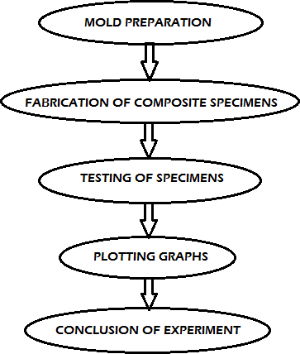

Fig. 1. Methodology (*flow chart).*

## EXPERIMENT PROCEDURE

1. *Tensile and compressive strength*

In this work both tensile and compression test is done with the help of universal testing machine according to ASTM D3039, results are compared by plotting the graph. The test specimen size was 100mm*15mm*5mm. 2mm/min is the strain rate conducted in 10 ton capacity UTM.

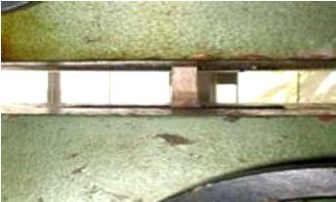

Fig. 2: Tensile test arrangement.

1. *Impact test*

In this work Izod impact test according to ASTM standard D256-56 is performed to measure the energy absorbed by the material just before fracture. The specimen was fixed to vice so when the pendulum is released it must face the notched face. The energy absorbed was then recorded.

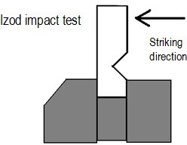

Fig. 3. Izod impact test

1. *Flexural strength*

Modulus of rupture or bends strength is the other two name of flexural strength. When the applied perpendicular to the horizontal work piece the resistance offered by the material to withstand bending load is termed as flexural strength. A rectangular cross-section work piece is fractured by using three point flexural testing machine.

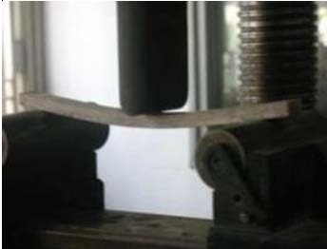

Fig. 4. Flexural strength testing.

1. *Time to ignition*

Time to ignition test will help the composite to know the application area in fire hazardous field. It is nothing but resistance offered by the material, when it is exposed to constant heat flux.

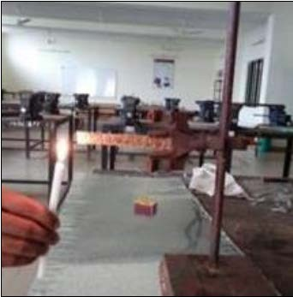

Fig. 5. Time to ignition test

## Results and conclusion

In the test three type of composites are prepared according to reinforcement and the ash filler is varied for all three composites (5%, 10%, and 15%).

1. *Tensile strength*

From the tensile strength of areca husk we can observe that we get maximum strength when the ash filler is 10% and lowest strength when the ash percentage is 0%.

This is also common for coir but the coir strength is high over all when compared to areca husk.

For sugarcane bagasse it is clear that we got highest strength at 10% and lowest at 15% for ash filler and also strength is low when compared to other two laminate.

Table-1: Tensile strength of specimens.

|  |  |  |  |
| --- | --- | --- | --- |
| **Percentage of filler materials** | **Coconut coir Young’s modulus(Mpa)** | **Sugarcane bagasse Young’s**  **modulus(Mpa)** | **Areca husk Young’s modulus(Mpa)** |
| 0% | 11.8 | 7.2 | 19.2 |
| 5% | 14.23 | 9 | 23.7 |
| 10% | 31.905 | 9.3 | 30.46 |
| 15% | 27.643 | 4.5 | 20.28 |

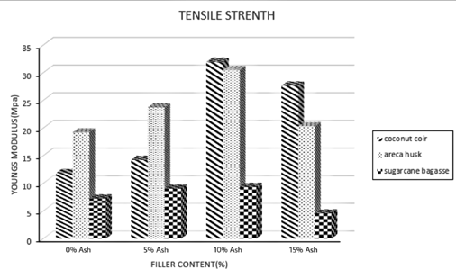

Fig. 6. Tensile strength comparison.

1. *Impact strength*

In this work we observed coconut coir can absorb more energy than other two composite that is at 10% ash filled material. Coconut coir had its lowest absorption of energy, when no filler material is added. This highest and lowest of energy absorption was same for other two composites also. The energy absorption decreases after further addition of filler.

Table-2: Impact strength of specimens.

|  |  |  |  |
| --- | --- | --- | --- |
| **Percentage of filler materials** | **Energy absorbed by Coconut coir(Mpa)** | **Energy absorbed by Sugarcane**  **bagasse(Mpa)** | **Energy absorbed by Areca**  **husk(Mpa)** |
| 0% | 2 | 1.2 | 1.46 |
| 5% | 2.3 | 1.9 | 2 |
| 10% | 2.9 | 2.6 | 2.26 |
| 15% | 2.5 | 2.2 | 2.13 |

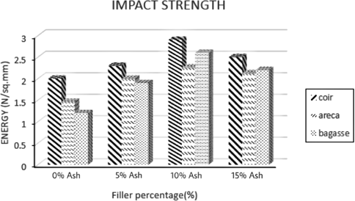

Fig. 7. Impact strength comparison.

1. *Flexural strength*

Flexural strength mainly depends on the length of the composite material as the length of matrix increases flexural strength decreases. In this work for the 10% filler material we get highest flexural strength and is decreases after further addition of filler material.

Table-3: Flexural strength of specimens.

|  |  |  |  |
| --- | --- | --- | --- |
| **Percentage of filler materials** | **Stress of Coconut coir (Mpa)** | **Stress of Sugarcane bagasse**  **(Mpa)** | **Stress of Areca husk (Mpa)** |
| 0% | 60 | 190 | 134.4 |
| 5% | 96 | 220 | 159.6 |
| 10% | 112 | 260 | 210 |
| 15% | 54 | 220 | 142.8 |

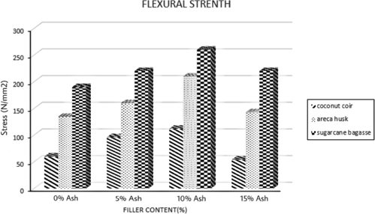

Fig. 8. Flexural strength comparison.

1. *Time to Ignition*

To find the resistance offered to burn material when constant heat flux is applied time to ignition also increases of ash filler. Time to ignition also increases also coconut coir require the highest time to ignition then areca husk and sugarcane bagasse.

Table-4: Time for ignition of specimens.

|  |  |  |  |
| --- | --- | --- | --- |
| **Percentage of filler**  **materials** | **Ignition time for Coconut**  **coir(min)** | **Ignition time for Sugarcane**  **bagasse(min)** | **Ignition time for Areca**  **husk(min)** |
| 0% | 6.42 | 2.33 | 4.27 |
| 5% | 8.37 | 5.25 | 6.34 |
| 10% | 10.05 | 8.33 | 9.25 |
| 15% | 11.14 | 10.16 | 10.5 |

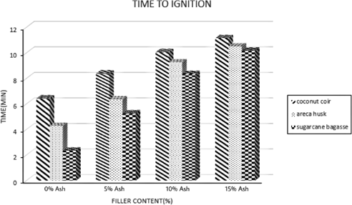

Fig. 9. Time to ignition comparison.

We also observe

1. Thermal conductivity decreases as ash as filer material reinforced with composite.
2. Thermal expansion coefficient decreases in matrix.
3. It fails to come under UL-94V returns because when the fire ignited it takes more than 30 seconds to extinguish the flame.

## CONCLUSION

In this work various test were conducted for epoxy based natural fiber composite matrix. In general the addition of ash as filler matrix leads to weight, cost reduction and thermal conductivity property. Addition to this following conclusion can be drawn:

1. Composite when fabricated using traditional hand lay-up method is time conclusion and cost reduction process.
2. Tensile test of this work concluded that up to 10% filler material strength increase with addition of filler and further addition results is decreases in strength and coconut coir had highest strength than other two composites.
3. Impact test of this work also concluded that coconut coir absorbs highest energy when compared to other two composites.
4. Flexural test of this work concluded that flexural test completely depends upon length of the composite and it is highest for sugarcane bagasse composite.
5. Time to ignition test was concluded to find the thermal conductivity of the composites. It gives the increment of ash as filler decreases the thermal conductivity. For coconut coir we get highest time to ignite than the other two composites.

## REFERENCE

* 1. Sudarshan M.L, Sourabh M.S, Shravan Upadhyaya, Shashank Anar, Preethan Kumar M. Study and comparision of Mechanical and Thermal Resisting Property of composite Materials Reinforced Using Natural Fibres and filler material as Ash. Journal of Refrigeration, Air conditioning, Heating and ventilation. 2019;6(2): 32-38p.
  2. Pankaj Tripati, Baji rav, Dharmendra kumar, Bhavnesh kumar.Study on Mechanical Behaviour of Sugar cane bagasse fiber reinforced polymer matrix composites. International journal of R&D in engineering science and management. 2015: 2393-865X.
  3. D.Verma, P.C.Gope, M.K.Maheshwari, R.K.Sharma. Bagasse fiber composite-A review. A journal of material and environmental Science-July 2012: 2028-2508.
  4. Srinivas Shenoy Heckada, Manjeshwar Vijay Kini, Raghuvir Pai Ballambat, Satish Shenoy Beloor, Sathish Rao Udupi, and Ullal achutha kini. Flexural strength analysis of starch based biodigreadable composite using areca frond fibre reinforcement. Interntional journal of manufacturing engineering. 2014: ID 769012.
  5. Satender kumar, Kakali Deka, P.Suresh. Mechanical properties of coconut fiber reinforced epoxy polymer composite. IRJET. 2016:2395-0056.
  6. Mohapatra, R.C. (2018) Experimental study on optimization of Thermal Properties of Natural Fibre Reinforcement Polymer Composites. Open access library journal,5:e4519.
  7. Nitin Mukesh Matur, Kedar Bairwa, Rajkumar. A literature review on composite material and scope of sugar cane bagasse. IJEDR. 5:2321-9939.
  8. Naheed Saba, Mohammad Jawaid, Othman Y Alothman, MT Paridah and Azman Hassan. Journal of reinforced plastics andcomposites. 2015. DOI: 10.1177/0731684415618459.
  9. A.Balaji,B.Karthikeyan, and C.Sundar Raj. Bagasse fiber- the future biocomposite material: A review. IJCEGG(2014). 7:0974-4290.
  10. Baikuntha Nath Sahu, Dilip Kumar Bisoyi. Flexural strength analysis of modified coir fiber composites. IJIRSET (2017). 6: 2319-8753.
  11. R.B.Ashok, C.V.Srinivasa, B.Basavaraju. A review on the mechanical properties of areca fiber reinforced composites. Science and Technology if Materials (2018). DOI: 10.1016/j.stmat.2018.05.004.
  12. Mr.Amol Sanjay Gurav, Dr.Manoj k. Chopra, Mr.Laxmikant G.Patil, Mr.Nitin R.Patil. Thermal analysis of composite material. IJSRD(2018). 6: 2321-0613.

## AUTHORS PROFILE

**Sudarshan M.L, working as Assistant professor at Dept of Mechanical Engineering, VCET, Puttur from past 14 years and Research Scholar at SMVITM, Bantakal. He has published three International and over 12 National Papers. He is a life member of ISTE.**



**Vaibhav N Poojary, Student (Mechanical engineering) Vivekananda College of Engineering and Technology, Puttur. (2016-20 batch)**



**Sukesh Anant Achari**, **Student (Mechanical engineering) Vivekananda College of Engineering and Technology, Puttur. (2016-20 batch)**



**Dr. Sudarshan Rao K**, **Professor & Hed, Department of Mechanical Engineering, SMVITM, Bantakal has 22 years of teaching and 6 years of research experience. He has published 24 research papers in Journals and conferences. He is a life member of ISTE, ISTD, ISH and fellow member of ISME.**

