**Smart Diaper Moisture Detection Using Cloud Computing**

Ranganatha K1, Arpitha M2, Rolvia Dsouza3, Shreya K4

*1Assistant Professor, Department of Information Science and Engineering, Canara engineering college, Benjanapadavu*

*2,3,4 Student, Department of Information Science and Engineering, Canara engineering college, Benjanapadavu*

*Ranganatha.kulkarni82@gmail.com1, arpithabhaskar8@gmail.com2, rolviadsouza23@gmail.com3, shreya.kotian63@gmail.com4*

**ABSTRACT:** This project is focused on Smart diaper moisture detection system using IOT. Smart described is a paper-based disposable moisture-activated Bluetooth communication device that could be incorporated into the traditional cellulose-based diaper.The Bluetooth connection device with sensor unit is optimized for low-cost manufacturing, utilizes screen-printing with electrically conductive ink on paper-based substrates and inherits very low EM radiation. A discussion on the manufacturability and cost efficiency of the system is presented. A prototype system is shown and other possible application areas of the system are mentioned. The proposed system contains Bluetooth connection device in diaper, when the kids wears the diaper it detects if moisture is present or not. If the moisture is present then it will send the signal to authorized person. There are a number of ways to detect and measure moisture where some examples can be seen, even though most methods require active electronics .When the diaper gets seriously wet, the moisture sensor becomes an energy source that feeds an oscillator circuit emitting a week connection through Bluetooth. The power of the transmitted Bluetooth connection is far below the levels when it could be thought to cause any harm to human.

***Keyword--*Moisture detection, Bluetooth , arduino nano ,sensor ,IOT**

1. **INTRODUCTION:**

In the modern hygiene, healthcare and care of the baby is important. There is a need and a desire to have a diaper that somehow alerts the caretaker to change the diaper of the baby. There should be a diaper of improved quality. Such diaper will make the life of caretakers less stressful and easier. The alert system in diaper will help them to handle everything without any difficulties. These diapers cost the minimum.

There are number of ways to detect the moisture of the diaper. It is very cheap and it detects without any delay. The diapers are easily disposable. When the diaper gets seriously wet, the moisture sensor becomes an energy source that alerts through the Bluetooth devices. The device can detect the weak signals and also the strong devices. It does not create any harm to human. The weak signals is however still good enough to be detected by a nearby Bluetooth device. It could be either throughaudio buzz, flashing light emitting diode or be coupled to the call the caretaker or any other alert line of a standard ward system.

It is always difficult to check the diaper manually. It will consume a lot of time, especially at night it is difficult for the caretaker to wake up and change the diaper. These diapers are easy to install and use. These are termed to be good choice. This system is of course the best one for the kids and even the elderly one.

There shall be other applications where wireless moisture detectors that are both cheap and easy to install and operate are needed and where this technology therefore might be a good choice.

* 1. **PURPOSE OF THE WORK**

The main purpose is in developing editorial strategies for some of these wide-ranging messaging platforms, news organizations are not just helping to future-proof themselves. They are also venturing into online spaces that could enable them to reach hundreds of millions of (often young) people with whom they have never engaged before.

**1.2 PROBLEM STATEMENT**

The aim of this project is In the modern hygiene, healthcare and care for elderly environment there is a need and a desire to have a diaper that somehow alerts a caretaker when it is time to change it. It is a prosaic necessity, but solving it can significantly improve the quality of care and make the life of caretakers much less stressful. Possible applications of such systems can range from the diapers for the kids to nursing homes and post- operational intensive care units and hospital ward.

**1.2 SCOPE**

The scope of the project is to improve the diaper for the better health condition of the infants by using smart diaper system and IoT technologies.These features can be used by worldwide. Wet diaper spread many kinds of rashes and dermatitis which is dangerous for infants.The doctor tries to prevent this dermatitis using diaper cream or gel. However, these kinds of gel or cream have some side effects.This is inconvenient to check diaper time to time for a nurse or patient family member.

**1.3 OBJECTIVE**

* To provide good and healthy life for the baby
* . To alert the caretaker when the baby urinate.
* To improve the quality of care
* To make the life of caretaker less stressful
* To detect the moisture of the diapers.

1. **LITERATURE SURVEY**

A low-cost smart care system is designed to detect wet diaper based on Smartphone and Bluetooth low energy (BLE) transmitter. The flexible conductors placed into the most urine absorption area into the diaper.[1] The wetting of the diaper decreases the resistance between two terminals which are connected with conductors. As a result, terminals resistance fall down below the predefine resistance value and BLE transmitter send the warning alarm to the Smartphone application and the phone starts ringing. The proposed wet diaper detector based on smart phone and BLE sensor. Above experimental results shows that proposed method is very convenient to detect wetness of the diaper. Our system gives a warning using a smart phone. Newsday smart phone is inexpensive and everybody has their own smart phone. Proposed sensor includes resistor, transistor and nRf51822 components which are very cheap compared to other wet detectors. Our development system is appropriate for all kinds of user who is able to use Smartphone

In this study, intelligent eco-diapers are made by combining antibacterial yarns coated with quaternary ammonium salts with conductive yarns to improve caretaking for urinary incontinence.[2] The combination of conductive yarns and sensors can detect the moisture content in eco-diapers, and an alarm is sent when moisture is significant. A wireless module is used to send detected signals to a Smartphone or tablet PC via the Internet. This concept is used for a scenario in which nurses do not randomly check on patients in a long-term care institution. When used offline, eco-diapers can send caregivers an alarm for the need to change diapers via cell phones. The diameters of the copper and silver-plated copper fibers are 0.08 and 0.10 mm, respectively. Cotton yarns are twisted with copper and silver-plated copper fibers to form the conductive yarns, which are 0.12 mm in diameter. Moreover, 30-count cotton and 150 D nylon yarns are coated with quaternary ammonium salt via dyeing and finishing processes to form antibacterial yarns. In the current study, intelligent eco-diapers are tested for their electrical and antibacterial properties as specified by AATC and JISL test standards.

A passive smart tag is described that responds to dampness in diapers once a pre-defined threshold value is reached.[3] A high-frequency (HF) system at 13.56 MHz is used as this allows operation through water or human tissues with less absorption that would occur for an ultra-HF signal. A circular spiral coil and swelling substrate facilitate a reaction to dampness that can be detected without contact to the diaper wearer. A prototype design is simulated and measured results are provided together with a demonstration of a tag integrated into a worn diaper. The HF tag reported here could communicate with a reader coil built into furniture or bedding. The read ranges obtained could allow discretion in detecting dampness and, being contactless, can be used without disturbing a wearer while they are asleep. External antennas fixed to bed posts with higher power readers (1 W) connected to a network could increase detection range to close to 1 m, and notify carer station.

**III. SYSTEM REQUIREMENT**

*A. PRODUCT PERSPECTIVE*

The SRS will touch all the functional requirements of the system to be developed. This Project is “IoT based smart diaper system” uses C#.net in the front end and MySQL 5.0 Server in the back end. Product Functions:Withadvancement of technology things are becoming simpler and easier for us:

User Management :

Login: The user will login to the main page with his registered name and password. Once the user successfully login the authorized page will be displayed otherwise that shows the error messages. Login is compulsory.

Registration: First time while using the website the admin or the caretaker should get registered into it, by registering this will help to maintain separate account for each user. Registration of the user is must before they log in.

Alarm: When the diaper is wet the alarm receives signal. A quick alarm either in the form sound or buzz.

Wet Detection: Urine or liquid is absorbed in a diaper. Send signal to the alarm.

*B. DESIGN & IMPLEMENTATION*

Constraints based on the working of the application: All the fields to be entered with text in respective format itself. Requires specifying the information for all the mandatory fields. The application shall have a relational database. The application shall be implemented using java, MySQL server and eclipse..The application shall display error messages to the user when an error is detected. The application shall be implemented using java, MySQL server and eclipse.

Constraints based on the working of the system

The system should be enabled with internet facility.

In order to receive the alarm alerts the users must be available.The system must support the runtime files of Eclipse

*C. EXTERNAL INTERFACE*

User Interfaces: The system is designed with the intension to improve the diapers by using modern technologies. The admin have to login into the application through the valid user name and password. After login into the system the admin can view and perform all the transactions assigned to him/her through the help of database. The database will help the admin retrieve and store all the valid information from tables

*D. SOFTWARE INTERFACES*

* Front end: visual studio 2010
* Languages : C#.Net
* Back end: My sql 5.0
* Framework : .Net Framework 4.0

*E. FUNCTIONAL REQUIREMENTS*

User Management :

Login: The user will login to the main page with his registered name and password. Once the user successfully login the authorized page will be displayed otherwise that shows the error messages. Login is compulsory.

Input :The admin should update all the mandatory values and phone number are not entered an error message will be displayed.

Output: Password is generated and sent to the user via SMS alerts.

Registration: First time while using the website the admin or the caretaker should get registered into it, by registering this will help to maintain separate account for each user. Registration of the user is must before they log in.

Alarm:

Input: when the diaper is wet the alarm receives signal.

Output: A quick alarm either in the form of sound or buzz.

Wet Detection:

Input: Urine or liquid is absorbed in a diaper

Output: Send signal to the alarm.

*F. Performance Requirements*

The performance requirements deal with performance of the system. The performance should upgrade every time the users uses it. There should not be any sort of degradation. They are classified into two types, static requirements and dynamic requirements. Static requirements are those which do not affect the execution behavior of the system and dynamic requirements which impose constraints on the execution behavior of the system. The system should support as many users as possible. All the necessary details should be stored in the database. To the users, the system should provide instant information as and when they need. The system should provide an easy access to the user. System should run fast with no errors.

*G. Design Constraints & Attributes*

Requires to specify the information for all the mandatory fields. The application shall have a relational database. The application shall be implemented using python and anaconda. The application shall display error messages to the user when an error is detected

*H. Security Requirements*

This section of the Evaluation of project SRS describes the applications attributes and properties:

Availability: IoT based smart diaper detection system shall be available in internet 24x7 and capable of supporting a multiple login. Availability is the process where a system is made available for the users at any cost even if there are any failures regarding the hardware or network or any other accessories. But this system is totally dependent on the network based system. Therefore if there is any network failure, then the action will not be completed.

Security: IoT based smart diaper detection system shall be managed by the administrator via predetermined roles. Security is one of the major problem or issues which we can see in the present computer world. All the users seek the security. Until they are trusted with their security, they will not join their hands for the working in the system. Thus security is the major reason or problem to work for in the system

Maintainability: During maintenance stage, the SRS can be referred for the validation

Portability: Since it is a system, it is portable. The proposed project or system can be made available for any other desktops. That is, this application will work efficiently on any systems when ported from one computer to another system with just a minimum requirement of .NET Framework 2.0 or above and normal internet connection. It will work even if the internet speed is not so high.

Timeliness: The system carries out all the operations with consumptions of very less time.

Reliability: It is the ability or the quality of the system to perform the similar operations regularly at a given interval of time. A product can be said as reliable only if it does not have any technical errors and it is trustworthy for the given organization. This project intends to be totally trustworthy and is acceptable for any period of time.

**IV. ARCHITECTURAL DESIGN**

The Figure 1 represents Architecture diagram the purpose of the design phase is to plan a solution of the problem specified by the requirement document. The design of a system is perhaps the most critical factor affecting the quality of the software, and has a major impact on the later phases, particularly testing and maintenance. The output of this phase is the design document. The design activity is often divided into two separate phases. They are system design and detailed design.

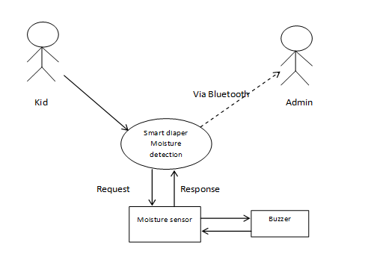 Figure 1: Architectural Design

**4.1 MODULAR DESIGN DIAGRAM**

The above modular diagram depicts that when the kid urinates or dirt the diaper the diaper moisture is detected, if the moisture detector detects that there is dirt or urine in the diaper the notification is sent to the admin or the parent. The signal is given as the alert sound is also available in the form of the buzzer. The admin can manage the notification either it can be ON so that all the notification are received by the admin or parent or OFF so that there is no notification is received.

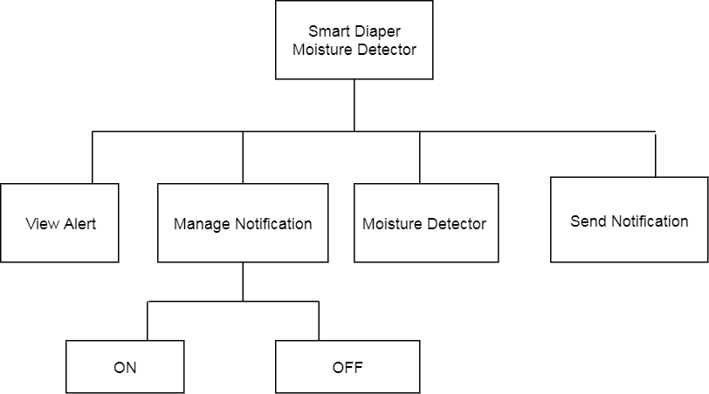

Figure 2: Modular design

**4.2 SEQUENCE DIAGRAM**

A sequence diagram simply depicts interaction between objects in a sequential order. A Sequence diagram is an interaction diagram that shows how processes operate with one another and in what order. It is a construct of a Message Sequence Chart. A sequence diagram shows object interactions arranged in time sequence. It depicts the objects and classed involved in the scenario and the sequence of messages exchanged between the objects needed to carry out the functionality of the scenario

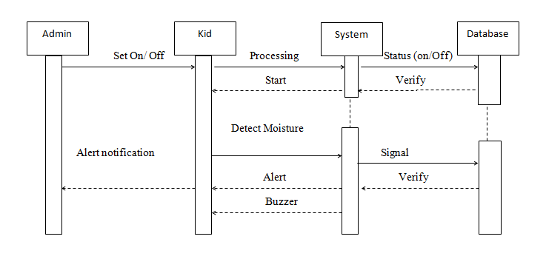

Figure: 3 Sequence Diagram

**4.3 USE-CASE DIAGRAM**

A use case diagram at its simplest is a representation of a user's interaction with the system and depicting the specifications of a use case. A use case diagram can portray the different types of users of a system and the various ways that they interact with the system.

In software and systems engineering, a use case is a list of steps, typically defining interactions between a role and a system, to achieve a goal. The actor can be a human or an external system

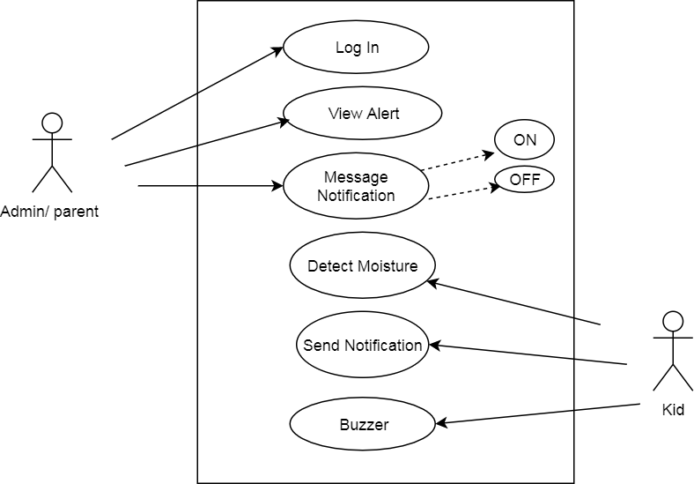

Figure 4:Use case Daigram

**V. CONCLUSION**

In the modern hygiene, health care and care for the babies environment. There is a need and a desire to have a diaper that somehow alerts a caretaker when it is dirty. There are a number of ways to detect and measure moisture where some examples can be seen, even though most methods require active electronics. Several ideas of putting extra functionality into a diaper have also been presented earlier. In a more automated, but also much more complex, self-emptying diaper system has been developed and in a system that also indicates abnormality in the urine with aid of reagent paper. Our solution is an inexpensive disposable Bluetooth connection device with integrated moisture sensor. Sensor unit can be either incorporated in to the diaper during the manufacturing process, or used as a strap-on addition to existing diaper solutions. When the diaper gets seriously wet, the moisture sensor becomes an energy source that feeds an oscillator circuit emitting a week radio signal. Novel moisture detection system for incorporating into diapers that transmits a Bluetooth connection device upon moisture detection is presented. It is optimized for low cost, easy handle.

The diaper is not only useful for babies but intended for hospitals and elderly care units too, where the small extra cost per the diaper may pay itself back in decreased working time, and also increase the quality of service for the patients. The diaper system is well suited for incorporating into existing intelligent health care systems. Thus through this we can conclude by saying that it is better to have such Upgraded diapers which are very helpful and such diapers will help the care takers to have a stress less life.

**VI. RESULTS**

It is optimized for low cost, easy handle and low EM radiation.The diaper system is well suited for incorporating into existing intelligent healthcare systems.Novel moisture detection system for incorporating into diapers that transmits a radio signal upon moisture detection is presented.The diaper is intended for hospitals and elderly care units, where the small extra cost per the diaper may pay itself back in decreased working time, and also increase the quality of service for the patients.

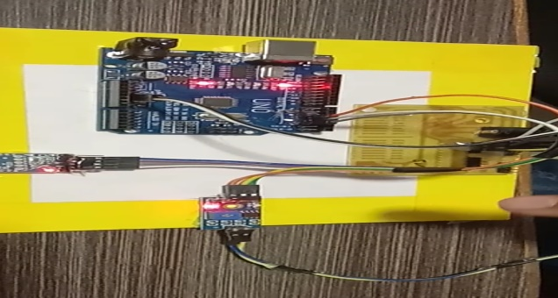

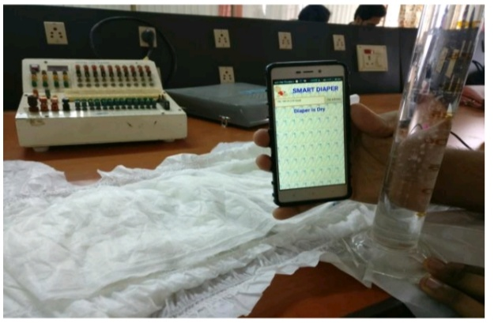

***REFERENCES:***

[1]. Johan Siden, Andrei Koppioug and Mikael Gulliksson “The diaper moisture detection system” Mid-SwedenUniversity,Electronics Department,2004.

[2] Aung Aung Phyo Wai, Foo Siang Fook and Jit Biswas “Towards Developing Effective Continence Management through Wetness Alert Diaper” Institute for Infocomm Research,Singapore,2010. [3] Mohamed Y.E Simik, Feng Chi, Randa S.I.Saleh “A Design of Smart Diaper Wet Detector using Wireless and Computer”,2015.

[4] MD Saifur Rhman,Chulhyung Choi,Youngpil Kim “A Low Cost Wet Diaper Detector Based on Smart Phone and BLE Sensor”, Kongju National University,2017.

[5] D.Pamela,K.Gerard,Kngston Stanley, “Wet Diaper Alert System For Bedside Patients with Wireless Communication to Nursing Station via Smart Diaper Mobile Application”,2018.

[6] S.Sanjal, Y.Atanasov,B.D.Braaten,”A Low

Cost Flexible Passive UHF RFID Tag for Sensing Moisture Based on Antenna Polarization, North