Coal Mine Safety Monitoring System using Wireless

Sensor Network

Rishma, Mahita Bangera, Abhishek A, Zaid Mohammed

Electronics and Communication, Mangalore Institute of Technology and Engineering  
Badaga, Mijar.Mangalore. Karnataka-574225.India

Abstract— **Coal is the most vital asset in the world. It is a non-sustainable source which can't be supplanted commonly by Humans. While in the process of extracting coal we encounter certain circumstances that are dictated by the ambient conditions underground which result in fatality of the miners underground. These conditions are difficult to monitor without placing someone’s life at risk. The conventional method for safety systems underground is a wired. With continuous enlargement of exploiting areas it becomes difficult to place expensive cables. Hence, this paper aims in designing a wireless safety monitoring system using STM32. The working of the system is divided into parts. The sensor Node and Receiving Node. The operating network is combination of Mesh and Star topology.**

Keywords— Coal mining, Mesh topology, Star topology, Wireless sensor network, monitoring system.

1. Introduction

Coal has always been the primary resource of energy in India, which has significantly contributed to the rapid industrial development of the country. About 70% of the power generation is dependent on it. In India, we have 493 coalmines present [1]. The importance of coal in energy sector is indispensable. An environment like coalmine always puts its habitants into life threating hazardous situation. Coal mines have accounted for the highest number of casualties due to accidents in mines [3]. With the continuous enlargement of exploiting areas and depth expansion, laneways have become blind zones, where numerous unseen dangers are hidden out. There are always chances of leaks of poisonous gases such as carbon monoxide or explosive natural gases, especially methane, collapsing of mine stopes, toxic gases arising from mine fires, mining-induced seismicity etc. If proper apparatus were to be used to monitor the health of the mines the flooding conditions, the acceptable loads acting on the load bearing structures such incidents could be avoided. If there was a system in place that would alert the miners about the water levels the quality of air inside the mines also the failure alerts of the structural members then such incidents could be avoided. Hence, we aim in designing a system which can be placed in mines so that there would be minimum chances of catastrophic accidents to occur.

1. Problem statement

Every year thousands of workers die in coal mining. The given graph (Fig 2.1) shows a trend of Deaths that occurred in 2002 to 2017 in India, USA and other Western countries. It is observed that Indian underground Coal mining has experienced more fatal accidents than other countries [2].



Fig 2.1 Fatal Accidents from 2002 to 2017 occurred in India, USA and other Western countries [2].

The Conventional safety system currently used are wired network system. As expansion underground increases, it became difficult to install these monitoring systems. Also installation of these systems are quite expensive. If a system with easy Installation and low cost could be developed it could replace the conventional method. Hence, we aim in designing a Wireless system.

1. METHODOLOGY

The system is divided into 2 major parts first part is sensor node or sensing device where all the sensors are placed, and various parameters are measured. Block diagram of this system is shown in Fig 3.1. This device is placed inside the coal mine. Many such devices will be placed in various blocks of coal mine. Second part is receiver or monitoring node which will be placed in base station or control room. It collects the information from various sensing devices in the mines. All the sensing devices and base station are connected to each other using a mesh network.

Sensor node consists of gas sensor to measure the poisonous gases like Carbon monoxide, Methane and other flammable gases, Temperature sensor to measure the temperature and humidity of the mining atmosphere, Barometric pressure sensor to measure the atmospheric pressure, IR flame sensor to detect fire. Humidity sensor is used to detect flood. Temperature, humidity and pressure sensors will have threshold value above which the alarm will be on. These sensors are connected to an ARM based microcontroller (STM32) which will analyze the levels of every parameter and if there is any imbalance in the measurement it will immediately on the alarm to alert the nearest working miners and these data are sent to the base station through a RF module.

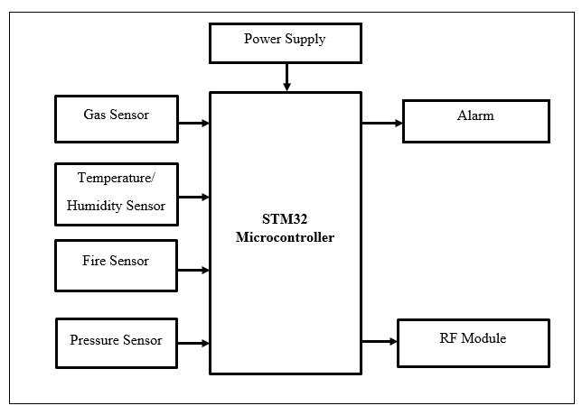

Fig 3.1 Block diagram of the sensor node.

The receiving node or monitoring node is in base station. If there are variations in the environmental parameters data signal is sent to the monitoring node for the analysis. Location of the occurrence of accidents can be determined since each sensor node will be in fixed place. At the monitoring node end, officers will take necessary actions if needed. Communication takes place through the RF transceiver which receives data from various nodes and sends it to computer in base station as shown in Fig 3.2. These data are then stored in cloud for the future reference and sent to other station to notify them about the security breach.

The mesh/star network block in the proposed system consists of a primary node at each block of the mine and few secondary nodes that is sensor nodes, which will be connected to primary node in the star topology. Each primary node will be connected to other primary nodes which are located at the other blocks. Since we are using both mesh and star topology, we can achieve reliable network and faster transmission of data.

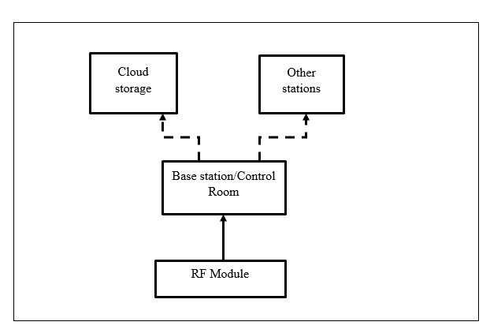Fig 3.2 Block diagram of Receiving

1. Components used
   1. *Microcontroller (STM32F103C8T6)*

The STM32F103C8T6 is a 48 pin IC which incorporates the high-performance ARMCortex-M3 32-bit RISC core operating at a 72 MHz frequency, high-speed embedded memories Flash memory of 64 Kbytes and SRAM of 20 Kbytes, Offer two 12-bit ADCs, three general purpose 16-bit timers plus one PWM timer. The devices operate from a 2.0 to 3.6 V power supply. A comprehensive set of power-saving mode allows the design of low-power applications.

* 1. *RF module (nRF24L01)*

The nRF24L01+ transceiver module is designed to operate in 2.4 GHz worldwide ISM frequency band and uses [GFSK modulation](https://en.wikipedia.org/wiki/Frequency-shift_keying#Gaussian_frequency-shift_keying) for data transmission. It can have up to 125 different channels. The data transfer rate can be one of 250kbps, 1Mbps and 2Mbps. The operating voltage of the module is from 1.9 to 3.6V. it consumes 26 µA in standby mode and 900 nA at power down mode. It comes with a special [RFX2401C chip](http://www.skyworksinc.com/Product/3213/RFX2401C) which integrates the PA, LNA, and transmit-receive switching circuitry. This range extender chip along with a duck-antenna helps the module achieve a significantly larger transmission range about 1000m. The PA stands for Power Amplifier. It merely boosts the power of the signal being transmitted from the nRF24L01+ chip. Whereas, LNA stands for Low-Noise Amplifier. The function of the LNA is to take the extremely weak and uncertain signal from the antenna and amplify it to a more useful level.

* 1. *Sensors*

*Gas Sensor:* The MQ-2 Gas sensor can detect or measure gasses like LPG, Alcohol, Propane, Hydrogen, CO and even methane. The module version of this sensor has 4 pins. It has a Digital Pin which makes this sensor to operate even without a microcontroller and that comes in handy when you are only trying to detect one gas. When it comes to measuring the gas in ppm the analog pin must be used. In this project we need to detect carbon monoxide and methane.

*Temperature sensor:* The DHT11 is a commonly used Temperature and humidity sensor. The sensor comes with a dedicated NTC to measure temperature and an 8-bit microcontroller to output the values of temperature and humidity as serial data. The sensor can measure temperature from 0°C to 50°C and humidity from 20% to 90% with an accuracy of ±1°C and ±1%.

*Fire sensor:* A flame sensor module that consists of a flame sensor (IR receiver), resistor, capacitor, potentiometer, and comparator LM393 in an integrated circuit. It can detect infrared light with a wavelength ranging from 700nm to 1000nm.The far-infrared flame probe converts the light detected in the form of infrared light into current changes. Sensitivity is adjusted through the onboard variable resistor with a detection angle of 60 degrees.

*Pressure Sensor:* Barometric Pressure sensor is designed to measure Barometric Pressure **or** Atmospheric pressure. BMP180 is a high precision sensor designed for consumer applications. It consumes less power i.e. 3uA and has an accuracy of ±0.12hPa. Barometric Pressure is nothing, but weight of air applied on everything. The air has weight and wherever there is air its pressure is felt.

* 1. *Software Implementation*

Programming of the microcontroller is done using Arduino IDE and STlink programmer. The Arduino Integrated Development Environment (IDE) is a cross-platform application (for Windows, macOS, Linux) that is written in functions from C and C++. It is used to write and upload programs to Arduino compatible boards. User-written code only requires two basic functions, for starting the sketch and the main program loop, that are compiled and linked with a program stub main() into an executable cyclic executive program with the GNU toolchain, also included with the IDE distribution. The ST-LINK/V2 is an in-circuit debugger/programmer for the STM8 and STM32 microcontrollers. The single wire interface module (SWIM) and the JTAG/serial wire debugging (SWD) interfaces facilitate the communication with any STM8 or STM32 microcontroller operating on an application board.

1. Conclusions

A real-time monitoring system may assist in monitoring and control over the mining environment. Thus, the primary objective of this project is to design an efficient real-time monitoring system so that various accidents such as leaked gases, fire, pressure, water , pressure difference underground, temperature variance etc. could be identified at times and preventive measures could be devised accordingly Acknowledgment

References

1. Pranay Mangulkar, Urmila Shrawankar,”*Monitoring and safety system for underground coalmines”* IEEE International Conference on Power Energy, Environment & Intelligent Control (PEEIC),2018
2. Valdo Henriques, Reza Malekian, *”Mine Safety System Using Wireless Sensor Network*”, Research Development Program, University of Pretoria under Grant AOX220, 2016
3. A. Di Nisio, T Di Noia, M.Spadavecchia *,”Design of low cost multipurpose sensor networks*” ,IEEE instrumentation and measurements society, 2015.
4. Mr. Kumarsagar M. Dange, Prof. R. T. Patil*,”Design of Monitoring System for Coal Mine Safety Based on MSP430”*, International Journal of Engineering Science Invention (ISSN), Volume 2 Issue 7, pp.14-19 ,2013