[1]

Bus Tracking System Using GPS & Android Application

Shwetha1, Sowmya2, Tejas Upadhya K C3, Vikhyath N V4, Ranjith Bhat5

*12345Shri Madhwa Vadiraja Institute of Technology and Management, Bantakal, Udupi, India*

*Abstract*— Bus tracking system is the technology to find the exact location of the buses using an android application. Data of the location is stored in the cloud and is retrieved from the cloud to the app. The system consists of hardware and software components. The tracking system mainly consists of three parts namely mobile vehicle unit, fixed base station and, database and software. Vehicle unit is hardware component consists of GPS (Global Positioning System)/GSM (Global System for Mobile Communication) modules. The function of this unit is to receive the signals from GPS module and using a controller or processor convents the data and sends the location data to the server. Fixed base station consists of a wireless network to receive the data and sends the data to the user. It mainly concentrates on the tracking software and geographic maps helps to find the vehicle location. Maps of every city are available in the system that has an in-built server. Database and software unit deals with the position information stored in database. It can be seen in display screen using maps. The bus location is transmitted to the server and will be retrieve in the app. So app will become handy and simple to track the location of the bus.

*Index Terms*— Database, Fixed base station, GPS

/GSM, Server, Software.

# INTRODUCTION

I

n this fast life, everyone is in hurry to reach their destinations. In this case waiting for the buses is not reliable. People who rely on the public transport their major concern is to know the real time location of the bus for which they are waiting for and the time it will take to reach their bus stop. This information helps people in making better travelling decisions [1]. Bus Tracking System is the technology used to determine the location of a vehicle using simple app and it can be viewed on a digital mapping with the help of a software via Internet. Even data can be stored and downloaded to a computer from the GPS unit at a base station and that can later be used for analysis. This system is an important tool for tracking each vehicle at a given period of time.

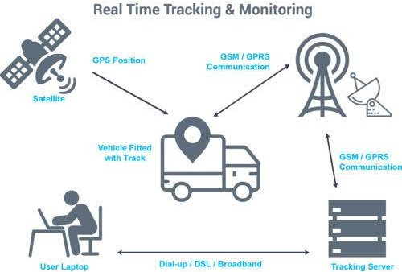

Fig. 1. The complete Tracking System

Now it is becoming increasingly popular for people having app for daily chores. The system consists of modern hardware and software components enabling one to track their vehicle online or offline. Any vehicle tracking system consists of mainly three parts mobile vehicle unit, fixed base station and, database and software system. The complete tracking system requirements are shown in Fig. 1.

1)Vehicle Unit: It is the hardware component attached to the vehicle having either a GPS/GSM modem. The unit is configured around a primary modem that functions with the tracking software by receiving signals from GPS satellites or radio station points with the help of antenna. The controller modem converts the data and sends the vehicle location data to the server [2].

2) Fixed Base Station: Consists of a wireless network to receive and forward the data to the data center. Base stations are equipped with tracking software and geographic map useful for determining the vehicle location. Maps of every city and landmarks are available in the based station that has an in- built Web Server.

3) Database and Software: The position information or the coordinates of each visiting points are stored in a database, which later can be viewed in a display screen using digital maps. In each point the location of the bus will be transmitted to server/database and then the data from the database will be retrieved to app. Hence the app will become handy and simple to track location of the bus according to the user’s requirement. First user has to login or sign in to the app and he/she has to enter the direction of the journey, by considering the direction the app will shows the nearer bus according to user’s location. Then that nearer bus location will be transmitted to the app so that user can adjust his/her timings according to their requirement.

# Proposed Methodology

In this project BUS tracking technology for tracking buses. Whole concepts as shown in Fig.2. are divided in three levels. First, the GPS module is installed to the bus and getting the location of the bus in terms of latitude and longitude. We create a data base for storing that location values (latitude & longitude). In next step we are creating the software application for the user. In that he/ she has to enter the destination and starting point according to that stops app will read the nearest bus location from the database which having the location of the buses. Through the App user can easily track his/her nearest bus and in that app several bus timings are also mentioned.

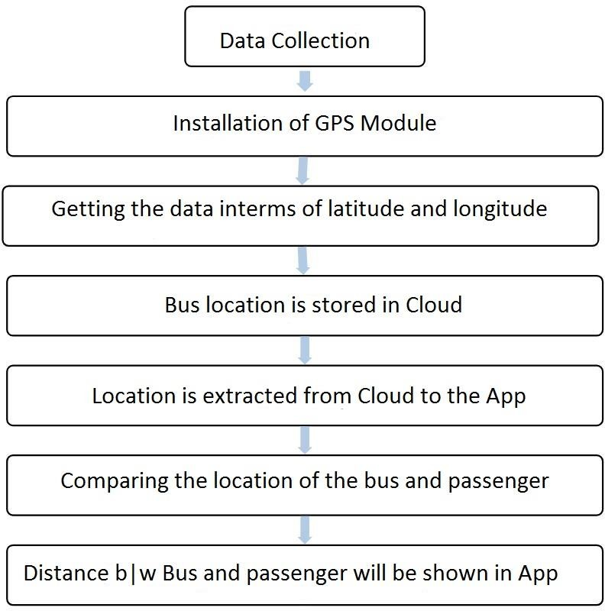

Fig. 2. Bus Tracking System Module

Data collection: In this process the information of the buses available and route map of particular area.

Installation of GPS module: For available buses GPS module is installed through microprocessor. It will continuously determine the location of the buses in terms of latitude and longitude [3].

Creation of database: The database is created using My SQL. It will store the data from the GPS to the cloud or database, it can be retrieved whenever user wants to find the Bus location.

Creation of Android Application: The application is created using Android Studio software. In this app user must sign up or login, in that user should enter their location and destination location. App will extract the data from the database compare it with the user’s location.

Displaying Nearest Bus and rout map: After comparing the locations, app will display nearest bus to the use’s location and the entire route map is also showed in the display of application.

Fig. 3. Android App pages

System has two main units as shown in Fig 4.

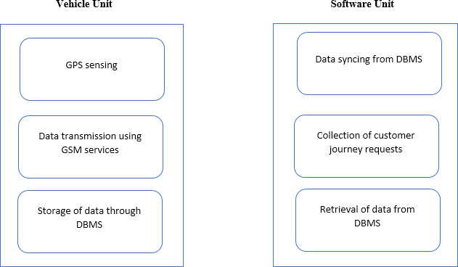

Fig. 4. Units in Bus Tracking System

## Vehicle Unit -

• Every vehicle associated with this idea will be having a Global Positioning System which helps in determining the 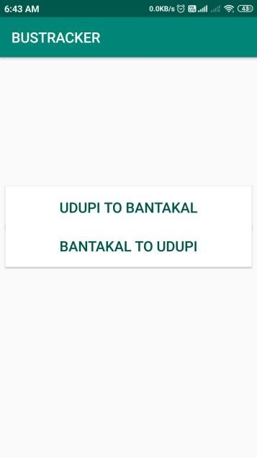exact position of the vehicle. Using NEO-6M GPS module the data is extracted in terms of latitude and longitude.

• The vehicle data is then uploaded to the cloud platform by making use of GSM and a microcontroller.

• The received data is then analyzed and monitored by making use of MY-SQL and DBMS services

## User/Software Unit -

• The user initially has to provide certain details before accessing the application. The details include Name, Frequent route, and login credentials and so on.

• After entering the login credentials, the user can search for the bus route he/she is intending to use in the near future.

• This particular route number is searched in the data- base and the corresponding details is displayed to the user.

# Results

An android application developed mainly needs a login and register option from the user as shown in Fig. 5.

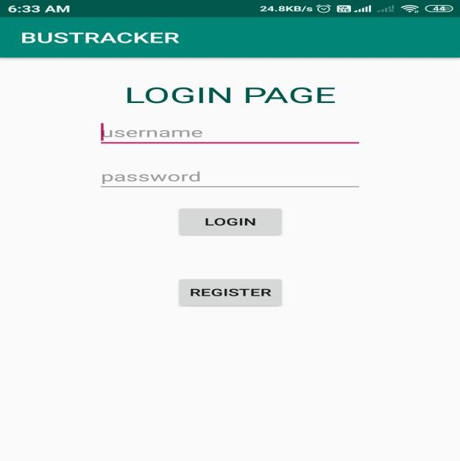

Fig. 5. Login page

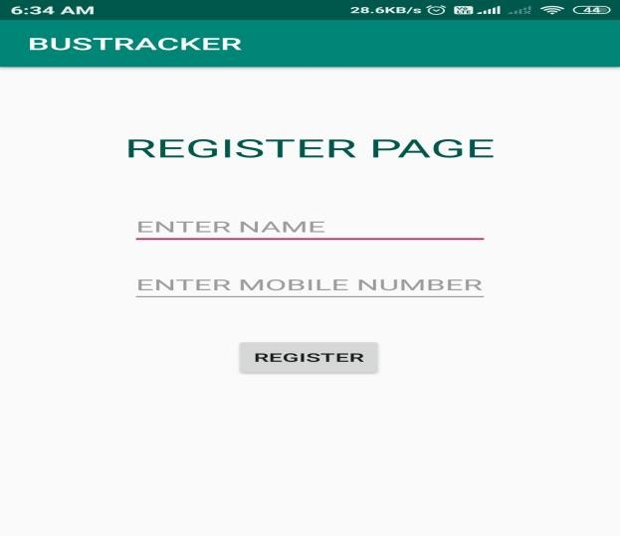 If the user is new to the system then he has to register with his name and the phone number. Then the user should login with his name and a phone number shown in Fig. 6. If the username and password are matched then bus tracking page will open else shows an error. Fig. 7. shows the bus tracker page which needs an input from the user to select the required travel path.

Fig. 6. Registration page

Fig. 7. Route selection page

Once the user selects the travel path next page will show the scheduled departure time of all the buses in that route as shown in Fig. 8.

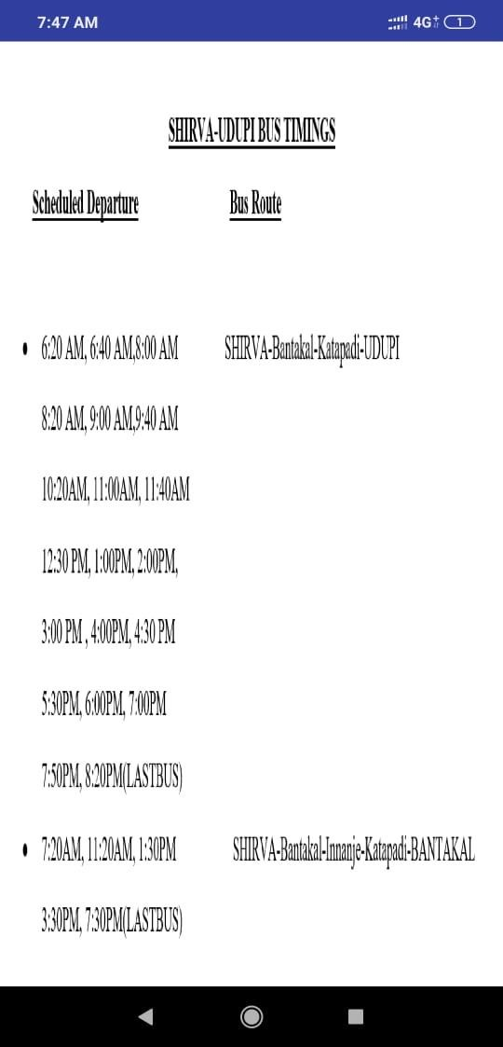

Fig. 8. Departure schedule page

The server is provided with data received from GPS at regular intervals. Now the server analyses the data received. And gives the location values in terms of longitude and latitude as in Fig. 9.

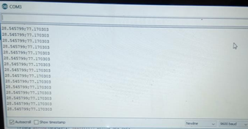

Fig. 9. Bus location values

The next page consists of two options called UDUPI to BANTAKAL and BANTAKAL to UDUPI which are the pickup and dropping points of bus. When the user press the buttons the Google map will be opened and it gives the current location of the bus as in Fig. 10. The bus device has the timestamp co-ordinates that are compared to the previous co-ordinates and if there is some discrepancy then the co-ordinates are modified and sent to the server via GPRS network (internet).

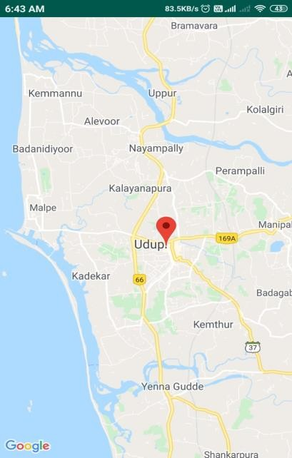

Fig. 10. Google map page

# Conclusion

Technology can be a huge benefit for the society if we try to include it in our day to day life. This paper presents an idea to ease the process of finding a bus to reach our destination. This approach encourages the use of public transport which is beneficial for the society. By extracting the location of the bus, it is very easy to find the exact location of the bus. And user can predict at what time the bus may arrive to his/her bus stop using the app. With this, users can easy schedule their plan or trip according to the bus location and bus timings.

References

1. Ajay Shingare, Ankiita Pendole, Nikita Chaudhari and Parikshit Deshpande, “GPS Supported City Busn Tracking & Smart Ticketing System,” in *Proc. ICGCIoT,* Noida, India, *2015*,   
   978-1-4673-791-2015.
2. Afshan Mulla, jaypal Baiskar, Amol Baviskar and aniket Bhovad, “GPS Assisted Standard Positioning Service for Navigation and Tracking:Review & Implementation,” in *Proc. ICGCIoT,* Noida, India, *2015*,   
   978-1-4799-6272-2015.
3. Hazza Alshamisi,Veton Kepuska, “Real-Time GPS Vehicle tracking system” in *Proc. IJARECE, 2017*.
4. Jessica Saini,Mayank Agarwal , Akriti gupta , Dr Manjula R “Android app based vehicle tracking using GPS and GSM” International Journal of scientific & Technology research volume 6, Issue 09, September 2017 ISSN 2277-8616.
5. Akshatha S.A “GPS Based vehicle tracking and monitoring system”,International Research Journal of Engineering and Technology (IRJET) Volume: 04 Issue: 04 | Apr-2017 p-ISSN: 2395-0072.
6. Amol dhumal, Amol naikoji “Vehicle tracking system using GPS and Android”International Journal of Advanced Research in Computer Engineering & Technology (IJARCET) Volume 3 Issue 11, November 2014 ISSN: 2278 – 1323.

 **Shwetha** Student, Dept. of Electronics and Communication, Shri Madhwa Vadiraja Institute of Technology and Management, Bantakal. Udupi. India.

 **Sowmya** Student, Dept. of Electronics and Communication, Shri Madhwa Vadiraja Institute of Technology and Management, Bantakal. Udupi. India.

 **Tejas Upadhya** Student, Dept. of Electronics and Communication, Shri Madhwa Vadiraja Institute of Technology and Management, Bantakal. Udupi. India.

 **Vikhyath N V** Student, Dept. of Electronics and Communication, Shri Madhwa Vadiraja Institute of Technology and Management, Bantakal. Udupi. India.

**Ranjith Bhat** Sr. Asst. Professor, Dept. of Electronics and Communication, Shri Madhwa Vadiraja Institute of Technology and Management, Bantakal. Udupi. India. M.Tech in Digital Electronics and Communication from NMAMIT, Nitte.

He has 6 years of teaching and 2 years of industrial experience.

1. Shwetha, is now with the Dept of Electronics and Communication at Shri Madhwa Vadiraja Institute of Techmology, Bantakal, Udupi, India (e-mail: shwetha.16ec059@sode-edu.in).

   Sowmya, is now with the Dept of Electronics and Communication at Shri Madhwa Vadiraja Institute of Techmology, Bantakal, Udupi, India (e-mail: sowmya.16ec062@sode-edu.in).

   Tejas Upadhya K C, is now with the Dept of Electronics and Communication at Shri Madhwa Vadiraja Institute of Techmology, Bantakal, Udupi, India (e-mail: tejas.16ec073@sode-edu.in).

   Vikhyath N V, is now with the Dept of Electronics and Communication at Shri Madhwa Vadiraja Institute of Techmology, Bantakal, Udupi, India (e-mail:vikhyath.16ec081@sode-edu.in).

   Ranjith Bhat, is now with the Dept of Electronics and Communication at Shri Madhwa Vadiraja Institute of Techmology, Bantakal, Udupi, India (e-mail: ranjithbhat@gmail.com).

   .