Bio-Based Lignin Carbon Nanofibers as high performance anode material for Li-ion battery

[1]

*Abstract*— Increased implementation of lithium ion batteries for all the electronic purposes has created a demand to develop more cost efficient and increasingly efficient sustainable materials for energy storage devices, such as Li-ion batteries. In this following, the preparation of carbon nanofibers (CNF) from biopolymer blends of lignin, with polylactic acid (PLA) is described. The microstructural surface morphology of these carbon nanofibers where analyzed using a field emission scanning electron microscope after each processing step (electrospinning, stabilization and carbonization). The porosity of the nanofiber is determined using miscibility/immiscibility rule between lignin and the additive polymer (PLA). PLA blend generates porous structure when carbonized. Electrodes produced from 30% PLA blend have specific capacitance of 572 mAhg-1 after 50 charge/discharge cycle; high for sustainable electrodes for Li-ion batteries. This work will promote the development of lignocellulose waste material as high performance energy storage materials

*Index Terms*—Biopolymer, Carbon Nanofibers, Carbonization, Capacitance, Electrode, Lithium-ion battery, Scanning electron microscopy.

# INTRODUCTION

Prathviraj Upadhyaya[a], Mario Culebras[b], Maurice N. Collins[b]

*aSEAM research Centre, Department of Engineering, Waterford institute of technology(Ireland), bStokes laboratory, Bernal Institute, School of Engineering, University of Limerick, Limerick,(Ireland)*

Energy storage devices are underpinning the rapid development of modern society [1]. There is a need for high capacity high power energy storage device such as batteries and supercapacitors in many areas of modern technological society which includes portable electronic devices such as smartphones, laptops, tablets and biomedical sensing equipment’s to meet their increased energy demands, Coupled to this, the increasing demand for electric vehicles, has dictated the necessity to investigate new materials for energy storage devices [2-5]. Li-ion batteries are the most efficient energy storage devices and are widely used in most of the application [6-8], carbon materials such as graphite is used in commercial Li-ion battery anodes due to their availability, processability and long-term cyclic stability [1]. However, graphite has a very low energy density, with its theoretical capacity of just 372mAhg-1. Many studies have been focused on finding new carbon materials to be used as anodes in Li-ion batteries [3, 11]. Several other carbon nanostructures including graphene, carbon nanotubes and mesoporous carbon have been studied as alternative to graphite [12-18], which however, due to high cost and production difficulty compared to traditional graphite, has not evolved as efficient alternative. Carbon nanofibers, which can be produced by electrospinning can be incorporated into the commercial production of Li-ion battery due to their low cost, larger surface area and ease of production [9-10, 19-20, 24]. The vast majority of the carbon fibers is produced by using petroleum-based polymer called as Polyacrylonitrile (PAN) which has a serious limitations such as; high cost, slow carbonization, solvent usage during synthesis and serious environmental issues such as high co2 emission [22]. Lignin is the most promising and most favorable alternative to PAN as carbon fiber precursor. Lignin is most abundant aromatic biopolymer on the planet which is amorphous and is present in the cell walls of plants. The aromatic molecular structure of lignin generated by the condensation of the three different monolignols (coniferyl alcohol, sinapyl alcohol and p-coumaryl alcohol) renders it ideal for carbon fiber production [23].

The present study presents a fully sustainable carbon nanofibers with differing tailored microstructures using lignin blended with polylactic acid (PLA). The method allows for the formation of porous structures after carbonization. In order to promote lignin crosslinking and avoid its melting, methylene diphenyl diisocyanate(MDI) was used as crosslinking agent during stabilization. This paper propose a sustainable anode material for Li-ion battery, utilizing biobased materials, leading to better performance compared to current state of the art materials.

# Experimental Section

## Materials

The biopolymer component, Alcell organosolv hardwood (TcA) lignin was obtained from technaro GmbH, (Germany). The biobased PLA (Ingeo Biopolymer 3001D) injection moulding grade was supplied by Natureworks, Minnetonka, MN. Dimethylformamide (DMF), Tetrahydrofuran (THF) and Methylene diphenyl diisocyanate (MDI) were purchased from Sigma Aldrich (Germany).

## Solution preparation

PLA was weighed and dissolved in a mixture of DMF/THF (1:1 v/v) for 1 hour under magnetic stirrer at 50°C. Once PLA was completely dissolved, lignin was added to the solution and the mixture was homogenized for 30 minutes under magnetic stirrer at 50°C to dissolve completely, followed by addition of 7% MDI with respect to the lignin content and was stirred for 5 minutes prior to electrospinning process. The solution composition is as summarized in Table 1.

Table 1: Compositions of electrospinning solutions [1].

|  |  |  |  |  |  |  |
| --- | --- | --- | --- | --- | --- | --- |
| Sample lignin/PLA | TcA (g) | PLA (g) | MDI (g) | DMF (ml) | THF (ml) | Solid content (%) |
| 80:20 | 2.976 | 0.8 | 0.223 | 8.44 | 8.99 | 20 |
| 70:30 | 2.604 | 1.2 | 0.196 | 8.44 | 8.99 | 20 |
| 50:50 | 1.86 | 2 | 0.14 | 8.44 | 8.99 | 20 |

## Preparation of CNF’s

A custom built electrospinner composed of a syringe driver hardvard PHD 2000 and a power source SIMCO Eurocharge Master were used for producing nanofibers, all the samples were produced at an infusion rate of 30 µl/min and the distance between needle and the collector foil was set to 10 cm and the electrospinning was performed at 7.7 kv with, collector foil grounded and needle connected to power supply. Electrospunn lignin/PLA nanofibers were collected over copper electrode connected to the aluminum foil. After one hour of electrospinning the copper electrodes were removed for the subsequent steps. The dried nanofibers were isothermally stabilized in oven under atmospheric environment. The temperature was ramped from 25 to 150 °C at 1 °C min−1 and kept at 150 °C for 14 h. Then the temperature was raised from 150 °C to 200°C at 1 °C min−1 and kept at 200°C for 1 h and then the temperature was ramped again from 200°C to 250°C at 1 °C min−1 and kept at 250°C for 1 h and then the sample was naturally cooled down to room temperature.

The stabilized Lignin/PLA and Lignin/TPU Nano fibres were being carbonized using the tubular furnace. The fibres were then heated from 200 to 900 °C at 10 °Cmin−1 under a flow of nitrogen or in inert atmosphere and the samples where carbonized at 900 °C for 30 minutes. The scanning electron microscopy (SEM) and energy dispersive x-ray spectroscopy (EDS) were performed to determine the nanofiber morphology and elemental analysis utilizing hitachi table top TM 1000 system coupled to an oxford instruments x-max EDS system at an accelerating voltage of 5Kv and working distance of 14 mm after each processing step.

For the electrochemical characterization, the samples were tested within two electrode Swagelok type cells as the working electrode versus a Li metal counter/reference electrode. All potentials are quoted relative to Li/Li+. Celgard separators impregnated with a carbonate based electrolyte (1.0 M lithium hexafluorophosphate (LiPF6) solution in ethylene carbonate and diethyl carbonate, battery grade Aldrich) with 3% weight vinylene carbonate (97 % Aldrich) were used. Half-cells were tested galvanostatically between 3- 0.011 V (vs Li/Li+) at C/2 rate (1C= 372 mA/g-1). Testing was conducted using a Biologic MPG-2. The cells were assembled and tested within an Ar filled glovebox with O2 and H2O levels below 0.1 ppm. The potential carbon yield of the materials was determined using a SETARAM TG-DTA 1600 (Setaram Instrumentation, France), using alumina crucibles. The samples were heated in nitrogen to 900°C at a heating rate of 10°C/min. Surface area, pores radius and volume values were obtained from nitrogen Adsorption desorption isotherms by the theory of Brunaeur-Emmett-Teller (BET).

# Results and discussion

Pure lignin solutions tend to have very low viscosity due to low molecular weight of lignin and are not suitable for electrospinning on itself [25], hence lignin blends were developed. In lignin/PLA blend mixture of solvent, DMF: THF (1:1 w/w), is required since phase separation occurs when only one solvent is utilized [1]. Figure 1, shows the evolution of the morphology after each step of the electrode production process i.e., electrospinning, stabilization and carbonization. Lignin/ PLA nanofibers exhibit diameter between 300nm to 700nm and the diameter decreases with the increase in the lignin content as the viscosity of the blend increase, the diameter of the fiber after carbonization is reduced to 150nm to 300nm (Figure 2).

The beading degree increases with lignin content with 50% and 30% PLA being the optimum composition to minimize beading along nanofibers.

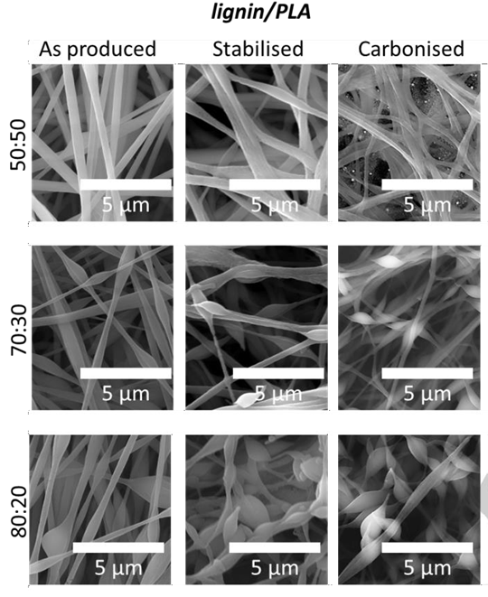

Fig. 1. SEM images of lignin based nanofibers after each processing step as a function of their composition [1].

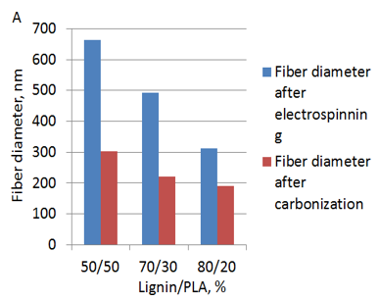

Fig. 2. Lignin/PLA fibre diameter after electrospinning and after carbonization.

Lignin/PLA- 50:50 and lignin/PLA 70:30 remain intact as result of efficient crosslinking reactions. The stabilization of the lignin nanofibers is known to be technically challenging due to the melting of lignin; hence considerable number of previous studies have used extremely low heating ramp rate. In this work nanofibers were stabilized combining several isothermal steps to prevent melting, the addition of MDI as crosslinker was crucial in order to maintain the shape of nanofibers. Crosslinking occurs between lignin hydroxyl groups and MDI isocyanate groups, generating urethane groups linking lignin molecules together and transitioning from thermoplastic to thermoset during stabilization.

After carbonization the morphology of the nanofibers remain unchanged keeping the shape obtained after the stabilization step. Lignin/PLA-50:50 and Lignin/PLA-70:30 displays the best shape and morphology retention as in figure 1, producing well defined nanofibers around the whole surface of electrode.

During the thermal treatments, phase separation occurs resulting in lignin serving as the carbon precursor, while PLA as the pore generator. Consequently, two different structures are obtained after carbonization resulting in PLA generating porous structure after carbonization as shown in figure 3. The fact that PLA depolymerizes and volatilizes completely above 370ºC, means that it becomes a sacrificial polymer during the carbonization process, generating pores along the carbon nanofibers.

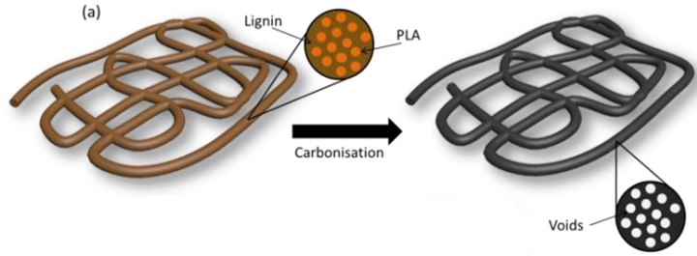

Figure. 3. Schematic of phase separation of lignin/PLA fibers, pore generation [1].

Electrochemical testing of electrodes composed of electrospun lignin/PLA carbon nanofibers and galvanostatic charge–discharge experiments were carried out at a rate of C/2 and within a voltage window of 1–3 V to evaluate the electrochemical performance of the porous carbon nanofiber anode. Lignin/PLA nanofibers with 30% PLA exhibited notably high specific capacity values as shown in figure 4. It was found that PLA electrodes exhibited extremely stable and long-term cyclic performance. After 50 charge/discharge cycles, the specific capacitance of the electrodes was 572 mAhg-1(Figure 4), which is a strong improvement over performance of conventional graphite electrode material and other alternatives being studied as shown in Table 2. The enhanced specific capacity of the PLA composed nanofibers is primarily attributed to increased porosity leading to additional sites for Li storage.

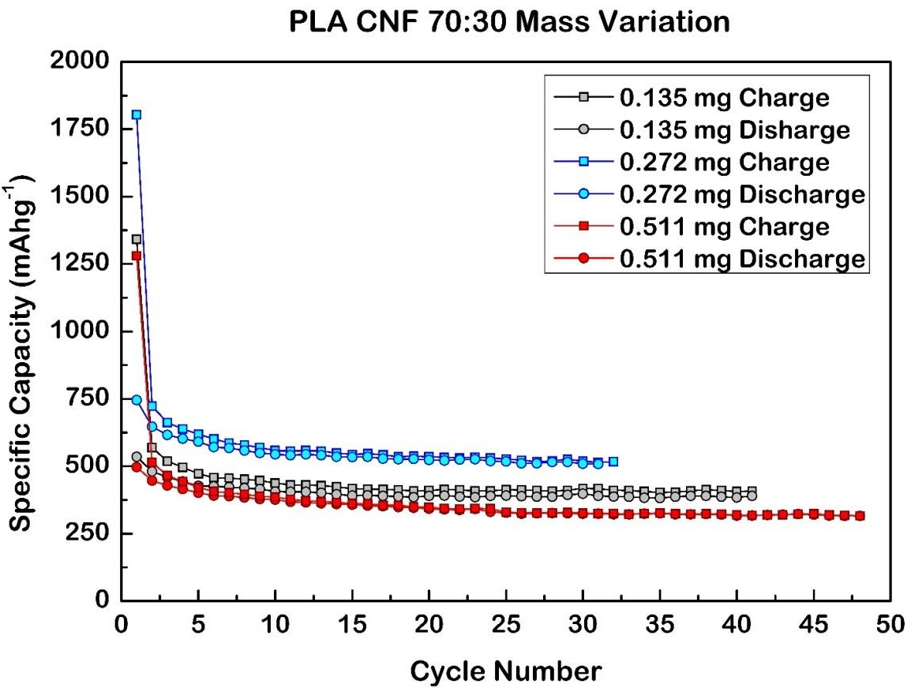

Figure. 4. Gravimetric capacity values for extended cycling testing at c/2 rate for PLA based electrodes of different masses [1].

Table. 2. Table comparing the performance of carbon nanofibers in this study to existing literature [1].

|  |  |  |  |  |
| --- | --- | --- | --- | --- |
| Ref | Preparation Method | Potential window  (v) | Cycle number(n) | Capacity at nth cycle (mAhg-1) |
| This Report | Epectrospun Lignin/PLA | 0.001-3 | 50 | 572 |
| [1] | Electrospun Lignin/TPU | 0.001-3 | 50 | 280 |
| [25] | Electrospun PAN/PLLA | 0.01-2.80 | 50 | 435 |
| [26] | Electrospun from PAN | 0-2.8 | 1 | 450 |
| [10] | Electrospun PAN | 0.01-3.0 | 50 | 400 |
| [9] | Electrospun Polypyrole (PPy) and PAN | 0.01-2.80 | 50 | 454 |

# Conclusion

Porous carbon nanofibers of lignin with PLA were successfully prepared by subsequently stabilizing and carbonizing electrospun lignin/PLA nanofibers. The addition of MDI promotes crosslinking between the OH groups of lignin generating urethane groups, which allow nanofiber shape retention after carbonization. The compatibility between lignin, PLA play an important role in the final carbonized CNF morphology. Samples based on PLA precursor produce a well-defined porosity with lignin serving as the carbon precursor, while PLA serving as pore generator. The resultant porous carbon nanofibers have capacity values well beyond state of art graphite material capacitance attributed to increased porosity levels, leading to additional sites for Li storage and can be directly used as anodes for lithium ion batteries. These results provide evidence for the potential of lignin to be used in next generation Li-ion battery critically in terms of better performance than conventional graphite material or any other petroleum-based alternatives.

References

1. CULEBRAS, M., GEANEY, H., BEAUCAMP, A., UPADHYAYA, P., DALTON, E., RYAN, K. M. & COLLINS, M. N. 2019. Bio-derived Carbon Nanofibres from Lignin as High-Performance Li-Ion Anode Materials. *ChemSusChem,* 12**,** 4516-4521.
2. FU, J., LIANG, R., LIU, G., YU, A., BAI, Z., YANG, L. & CHEN, Z. 2019. Recent Progress in Electrically Rechargeable Zinc-Air Batteries. Adv Mater, 31, e1805230.
3. WU, C., TONG, X., AI, Y., LIU, D. S., YU, P., WU, J. & WANG, Z. M. 2018. A Review: Enhanced Anodes of Li/Na-Ion Batteries Based on Yolk-Shell Structured Nanomaterials. Nanomicro Lett, 10, 40.
4. BRUCE DUNN, H. K., JEAN-MARIE TARASCON 2011. Electrical Energy Storage for the Grid: A Battery of Choices. *Science,* 334**,** 928-935.
5. LIN, D., LIU, Y. & CUI, Y. 2017. Reviving the lithium metal anode for high-energy batteries. *Nat Nanotechnol,* 12**,** 194-206.
6. RUIZ, V., PFRANG, A., KRISTON, A., OMAR, N., VAN DEN BOSSCHE, P. & BOON-BRETT, L. 2018. A review of international abuse testing standards and regulations for lithium ion batteries in electric and hybrid electric vehicles. *Renewable and Sustainable Energy Reviews,* 81**,** 1427-1452.
7. NYKVIST, B. & NILSSON, M. 2015. Rapidly falling costs of battery packs for electric vehicles. *Nature Climate Change,* 5**,** 329-332.
8. CHOI, J. W. & AURBACH, D. 2016. Promise and reality of post-lithium-ion batteries with high energy densities. Nature Reviews Materials, 1.
9. JI, L., YAO, Y., TOPRAKCI, O., LIN, Z., LIANG, Y., SHI, Q., MEDFORD, A. J., MILLNS, C. R. & ZHANG, X. 2010. Fabrication of carbon nanofiber-driven electrodes from electrospun polyacrylonitrile/polypyrrole bicomponents for high-performance rechargeable lithium-ion batteries. *Journal of Power Sources,* 195**,** 2050-2056.
10. NAN, D., HUANG, Z.-H., LV, R., YANG, L., WANG, J.-G., SHEN, W., LIN, Y., YU, X., YE, L., SUN, H. & KANG, F. 2014. Nitrogen-enriched electrospun porous carbon nanofiber networks as high-performance free-standing electrode materials. J. Mater. Chem. A, 2, 19678-19684.
11. LU, Y., YU, L. & LOU, X. W. 2018. Nanostructured Conversion-type Anode Materials for Advanced Lithium-Ion Batteries. Chem, 4, 972-996.
12. GANG HUANG, F. Z., XINCHUAN DU, YULING QIN, DONGMING YIN, LIMINWANG 2015. Metal Organic Frameworks Route to in Situ Insertion of Multiwalled Carbon Nanotubes inCo3O4 Polyhedra asAnode Materials for Lithium-Ion Batteries. ASC Nano, 9, 1592-1599.
13. CHEW, S. Y., NG, S. H., WANG, J., NOVÁK, P., KRUMEICH, F., CHOU, S. L., CHEN, J. & LIU, H. K. 2009. Flexible free-standing carbon nanotube films for model lithium-ion batteries. Carbon, 47, 2976-2983.
14. XU, Z., ZENG, Y., WANG, L., LI, N., CHEN, C., LI, C., LI, J., LV, H., KUANG, L. & TIAN, X. 2017. Nanoconfined phosphorus film coating on interconnected carbon nanotubes as ultrastable anodes for lithium ion batteries. *Journal of Power Sources,* 356**,** 18-26.
15. XU, Y., LIN, Z., ZHONG, X., PAPANDREA, B., HUANG, Y. & DUAN, X. 2015. Solvated graphene frameworks as high-performance anodes for lithium-ion batteries. *Angew Chem Int Ed Engl,* 54**,** 5345-50.
16. SUN, J., LEE, H. W., PASTA, M., YUAN, H., ZHENG, G., SUN, Y., LI, Y. & CUI, Y. 2015. A phosphorene-graphene hybrid material as a high-capacity anode for sodium-ion batteries. *Nat Nanotechnol,* 10**,** 980-5.
17. GUO, B., WANG, X., FULVIO, P. F., CHI, M., MAHURIN, S. M., SUN, X. G. & DAI, S. 2011. Soft-templated mesoporous carbon-carbon nanotube composites for high performance lithium-ion batteries. *Adv Mater,* 23**,** 4661-6.
18. CHUANPENG XU, D. N., NAN ZHENG, HAINING YU, JIANPING HE, YONGSHENG LI 2018. Facile synthesis of nitrogen-doped double-shelled hollow mesoporous carbon nanospheres as high-performance anode materials for lithium ion batteries. *ACS Sustainable Chemistry & Engineering,* 6**,** 5999-6007.
19. THINES, R. K., MUBARAK, N. M., NIZAMUDDIN, S., SAHU, J. N., ABDULLAH, E. C. & GANESAN, P. 2017. Application potential of carbon nanomaterials in water and wastewater treatment: A review. *Journal of the Taiwan Institute of Chemical Engineers,* 72**,** 116-133.
20. ZHANG, B., YU, Y., XU, Z.-L., ABOUALI, S., AKBARI, M., HE, Y.-B., KANG, F. & KIM, J.-K. 2014. Correlation Between Atomic Structure and Electrochemical Performance of Anodes Made from Electrospun Carbon Nanofiber Films. Advanced Energy Materials, 4, 1301448.
21. No
22. DAS, S. 2011. Life cycle assessment of carbon fiber-reinforced polymer composites. *The International Journal of Life Cycle Assessment,* 16**,** 268-282.
23. CULEBRAS, M., SANCHIS, M. J., BEAUCAMP, A., CARSÍ, M., KANDOLA, B. K., HORROCKS, A. R., PANZETTI, G., BIRKINSHAW, C. & COLLINS, M. N. 2018. Understanding the thermal and dielectric response of organosolv and modified kraft lignin as a carbon fibre precursor. *Green Chemistry,* 20**,** 4461-4472.
24. JI, L. & ZHANG, X. 2009. Fabrication of porous carbon nanofibers and their application as anode materials for rechargeable lithium-ion batteries. *Nanotechnology,* 20**,** 155705.
25. MARIO CULEBRASA, A. B., YAN WANGA, MANUEL M. CLAUSS, ERIK FRANK, MAURICE N. COLLINS 2018. Bio-based structurally compatible polymer blends based on lignin and thermoplastic elastomer polyurethane as carbon fiber precursors. *ASC Sustainable Chemistry and Engineering,* 6**,** 8816-8825.
26. KIM, C. YANG,K. S. KOJIMA, M. YOSHIDA, K. KIM, Y. J. KIM, Y. A. ENDO, M. 2006. Fabrication of Electrospinning-Derived Carbon Nanofiber Webs for the Anode Material of Lithium-Ion Secondary Batteries. *Advanced Functional Materials,* 16, 2393-2397.

Prathviraj Upadhyaya, received the B.E. degree in mechanical Engineering from Shri Madhwa vadiraja institute of Technology, Karnataka, India in 2016 and was awarded with MSc degree in advanced engineering materials from University of Limerick, Limerick, Ireland. His research during masters included fabrication of carbon nanofibers by electrospinning biopolymer blends and carbonizing the generated nanofibers to use as anode material for Li-ion batteries.

He is currently pursuing the Ph.D. degree in mechanical engineering at SEAM Research center, Waterford institute of technology, Waterford, Ireland. His research interest includes structure property relationship of additively manufactured magnesium alloys.

A PhD in chemistry graduated by the university of Valencia in 2017. Expertise in Polymer science, polymer chemistry, polymer processing, biopolymers, functional and structural composite materials and techniques for thermal, structural, mechanical, morphological and electrical characterization. Currently involved in developing carbon fibers from sustainable bio based polymers blends based on lignin. He has authored over 40 articles published in peer reviewed academic journals, some of them leader in the field, 4 patents, and more than 40 works presented at conferences, workshops and seminars.

Mario Culebras currently works at the Stokes Research Institute, University of Limerick.

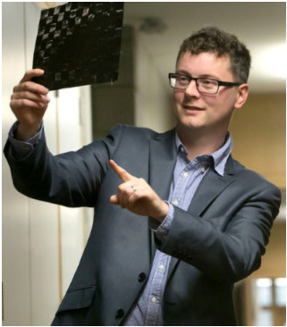Dr Maurice N.Collins received a PhD in Materials Science from the University of Limerick. He is a lecturer in the School of Engineering and is a member of the Bernal Institute and is the course director of the MSc in biomedical device materials. The principal focus of his research group is on the structure/property/processing relationships of polymers in the application areas of regenerative medicine, drug delivery, and pharmaceutical materials. Dr Collins has a strong track record in attracting funding to enable his research. He is the lead PI and coordinator of the H2020 LIBRE consortium, which focuses on next generation biomaterials. Other current areas of interest include the development of bioinks for 3D bioprinting and the development of immunomodulatory materials. Maurice is on the editorial board of Carbohydrate Polymers and is the editor of International Journal of Biological Macromolecules. He has authoured over 70 journal articles, several book chapters and over 70 conference articles. He has filed 6 patents. His works have gathered over 2.5K citations with a current h-index of 27

1. MC, AB and MNC acknowledge received funding from the BioBased Industries Joint Undertaking under the European Union’s Horizon 2020 research and innovation programme under grant agreement No 720707.

   The Journal article was submitted for review on 10 June, 2019 in Chemsuschem, and the article was accepted on 07 august, 2019 and first online version was published on 12 september 2019 under the title “Bio-derived carbon nanofibers from lignin as high performance Li-ion anode materials” with the doi: <https://doi.org/10.1002/cssc.201901562> and should be sited as ChemSusChem 10.1002/cssc.201901562.

   Prathviraj Upadhyaya, was with Stokes laboratory, University of Limerick, Limerick, Ireland. He is now with SEAM research center, Department of Engineering, Waterford Institute of Technology, Waterford, Ireland. (email: prathviraj.upadhyaya@postgrad.wit.ie)

   Mario Culebras, is with stokes laboratory, University of Limerick, Limerick, Ireland. (email: Mario.Culebrasrubio@ul.ie )

   Maurice N Collins, is with Stokes laboratory, University of Limerick, Limerick, Ireland. (email: Maurice.Collins@ul.ie)