[1]

Automated Medicine Dispenser

Sandesh A Mesta1, Vikas H V2, Prasthuthi3, Vanisha Sonal Lobo4, Chaitra U R5

*Department of Electronics and Communication, St Joseph Engineering College, Mangaluru*,

*Abstract*—**Medicine which is taken untimely can always show adverse effect on the health of the patients. The system developed is designed specially to help the patients to take the required medicine in the right proportional at the right time. The automated medicine dispenser is featured with availability of automated alert system which reminds patient to take tablet on time and in correct proportion. It also provides a direct link between the doctor and patient for emergency assistance. Also provides convenient reminding for proper refill of the medicine. A box is connected with Wi-Fi module which helps the patients to take tablet when they are far from the device.**

# INTRODUCTION

Nowadays, a promising trend in healthcare is to move routine medical checks and other health care services from hospital to the home environment. With that patients get health care more easily specially in case of emergencies. Moreover, hospitals can reduce their burden by shifting the possible and easy tasks to home environment. One major advantage is reduction in expenditure.

With the tremendous growth in medical technology, there is cure for many dreadful diseases through the intake of several new medicines. The number of medicines to be taken by each person has increased. It has become hard for us to remind ourselves to take the medicines at particular time. Most of the time, it is due to number of work for the people as well as age and some diseases which leads to forgetting the basic things among daily routine. If the right medicines are taken at the right time, there are fewer chances that the condition of the patient becomes worse. There are chances that they may forget to take their medicines on time. Poor medication adherence is a major problem for the patient.

Most of the people have trouble of remembering the number of pills they need to take. To overcome this problem device should be able to generate loud sound so that even people with impaired hearing are able to hear it. If a patient has to take medicine on the prescribed time, a buzzer reminds patient to take medicine.

# LITERATURE SURVEY

The paper gives an insight about the Smart pill box using barcode. The matrix barcode was printed on each medicine

Bag and the information contained in the matrix barcode included the patient name, patient identification (ID), hospital ID, medicine name, medicine ID, medication time, and other related information about the medicine bag. The camera was placed on the inner side of the cover to detect the matrix barcode and the medicine bag. A user interface on the surface of the cover was used to provide pill remind and alarm functions. After visiting a doctor and returning home, a patient needs to only scan the matrix barcode using the camera of the pillbox, and all medicine related information will be loaded into the pill box. After the matrix barcode is scanned, the patient places the medicine bags in the pill box without dispensing the medicine in to the cell. The main advantage of this project was it is suitable for the elderly who do not have access to the internet. [1]

An electronic pill dispenser was built using Arduino with keyboard and an LCD that let the user schedule his/her pills manually on a plate. It dispenses the pills and generates an audio alarm to alert the patient. Also, an SMS is sent to the caregiver phone number in case the pill wasn’t taken. [2]

This paper gives insight about a smart technology that is with medication regarding too many diseases. Intelligent pill box is a smart device which provides medicines based on the scheduled time. The pill box consists of Arduino chip which is programmable for distinct times. The Arduino signal is sent to motor and it will rotate and medicine comes out. There will be IR sensor which detect medicine is taken or not and it will record the data. If the person did not take the pill then alarm for every 30 min will be sent from the Skype software to the caregiver. [3]

This paper gives an insight about weekly pill dispenser with circular containers. Here the compartments are made for the medicines which will be distributed at prescribed time intervals. The package has 7 circular containers with compartments. The first compartment contains the pills, which has to be taken in the morning and second one in the noon and third one in the evening and fourth compartment pills have to be taken in night. All seven circular containers are driven by a single stepper motor. The pill box is controlled by microcontroller which can be programmable. The user has to set time for the medicine and at the prescribed time pill will be released and the pill box will generate an alarm. If the patient doesn't take medicine, the dispenser will send a signal to a monitoring station, which can handle the situation. [4]

# METHEDOOGY

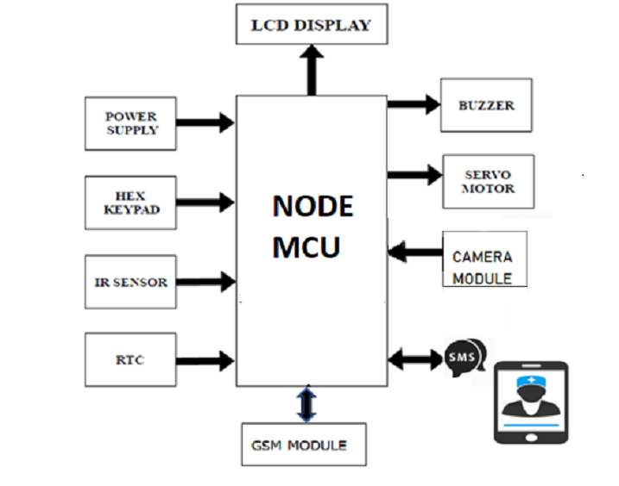

Fig 1 Block diagram of Automated Medicine Dispenser

The Automated Medicine Dispenser will help the patients to take their medicines regularly without any assistance.

Initially the tablets will be manually sorted and placed in different compartments which will be dispatched at the prescribed intervals as specified by the user. Based on the timing specifications for each compartment, microcontroller will dispatch the medicines contained in those compartment. Accordingly the microcontroller makes use of a RTC to monitor the time. When the time matches the input which was specified by the user, microcontroller will trigger the buzzer. The patient has to manually attend to turn off the alarm and take the medicine from the medicine box. Now the patient can take the medicine without any confusion. If the patient does not respond to the alarm within the prescribed time, a reminder message will be sent to him/her to the registered mobile number to take the medicine. Through Wi-Fi module, database is added. Node MCU will send the message to IFTTT app and through IFTTT app Google calendar will be automatically updated according to the current time. After 5 minutes system will automatically send the notification message to the patient mobile number through IFTTT app. Further user has to come and press the hex keypad button to take the previous medicine.

A switch is specially placed for emergency situations. When the patient feels his/her condition is going critical he/she can make use of the switch to send the message which will be conveyed to the contact number of the family physician from the smart medicine box so that the doctor can attend to the condition of the patient. If the medicines are not available in the smart medicine box, an alarm is arranged to ring in order to remind to refill the smart medicine box. If the patient has to go out before the prescribed time he/she can make use of the switch to manually take the medicine. Fig 1 shows the block diagram of Automated Medicine Dispenser.

# FLOW CHART

Fig 2 shows the flow of working of the Automated Medicine Dispenser.

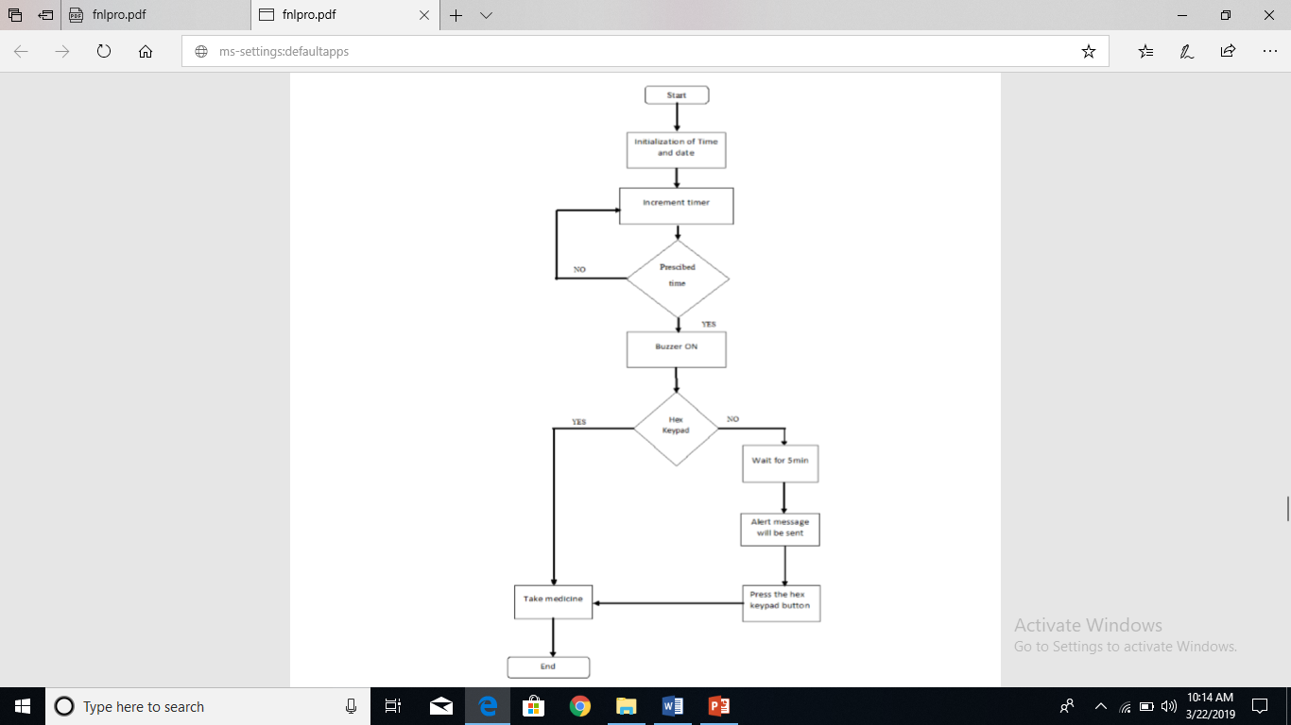

Fig 2 Flow chart

Step 1: Initialization of various parameters

Step 2: Increment timer using RTC.

Step 3: Confirm is it a prescribed time

If “Yes” Go to Step 4.

If “No” Go to step 2

Step 4: Buzzer beep which reminds patient to take medicine for a prescribed time.

Step 5: Press key in hex keypad.

Key pressed: Take medicine from.

Key is not pressed: It waits for 5 minutes, then send alert message to the patient mobile number. Press key in hex keypad and takes the medicine.

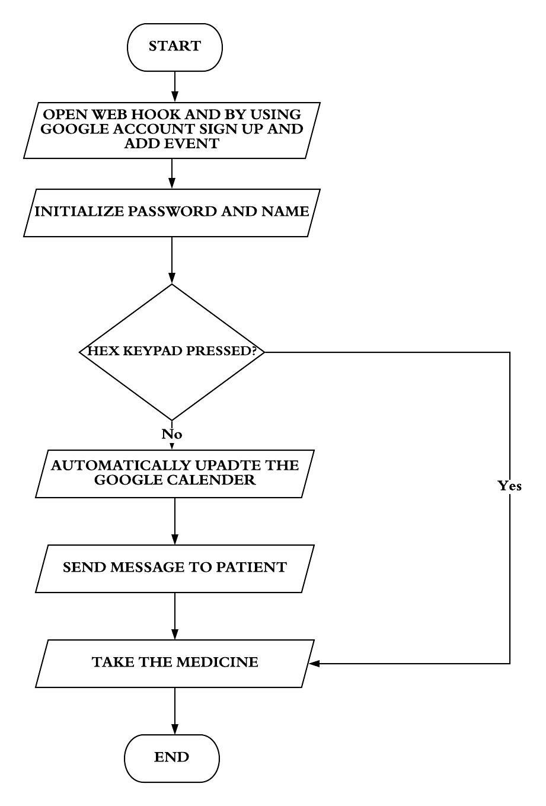

Fig 3 Server unit

Fig 3 shows the working of the server unit which sends message to the patient..

Step 1: Open web hook in IFTTT site. Sign in through the Google account and Copy the serial code. Create the event to notify the data using Google calendar, to send the message to patient and doctor mobile number.

Step 2: Enter the serial code from the IFTTT app, Wi-Fi name and password of the user mobile.

Step 3: Press key in hex keypad.

Key pressed: Take medicine from the box.

Key is not pressed: Node MCU will send the message to IFTTT app, through IFTTT app Google calendar will automatically update for the current time.

Step 4: After 5 minutes patient will get the alert message to his/her mobile number to take the medicine.

Step 5: When he/she reaches to the smart medicine box press key in hex keypad and takes the medicine.

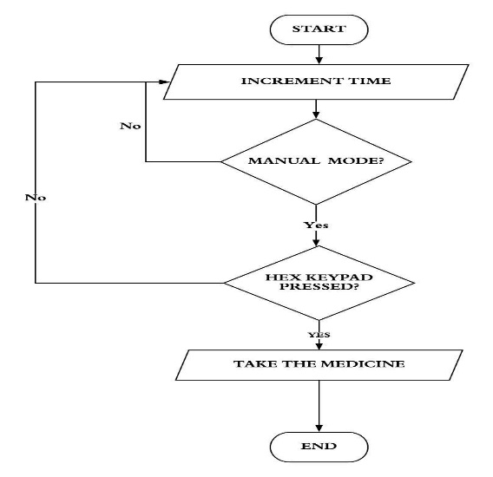

Fig 4 Manual Mode

Fig 4 shows the manual working mode of the dispenser.

Step 1: Increment timer using RTC.

Step 2: Press manual mode

If “Yes” continue. Proceed to step 3.

If “No”. Proceed to step 2

Step 3: Press key in hex keypad.

Key pressed: Take medicine from the smart medicine box.

Key is not press: increment timer

V. Results

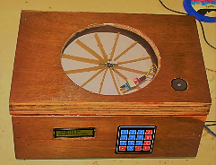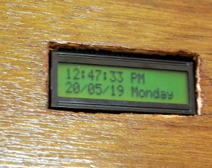

Fig (a) Fig (b)

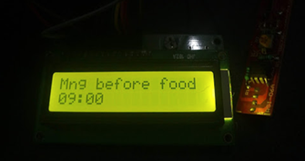 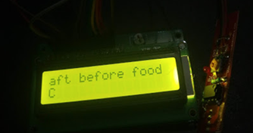 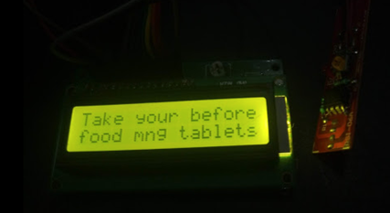

Fig (c) Fig (d) Fig (e)

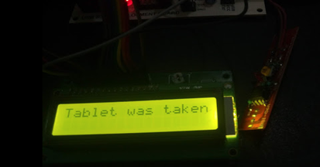 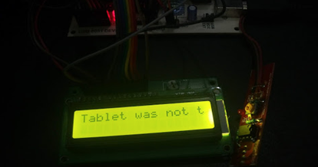

Fig (f) Fig (g)

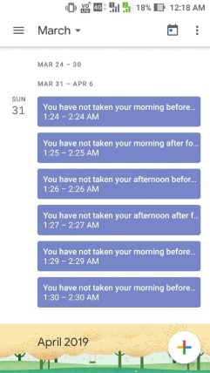 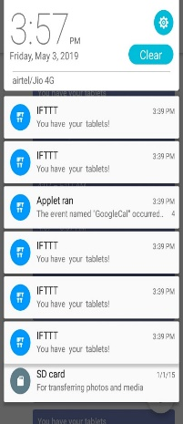 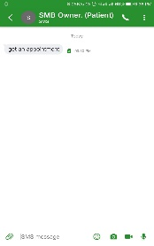

Fig (h) Fig (i) Fig (j)

Fig 5 Results

When the power is on, the LCD would display characters with the gentle yellow backlight, which allows the user to recognize the characters on the screen even in dark environment. With the implementation, the keypad responded promptly and accurately when pressed the buttons. The servo motor and IR sensor were placed inside the box. The buzzer was able to produce clear and loud synthesized sound when the comparison stage was triggered. IR sensor was placed inside the box to count whether the user consumed the medicine.

Fig 5(a) shows the overall circuit. When the Real time is initialized it is displayed in the LCD as shown in Fig 5(b).Fig 5(c) indicates the patients to take medicine in the morning before food and also displays time. Fig 5(d) indicates the patients to take medicine in the afternoon before food and also displays time. If the user presses button C in hex keypad it means user don’t have tablet for the afternoon time. Every day at the prescribed time buzzer will buzz and in LCD “take your tablet” message will be displayed. This is shown in Fig 5(e). Fig 5(f) indicates the patient responded to the buzzer within 5 minutes. The IR sensor will sense whether the “tablet was taken” from the box by the patient and the message will be displayed. Fig 5(g) shows the condition if the patient does not respond to the buzzer within 5 minutes, LCD will display “tablet was not taken”. Fig 5(h) indicates when the patient does not respond to the buzzer within 5 minutes Google calendar will automatically update that tablet was not taken. Fig 5(i) shows that the Google calendar was updated, through the IFTTT application and the notification message will be sent to the patient mobile number to take the tablet. Fig 5(j) indicates the emergency situation. If the patient presses “D” key in hex keypad “get an appointment” message will sent to the doctor by patient mobile number

# FUTURE SCOPE

The application can be linked to Med Carts. In case if the tablets are empty it directly sends a prescription message in the Med Cart, which helps the patient by delivering the prescribed medicine to the door step. Scanning the prescription to load the app can be done using image processing technology.

References

[1]. Huai-Kuei Wu ,Member, IEEE, Chi-Ming Wong , Pang-Hsing Liu , Sheng-Po Peng , Xun-Cong Wang , Chih-Hi Lin and Kuan-Hui Tu “A smart pill Box with remind and consumption confirmation function”- 2015 IEEE 4th global conference on consumer electronics (GCCE).

[2]. WissamAntoun, Ali Abdo and Suleiman Al-Yaman, AbdallahKassem, Mustapha Hamad and Chady El-Moucary “Smart medicine dispenser”-2018 IEEE 4th Middle East conference on biomedical engineering (MECBME).

[3] Shih-Chang Huang,Yu-Chen Jhu, Guan-You Chen Hong-Yi Chang “The Intelligent Pill Box - Design and Implementation” 2014 ICCE-Taiwan.

[4] C. Parcas, I. Ciocan, N. Palaghita and R. Fize “Weekly Electronic Pills Dispenser with Circular Containers” 2015 IEEE 21 international Symposium/or Design and Technology in Electronic Packaging (SIITME)

1.