**SYNTHESIS OF NANOPARTICLES USING MEDICINAL HERBS AND UTILIZATION IN WATER TREATMENT**

Shilpa Acharya, Shetty Pavan Anand, Sheethal B.R, Shreya, Mr. Rohith.P. Veigas, Dr. K.K. Srinivasan.

Shri MadhwaVadiraja Institute Of Technology And Management, Bantakal.

***Abstract:*** **Over the years, many methods have been developed for the treatment of water. Among those the use of nano-particles has gained significant importance in recent years. The chemical synthesis of nano-particles however, comes with the disadvantage of the production of chemical waste. Though an alternative method has been devised where the plant extract is used instead of a chemical as a base for the reaction, which subsequently reduces the production of chemical waste in considerable amounts, making it more eco-friendly. Such efforts have been made for synthesizing metal nano-particles of silver, gold, copper etc. using the extracts of herbs and plants like Neem, Aloe vera, Tea leaves etc. In the present study, we propose the extract of Tulsi leaves (*Ocimum sanctum)*, for the synthesis of zinc nano-particles. Results conclude that extract and zinc nitrate of lesser concentration helped in synthesis of nanoparticles with size of around 200-300nm and they have been effiectively showing activity against microbes like *Staphylococcus aureus and E.coli.***

1. **INTRODUCTION**

Nanoparticles, basically are microscopic particles. They have found their applications in varied fields like medicine, tissue synthesis, material engineering and electronics. They are are normally synthesized in various different forms like crystals, powders etc. Some of the types of nanoparticles are nanotubes, fullerene spheres, dendrimers, nanowires etc The microscopic size of the nanoparticles alters its material properties. Among the many fields that the science of nanoparticles has ventured into, the field of water treatment is fairly new. The use of nanoparticles in the treatment of water has been done for quite a while now. The adsorbent property of nanoparticles helps in eliminating the suspended impurities in water while the antimicrobial properties help in eliminating certain pathogens. The small size of nanoparticles provides a lot of surface for interaction and ultimately the elimination of contaminates.

However, the chemical synthesis of nanoparticles produces chemical waste. Hence, the mass production of nanoparticles would greatly add to the already severe waste disposal problems. Although, there have been few researches which involves use of emulsion of herbs for the synthesis of nanoparticles. The advantages are that the chemical waste production is considerably reduced and the use of commonly available herbs makes it economic for the synthesis of nanoparticles. There has been lot of work done towards this research in the biosynthesis of gold, silver and copper nanoparticles. This project has its focus on the synthesis of zinc nanoparticles using the Tulsi (*Ocimum sanctum)* leaf extract.

Also the efforts are towards the usage of plant extracts that could be easily available to make the process more economic by and large.

1. **Nanoparticle synthesis using medicinal herbs**

Nanoparticles are a fundamental unit of a nanostructure and are smaller than the objects in general that come under the purview of Newton’s laws of motion, and bigger than the atoms. Use of herbs for the synthesis of nanoparticles considerably reduces the involvement of chemicals in to the entire process, making it more eco-friendly. Also the use of locally available herbs makes the process more feasible and economic.The utilization of plant in the biosynthesis of nanoparticles involves the use of secondary metabolites as reducing agents. Additionally, plant leaf extract play a dual role by acting as both reducing and stabilizing agents in the process of forming nanoparticles. The particles would possess combined effect of metal nanoparticles and antibacterial effect, if any, of the plant extract.

1. **Metal ion nanoparticles**

In many of the previous studies there has been confirmed synthesis of metallic nanoparticles by the means of reduction and stabilization by herb extracts. Metal compounds of silver, copper and also gold were used for biosynthesis of nanoparticles. Silver has been known for its antimicrobial properties and hence has been an effective agent for the treatment of water. Many of the studies previously used Silver Nitrate (AgNO₃) along with the herb extracts.

Extracts of plants like Aloe vera, Neem leaves, Tea leaves, *Buddleja globosa* have been used with silver compounds for the synthesis of nanoparticles. However silver compounds being expensive raise the overall cost of the whole process. Also there are fewer studies pertaining to nanoparticles’ biosynthesis that explore the avenues of their use in antimicrobial action in any way.

1. **PROBLEM STATEMENT**

Water-borne diseases have always had a major share in the health hazards that have been inflicted upon the general population around the world. Water is a resource so essential that the poorest classes of the society are dependent on it. In such case, people become easily vulnerable to the diseases caused by pathogens that spread through water.

The spread of diseases like jaundice, cholera and typhoid is a result of pathogen infected water. In many cases, these diseases also turn out to be fatal due to lack of medication. Children and aged adults are more vulnerable to such diseases. There are many sections of the society which still can’t avail clean and safe drinking water and as a result are majorly affected by the water –borne diseases. Though there are treatments and medications available for those diseases, the weaker sections of the societies and the people living in the remotest villages have to undergo great difficulties to avail even the basic medical attention required. Hence, it would be wiser to come up with a preventive measure to curb the diseases. Though boiling is an effective way to do away with the pathogens in water, it is an energy consuming process and the overall consumption of energy for just day to day boiling of water can be considerably huge on a larger scale.

Among the many methods and technologies, use of metal-ion nanoparticles has been proving to be an emerging approach towards the elimination of pathogens in water. The nanoparticles due their smaller size have a better interaction to the microbes and hence deliver effective antimicrobial activity. However, these nanoparticles are by and large synthesized by chemical processes which makes the synthesis harmful and hazardous.To reduce the involvement of chemicals in the process, herb extracts are being used as reducing and stabilizing agents for the synthesis of nanoparticles.

While there have been many successful attempts to synthesize gold and silver nanoparticles, the process could be expensive provided the high costs of gold and silver compounds. Hence, this project focuses at using zinc compounds for synthesizing nanoparticles with the help of Tulsi (*Ocimum sanctum.)* leaf extracts, which is an easily available herb. The choice of zinc and Tulsi for the synthesis makes this process more feasible and viable than the others and if ways for the application of this method is derived, it would be affordable enough for every section of the society to access.

1. **METHODOLOGY**

Methodology pursued was divided into four stages as given below:

**Figure 1:** Methodology followed

**Stage 1:**

* The required herbs i.e. Tulsi leaves (*Ocimum sanctum*) were procured from local sources.
* These leaves were grinded and boiled to get two set of samples out of it. The samples were filtered.
* 150ml of grinded and boiled samples were taken for the preparation of nanoparticles.
* The chemical used in the process was Zinc Acetate of 0.04M.
* The Zinc Acetate crystals were procured and were diluted in 100ml of water to obtain 0.04M Zinc Acetate solution.
* The obtained Zinc acetate solution was added to the sample prepared as shown in Figure 2. And Figure 3.
* This solution was stirred for sixty minutes a day at 1000 rpm.
* The sample was later sonicated for five minutes at amplitude of 50%.

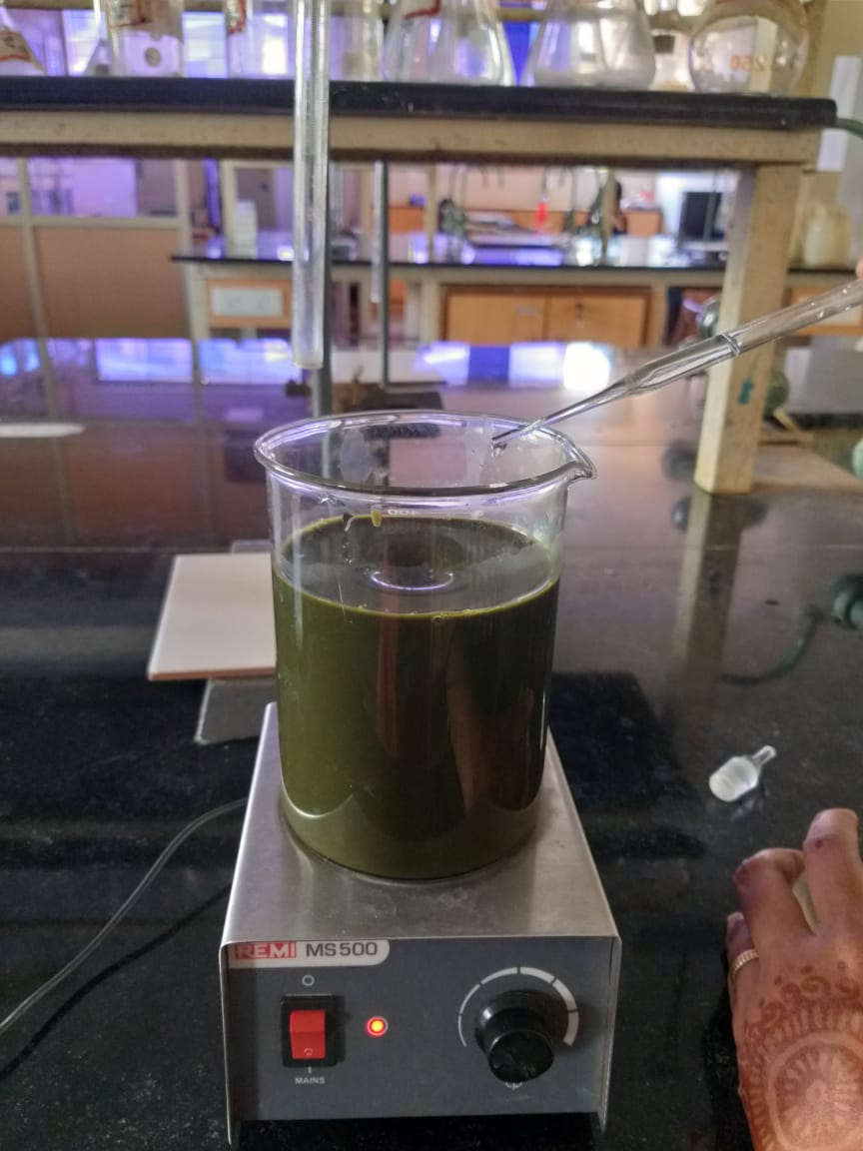

Figure2: Grounded extract solution

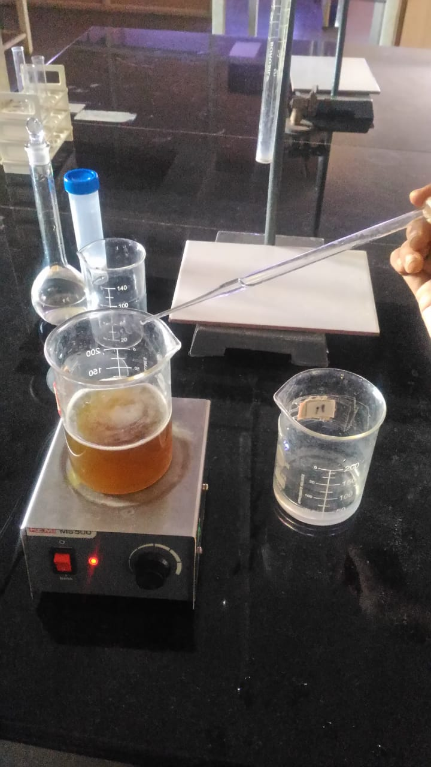

**Figure 3:** Boiled extract solution

**Stage 2:**

* The obtained solution was sent for characterization under particle size analysis and Dynamic Light Scattering (DLS) to study and confirm the presence of nanoparticles in it.
* Dynamic light scattering (DLS) is a method wherein the principle of scattering of light is used to understand the distribution profile of the small particles in any particular solution or an emulsion.
* This distribution of particles is expressed by Poly-dispersion Index. This helps us in characterizing the size of the nanoparticles.
* The particle size analysis and DLS tests have shown the presence of nanoparticles of size 272.5nm
* The desired PdI value was required to be within the range of 0.5. PdI value for the tested sample was found to be 0.135
* The Zeta potential was found to be good as per the reports in Figure 4. and Figure 5.

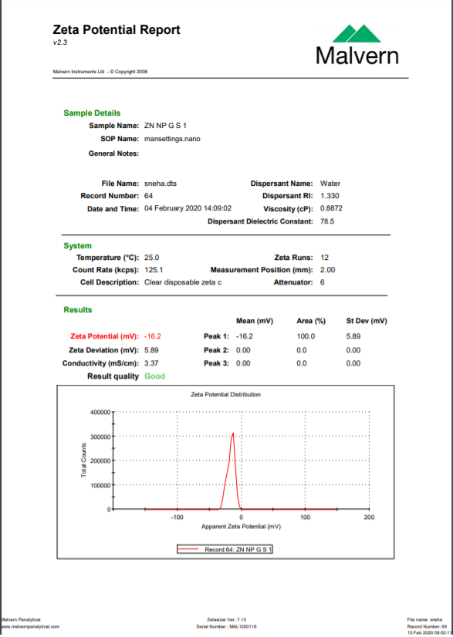

**Figure 4:** Zeta potential Report

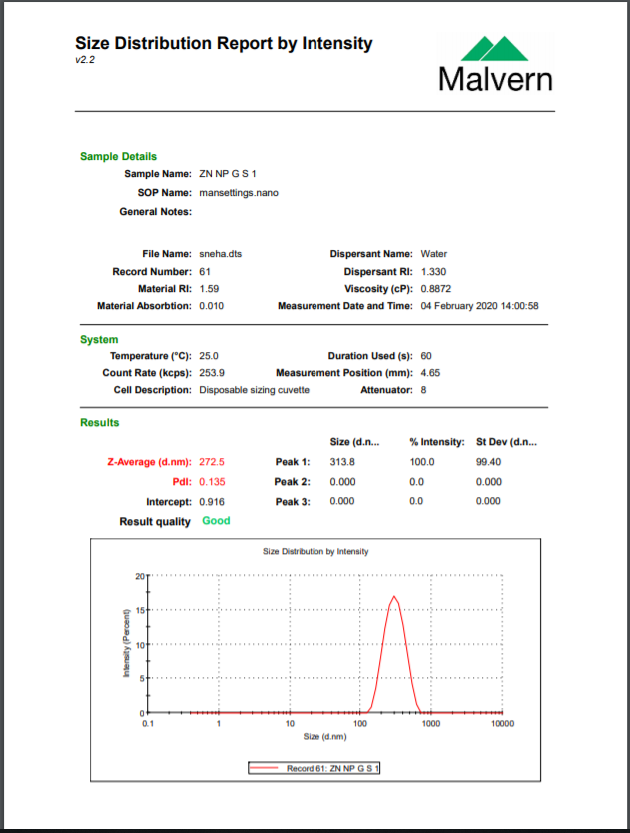

Figure 5: Size Distribution report

**Stage 3:**

* The samples have been sent for testing of their antimicrobial activity.
* The sample is to be tested for strains of gram positive and gram negative bacteria.
* The antimicrobial activity is confirmed by zone of inhibition test also known as Kirby-Bauer test.
* In this test a strain of pathogens like bacteria are laid on an agar plate, and then are placed in incubation in the presence of the antimicrobial agent whose activity is to be tested.
* If the tested agent shows antimicrobial activity, a zone of inhibition is created on the agar plate as shown in the Figure 6
* The zone of inhibition for the sample synthesized by boiling was found to be of around diameter 22mm whereas that of the sample synthesized by grinding showed a smaller zone of inhibition of around 11mm for the sample quantity of 100 micro liters.

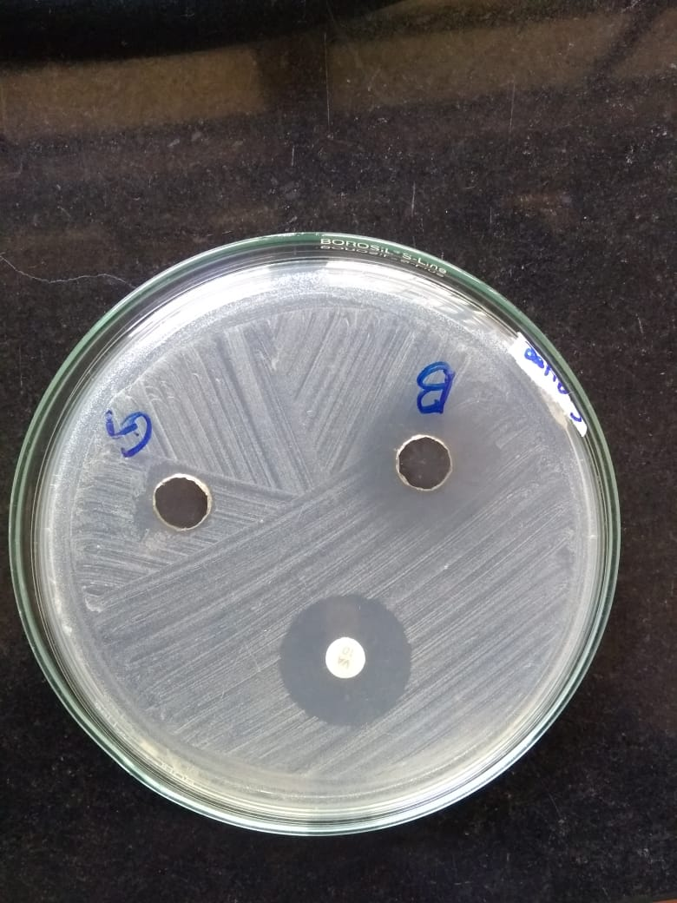

Figure 6: Kirby Bauer test on strain of *Staphylococcus aureus*

**Stage 4:**

* Once the antimicrobial activity is confirmed, further test will be conducted to check their efficiency for the same.
* Higher concentration will be used in the beginning and then the concentration will be decreased as long as the antimicrobial activity is noticed.
* This way the minimal concentration of nanoparticles required for inhibition of microbes will be deduced.

1. **CONCLUSION AND FUTURE WORK**

Through the course of the project so far, the prepared emulsion for the synthesis of nanoparticles has been tested for the presence of nanoparticles under the Dynamic Light Scattering (DLS) test and synthesis of nanoparticles of size 272 nm. has been detected, hence, confirming that the process is effective for the synthesis of nanoparticles. The Poly-dispersion Index (PdI) was found to be 0.135 while the preferred value was required to be below 0.5 confirming a good result quality.

The future work would entail the testing of the synthesized nanoparticles for its pathogen resisting capabilities. The antimicrobial activity has been primarily tested against water-borne bacteria like *E.coli* and *Staphylococcus aureus*. provided that these are the major sources of water-borne illnesses. Zone inhibitions test also known as Kirby Bauer test has been used for detecting the antimicrobial activity of the synthesized nanoparticles. The antimicrobial activity for the respective microbes has been confirmed, the zone of inhibiition of the nanoparticles was found to be 11mm against *E.coli* and 12mm against *Staphylococcus aureus,* concluding that the nanoparticles have shown greater effectiveness against *Staphylococcus aureus* than *E.coli*.

Further the nanoparticles will be tested for antimicrobial activities against other strains of gram positive and gram negative bacteria, by which the scope of its applications will widen. If the nanoparticles are found to be showing successful resistance against multiple microbes and pathogens, methods and techniques to put them into application could be devised in such a way that the technology could be accessed for the purification of water by the general public.

**REFERENCES**

1. Alyousef, A. A., Arshad, M., AlAkeel, R., &Alqasim, A. (2019). Biogenic silver nanoparticles by Myrtuscommunis plant extract: biosynthesis, characterization and antibacterial activity. *Biotechnology & Biotechnological Equipment*, *33*(1), 931-936
2. Terra, A. L. M., Kosinski, R. D. C., Moreira, J. B., Costa, J. A. V., &Morais, M. G. D. (2019). Microalgae biosynthesis of silver nanoparticles for application in the control of agricultural pathogens. *Journal of Environmental Science and Health, Part B*, *54*(8), 709-716.
3. Sharma, P., Pant, S., Rai, S., Yadav, R. B., Sharma, S., & Dave, V. (2018). Green synthesisand characterization of silver nanoparticles by Allium cepa L. to produce silver nano‐coated fabric and their antimicrobial evaluation. *Applied Organometallic Chemistry*, *32*(3), e4146.
4. Carmona, E. R., Benito, N., Plaza, T., &Recio-Sánchez, G. (2017). Green synthesis of silver nanoparticles by using leaf extracts from the endemic Buddlejaglobosa hope. Green Chemistry Letters and Reviews, 10(4), 250-256.
5. Devatha, C. P., Thalla, A. K., &Katte, S. Y. (2016). Green synthesis of iron nanoparticles using different leaf extracts for treatment of domestic waste water. Journal of cleaner production, 139, 1425-1435
6. Ahmed, S., Saifullah, Ahmad, M., Swami, B. L., &Ikram, S. (2016). Green synthesis of silver nanoparticles using Azadirachtaindica aqueous leaf extract. Journal of Radiation Research and Applied Sciences, 9(1), 1-7.
7. Jin-Liang Jia, Han-Hong Xu, Dan-Qi Li, Wei-Hao Ye & Wen-Jian Liu (2015). Biosymthesis of Silver and Gold Nanoparticles using Huangdan (Camellia sinensis) Leaf Extract, ISSN:1553-3174.
8. Karimi, J., &Mohsenzadeh, S. (2015). Rapid, green ans eco-friendly bio synthesis of copper nanoparticles using flower extract of Aloe vera. Synthesis and reactivity in Inorganic, Metal-Organic, and Nano-Metal Chemistry, 45(6), 895-898.
9. Ponarulselvam, S., Panneerselvam, C., Murugan, K., Aarthi, N., Kalimuthu, K., &Thangamani, S. (2012). Synthesis of silver nanoparticles using leaves of Catharanthusroseus Linn. G. Don and their antiplasmodial activities. Asian Pacific journal of tropical biomedicine, 2(7), 574-580.
10. Sangeetha, G., Rajeshwari, S., &Venckatesh, R. (2011). Green synthesis of zinc oxide nanoparticles by aloe barbadensis miller leaf extract: Structure and optical properties. Materials Research Bulletin, 46(12), 2560-2566.