A SURVEY ON SMUGGLING DETECTION AND PREVENTION SYSTEM FOR

TREES IN FOREST

Pradeepa Acharya, Prajwal K, Niveditha, Shilpa, Nagaraj Bhat

*Shri Madhwa Vadiraja Institute of Technology and Management, Bantakal, Udupi-574115l.*

***Abstract:*** ***Smuggling of trees is a long and evoking issue. Trees are vulnerable to Smugglers and cutting of trees like Sandal wood, Teak wood, Red sanders are still an existing problem. In spite of growing technology, protection for trees in a large area like forest is difficult. It is also expensive to implement. We are making a system that can prevent the smuggling of trees in forest. The systems consist of NodeMCU interfaced with fire sensor, vibration sensor.In case of any vibration the ML algorithm will check the which tyoe of vibration and based on that the alert message will be send to the respective departments.This ensures data security and provides privacy.***

1. **Introduction**

The importation of trees like red sandalwood, sandalwood, associate degreed teak wood continues to be an existing drawback. These trees area unit created used for healthful purpose. Trees area unit impede and sold in amerciable market threatens the rare tree species population. These trees area unit extraordinarily expensive and fewer presumably obtainable within the market[1]. The wood trees area unit aforementioned to be imperial in recent times of India, the Indian government has already set some measures to shield these trees from smugglers however implementing it over an outsized space like forest is ineffective.

• Fencing the forest space. this can be one amongst the oldest ways used however the value needed to create it will increase proportionately to the world of forest.

• Manual observation of forest by imposing the protection personals in specific forest region is one amongst the ways to manage the cutting of trees. however it's arduous to watch the complete space by humans and providing continuous over day and night is not possible.

• Tagging of trees exploitation RFID a bit like tagging the animals is used. However, this doesn't give period of time info once the matter happens. It leaves a message only if the tree is affected from its original position.

• CCTV camera installation within the forest is once more terribly expensive and arduous to implement.

To address these problems we have a tendency to area unit exploitation smoke sensors to sight the hearth catches and for the movement of any object we have a tendency to area unit exploitation PIR sensors, for the vibration detection we have a tendency to area unit exploitation vibration detection, to differentiate between the various causes of vibrations we have a tendency to area unit exploitation pattern matching, By this we are able to get once naturally the tree falls furthermore as Is anyone cut the trees. we have a tendency to area unit exploitation image process to differentiate between the human and also the animal.

**II. Sensors and different elements utilized in IoT**

Vibration sensing element: Sensors accustomed live vibration area unit obtainable three basic types displacement, velocity,acceleration(Fig.1)..Displacement sensors live changes in distance between a machine’s rotating component and its stationary housing (frame). Displacement sensors area unit obtainable the form of a hunt that threads into a hole trained and tapped at intervals the machine’s frame, simply on top of the surface of a shaft .Velocity and acceleration sensors, against this , live the speed or acceleration of no matter component the sensing element is connected to, that is often some external a neighborhood of the machine frame.

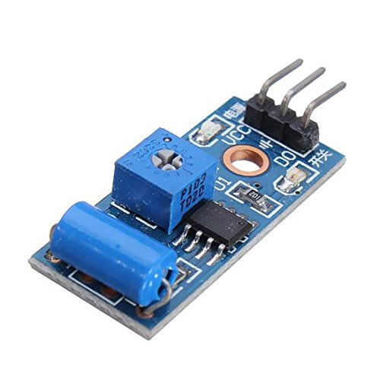

Figure.1 vibration sensor

Flex sensing element : A flex sensing element or bend sensing element is also a sensing element that measures the number of deflection or bending. Usually, the sensing element is stuck to the surface, and resistance of sensor detector sensing component device element is varied by bending the surface(Fig. 2). Since the resistance is directly proportional to the number of bend it's used as goniometric, and sometimes known as versatile potentiometer.

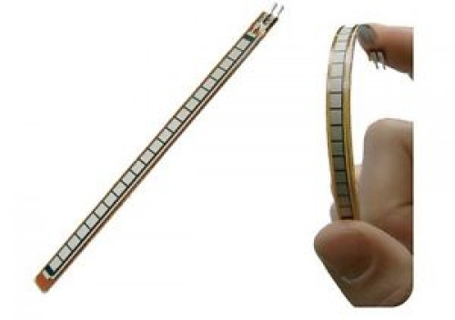

Figure.2 Flex sensor

Tilt detector: A tilt sensor encompasses a auriferous ball that's designed to maneuver the 2 pins of the instrument from the 'on' to the 'off' position, and contrariwise, if the detector reaches a pre-determined angle(Fig.3). Tilt sensors square measure the environment-friendly version of a mercury-switch.

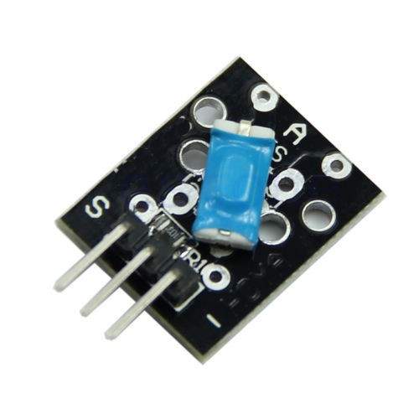

Figure. 3 Tilt sensor

Smoke sensor: The oldest variety of fire-detection device may be a heat detector. It functions with a detection part that activates once it reaches a tough ANd quick temperature or an extreme increase in temperature happens(Fig.4). other than heat detectors, you've 3 choices once it involves smoke detectors: ionization, physical phenomenon, or a combination of the two .

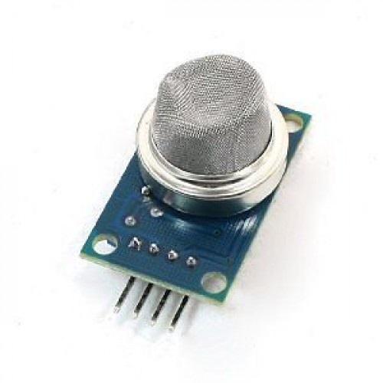

Figure.4 Smoke sensor

Temperature Sensor: Temperature detector could also be a tool, to measure the temperature through AN electrical signal it needs a thermocouple junction or RTD (Resistance Temperature Detectors)(Fig.5). If the distinction in voltage is amplified, the analogue signal is generated by the device and it's directly proportional to the temperature.

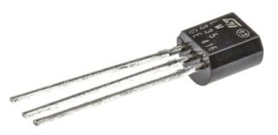

Figure.5 fire sensor

MEMS detector: MEMS sensor is employed to sight the bending of the tree(Fig6). [4]Inductive Proximity detector is employed to sight the cutting of the tree with the metal.

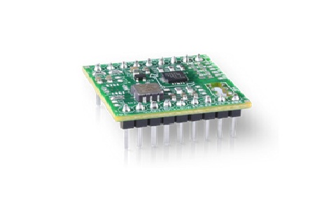

Figure.6 MEMS Sensor

Fire detector: heat or fire sensor could also be a sensor designed to detect and answer the presence of a flame or fire, permitting flame detection. Responses to a detected flame depend on the installation, (Fig.7)however will embody sounding AN alarm, deactivating a gas line (such as a fuel or a gas line), and activating a hearth suppression system. once utilised in applications like industrial furnaces, their role is to produce confirmation that the chamber is functioning properly; in these cases they take no protest on the far side notifying the operator or system. A flame sightor will typically respond quicker and additional accurately than a smoke or heat detector because of the mechanisms it uses to detect the flame.

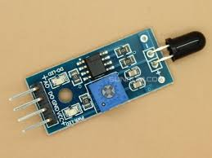

Figure.7 Fire detector

Zigbee: Zigbee is employed after we need low rate application with long battery life and secure network. Zigbee Technology is low price(Fig 8), low power, straightforward to place in , low maintenance, and comes with multiple topologies. These specifications created Zigbee protocol offered for usage throughout a large choice of applications.

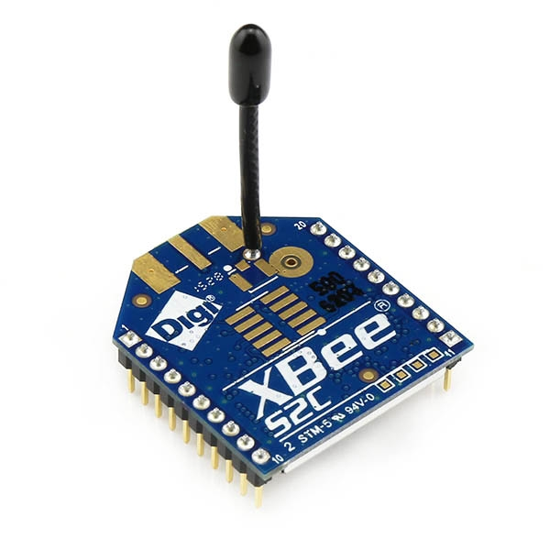

Figure.8 Zigbee

AWS: IoT information is very unstructured that makes it tough to investigate with ancient analytics and business intelligence tools that square measure designed to method structured information. IoT information comes from devices that invariably record fairly uproarious processes (such as temperature, motion, or sound). the info from these devices will often have vital gaps, corrupted messages, and false readings that has to be clean up before analysis will occur. Also, IoT information is typically solely meaty inside the context of extra, third party information inputs. as an example, to help farmers confirm once to water their crops, vinery irrigation systems typically enrich wetness detector information with precipitation information from the vinery, permitting additional economical water usage whereas maximising harvest yield.

RFID: RFID tags square measure a sort of trailing system that uses good barcodes so as to spot things. RFID is temporary for “radio frequency identification,” and as such , RFID tags utilize frequency technology. These radio waves transmit information from the tag to a reader, that then transmits the knowledge to AN RFID worm(fig 9)..RFID tags square measure oft used for merchandise, however they are progressing to even be used to track vehicles, pets, and even patients with Alzheimer’s malady. AN RFID tag may also be known as AN RFID chip.

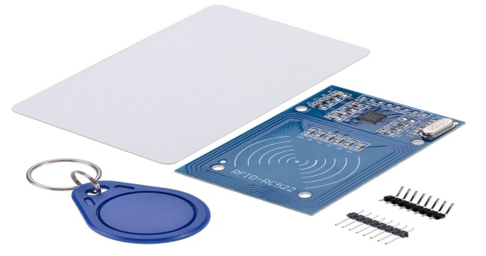Figure.9 RFID tag

**III. Machine learning algorithmic program**

Support Vector Machine: Support vector machines square measure a sort of supervised machine algorithmic program for learning that is employed for classification and regression tasks. although they are used for each classification and regression, they are principally used for classification challenges. A support vector algorithmic program is performed by plotting every nonheritable worth of data as some extent on AN n-dimensional house or graph. Here “n” represents the whole range of a feature of data that is gift. the worth of each information is delineated as a selected coordinate on the graph. once distribution of coordinate information, we'll perform classification by finding the road or hyper-plane that clearly divides and differentiates between the 2 categories of knowledge .

Applications of SVM: the utilization of support vector machine algorithms and its examples square measure utilized in several technologies that incorporate the utilization of segregation and distinction. The real-life applications it vary from image classification to face detection, recognition of handwriting and even to bioinformatics. It permits the classification and categorization of each inductive and transductive models. The support vector machine algorithms build use of coaching job information to segregate differing kinds of documents and flies into completely different classes.The segregation done by it's supported the data and score generated by the algorithmic program then is compared and contrasted to the initial values provided.

Use of Support Vector Machine algorithmic program

It is the foremost primarily and additionally the foremost well-known classifier. it's one in all the known machine algorithms for effectively classifying information points and helps at intervals the simple creation and separation of categories. they square measure they're useful once there are a much bigger range of variables. Such support vector machine example square measure typically aforementioned for text classification from a bag of words model. Non-linear kernels show promising and effective performance in most eventualities and generally square measure head to travel with alternative random forests. Also, they're they square measure helpful significantly once the requirement is t classify information by rank or usually named as ordinal classification and are wide enforced in “learning to rank” algorithms.

Advantages of Support Vector Machines

1.Avoiding Overfitting: Once the hyperplane of the vector machine has been found, except the points nighest to the plane( support vectors), most of the opposite information become redundant will be omitted. this means that little changes created cannot build any vital changes to the overall information and additionally leave the hyper-plane additionally unaffected. so the name ‘support vector machine’ suggests that such algorithms tend to generalize information with efficiency.

2.Simplification of Calculation :They have comprehensive algorithms of regression which help within the classification of sophistication data of two classes. This allows us to form our predictions and calculations simpler because the algorithm is presented during a graph image and may be wont to estimate the category distinction. Simpler visual calculation helps faster and more reliable data output instead of individually corresponding each support co-ordinate of the two cases.

**IV. Real time object detection to classify the human and animal**

You Look only Once has the major advantages compare to others and in this the convolution network is used for the image recognition in this the objects are detected using the grid or the boxes and the output will be in the 7*7*30 tensors. YOLO mainly resizes the image and then run the convolution network and at last they suppress the image. It will be very helpful for the crime detection because it directly recognizes which object or the person in that image. For live video tracking also done by this .[16] compare to ]00other techniques this will be better. At first they make bounding boxes and then run classifier in this boxes and After classification this bounding boxes will be further go under the post processing to remove the duplication in the images which means that if once the one object is detected then that image will not be detected again. In this single convolution network works with the multiple bounding boxes and class probabilities. The input image in this process will become S*S and that will be passed into the bounding box confidence and the Class probability Map that will yield the output with the detecting objects.

**V. Literature Survey**

The planned system uses GPS technology. Using this, they will ready to realize the precise location of the embezzled tree cutting. The system uses a IoT technology that's web of things. The detectors like flex detector and fireplace sensor are fastened to the chip and are controlled exploitation IoT. Android app is put in within the Smartphone exploitation this forest officer will access the activities within the forest.The detector unit consists of the flex detector, fireplace detector and sensors are connected to the tree and can communicate with the android app exploitation Wi-Fi module.[2] The bending motion is detected by the flex detector exploitation deflection of the tree and sends the notification to the Android app. fireplace within the forest is detected by the fire detector. It sends the notification to the app and lift associate alarm once metal touches the tree, it is detected by the sensor and straightaway offers info to the forest officer.A info is maintained. All the small print are keep within the info. Each GPS and GSM technology is employed. GSM is employed for message causing purpose and GPS is employed to search out the placement of the tree.

Trees like sandalwood, red sandal are valuable trees and costs a lot. So smuggling of these trees will take place in the forest. In this paper they have used vibration sensor, continuity sensor to detect the cutting down of trees. Vibration sensor checks if the vibration sensed is actually occurred during the tree cutting. This can be done using machine learning algorithm[3]. To check the flow between adjacent trees continuity sensor is used.The system composed of 3 sections, tree unit, subserver and forest officer unit. In tree unit, sensors are attached to tree. Sensors include vibration sensor, continuity checker and zigbee. Zigbee is used if in any case GSM does not work. Vibration level of tree can be detected using vibration sensor. The vibration level of tree will be high, if any one tries to cut the tree. If the value exceeds the threshold value, then sensor activate the microcontroller. All the trees will be link in a network using continuity checker. If the vibration sensor does not detect the tree cutting then they will be able to find using continuity checker after tree is being cut down. Sub server has control section in which all the control activity will be done.

The smuggling can be prevented using IoT. The system consists of a chip on that sensors are fixed and are controlled using IoT. The sensor includes MEMS sensor, fire sensor, Inductive Proximity sensor, ultrasonic sensor. The android app was developed through that they can get the information like cutting, burning and tilting of the trees.Fire sensor is used to detect the fire in the forest. MEMS sensor is used to detect the bending of the tree. Inductive Proximity sensor is used to detect the cutting of the tree with the metal.[4] Ultrasonic sensor is used to sense the distance between trees. All sensors are connected to Arduino UNO microcontroller and GPS is used to find the exact location. Power supply will be given to Arduino using solar power. Using wifi network the result of Arduino UNO will be given to android app through server.

This system contains mainly 3 unit1.tree unit 2.sink node unit 3.server unit. Tree unit-Tree unit mainly contains 3 sensors that is tilt sensor, sound sensor and temperature sensor.[5] Tilt sensor is used to detect the tree inclination angle and if any fall is detected notification sent to an android phone which contains blynk application in it. Temperature sensor is used to detect the forest fire. Sound sensor will detect the sound of chainsaw while cutting the tree.This system will consists of two modules. One containing sensors, controller which is attached to tree and another one is android phone. Blynk application is used for this project which receives sensor data continuously. In case of forest fire water pump will turn on. In case of smuggling alarm device will turn on. Accelerometer sensor used in tree unit finds the tree cutting. Bending of tree will be detected by the sensor. Interface between forest tree network and internet is through sink node which collects the information from tree unit and sends it to server using wifi module. GSM will be used to send the sms to registered mobile phone.

Illegal work could be a timber thieving activity which will hurt several aspects. one in all the problems is work on an outsized scale will injury a forest system and have an effect on humthus we tend to area unit decreasing the sensors a amount by increasing the potency. The implementation of vibration sensing elements here is to substantiate the incidence of work to the sound recognition limitations of the sound sensor. By inserting a vibration sensing element, there area unit two occasions method checking (sound and vibration) to make sure that black-market work is going onan life [6]. a way to cut back black-market work is implementing a technology. This analysis was coming up with a example which is able to notice the incidence of black-market work. this method uses a combination of sound sensing element and vibration sensing element. Sound sensing element, it applies to spot the power saw whereas the vibration sensing element, it uses to notice the falling trees. This analysis was designed with Arduino Nano and GSM module as data suppliers for forest guard patrols. the brink price of sixty three.4 sound unit for the power saw and therefore the threshold price of 400 for vibration sensors will offer a superb combination to notice black-market work. during this project they place sensors each|for each} tree in every space, it'll consume extra money.

The system comprises of Raspberry pi interfaced with flex sensor [7], fire sensor and relay and the GSM model is connected to a tree where it is having a centralized microprocessor interfaced with flex sensor on the body of a tree. When somebody tries to cut the tree then the sensor senses the variation and sends the information to a processor. The processor tracks the location and sends it to the server using IOT modem which is inbuilt in Raspberry Pi. The server sends it to the respective department or person. Model is monitored using a centralized mobile app as receiver having a web app. Relay is used to control a circuit by a separate low-power signal or where several circuits must be controlled by one signal. Flex sensor is used to measure the amount of deflection or bending. However Raspberry Pi is superior to Arduino, but that’s only when it comes to software applications. Arduino’s simplicity makes hardware projects simple.

As human advances in technology, simulated and natural disasters ar increasing exponentially. it's essential to safeguard the environment and nature [8]. during this fashionable age, the technology is wont to offer a contributory setting to measure by preventing the harmful failure. within the forest, one in every of the foremost issues is that the fire. additionally to the current, the planned model is meant to include with the involuntary options like self- observance and self-healing so the ever present setting that's created for a selected objective is earned with strong and fault-tolerant system, by embedding analytics as service and, by providing intelligence at the fringe of the network. during this work the system is meant and evaluated for its effectiveness yet as measurability because of the development of sensing element technology, the most recent technology will facilitate to scale back harmful accidents caused because of hearth. during this project, the battery that is employed should be modified typically.

This paper proposes a microcontroller-based antipoaching framework using Wireless Sensor Network (WSN) innovations [9]. Which is fit for identifying robbery by checking vibration created by cutting of trees or branches. Here they used a tilt sensor (to identify the tendency of cutting), temperature sensor (to distinguish woodland fire), sound sensor (to identify the tendency of sound).In this, the condition of trees were sent to officers using GPRS. Here Iot, WSN and AWS are secure nature.

The main objective here is to detect person in the forest during the restricted time. Since it is using infrared images so it is visible even in the night time. Inception V3 model of tensor flow which will help in detecting the type of weapon which person is having, with help of SVM classifies the infrared images are classified. The system is designed in 5 stages. In the first stage image from the infrared are reshaped to 224pixel because each image dataset may be in the different resolution(if high resolution taken more time).In the 2nd stage inception V3 model(CNN)is used,[10] which can be trained on Image Net large visual recognition dataset. Reshaped infrared images dataset are feed to inception model. Then feature extraction is done by technique transfer learning.3rd stage when the transferred value from the inception model stored as the cache value in local pc. Whenever an image is to be tested that can be directly get from the cache value. In the stage 4 back propagation algorithm is used to update the fully connected n/w model .In the last stage prediction is done for the outcome.

This system is designed for health monitoring and tracking system for animals and also for monitoring of forest accidents such as forest fire. Using Iotized transmission and GPS,this system tracks animals and measures the animal physo signal. PIR sensor is used which sense if animal is present or not.If animal is detected,then LCD monitor wil display . for alert buzzer is used.This project splits into 3 sections,the boundary section ,the animal section and server room.The boundary section observes the boundary of the forest. This section detects and avoid the entering of animals into the village area near forest. In the forest border ,the PIR sensor detects the motion of the animals[11]. If the animals are moving towards the boundary section then zigbee transmitter sends the message signal to the zigbee receiver. The al;arm will set when the animal is detected in the boundary, All the information are stored in the cloud using Wi-Fi module.Animal section is used for detection,stacking and observing the health of wild animals. The temperature sensor is used to observe the health state of the animal. To track the location of the animal GPS is used and the location is updated to the cloud using Wi-Fi module. This information is sent to the mobile of the required authority.The tree section observes the forest activities like forest fire and illegal smuggling of the trees. Both smoke sensor and fire sensors is used to detect the forest fire. Smuggling of trees can be prevented using RF transmitter which sends the radio signal to the RF receiver at the boundary section.

Power is required for working of wireless sensor network .If we use the battery we cannot able to replace battery frequently in forest .So, for power we are using solar system .The Solar power system main function is to manage the diffusion of PV energy between the load and energy storage device .The solar power system manage and protect the charging and discharging of energy and also controls the energy storage device .The load power is managed by solar power system .The solar power system is of 2 types .The power electronic charging regulating circuit and the system control circuit with MSP430F147 as the basic[12] .The power electronic charging regulating circuit is split into two parts .A buck circuit with 7416MOS tube as the basic is a first part. And the second part holds 5V,3.3V regulating circuit and a 24V step-up circuit .The other functional circuits is attached to I/O pins of microprocessor circuit. To reach the battery measurement, it uses A/D input port. To provide the microprocessor and external load, regulating circuit will alter 12V DC voltage to 5V and 3.3V.The microprocessor port p1 is attached with the charge switching circuit by a control line. The output is obtained by PMW control signal through software analog waveform. Fuse is used for solar cells and battery interface circuit.

The system consist of flex sensor, fire sensor and relay which is interfaced with Rasberry pi. Each tree will be placed with one electronic unit consisting of microcontroller, sensors and IoT modem that is interfaced with raspberry pi module. This is one sub server unit for specific area of forest which will collect the data of different tree units. This sub sever send data to main server using GSM[13]. Tree unit will receives the sensor data sends the data to the raspberry pi using IoT modem(IoT modem inbult in raspberry pi). Then server sends the data to government through web app and also nearest base station where mobile having web app as receiver.

Fire is a major problem to our forest. Now a days forest fire are increased in the Hilly around the globe. To reduce this problem several technique have been used. Optical fire server, satellite based method and wireless sensor network are major techniques among them. Early detection of fire is the primary concern.[14] Wireless sensor network can detect and monitor fire immediately compared to satellite based techniques. Satellite based technique take more time for scanning, so it is less efficient. In WSN sensor node collects the temperature, humidity, smoke and other data and sends them to cluster head. Then these cluster head sends data to manager node making a network.

Weather station gives us the information about the weather like temperature, humidity, pressure etc in our surroundings. The system consists of sensors which senses the temp, pressure, humidity, rain value and light intensity. Other parameters like dew point can be calculated using humidity and temp. Nodemcu is used in this system which is a ESP8266 based wifi module. Nodemcu is used to push values to the cloud. ESP8266 Opensource Community is the developer of the nodemcu board. The operating system of nodemcu is XTOS. The CPU is LX106(ESP8266). It has storage capacity of 4MBytes and in built memory of 128KBytes. Four sensors namely DHT11(temperature and humidity sensor), raindrop module, LDR(light dependent resistor) and BMP180(pressure sensor) are connected to the nodemcu. DHT11 is used to sense the temp of the neighbouring environment. It has 4 pins. In between pin1 and pin2 a 10K resistor is to be connected. Pin1 is connected to 3.3V. Pin 4 is connected to the ground. No connection for pin3. Raindrop module is used to measure the intensity of the rain. It consists of both analog output and digital output. It measures the moisture using analog output and gives digital output if the moisture exceeds the threshold. The lower output voltage when more water and less resistance. Higher output voltage when less water and high resistance. Analog output pin is connected to the A0 pin of the nodemcu. Light Dependent Resistor is a variable resistor controlled by light. The light intensity falls on the LDR increses, the resistance of the LDR decreases. Analog output pin is connected to the A0 pin of the nodemcu. Pressure sensor senses the barometric pressure from the surroundings. It is an 12C standard device. It has 4 pin namely SDA, SLC, VIN and GND. Vin `+is connected to 3.3V. GND is connected to the GND. SDA and SLC are connected to the D2 and D3 pin of nodemcu respectively. If the sensed value exceeds the threshold value, an email, tweet and sms is send to the owner.

**References**

[1] Subhashini A, Shamini G and Sarubashini K. “ Smuggling Prevention System For Trees In Forest Using IOT”. International journal of scientific research and innovations IX 15-22(2018).

[2] Raghavendra I. Hegde “IoT Based Anti-Smuggling System for Trees in Forest”. International Journal of Scientific Research and Review( Volume 8, Issue 6, 2019).

[3] Suguvanam K R, Senthil Kumar R, Partha Sarathy S, Karthick K,Raj Kumar S. Innovative “Protection of Valuable Trees from Smuggling Using RFID and Sensors”(IJIRSET) (Vol. 6, Issue 3, March 2017).

[4] Prof. Raghavendra Hegde (Guide), Ms. Akshata G. Nayak, Ms. Pooja Govind. Pednekar, Ms. Sonam Naik, Ms.Meghana Vernekar. “An Intelligent Anti-Smuggling System for Trees”. International Journal for Research in Applied Science & Engineering Technology (IJRASET) ISSN: 2321-9653; IC Value: 45.98; SJ Impact Factor: 7.177 Volume 7 Issue V, May 2019.

[5] Shreya J Kumar, Jayashree M, Abhijeeth Suman, Ashwin R, Abhijeeth H V . “An IoT Based System to Prevent Of Illegal Cutting of Trees”. International Journal of Research in Advent Technology, Special Issue, August 2018 E-ISSN: 2321-9637.

[6] Prasetyo, D. C., Mutiara, G. A., & Handayani, R.” Chainsaw Sound Control.Electronics, Renewable Energy and Communications” *(ICCEREC)* (pp. 93-98)2018. IEEE.

[7] Raghavendra L R, Vivek B T, Suhas Gowda, Vijay Kumar M, Vinneth M S . “ Iot Based Illegal Tree Cutting And Monitoring with Web application” (IJSRED) Volume-2,Issue-3 2019.

[8]Niranjana, R., & HemaLatha, T. An autonomous IoT infrastructure for forest fire detection and alerting system. *Int. J. Pure Appl. Math*, *119*, 16295-16302, 2018.

[9]Prathiban M,Dharani M,Kathiga S ,Keruthika M “IOT Based Anti-Poaching Sensor System for Trees in Forest” (IJITEE),Volume-8,Issue-6S4.(2019).

[10] Mohan Sai.S, Naresh K, RajKumar.S, Ganesh, LokSai, Abhinav. “An Infrared Image detecting System model to monitor human with weapon for controlling smuggling of Sandalwood Trees” 978-1-5386-1974-2/18/$31.00 ©2018 IEEE

[11] B S Sudha Yogitha H R Sushma K M and Pooja Bhat. “Forest Monitoring System Using Wireless Sensor Network”. International Journal of Advances in Scientific Research and Engineering (ijasre) Volume 4, Issue 4 April – 2018.

[12] Zhen-jia Sun, Wen-bin Li, Hua-fei Xiao, Liang Xu. “The Research on Solar Power System of Wireless Sensor Network Node for Forest Monitoring”(2016).

[13] Raghavendra L R, Vivek B T, Suhas Gowda, Vijay Kumar M, Vinneth M S . “ Iot Based Illegal Tree Cutting And Monitoring with Web application” (IJSRED) Volume-2,Issue-3 2019.

[14] Pradeep Kumar Singh, Amit Sharma. “An Insight to Forest Fire Detection Techniques using Wireless Sensor Networks”. IEEE 2017

[15] Ravi Kishore Kodali and Snehashish Mandal. “IoT Based Weather Station” 2016 International Conference on Control, Instrumentation, Communication and Computational Technologies (ICCICCT).

[16] Joseph Redmon, Santosh Divvala, Ross Girshick, Ali Farhadi. “YouOnlyLookOnce: Uniﬁed,Real-TimeObjectDetection” 1063-6919/16 $31.00 © 2016 IEEE DOI 10.1109/CVPR.2016.91