**DESIGN AND FABRICATION OF GEARLESS POWER TRANSMISSION WITH ELBOW**

**Harshith Shetty, Deepa, Karthik A.V., Prakhyath**

**1,2 Student, Department of Mechanical Engineering,**

**A.J. institute of Engineering and Technology, Mangalore**

**3,4 Assistant professor, Department of mechanical,**

**A.J. Institute of Engineering and Technology**

***Abstract* -**Power transmission for slant shafts is with the assistance of either crossed helical apparatus or worm gear or hypoid outfits in a machine, yet the assembling of these rigging is mind boggling, power misfortune in gears because of sliding movement and the pole directions is extremely restricted, so need emerges for a superior framework. In Gearless force transmission for slant shafts which diminish the misfortunes, cost and spare the existence. This framework permits the changing in the direction of shafts during movement which is intriguing and entrancing about this system. Right now no. of pins or connections utilized must be odd 3,5,7,9... Pins or connections are fixed in the penetrated gaps at the both shaft finishes because of which movement is moved. The Working of this game plan is smooth and work successfully with an extremely least measure of intensity misfortunes, which is able and is having something exact in transmitting influence at right point with no apparatuses being fabricated.

**Key Words:** Gearless mechanism, Skew shaft, Component of the model and its operation, Design of Shaft, Hub, Elbow rod.

**1. INTRODUCTION**

The present world requires speed on every single field. Henceforth quickness and speedy working is the most significant. Presently days for accomplishing rate, different machines and hardware's are produced. Riggings are exorbitant to produce. Its need to expand the productivity of transmission which is impossible utilizing outfitted transmission. Gearless transmission system is fit for transmitting power at any point with no riggings being produced.

So here I presented a gearless force transmission framework for slant shafts which decrease the misfortunes, cost and spare the reality. This framework permits the changing in the direction of shafts during movement which is intriguing and entrancing about this component.

Additionally during examination of system and working it is seen that this gearless transmission can be utilized for both crossing shafts and slant shafts however here we presented an answer for slant shafts so principle consideration is towards the slant shafts.

**2. Components of the model and operations**

Right now perspectives on the course of action and the parts utilized for game plan are appeared, which is essential for understanding the correct working and arrangement of the game plan.



**Fig-1: Concept Drawing of Machine**

**A. View of planes**

Here in the below diagram, planes are shown in the 3D, which helps us in the understanding of the mechanism and movement of shafts and link used.

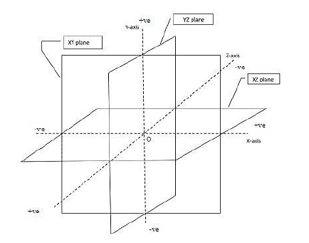

**Fig-2: View of the planes**

**B. View of the shafts**

Below diagram shows a different view of the shaft arrangement which are skew and angle between them is 90 degrees, which helps us in the understanding of the arrangement of shafts. In below figure (a) front view (b) side view (c) top view.

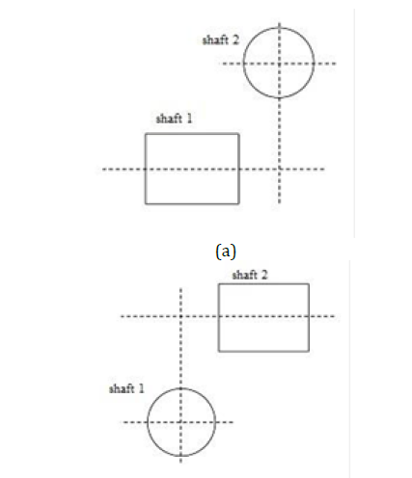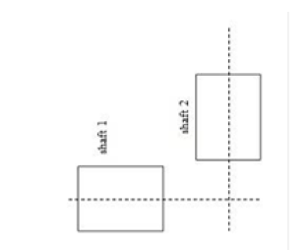

**Fig-3: View of Shafts Arrangement**

**C. Views of Setup**

Different views of the setups are shown in Figure (a) Front view. (b) Side view (c) Top view. These views show the arrangement of links and shafts**.**

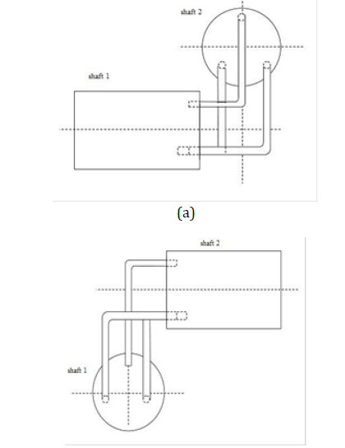

**(b)**

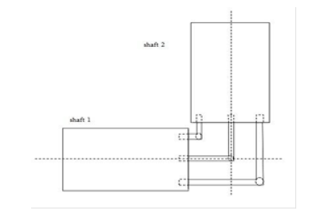

(c)

**Fig-4: View of the setup**

**D. Views of the Pins**

Here different views of the pins according to the setup are shown (a) Front view (b) Side view (c) Top view. These pins are used for transmitting the power when there is no change in orientation of shafts during motion

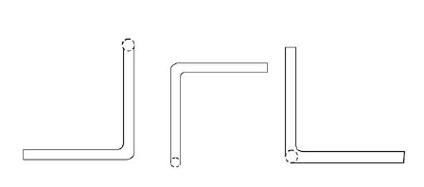

(a) (b) (c)

**Fig-5: View of pins**

**E. Arrangement of Pins in Shaft**

In the below diagram for basic arrangement of pins in the shaft holes are shown. The diagram clearly shows that pins used are in odd no.3, 5, 7, 9… and centers of any two pin holes must not be on that line which represent the diameter of the shaft and angle between all consecutive holes should be equal for smoother power transmission. Value of angle such that it’s multiple with any integral not equal to 180 degrees.

Let the Value of angle = x degree, then n*x ≠ 180 degree. Where n is an integral value.

As mentioned, Angle between the centers of any two pin holes must not be on that line which represent the diameter of the shaft because if this happen angle between them is 180 degrees and during motion pins or links use are trying to overlap each other because of this motion interrupted. Also, as we mentioned that pins no. should be odd and angle between consecutive holes are equal so it can be easily understood by below table that why it is necessary.

**Table no.1: Arrangements of pins in shafts**

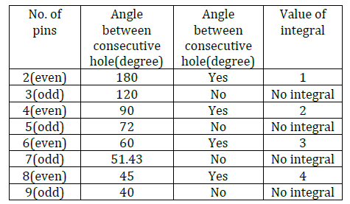

In upper table it is seen that with any no. of pins other than odd there must be an integral whose multiplication with angle gives the value 180 degrees so only odd no. of pins used.

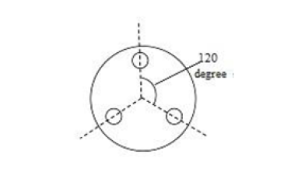

**Fig-6: View of Shaft with Holes**

**F. Analysis of Mechanism**

From the above diagrams and views the setup is clearly established in the mind, but as for convenience here we use the front view of the setup for analyzing the mechanism of setup.

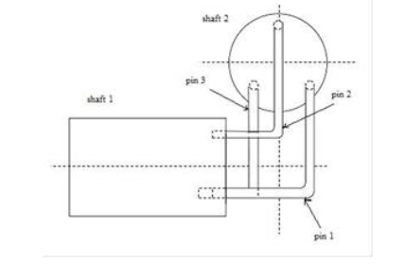

**Fig-7: Setup**

Let at the starting instant shaft 1 starts rotation with 3 pins in anticlockwise direction and a reaction force developed at the pin surface which in contact with the shaft and this force transferred to the other end of the pin which is in the shaft and applying on the shaft 2 due to which shaft 2 starts rotating in the same direction as shaft 1, after 120 degree rotation pin 1 comes at the place of pin 2 & pin 2 comes at the place of pin 3 & pin 3 comes at the place of pin 1 by sliding in shaft and self-adjusting. This motion repeated for next 120 degrees and further for next 120 degrees and pins are exchanging the position in successive order as discussed before.

**3 DESIGN CALCULATIONS**

Testing of the machine and for functioning

Power of motor = ¼ H.P = 746 x 0.25 = 186.5 N- m /s

Rpm of motor N= 1440 rpm

Power of motor P =186.5 watt.

P = 2 πN TP /60 --------- (Eq.1)

Where, N = Rpm of motor = 1440

T = Torque transmitted

From eq.1 we get,

186.5 = 2π×140×T/60

T = 1.23 N-m

T = 1238 N-mm.

**3.1 DESIGNING OF SHAFT**

Following stresses are normally adopted in shaft design

Max tensile stress = 60 N/mm2

Max shear stress = 40 N/mm2

Considering 25 % overload

Tmax= 1238 x 1.25= 1.525 x 10 3 N-mm

The shaft is subject to pure torsional stress

We know T= 3. 14/16 x fs x d3

15250 = 3. 14/ 16 x 70x d3

**D =10.20mm**

Taking factor of safety = 2

D = 10 x 2 = **20mm**

A shaft diameter is 20mm and length is 230mm

𝑀=2151.11𝑁×230𝑚𝑚

**=494755.3𝑁𝑚𝑚**

Bending stress for shaft

𝜎=32𝑀𝜋×𝑑3

**=186.649N/mm²**

Tensional shear stress of shaft

𝑀𝑡=60×106𝑘𝑤2𝜋𝑛

Where, Kw=7.5, n=120

Mt=596831.03Nmm

τ=16Mt/πd³

=16×596831.03/π×203

**=112.57N/mm²**

**3.2 DESIGNING OF HUB**

Considering a hub of internal diameter is 32mm and outer diameter is 92mm, length is 82mm.

𝑝 =100×9.81=981

𝜎𝑏 =𝑝𝐷𝑖2 /𝐷02−𝐷𝑖2

=980×322 /922−322

**=135.01N/mm**

**3.3 DESIGNING OF EL-BOW ROD**

We know that,

Same torque is transmitted to bent link shaft

So torque on each shaft = T /3 = 15250 /3 = 5083 N mm

T= 3. 14/16 x fs x d3

5083 = 3. 14/ 16 x 70x d3

D = 7.17 mm.

Take approximately D=8mm.

Diameter of rod is 8mm and length is 300mm

𝑍 =0.78𝑅3

=0.78×43

**= 49.92 kg/mm²**

Bending stress of rod

σ =PL/4Z

=186.5×300/4×49.92

=**280.19 N/mm²**

**4. WORKING**

The Gearless transmission or El-bow component is a gadget for transmitting movement at any fixed point between the driving and driven shaft. The union of this system would uncover that it includes various pins would be in the middle of 3 to 8, the more the pins the smoother the activity. These pins slide inside empty chambers in this manner organizing a sliding pair. Our system has 3 such sliding sets. These chambers are set in a Hollow funnel and are attached at 120 degree to one another. This entire gathering is mounted on sections wooden table. Force is provided by an electric engine. The working of the instrument is comprehended by the graph. An unused type of transmission of intensity on shaft situated at a point. Movement is transmitted from heading to the determined shaft through the streets which are bowed to fit in with the edges between the poles. These streets are situated at in the gaps similarly separated around a circle and they are allowed to slide in and out as the pole spins. This kind of drive is particularly appropriate where very activity at fast is basic yet prescribed for high obligation.

The activity of this transmission will be evident by the activity of one pole. During an upheaval. On the off chance that we expect that driving shaft "An" is spinning as showed by bolt the determined shaft B will pivot counter clockwise. As shaft A turns through half insurgency C appeared in the inward and best driving position slides out of the two shafts An and B The main half upset and bar "C" at that point will be at the top then during the staying a large portion of this pole "C" slide in wards until it again reaches to internal most position appeared in Fig. in the in the interim different streets have obviously gone through a similar pattern of developments all bars are progressively sliding inwards and outwards Although this transmission is an old one numerous technicians are wary about its activity, anyway it isn't just practicable yet has demonstrated good for different applications when the drive is for shafts which are for all time situated at given point.

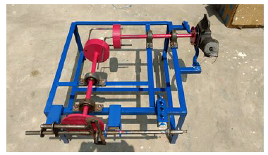

**Fig-7: Gearless power transmission for skew shafts**

In spite of the fact that this representation shows a correct edge transmission this drive can be applied likewise to shafts situated at middle point somewhere in the range of (0 and 90 degree) separately. In making this transmission, it is basic to have the openings for a given bar found precisely in similar gaps must be similarly dispersed in outspread and circumferential ways, be corresponding to every bar ought to be twisted to at edge at which the pole are to be found. In the event that the gaps bored in the parts of the bargains have "daze" or shut closures, there should be a little vent at the base of every bar opening for the getaway of air compacted by the siphoning activity of the poles.

**5. COMPARISION WITH EXISTING SOLUTIONS**

* This arrangement gives the coverage of a wide range of shaft diameter, which may be standard or non-standard which is not possible in the existing gear arrangement because the manufacturing of gears for skew shafts very complex and because of standardization its only use of shafts of standard diameter.
* Proposed gear less transmission with pins can be used for very high speeds and for high loads which is comparable to the worm gear and not possible for crossed helical gears.
* This system not having any possibility of like sliding and point contact as in crossed helical gears so power loss is very low in introduced arrangement and used for high loads with proper rigidity of shafts and pins.
* The main and very interesting advantage of this proposed system is that we can changes the position of shafts during motion or during intermittent position according to need by using given type of links at the place of pins which is not possible in any existing system till now.
* Since any dimension of any component used is not out the shafts dimensions limit, a large reduction in the size of the machines is possible .in short a large space saving should be done.
* Repairing cost on failure of any component is very low.
* Very low setup cost.
* Easy and time saving installation of setup.
* Easy manufacturing of links and pins in comparison of crossed helical and worm gear.
* Very less skill is required for setup.

**6. APPLICATIONS**

The featured product has its widest application as an extension for a socket wrench. Here the design makes it easy to reach fasteners in the automotive and other mechanical industries, where direct access to bolts and screws is often limited. However, the possible applications for this technology extend into numerous fields. Just think of the possibilities for power transmission in push bikes, toy sand hand-cranked equipment, or for movement transmission in store and Outdoor signage.

* Driving for all kinds four faced tower clocks. The elbow mechanism was made use of the “Big Ben Clock” having four dials on the tower of London. This clock was installed on 1630 AD and still it is functioning in good condition.
* The mechanism is invariable used for multiple spindle drilling operation called the gang drilling.
* Used for angular drilling between 0 to 90 degree position.
* Lubrication pump for C.N.C. lathe machines.
* The mechanism is very useful for a reaching a drive at a clumsy location.
* Air blower for electronic and computer machine.
* The mechanism has found a very usefully use in electronic and computer technology for multiple.
* The elbow mechanism is used for movement of periscope in submarines.

**7. RESULTS**

The final design thus obtained is capable of transmitting torque and power at varied angles depending on the angular limitation of the hooks joint. With further research and advanced analysis in the design wide-ranging applications of the drive can be discovered.

The model works correctly as per the design. With the help of this system, we can efficiently reduce the cost in power transmission and further advancement in this technology can be made.

There is clear in design and Fabrication of our project is safe at 140rpm to 260rpm for gearless transmission system.

**8. CONCLUSION**

During dealing with exploratory arrangement and after a meaningful conversation it is seen that proposed game plan utilized for any arrangement of measurements with any profile of shafts for slant shafts of any point however the pole's must have the rotational movement about his own pivot, transmission of movement is smooth and alluring and utilized distinctly for the equivalent R.P.M. of driving shaft and driven shaft by utilizing connections or given sort of connections for suitable joints for revolute pair.

Some fruitful mechanical gadgets work easily anyway poor fly they are made while different does this just by ideals of a precise development and fitting of their moving parts.

This ventures which looks basic and simple to build was in reality exceptionally hard to consider and envision without seeing a real one by and by. Movements requests to be considered first and we have done that very thing. We find that while satisfactory investigation for existing component can frequently be Made effectively we can't without knowledge and creative mind make compelling combination of new system consequently we are shape to introduce this our venture gear less transmission at 90 degree (El-bow instrument) which we have figured out how to effectively gadget after long and hard contribution to imagining its working rule.

**REFERENCES**

[1]Prof. A. Kumar and S. Das, “An arrangement for power transmission between co-axial shafts of different diameter”, International Journal of Engineering Research and Technology (IJERT), ISSN: 2278-0181, Volume 2, Issue 2, March 2013, Page .no: 338-347.

[2]Prof. B. Naveen Bardiya, T. karthik, L Bhaskara Rao “Analysis and Simulation of Gearless Transmission Mechanism", International Journal Of Core Engineering & Management (IJCEM) ,Volume 1, Issue 6, September 2014, Page.no: 136-142.

[3]Prof. Mahantesh Tanodi, “Gearless power transmission-offset parallel shaft coupling", International Journal of engineering Research and Technology (IJERT), volume 3, Issue 3, March 2014, Page.no.129-132.

[4]R.S. Khurmi and J.K Gupta, “Theory of machines”, S. Chand publications, Hyderabad, IInd edition, 2008, Page.no: 569-589.

[5]https://www.youtube.com/watch?v= School of Mechanical and Building Sciences.

[6] Book s. s. rattan Mc Graw Hill Education (India) private limited, New Delhi.

[7] PSG Design data book by Dr. P. Mahadevan.