Abstract---Educational institutions attempt to collect feedback from students to study their sentiment towards courses and facilitates provided by the institution to improve the college environment. In present scenario, grading technique is used for feedback. This grading technique does not reveal the true sentiment of students, but the textual feedback provides a chance to the students to highlight certain aspects. In this paper, a method has been proposed for sentimental analysis of student feedback using machine learning algorithms such as Multinomial Naïve Bayes, Support Vector Machine and Random Forest. A comparative analysis is also conducted between these machine learning techniques. The experimental results suggest that Multinomial Naïve Bayes is more accurate than other methods.
Sentimental Analysis of Student Feedback using Machine Learning Techniques

Index Terms: Sentimental analysis, Multinomial naïve Bayes, Machine Learning

INTRODUCTION
Feedback is the information sent to an individual about its past behavior so that individual can adjust the current and future behavior to achieve desired result. Feedback plays an important role in education and learning by helping to adopt new knowledge and prevent repetitive mistakes. In matters concerning quality in higher education, a lot of people wonder about whose opinion should really be taken seriously or has greatest importance in the decision-making processes. Feedback is considered as an essential approach to facilitate student’s development as independent learners in order to monitor, evaluate, and regulate their own learning. Good feedback practice provides useful information to the students in improving their learning.
Depending on the feedback given by students it can be classified as textual or grading (Likert-scale based score) form. In Likert-scale based score a set of questions are given to the students and they are asked to answer each of the question using a five-point scale. This technique mainly focuses on questions that is related to same topic and it does not express the exact sentiment of the students.
In order to know the exact sentiment of the students textual feedback technique is used.In this textual form students are given with set of questions and they need to answer it in sentences.It is helpful to both the instructor and the academic administration to overcome the issues related to their organization. In this paper, the student feedback with varied opinion is collected using Google forms. The aim is to extract expressions of opinion and classify it as positive, negative or neutral using machine learning techniques.

Sentimental Analysis is a method for identifying the sentiment expressed in texts. The need of Sentiment Analysis of text has gained more importance in today’s situations faced by the people of the world. Generally, there are three approaches in sentimental analysis. They are machine learning based, lexicon based, hybrid approach. In machine learning technique, it uses unsupervised learning or supervised learning. Classification problem can be carried out using several algorithms like naive Bayes, Support vector machine, Random forest. In Lexicon based method sentiment polarity of the textual content is detected using sentiment lexicon. A lexicon is a list of words with associated sentiment polarity. Hybrid approach is a combination of machine learning and lexicon-based methods. The training data set is labelled using sentiment lexicon and this is used to for the machine learning model. Then testing data is evaluated using this model.

The rest of this paper is organised as follows: In section ‘Literature Review’ we provide a brief description about some work related to sentiment analysis and machine learning techniques. The process of classification of text into different classes using feedback obtained from students are presented in section ‘Methodology’. Comparative analysis of different machine learning algorithms based on accuracy and F-score are presented in section ’Performance Analysis’. section ‘Conclusion’ concludes the section.

LITERATURE REVIEW
Lot of work has been done in the area of sentiment analysis. However, there was not much research done in area of text classification which classifies the sentence into three classes i.e. positive, negative and neutral.

Sentiment analysis aims at identifying, analyzing and extracting opinions from texts. This paper describes hybrid approach for performing sentiment analysis and it is done using TF-IDF and domain-speciﬁc sentiment lexicon. However, the limitation of this approach is, it only computes overall sentiments of feedback that is provided by the student [1].

In [2] an overall survey is conducted in three major field to analyze the sentiment i.e. framework, feature extraction and sentiment analysis. The methods used in current research are focused and the existing problems of those studies are discussed.

In paper [3] Supervised learning methods like Support Vector Machine and Naive Bayes are considered as standard learning method. Accuracy provided by support vector machine is good when compared to other classifiers. This paper concludes that Naïve Bayes learning method performs better if small data set is taken and SVM performs better if large data set is taken.

The paper [4] proposed a data mining methodology to rate the faculties into the classes i.e. from 1 to 5 of an institution by considering certain characteristics. Text mining and Naive Bayes classifier was used to process the feedbacks received from the students. The drawback of this paper was it did not reveal the true sentiment of students.

To process the number of feedbacks that are gathered at the end of semester was tedious job and time consuming. This paper addresses this problem and uncovers the model for analyzing these feedbacks by using machine learning techniques such as Maximum Entropy (ME), Support Vector Machine (SVM), Naïve Bayes in [5,6].

The paper [7] explains the sentimental analysis on twitter data using Decision tree and Multinomial Naive Bayes algorithms. Results concluded that Decision tree algorithm performs better using parameter accuracy, recall, precision, and F1-Score.

In paper [8], Naïve Bayesian approach was used for text and document classification. For the classification 1150 documents were considered and to extract the features n-gram method was used. The performance was measured by considering the performance parameters such as recall, and f-measure, precision, accuracy.

The paper [9] solves problem of sentiment polarity categorization. The data selected for this work is Online product reviews from Amazon.com. A sentiment polarity categorization process was proposed. Categorization for both sentence-level and review-level were performed to estimate the result.

METHODOLOGY
The Student feedback collected using Google form is an input data. i.e. training data using which the system is trained. On receiving test samples, the trained system classifies the sentence as positive, negative and neutral classes using machine learning algorithms. This outcome is graphically represented. The proposed methodology consists of six steps: preparing training data, collecting student feedback, Feature Extraction, Model training, Evaluation of test data, graphical representation of the result as shown in Figure 1.

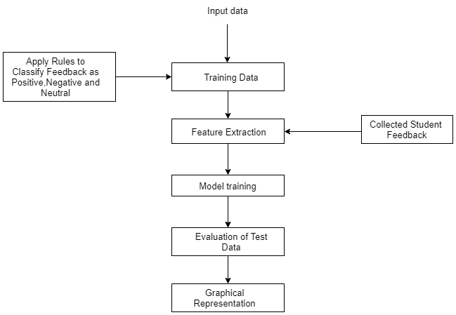
Figure 1: Methodology of sentiment analysis
To carry out these steps data required is collected through student feedback.

1. Preparing training data:
Machine learning is classified into supervised and unsupervised learning. In supervised learning the sentences are given with label of classes, whereas labels are not provided in unsupervised learning. Training data is collected for each question which is used to train the system. This training data is the responses in the form of sentence from the students. Each sentence is converted to lower case and is given as input to the SentimentIntensityAnalyser() method which is available in package VaderSentiment. VADER (Valence Aware Dictionary and Sentiment Reasoner) sentiment analysis returns a sentiment score in the range -1 to 1 from negative to positive. Individual words have sentiment score between -4 and 4. The sentiment score (Compound Score) of a sentence is calculated by summing up the sentiment scores of each VADER-dictionary-listed word in the sentence and normalized to map it to the value between 1 and -1 [10]. The normalization used by Hutto is
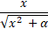
Where x is the sum of the sentiment scores of constituent words of a sentence and α is the normalization parameter set to 15.
If the compound score is >=0.05 the sentence is classified as positive, if the compound score is >-0.05 and <0.05 the sentence is classified as neutral, if the compound score is <=-0.05 the sentence is classified as negative.

2. Collecting Student Feedback:
The questions are sent to students through Google form and the student responses are collected and stored in Microsoft Excel Comma Separated Values File. Google forms containing feedback questions are shown in Figure 2.

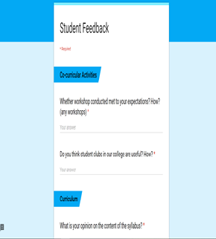
Figure 2: Google Forms containing feedback questions

3. Feature Extraction:
This process involves feature extraction in a format required by machine learning algorithms from datasets which consists of formats such as image and text. Both train and test data are subjected to Feature Extraction. The Scikit-learn library offers tools to perform both feature extraction and tokenization of text data. CountVectorizer provides a simple way to both tokenize a collection of text documents and build vocabulary of known words.
It works as follows:
a. Create an object of the CountVectorizer class.
b. Invoke the fit() function to learn a vocabulary from one or more documents.
c. Invoke the transform() function on one or more documents as needed to encode each as a vector.

4. Model Training:
There are many different algorithms for text classification with machine learning.

a) Multinomial Naïve Bayes classifier
The basic idea involved in Naive Bayes classification technique is to find the classes probabilities assigned to texts by using joint probabilities of classes and words. The features/predictors used by the classifier are the frequency of the words present in the document.

ALGORITHM
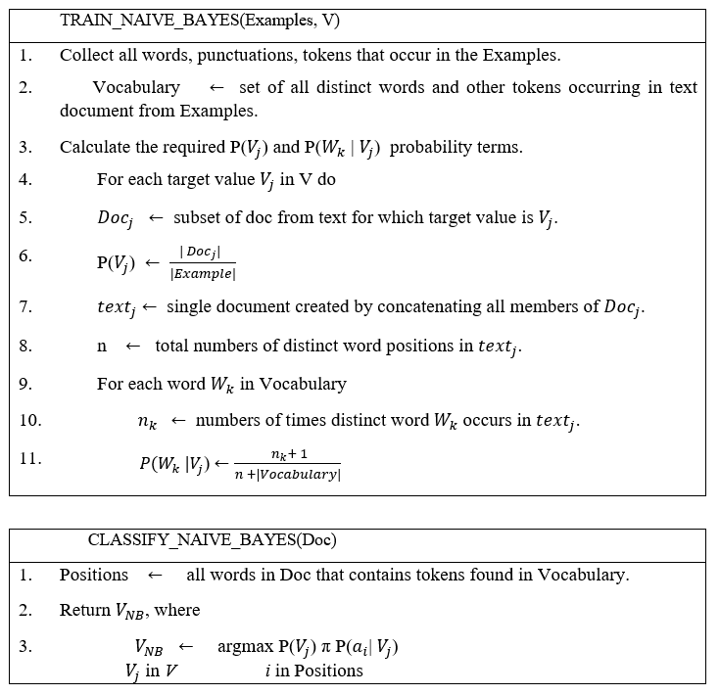 Source: [11]
b) Support Vector Machine
SVMs are supervised learning models that examine data used for classification and regression analysis. A support-vector machines constructs a hyperplane or set of hyperplanes in an n-dimension space, which can be used for regression, classification or another task. Support Vector Machine is used to categorize the data points by mapping data to a high-dimensional feature space, even when the data is not linearly separable.First a separator between the categories is found, then the data is transformed so that hyperplane is drawn as a separator. At the end, new data characteristics are used to predict the class for a new record.

c) Random Forest
Random Forest is a supervised learning method. It can be used for both regression and classification task. Random Forest algorithm creates a forest with number of trees. As the number of trees in the forest increases accuracy also increases.

General steps in Random Forest:
Step 1: Creation of random vectors.
Step 2: Using random vectors to build multiple decision tree.
Step 3: Combining decision trees.

5. Evaluation of the test data
Evaluation is the process of collecting and analyzing data, where the resulting information can be used to determine whether an organization is effectively carrying out the planned activity. This corresponds to the final evaluation that the model goes through after the training phase has been completed. This step is critical to test the generalizability of the model by using test set we can get the working accuracy of the model.

6. Graphical representation
Data visualization is the presentation of data in graphical format. Python offers multiple graphical libraries that provide different features. Matplotlib is one among them. It is the library which offers lot of freedom at the cost of having to write more code.

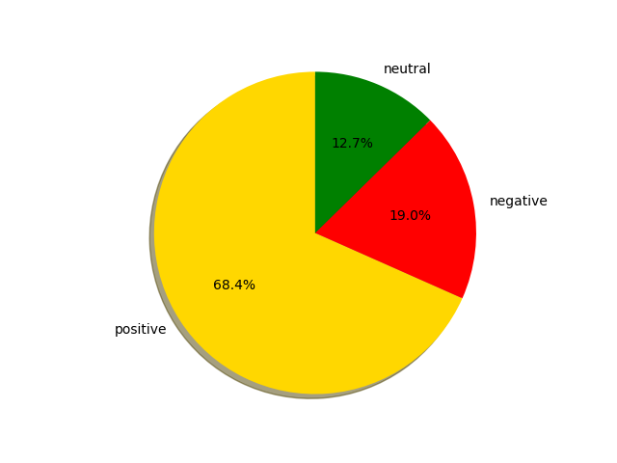
Figure 3: Graphical Representation of the result

PERFROMANCE ANALYSIS
In this section, a comparative analysis is carried out using three machine learning algorithms such as Multinomial Naïve Bayes, Random Forest and Support Vector Machine for unigram and bigram based on accuracy and F score. Unigrams is a sequence of single element from a string of tokens whereas bigram is a sequence of two element from a string of tokens.

Test dataset is used to evaluate the performance of learned model. The following metrics were considered: Accuracy, F Score.
Accuracy: Accuracy is deﬁned as the ratio between number of correct predictions done by the model to the total number of rows in the dataset.

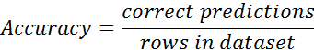

F-score: It is the weighted average of recall and precision.
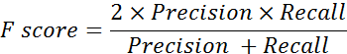

The graphs in figure 4 and 5 shows the accuracy of the Support Vector Machine, Multinomial Naïve Bayes and Random Forest for unigrams and bigrams by keeping the test data constant and varying the size of the train set. It can be observed that as the training data increases accuracy also increases. When we compare MNBC with Random Forest the accuracy of MNBC increases as the model is trained with more data whereas, the accuracy of Random Forest does not vary linearly due to lot of randomization in the training phase. Also, machine learning algorithms with unigrams perform better than bigrams.

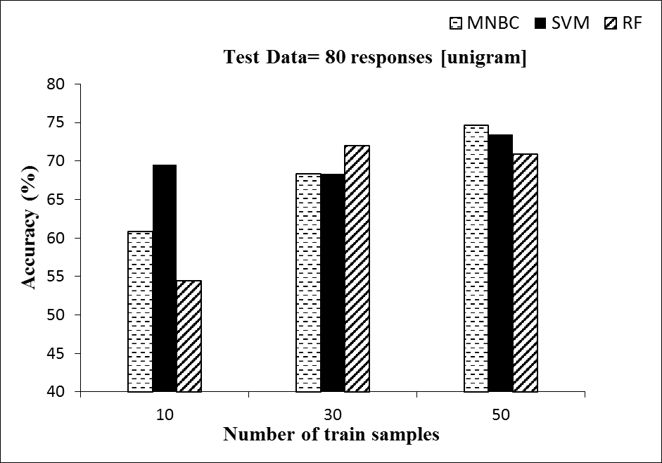
Figure 4: Plot of accuracy versus Number of train samples for Unigram

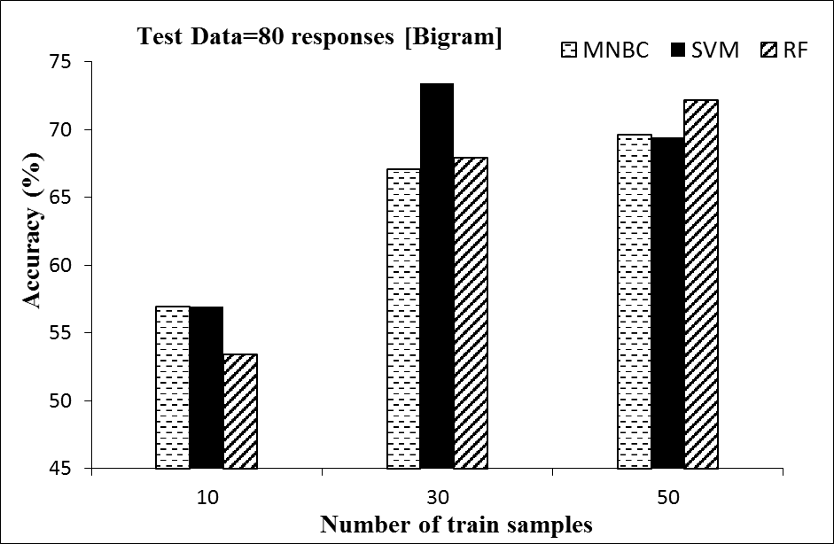
Figure 5: Plot of accuracy versus Number of train samples for Bigram

The graphs in figure 6 and 7 shows the F Score of the Multinomial Naïve Bayes, Support Vector Machine and Random Forest for unigrams and bigrams by keeping the test data constant and varying the size of the train set. It can be observed that F Score of Multinomial Naïve Bayes and Support Vector Machine algorithm increases linearly as the training data increases.

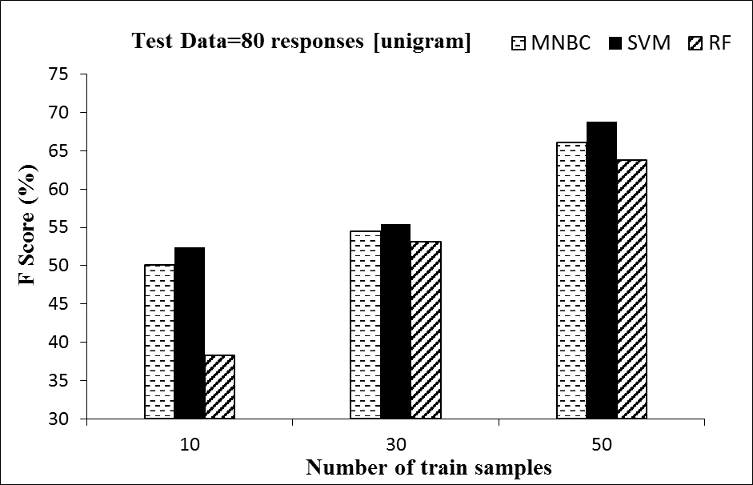
Figure 6: Plot of F Score versus Number of train samples for Unigram

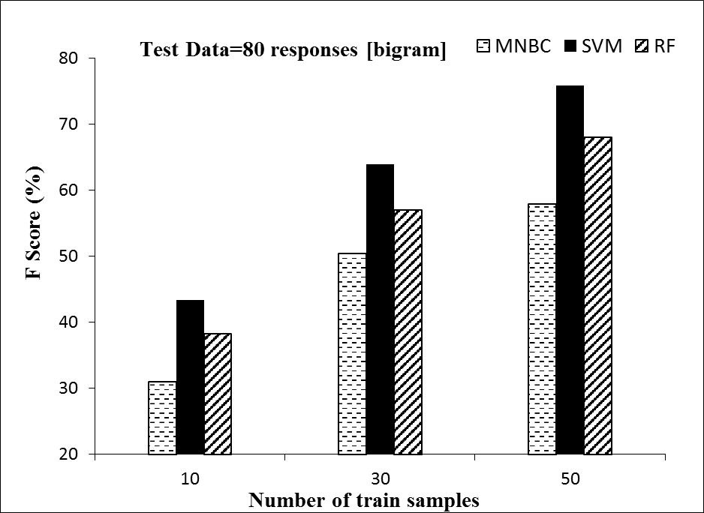
Figure 7: Plot of F Score versus Number of train samples for Bigram

The figure 8 depicts the F Score of the Support Vector Machine, Multinomial Naïve Bayes and Random Forest for unigrams by keeping the train data constant and varying the size of the test set. Analysis shows that accuracy of MNBC is 0.77%-1.27% better than Random Forest and SVM performs 0.78%-0.81% better than MNBC.

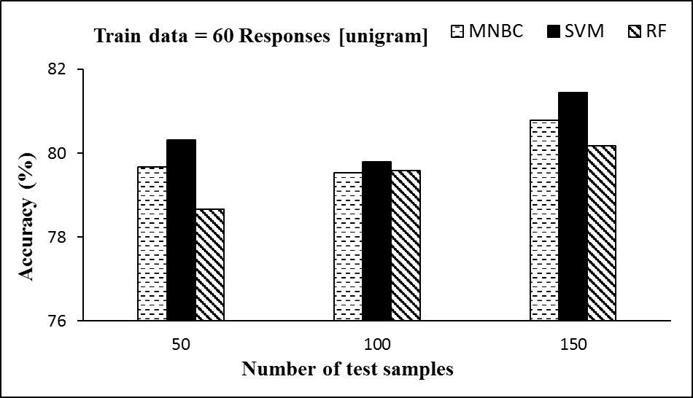
Figure 8: Plot of Accuracy versus Number of test samples for Unigram

CONCLUSION
Grading based feedback has disadvantage that it does not reveal exact sentiment of the students. To overcome this disadvantage textual feedback is used. Sentimental analysis enables institution to know the sentiments of the student using their feedback. From this analysis they can improve the quality of teaching and college environment. This project can also be used to obtain student’s opinion towards an event, workshops etc.

In this paper to perform sentimental analysis, first the feedback was collected, given to the trained model and the sentiments are classified. A comparative study suggests that Multinomial Naïve Bayes algorithm is more accurate when compared to Support Vector Machine and Random Forest algorithms. From the analysis we could say that Multinomial Naïve Bayes algorithm performs better with accuracy of 80% when compared to other two algorithms. Future work in this field can be focused on increasing the accuracy of the model by considering large training data.

REFERENCES
- Z Nasim, Q Rajput, S Haider. “Sentiment Analysis of Student Feedback Using Machine Learning and Lexicon Based Approaches”, pp.1-6, 2017.
- Z. Nanli, Z. Ping, L. I. Weiguo, C. Meng, “Sentiment Analysis: A Literature Review”, Proceedings of the 2012 IEEE ISMOT, pp. 572-576, 2012.
- B. K. Bhavitha, A. P Rodrigues, N. N Chiplunkar, “Comparative Study of Machine Learning Techniques in Sentimental Analysis”. International Conference on Inventive Communication and Computational Technologies, pp.216-221, 2017.
- K S Krishnaveni, Rohit R Pai, V. Iyer, “Faculty Rating System Based on Student Feedbacks Using Sentimental Analysis”, International Conference on Advances on Computing, Communication and Informatics, pp.1648-1653, 2017.
- M. A. Ullah,” Sentiment analysis of students feedback: a study towards optimal tools”, International Workshop on Computational Intelligence (IWCI), pp. 17-180, 2016.
- M. D. Devika, Sunitha, A. Ganesh “Sentiment Analysis: A Comparative Study on Different Approaches”, Fourth International Conference on Recent Trends in Computer Science & Engineering, Procedia Computer Science 87, pp. 44 – 49,2016.
- A. P Jain, P. Dandannavar, “Application of Machine Learning Techniques to Sentiment Analysis”, Proceeding of 2018 IEEE International Conference on Current Trends toward Converging Technologies, pp. 628-632, 2018.
- M. BAYGIN, “Classification of Text Documents based on Naive Bayes using N-Gram Features”, International Conference on Artificial Intelligence and Data processing (IDAP), pp. 1-5, 2018.

- X. Fang, J. Zhan, “Sentiment analysis using product review data", Journal on Bigdata, pp.2-5, 2015.
- VaderSentimental Analysis [Online], www.github.com/cjhutto/vadarSentiment/blob/master/README.rst/introduction; [Accessed May 7, 2019]
- T. M. Mitchell, Machine Learning, India Edition 2013, McGraw Hill Education.
- Y. Huang, Lei Li, “Naive Bayes classification algorithm based on small sample set”, Proceedings of IEEE International Conference on Cloud Computing and Intelligence System, pp.34-39, 2011.
- H. P. Patil and M. Atique, "Sentiment Analysis for Social Media: A Survey," 2nd International Conference on Information Science and Security (ICISS), Seoul, pp. 1-4, 2015.
- G. Qiang, “Research and Improvement for Feature Selection on Naive Bayes Text Classifier”,2nd International Conference on Future Computer and Communication, pp. V2-156-V2-159, 2010.
- W. Medhat, A. Hassan, H. Korashy, “Sentiment analysis algorithms and applications: A survey”, Ain Shams Engineering Journal, pp. 1093–1113, 2014.
- J. Singh, G. Singh and R. Singh, “Optimization of sentiment analysis using machine learning classifers”, Human-centric Computing and Information Sciences, Volume 8, Number 1, 2018.
- Xu, Shuo & Li, Yan, Zheng, Wang, “Bayesian Multinomial Naïve Bayes Classifier to Text Classification”, pp. 347-352, 2017.
- Wang, Yong & Hodges, Julia & Tang, Bo, Classification of Web Documents Using a Naive Bayes Method. IEEE Transactions on Applications and Industry, pp.560- 564, 2003.
- J. Maier and K. Ferens, "Classification of english phrases and SMS text messages using Bayes and Support Vector Machine classifiers," 2009 Canadian Conference on Electrical and Computer Engineering, St. John's, NL, pp. 415-418, 2009.
- Bouazizi, M., & Ohtsuki, T. Sentiment analysis in twitter: From classification to quantification of sentiments within tweets. 2016 IEEE Global Communications Conference, GLOBECOM, 2016.
- N. Sharma and M. Singh, "Modifying Naive Bayes classifier for multinomial text classification," 2016 International Conference on Recent Advances and Innovations in Engineering (ICRAIE), Jaipur, pp. 1-7, 2016.
- S. K. Khatri and A. Srivastava, "Using sentimental analysis in prediction of stock market investment," 2016 5th International Conference on Reliability, Infocom Technologies and Optimization (Trends and Future Directions) (ICRITO), pp. 566-569, 2016.

 

