**Assessment of Road Safety Audit of NH-69, Karnataka State, India**

**Jayaprakash M C, Shreyas K S, Vikram M C and Manasa Nair**

***Abstract*: *Road Safety Audit (RSA) is a formal procedure for assessing accident potential and safety performance of new and existing roads. RSA is an efficient, cost effective and proactive approach to improve safety of the road users with leading to any trend of accidents and their impacts. RSA appears to be an ideal tool for improving road safety in India, as basic and accurate data on accidents have yet to be collected in a scientific way as well as in a systematic method. It is evident from the traffic composition for the countries like India, where heterogeneous traffic with varying vehicle types differing in their vehicle static and dynamic characteristics.***

***The project stretch considered is NH-69 (Bhadhravathi to Shivamogga – Karnataka State) ranging 22.1 Kms. The present study deals with road inventory, signage inventory, traffic volume count survey, spot speed study, Speed and delay study and other surveys such as topographic survey and Accident data has been collected for the stretch for a period of 2012-16 is collected and analysis is carried out. The study aims to evaluate Road Safety Audit of a section of four-lane National Highway (NH)-69 and will focus on evaluating the benefits of the proposed actions that have emanated from deficiencies identified through the audit process. Missing road and median markings to be done and speed signs should match with speed. Access and service lanes are also deficient which requires immediate improvement.***

***Keywords (Index Terms)*: *Road Safety Audit (RSA), NH-69,*** ***road safety in India and speed signs.***

# INTRODUCTION

In 1980’s the Road Safety Audit (RSA) process was started in the United Kingdom. On 11 May 2011, the plan of action for Road Safety 2011-2020 was launched around 100 countries including India. The main goal of the plan is to prevent five million road traffic deaths globally by 2020 *(Arun S Bagi et al.).* Road safety audit has the greatest ability when it is considered for traffic design before and after the construction stage. Main purpose of RSA is to focus on the accident influential and safety condition of the highways. RSA is a formal procedure having definite aim with standard procedure. For the effective outcome, its need to be conducted by appropriate experienced and trained persons and they should be of independent of design team. An audit procedure initiates from beginning of design and at construction stage.RSA can also conducted on the existing road, so it can help to identify the deficiencies and form

**Revised Manuscript Received on December 22, 2018**.

**Jayaprakash M C**, Department of Civil Engineering, Mangalore Institute of Technology & Engineering, Mangalore, India.

**Shreyas K S**, Department of Civil Engineering, Mangalore Institute of Technology & Engineering, Mangalore, India.

**Vikram M C**, Department of Civil Engineering, Jawaharalal Nehru National College of Engineering, Shivamogga, India.

**Manasa Nair**, Department of Civil Engineering, Mangalore Institute of Technology & Engineering, Mangalore, India.

opportunity becomes to identify the highway engineering measures to improve safety.

The start of this century, the rate generation of mechanized vehicle has been expanding constantly. The awesome increment in number of engine vehicles out and about has not similarly coordinating with relating increment in complete length of highway arrange *(S. S. Jain et al.,).* The highway length has not possessed the capacity to take care of the demand made by the gigantic development of vehicle populace. The blended movement condition winning on our street organize has additionally exasperated the activity circumstance. Along these lines the vehicles populace increments in step by step *(Atul Kumar)*. Because of this advancement with changing condition situation, the rates of mishaps are expanding radically. RSA is the principle worry to lessen mischance. Mischance fatalities rate in India is high in the correlation with that in the created nations.

Fundamental methodologies of road safety are counteractive action and diminishment of accidents. In accident decrease, consciousness of accidents that happened on existing highway to enhance the outline of highway or to impact the conduct of road user is utilized *(S. S. Jain et al.,)*.

In accident prevention, learning of aptitude in safe street outline – street geometry, and in addition the materials utilized. Accident reducing action ought to be the fundamental target of the highway specialist to guarantee that the roads are safe *(Pavan Deshpande).* At the point when the accident rate is least on roadway extend then the highway is to be considered as more secure for road user. In the event that accident rate is more than the street is not protected, paying little respect whether all principles were seen amid arranging and plan

# Road Accident Scenario in India

The Road safety is more important in India because close to 5, 00,000 road accidents and nearly 1, 46,000 deaths caused in 2015.Non highway roads witnessed 47.6% of total accidents. This is followed by NH with a rate of 28.4% and SH with 24%. The 2% length on National Highway carry 40% of good traffic, while 7% of State Highway carry 30% of good traffic. The road safety on Indian roads has slowly worsened over the past years. As seen from the below table and graph, number of deaths is increased year by year *(Pavan Deshpande).*

# Project location

NH-69 is a major National Highway in India that runs along the states of Andhra

Pradesh and Karnataka. The western terminal is at the junction of NH-66 near Honnavara and terminates at the east end at Chittoor. It passes through Honnavar, Sagara, Shivamogga, Banavara, Sira, Madhugiri, Chinthamani, and Mulabagilu in Karnataka and in Andhra Pradesh it passes through Palamaner, Chittoor. NH-69 is 625 km in length.

# Study Area

A portion of NH-69 was selected for project.The selected stretch has a bypass portion of Bhadravathi. Thestretch starts from Km 183.100 (at joining of bypass and NH-69) and ends at Km 205.2 (at MRS circle). The length of study section is approximately 22.1Kms.

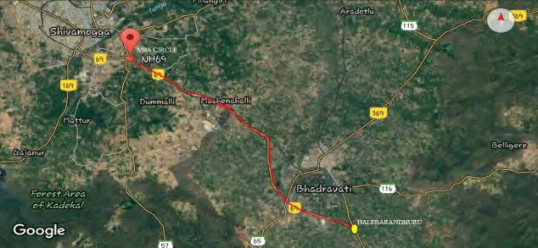

**Fig. 1:** Spatial view of study area

# OBJECTIVES

* To examine safety features and find out deficiencies and conflict point in the road network which lead to accident and safety hazards to road users.
* To conduct a RSA according to specification given in the IRC:SP:88:2010

# METHODOLOGY

pedestrians, cyclists, motorcyclists, truck/bus drivers, on-road public transport users, etc. So for that different data’s are collected like accident data, traffic data and road inventory data.

# Accident statistics

The road accident data was collected from Tunganagara Police Station, Vidyanagara Police Station, and Bhadravathi Traffic Police Station limits of five years data from 2012-16.

## *Accident data from Bhadravathi Police Station (ch.183.100*

***– ch.192.500)***

***Table 1:*** *Year Wise Road Accident Statistics of Selected Stretch*

|  |  |  |  |
| --- | --- | --- | --- |
| Year | No of accidents | Total no. of deaths | Total no. of injuries |
| 2012 | 43 | 4 | 51 |
| 2013 | 41 | 7 | 57 |
| 2014 | 51 | 15 | 50 |
| 2015 | 28 | 6 | 28 |
| 2016 | 35 | 9 | 32 |

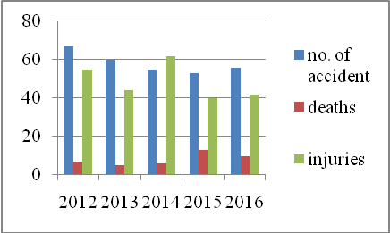

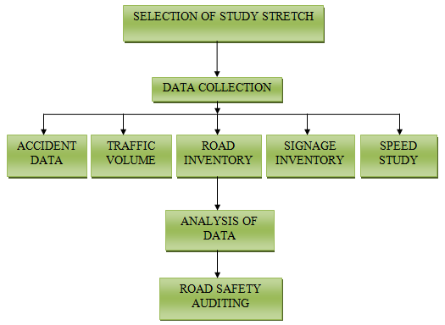

**Fig. 2:** Flow chart of methodology

# RESULTS AND DISCUSSIONS

The main aim of the RSA is to ensure the entire new road and existing road network operate safely. Road safety audits evaluate the operation of a road by focusing on road safety as

**Fig. 3:** Accident Statistics of Selected Stretch (ch.183.100 – ch.192.500)

## *Accident data from Vidyanagara and Tunganagara Police* Station (ch. 192.500– ch.205.200)

**Table 2:** Year Wise Road Accident Statistics of Selected Stretch

|  |  |  |  |
| --- | --- | --- | --- |
| Year | No. of accidents | Total no. of deaths | Total no. of injuries |
| 2012 | 67 | 7 | 55 |
| 2013 | 60 | 5 | 44 |
| 2014 | 55 | 6 | 60 |
| 2015 | 53 | 13 | 38 |
| 2016 | 56 | 10 | 39 |

# Spot Speed Study

Spot speed is the instantaneous speed at a particular section or a point. There are different methods are used. In the first method, the time taken by the vehicle to travel a short distance is determined. Then the instantaneous speed is measured by pre calibrated

radar equipment which

displays or records the speed in

desired units such as kmph. In this project, Radar Gun is used.

Results of spot speed study (**ch.183.100– ch.192.500)**

Modal speed= **49** Kmph.

Design speed (98th percentile) = **80**Kmph. Maximum speed (85th percentile) =**70**Kmph. Minimum speed (15th percentile) =**39**Kmph.

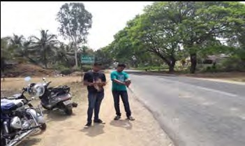

**Fig. 4:** Spot speed study using RADAR

## *At section from ch.183.100 – ch.192.500 (undivided 2 lane* highway) spot speeds are summarized in table below.

**Table 3:** Frequency Distribution of Spot Speed Data

|  |  |  |  |  |
| --- | --- | --- | --- | --- |
| Frequency distribution of spot speed data | | | | |
| Speed range  Kmph | Mean speed  Kmph | Frequency | Percentage frequency | Cumulative frequency |
| 0-10 | 5 | 0 | 0 | 0 |
| 10 20 | 15 | 0 | 0 | 0 |
| 20-30 | 25 | 4 | 3.2 | 3.2 |
| 30-40 | 35 | 12 | 9.6 | 12.1 |
| 40-50 | 45 | 28 | 22.4 | 35.2 |
| 50-60 | 55 | 28 | 22.4 | 57.6 |
| 60-70 | 65 | 24 | 19.2 | 76.8 |
| 70-80 | 75 | 21 | 16.8 | 93.6 |
| 80-90 | 85 | 5 | 4 | 97.6 |
| 90-100 | 95 | 3 | 2.4 | 100 |
| Total | | 125 | 100 |  |

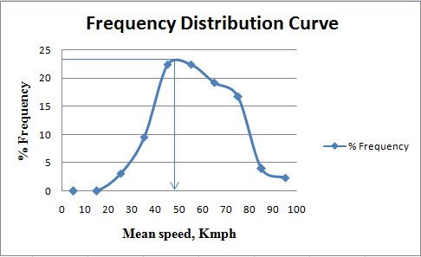

**Fig. 5:** Frequency Distribution Curve

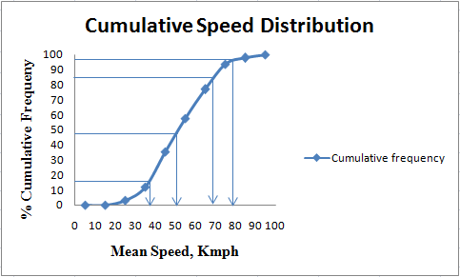

**Fig. 6:** Cumulative Speed Distribution Curve

***Figure 6.*** *Cumulative Speed Distribution Curve*

## *At section from ch.192.500 – ch.205.200 (divided 4 lane* highway) spot speeds are summarized in table below.

**Table 4:** Frequency Distribution of Spot Speed Data

|  |  |  |  |  |
| --- | --- | --- | --- | --- |
| Frequency distribution of spot speed data | | | | |
| Speed range Kmph | Mean speed Kmph | Frequ ency | Percent age  frequen | Cumulat ive  frequenc |
| 0-10 | 5 | 0 | 0 | 0 |
| 10 20 | 15 | 0 | 0 | 0 |
| 20-30 | 25 | 11 | 3.14 | 3.14 |
| 30-40 | 35 | 69 | 19.7 | 22.84 |
| 40-50 | 45 | 87 | 24.85 | 47.69 |
| 50-60 | 55 | 106 | 30.28 | 77.97 |
| 60-70 | 65 | 61 | 17.42 | 95.39 |
| 70-80 | 75 | 16 | 4.57 | 100 |
| 80-90 | 85 | 0 | 0 | 100 |
| 90-100 | 95 | 0 | 0 | 100 |
| Total | | 350 | 100 |  |

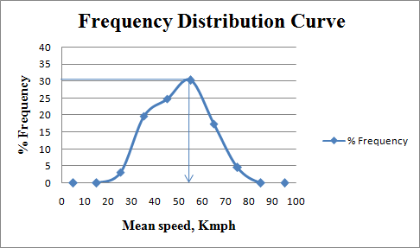

**Fig. 7:** Frequency Distribution Curve

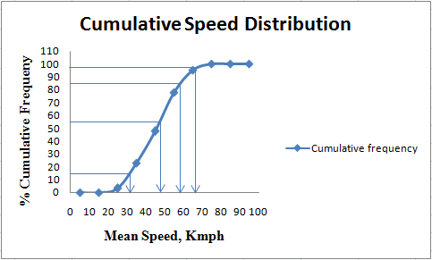

**Fig. 8:** Cumulative Speed Distribution Curve

Results of spot speed study (**ch.192.500– ch.205.200)**

Modal speed= **55**Kmph.

Design speed (98th percentile) = **68**Kmph. Maximum speed (85th percentile) = **60**Kmph. Minimum speed (15th percentile) = **31**Kmph.

# Traffic Volume Count

A traffic count is a count of vehicular or pedestrian traffic, which is conducted along a stretch. Traffic volume study is

conducted to find the number, movements, and classification of vehicles at the given stretch. In this project, volume count is conducted for 3 days i.e., weekend and one working day for 12 hours from 6.00am to 6.00pm.

**Table 5:** Traffic composition (ch.205.200 to ch. 192.500)

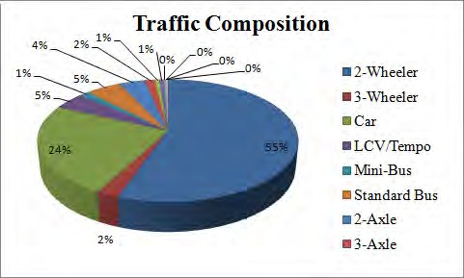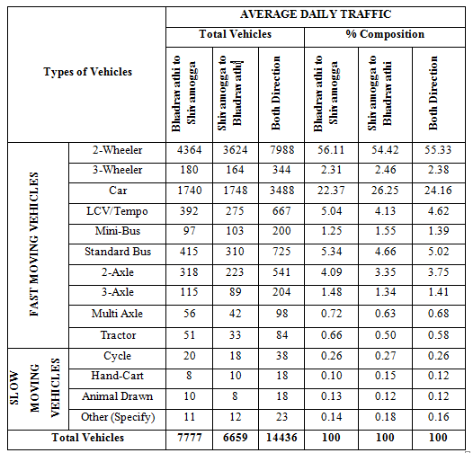

inventory is necessary to know present condition of traffic signs in the selected stretch

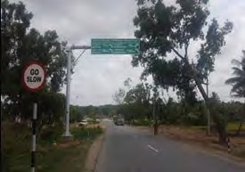

**Fig. 10:** Road inventory at 194.300 Km

# Black spots on National Highway

Road accident black spot is a stretch of national highway of about 500m in length in which either 5 road accidents took place during last 3 years or 10 fatalities took place during last 3 years. With the help of FIR copies around 8 black spots are identified.

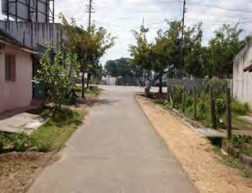

**Fig. 11:** Lack of sight distance

**Fig. 9:** Traffic Composition

In this stretch i.e., from ch.205.200 to ch. 192.500 which is 4 lane highways observed large proportion of two wheelers and cars. Vehicles like bicycles, tractors and animal drawn are very less in the entire study stretch. And also heavy vehicles like trucks are in considerable proportion.

# Road Safety Auditing

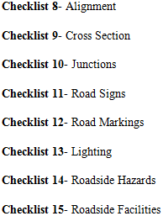

IRC: SP: 88-2010provided the checklist for auditing. These checklists help to guide the road safety audit team. These checklists depict the performance and condition that affects the road network in safety point of view.

IRC: SP: 88-2010 has

provided 18 checklists for auditing. For the existing

# Road Inventory

Road inventory survey was conducted in the selected stretch to know the existing conditions like the roadway width and footpath width, shoulder width, type of pavement, condition of pavement, shoulder, footpath, and details of cross road. Cross section includes width of carriageway, width of shoulders, median, drains etc. Road inventory survey is conducted to know the existing condition of the highway. In RSA, cross section are checked regarding their dimensions are accordance with IRC standards and their performances.

# Traffic Signage Inventory

Road signs are basically of three types namely, mandatory,

cautionary, informatory signs. Therefore traffic signage

highway and for this project checklist are listed as below.

From the road inventory survey, width of shoulder at the selected stretch is not as per IRC standards. The width is varying from 0.3m to 3.0m. Due to the poor maintenance of shoulder vegetation covers the width of shoulder (earthen shoulder) and the strength of shoulder is poor. The fig.15 and fig.16 showing poorly maintained shoulder of inadequate width and strength. During rainy season condition of shoulders would worsen, results in the drainage problem and condition of the pavement may effected.

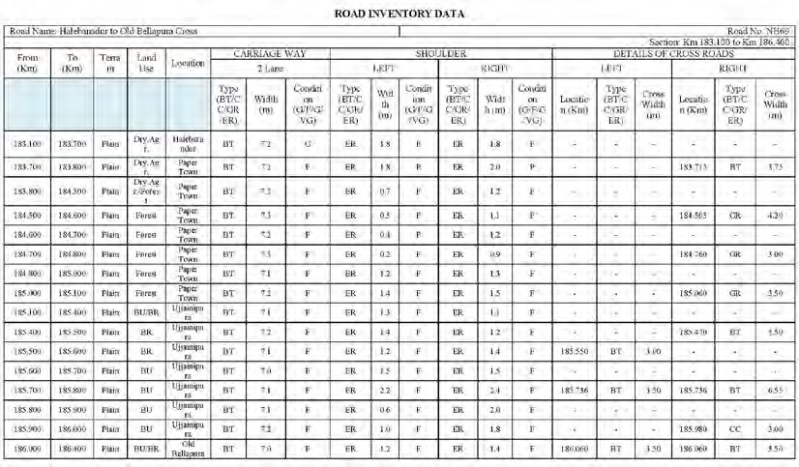

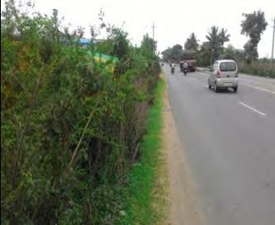 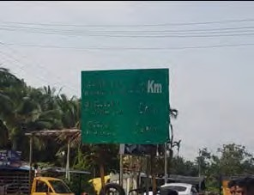

# Median

**Fig. 12:** Inadequate width of shoulder

**Fig. 15:** Poor condition of sign Board at ch.190.100 Km

In selected stretch more number of T- Junction are present. Most of these junction have poor sight distance for the minor roads due to the presence of vegetations, buildings etc. and also sign boards are not installed; speed breakers are not used in minor roads.

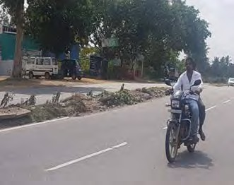

**Fig. 13:** Damaged median at ch.202.300 Km

# Visibility of Signs

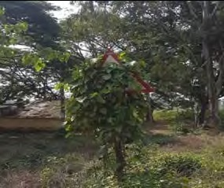

**Fig. 14:** Sign board covered with vegetation at ch.188.100 Km

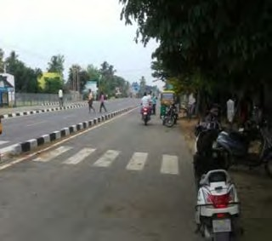**Fig. 16:** Poor visibility of Bus stop at ch.197.300 Km

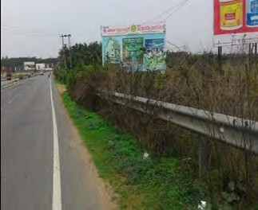

**Fig. 17:** Vegetation covering over barrier

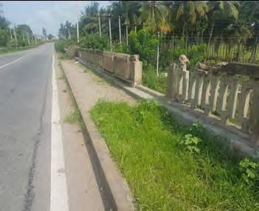

**Fig. 18:** Damaged parapet

# CONCLUSION

The present work is made to conduct road safety audit for the existing highway i.e., from ch.183.100 – ch.192.500 which is bypass section and ch.192.500-ch.205.200 which is four lane highway. Accident data is collected from 3 police stations and it is observed that from 2012-16 accident rates is less varied. Because of recently upgraded four lanes national Highway-69 from km 192.200 to km 205.200, those highway guidelines have been brought up abruptly. Be that as other related factors would not bring should this level for example, road user behavior, encompassing prevailing states and so on.

Many villages come along the project stretch, so intersections are more and also pedestrian traffic and two wheeler traffic is more. But safety measures such as sight distance, placement and maintenance of sign boards, marking at these junctions are not good. Throughout the stretch shoulder width is varying and it is covered by vegetation, so it causes drainage problem and bus bays are occupied for parking and some agricultural activities. Crash barriers are not maintained properly, markings on road, divider are averagely maintained. Reflecting properties of sign boards are damaged due to irregular maintenance.

Hence, there is needed to develop the knowledge about the traffic conditions, sign boards, road markings among the road users and regular auditing to improve the road safety is necessary by highway authorities.

# REFERENCES

* 1. Arun S Bagi and Dheeraj N kumar “ Road Safety Audit” IOSR Journal of Mechanical and Civil Engineering (IOSRJMCE)
  2. Atul Kumar, Engineering Design Standards to Ensure Road Safety: Experiences from India.
  3. Code of Practice for Road marking, IRC:35-1997, Indian Road Congress, New Delhi.
  4. Code of Practice for Road Signs, IRC:67-2012, Indian Road Congress, New Delhi.
  5. Kayitha Ravinder and Dr.JakklaNataraju, scientist, CSIR, “Road Safety Audit of National Highways in India at Construction Stage”.
  6. Manish.D.Katiyari, “Road Safety Audit: A Case Study for Wardha Road in Nagpur City.
  7. Manual for Specifications & Standards for Four Laning of Highways Through Public Private Partnership, IRC:SP-84-2009, Indian Road Congress, New Delhi.
  8. Manual of Standards & Specifications for Two Laning of State Highways on B.O.T. Basis, IRC: SP: 73-2007, Indian Road Congress, New Delhi.
  9. Manual on Road Safety Audit, IRC: SP: 88-2010, Indian Road Congress, New Delhi.
  10. Ministry of Road Transport and Highways, Ref: no.
  11. Ministry of Road Transport and Highways, Ref: no. RW/NH-29011/2/2015/P&M (RSCE).
  12. Pavan Deshpande, Review article on “ Road Safety and Accident Prevention in India”.
  13. Recommended Practice for Road Delineators, IRC: 79-198, Indian Road Congress, New Delhi.
  14. SS Jain, P. K. Singh, Dr. M Parida(9), “Road Safety Audit For Four Lane National Highway”
  15. Type Designs for Pick-up Bus Stops on Rural (i.e., Non-Urban) Highways, IRC: 80-1981, Indian Road Congress, New Delhi.

# AUTHORS PROFILE

**Dr. Jayaprakash M C** has been completed his Ph.D in Geoinformatics in Mangalore University, Karnataka, He worked in many National level natural resources projects which was sponsored by Indian Space Research Organisation, Govt. of India: As a Scientist at KSRSAC,



Bangalore. Presently, he is working as a associate professor in Dept. of Civil Engineering, MITE, Moodabidri since from 2013. He is a life member of *‘The Indian Science Congress Association’*, from2015 and Secretary, CAFET Innova Technical Society, MITE Chapter.

**Mr. Shreyas K S** has been completed M.Tech in Transportation Engineering at JNNCE Shimoga and presently working as Assistant Professor at MITE, Moodabidri.

