Abstract: Concrete structures are susceptible to cracking, creep and possess low tensile characteristics under extreme environment. Application of ureolytic bacteria presents an easier, cheap and environment friendly approach for improving the strength of concrete. In this study, five bacteria were accessed for their concrete healing activities in Pozzolanic material. All bacteria with the exception of Proteus inconstans showed good calcite precipitation due to urease activity. This carbonate precipitates were utilized in filling up cracks and voids present in the final material. Bacillus coagulans showed maximum improvement in concrete properties with 53.10 MPa, 3.80 MPa and 6.66 MPa of compressive, split tensile and flexural strengths after 28 days of curing. Maintenance over a longer curing period resulted in improved densification in the concrete matrix. Scanning electron microscopy (SEM), Energy dispersive spectroscopy (EDS) and X-ray diffraction (XRD) further confirmed the presence of increased calcite crystals in bacterial samples as compared to conventional concrete.
Chemical analysis of various ureolytic bacterial activity and its effects on the strength of concrete
Sandesh Upadhyaya K., Priyodip Paul, S. Sumanth Akhil, Nishanta Khatoniyar
Index Terms: Self-Healing Concrete; Bacillus coagulans; Ureolytic bacterial activity; Calcite precipitation.

INTRODUCTION
Concrete is the most widely used material in the construction industry used because of its prolonged durability, cost-effective maintenance, and ease of degradability [1]. Typical concrete is made up of cement, fine and coarse aggregates (sand, gravel) along with water in specific proportions suited to our needs [2]. Cement is categorized into many subsections based on its compositions. The most well-known types used in construction include - i) Ordinary Portland Cement (OPC) is composed of calcium, silicon, aluminum and sulfur oxides in addition to gypsum [3], ii) Pozzolana Portland Cement (PPC) contains fly ash in addition to normal cementing components [4]. PPC supplemented concrete is environment friendly and well suited for construction of higher load bearing structures as they have lower heat of hydration, less porosity, better reactivity with aggregates, good surface finish and improved calcium-silicate-hydrate (C-S-H) formation [5 and 6].
There are certain disadvantages associated with concrete structures which include cracking, creep, shrinkage, brittleness, low ductility, high temperature, external stress and weak tensile characteristics [7 and 8]. Internal, as well as external cracks, are formed due to increased dehydration under extreme conditions [9]. These cracks can be efficiently healed through a cost effective approach using Microbial Induced Calcite Precipitation (MICP), which is a form of autonomous concrete healing [10].

SELF-HEALING CONCRETE
As the name indicates, Self-Healing Concrete (SHC) is concrete which will heal the cracks. In this process, bacteria added to the concrete mix remains viable and produces urease which converts urea present in the surrounding environment to ammonia and carbonic acid. These two intermediates react and liberate bicarbonate, ammonium and hydroxide ions. The hydroxide ions increase the pH of the solution and result in the formation of carbonate ions. The presence of ammonium further increases the pH and results in calcite precipitation in the presence of calcium [11].
Recent reports on bacterial concrete have revealed newer strategies in improving the efficacy of self-healing concrete. Till date, there are extensive reports on microbial healing concrete healing on OPC concrete as in Bacillus sphaericus [12], Sporosarcina pasteurii [13], Bacillus subtilis [14], Bacillus massiliensis, Arthrobacter crystallopoietes, Lysinibacillus fusiformis [15], Bacillus pseudofirmus [16] and Bacillus alkalinitrilicus [17].
Bacteria belonging to Bacilli genera are generally gram-positive, rod-shaped, facultative anaerobic microbes with endospores which is responsible for their prolonged viability under harsh environment [18]. Bacteria selected in this study possess the same characteristics and grow mostly in the optimum temperatures range in between 20 to 40 °C with the exception of Geobacillus stearothermophilus which can grow at very high temperatures.
Till date, there are very limited reports available on bacteria induced healing in PPC concrete. Therefore, in the present study, five bacteria namely Bacillus coagulans, Bacillus tequilensis, Bacillus circulans, Geo-bacillus stearothermophilus and Proteus inconstans were evaluated for their ureolytic activity on PPC. Overall improvement in concrete was confirmed by compression, split tensile and flexural strength testing in addition to SEM, EDS and XRD analytical studies.

MATERIALS AND METHODS

Culturing of bacteria
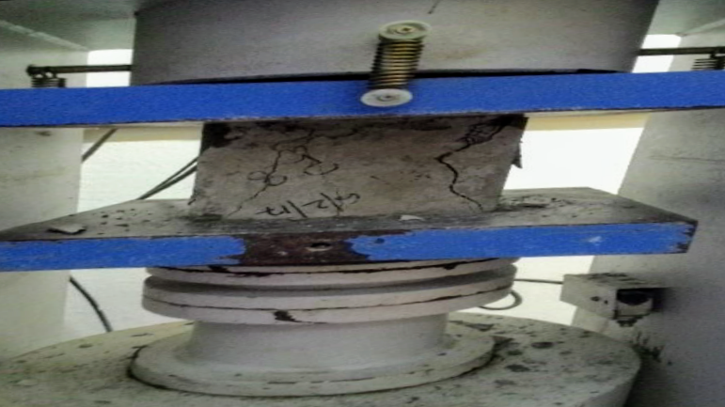
Five bacterial strains namely Bacillus coagulans, Bacillus tequilensis, Bacillus circulans Geobacillus stearothermophilus and Proteus inconstans were procured from Microbial type culture collection (MTCC, Chandigarh, India). 12.5 g of nutrient broth was dissolved in 500 mL of distilled water taken in a conical flask. This setup was sterilized in an autoclave at 121 °C, 15 psi for 15 minutes. After appropriate cooling for 30 minutes, a small amount of freeze dried culture was inoculated in the liquid broth and incubated at 37 °C under constant shaking at 180 rpm. The cultures were periodically subcultured and stored in the form of Petri plates and glycerol stocks at -70 °C for future use.

Casting of concrete specimens
Pozzolana Portland Cement (PPC) of ACC brand containing 15-30% fly ash cement is used in our study. Cement has a specific gravity of 2.74. All the preliminary tests were conducted according to Indian standard (IS) 4031 and were found to satisfy IS 1489. The locally available coarse aggregate of 20 mm size was selected. It has a fineness modulus of 7.3 according to IS 383.Local river sand is used. It is having a fineness modulus of 4 according to IS 383. Portable water is used in the concrete mix.
According to the designed mix proportion, a ratio of 1: 1.87: 2.281 was obtained. The grade of concrete used in the design is M30. The water-cement ratio is 0.45. The specific gravity of the bacteria was found to be 1.1 and the concentration of the bacteria is 20 mL per liter of water. The target mean strength is taken as 38.25 N/mm². The conventional concrete sample and bacterial concrete were prepared according to table I below.

Table I: Quantities of concrete constituents

Component | Quantity (kg/m³)
Component | Conventional concrete | Bacterial concrete
Cement | 437.77 | 437.77
Fine aggregate | 755.058 | 755.058
Coarse aggregate | 941.661 | 941.661
Water | 197 | 941.661
Bacteria | _ | 18.18
Slump test was performed to assess the workability and consistency of the concrete mix. The standard slump cone, tamping rod of 16mm and 60 cm length, measuring jar and scale were used to perform this test. This test procedure is mentioned in IS 1199-1959 and the mix was workable. Slump test was performed for each batch of moulds before casting.
An appropriate amount of cement, sand, coarse aggregate and water are taken and mixed well using a pan mixer (having a capacity of 21 L). Cube moulds of dimensions 150 mm × 150 mm × 150 mm, beam moulds of 500 mm × 100 mm × 100 mm and cylindrical moulds of 150 mm × 300 mm are used for casting of concrete. Concrete moulds should be clean and lubricant is applied to it to avoid the honeycombing effect. Both conventional and bacterial concrete are casted in 6 cubes, 4 beams, and 4 cylinder moulds. These are then allowed to dry or harden for 24 hrs. The moulds are removed and the specimens are kept in the curing tank for 7 and 28 days.
(a) (b) (c)
Fig. I: Hardened property test, (a) compressive, (b) split tensile and (c) flexural strength on concrete specimens after curing.

Testing of concrete specimens
36 cubes (6 conventional and 30 bacterial) of dimensions 150 mm x150 mm x 150 mm are tested as per IS 516. Tests were conducted in the Compression Testing Machine (CTM) after 7 and 28 days of curing. The machine has a maximum load bearing capacity of 3000 kN. Experiments were conducted in triplicates and the average of the three samples was used for interpretation (Fig. I(a)).
The tensile strength of concrete is obtained as per IS 5816. Cylinders of diameter 150 mm and length 300 mm are kept for 7 days and 28 days of curing. A manual load is applied to the specimen until the sample cracks (Fig. I(b)). The crack must compulsorily be formed towards the diameter of the cylinder.
Split tensile strength $=\frac{2P}{π\text{DL}}$ (1)
where,
‘P’ is the external load applied on the specimen (in kN),
‘D’ is the diameter of the specimen (in cm),
‘L’ length of the specimen on which load is applied (in cm).
Beams of size 100 mm x 100 mm x 500 mm were cast according to IS 516. After curing, for testing the beam is first marked at 5 cm from each of the ends and the rest is equally divided into three parts of 13.33 cm each. Then the specimen is placed on the roller supports and the load is gradually applied through the Universal Testing Machine (UTM), till cracks are formed (Fig. I(c)).
Flexural strength $=\frac{\text{PL}}{\text{bDD}}$ (2)
where, ‘P’ is the external load applied (in kN),
‘D’ is the diameter of the specimen (in cm),
‘L’ length of the specimen on which load is applied (in cm),
‘b’ is the width of the specimen (in cm).

SEM and EDS analysis
Bacterial calcite precipitation in different concrete samples was analysed using SEM SE EVO 18 with Oxford EDS (X-act). The instrument had a maximum magnification range up to 1,00,000x. All the samples (after 28 days of curing) were cut into 25 mm thickness using an angle grinder and immersed in isopropyl alcohol to stop the process of hydration. Then these were air dried in an oven at 100 °C for 24 hours. The dried samples were gold-palladium coated using a 6” sputtering unit model- 6 SPT (Hind high vacuum, Bangalore, India) and subjected to 20 kV of acceleration voltage under low nitrogen pressure.
A corresponding EDS spectrum was used for chemical characterization of precipitated calcite, which estimated the weight and atomic percentage of the elements present in the sample.
XRD studies of concrete were carried out using RigakuMiniflex 600 operating at a power of 600 W, electric voltage of 40 kV and current of 15 mA with nickel filters. The diffraction angle (2θ) was set in between 5° and 80°. The specimens were crushed into powder form using a pestle and subjected to analysis. This test is used for measuring crystallinity of the sample based on the peaks obtained in the diffraction pattern.
SEM, EDS, and XRD analysis were carried out in the Central Instrumentation Facility (MIT, Manipal, India).

RESULTS AND DISCUSSIONS
Hardened property tests were performed for conventional as well as bacterial concrete specimens and tabulated (Table II & Table III).

Table II: Hardened properties test results for 7 days of curing
Samples | 7 day Strength (MPa)
Samples | Compression | Split tension | Flexural
Conventional concrete | 27.56 | 2.77 | 4.27
Bacillus coagulans | 31.38 | 3.31 | 6.06
Bacillus tequilensis | 30.90 | 2.88 | 5.79
Bacillus circulans | 26.76 | 2.80 | 5.15
Geobacillus stearothermophilus | 22.67 | 2.81 | 4.95
Proteus inconstans | 25.20 | 2.42 | 3.68

Table III: Hardened properties test results for 28 days of curing
Samples | 28 day Strength (MPa)
Samples | Compression | Split tension | Flexural
Conventional concrete | 39.01 | 2.94 | 5.06
Bacillus coagulans | 53.10 | 3.80 | 6.66
Bacillus tequilensis | 43.20 | 3.53 | 6.15
Bacillus circulans | 38.02 | 3.24 | 5.95
Geobacillus stearothermophilus | 41.26 | 3.02 | 5.53
Proteus inconstans | 35.35 | 2.62 | 4.27

The standard deviation for the three set of specimens tested in each case did not exceed 2.36 MPa for compressive strength, 0.31 MPa for split tension and 0.25 MPa for flexural strength. The compressive strength of concrete increased with higher curing period. The samples after 28 days of curing showed higher load bearing capacities when compared to 7 days. This may be due to lower porosity and improved calcium silicate hydrate (CSH) formation [19, 20 and 21].
The addition of bacteria to the PPC concrete improved its overall characteristics as they yielded higher compressive strength as compared to conventional concrete. B. coagulans showed a maximum strength of 53.10 MPa after 28 days of curing which is higher as compared to previous work [22 and 23] and similar to [24] where a maximum strength of 53 MPa was recorded. Bacilli genera are widely used in improving the strength of concrete as bacterial spores remain viable in the environment and are resistant to a wide range of pH fluctuations, extreme chemical environment [25]. In addition to sporulation, bacteria produce urease which creates a favorable alkaline pH for increase calcite precipitation as compared to conventional concrete. This eliminates the cracks and fissures present in the concrete surface [26].
The application of PPC can also improve the tensile properties of the overall concrete as compared to the OPC as the former contains fly ash which reduces the interlinking voids [27]. B. coagulans recorded the highest split tensile and flexural strengths of 3.80 and 6.66 MPa respectively as seen in Tables II. The flexural strength of concrete was higher as compared to published results [28] where Bacillus mucilaginous L3 and Bacillus sp. were utilized in healing concrete. P. inconstans showed lower tensile characteristics as compared to conventional concrete.
SEM image for bacterial calcite precipitation is shown in (Fig. II).
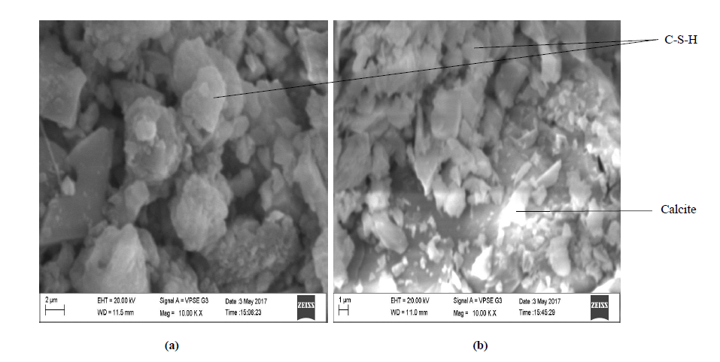
Fig. II: SEM image analysis, (a) conventional concrete, (b) B. coagulans concrete after 28 days of curing

A sizeable number of voids are present in the conventional concrete even after 28 days of curing which indicates the possible presence of air bubbles and voids due to insufficient C-S-H formation as seen in [29]. In contrast to conventional concrete, a newly formed white layer is visible in case of a bacterial sample which confirms efficient calcite precipitation. The calcite crystals as discussed in [30] were mostly rhomboidal in shape with a diameter up to 4.102 µm and were stacked next to each other as per their observations.

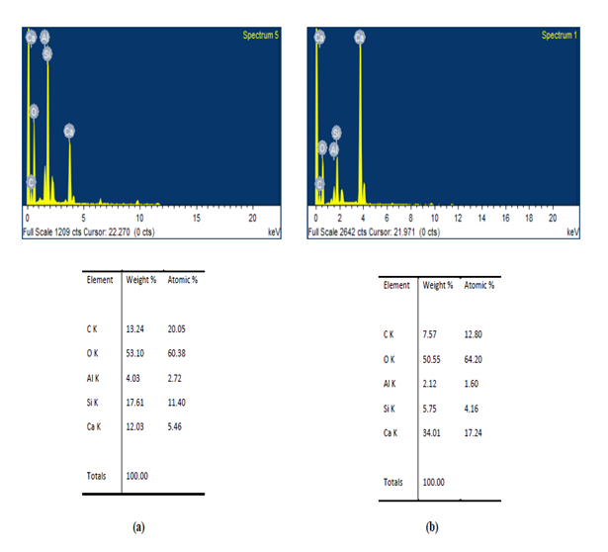
Fig. III: EDS analysis conventional concrete after 28 days of curing

Fig. IV: EDS analysis B. coagulans concrete after 28 days of curing

EDS spectral analysis (Fig. III and Fig. IV) showed increased calcite precipitation in case of bacterial concrete. In this case, the weight of deposited calcium was 34.01 % as compared to 12.03 % of conventional concrete (Table IV). The proportion of oxygen and carbon in the bacterial sample was less than conventional concrete as the number of micro-cracks and fissures were eliminated by efficient nucleation. These results were similar to concrete healing catalyzed by B. megaterium [31] and B. halodurans [32].

Table IV: EDS analysis quantitative analysis of conventional concrete and B. coagulans concrete after 28 days of curing
Element | Conventional Concrete |  | B. coagulans concrete
Element | Weight % | Atomic % |  | Weight % | Atomic %
C K | 13.24 | 20.05 |  | 7.57 | 12.80
O K | 53.10 | 60.38 |  | 50.55 | 64.20
Al K | 4.03 | 2.72 |  | 2.12 | 1.60
Si K | 17.61 | 11.40 |  | 5.75 | 4.16
Ca K | 12.03 | 5.46 |  | 34.01 | 17.24
Total | 100 | 100 |  | 100 | 100

XRD analysis of conventional and bacterial concrete further confirmed calcite precipitation due to ureolytic activity in the latter (Fig. V).
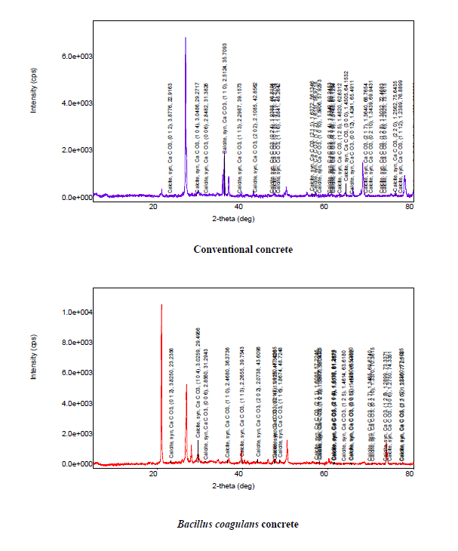
Fig. V: XRD analysis of conventional concrete B. coagulans concrete after 28 days of curing

Bacterial concrete produced higher intensity peaks of the order 1e⁰⁴ for calcium carbonate as compared to conventional concrete for a 2θ value of 22º (Fig. V). The excess calcite production in bacterial sample results in a denser concrete matrix similar to results suggested in the literature [33]. This might cause a shift in (d= lattice spacing) thereby allowing the X-rays to be diffracted at a different angle than the pattern obtained for normal concrete.

CONCLUSION
All the selected bacteria with the exception of P. inconstans displayed effective ureolytic activity and showed better hardened properties as compared to conventional concrete. B. coagulans aided in the maximum improvement of concrete as they recorded the highest compressive, split tensile strength and flexural strengths of 53.10 MPa, 3.80 MPa and 6.66 MPa after 28 days of curing respectively. SEM, EDS and XRD analysis confirmed higher calcite precipitation in bacterial concrete samples. There are certain parameters associated with the process of bacterial concrete healing such as the presence of calcium, pH of the surrounding environment, nucleation sites and viability of bacteria. Till date, researchers have devised methods to increase bacterial survival in concrete, introduce carbon silicates, reduce cracks and replace cement components with additives. However, it is important to work on crystallization sites as well as maintaining ideal conditions (for e.g. alkaline pH) for improving self-healing in concrete.

ACKNOWLEDGMENT
We are thankful Head of the Department of Civil engineering and Department of Biotechnology, Manipal Institute of Technology for their assistance and timely inputs.

REFERENCES
- O. Bozkurt, M. Islamoglu, “Comparison of cement-based and polymer-based concrete pipes for analysis of cost assessment”, Int J Polym Sci, 2013, Article ID 921076. doi: 10.1155/2013/921076.
- F. Goodwin, Significance of tests and properties of concrete and concrete-making materials, ASTM International, 2006, New Jersey, pp. 218-219.
- R. Taylor, I. G. Richardson, R. M. D. Brydson, “Composition and microstructure of 20-year old ordinary Portland cement ground granulated blast-furnace slag blends containing 0 to 100% slag”, Cem Concr Res 40, (2010), pp. 971–983.
- Paya, J.M.V. Borrachero, J. Monzo, E. Peris Mora, F. Amahjour, “Enhanced conductivity measurement techniques for evaluation of fly ash pozzolanic activity”, Cem Concr Res 31,2001, pp. 41-49.
- A. K. Parande, B. Ramesh Babu, K. Pandi , M.S. Karthikeyan, N. Palaniswamy, “Environmental effects on concrete using Ordinary and Pozzolana Portland cement”, Constr Build Mater, 25, 2011, pp. 288–297. doi: 10.1016/j.conbuildmat.2010.06.027.
- R. O. Yusuf, T. A. Salawudeen, “Pozzolanic properties of calcareous clay in blended cement pastes”, Global Jour of Engg and Tech, 2(2) ,2009, pp. 2161-2166.
- A. Mačanovskis, A. Krasņikovs, I. Spruge, G. Sahmenko, A. Lukasenko, “Mechanical properties and self-healing effect of concrete containing capillary hydro insulation admixture”, Constr Sci, 18, pp. 17-21, 2016, doi: 10.1515/cons-2016-0003.
- J. Xu, W. Yao, “Multiscale mechanical quantification of self-healing concrete incorporating non-ureolytic bacteria based healing agent”. Cem Concr Res 64, 2014, pp. 1–10.
- M. Luo, Q. Chunxiang, R. Li, R. Hui, “Efficiency of concrete crack-healing based on biological carbonate precipitation”, J Wuhan Univ Technol-Mat Sci Edit, 30, 2015, pp. 1255-1259.
- H. M. Jonkers, A. Thijssen, G. Muyzer, O. Copuroglu, E. Schlangen, “Application of bacteria as self-healing agent for the development of sustainable concrete”. Ecol Eng, 36, 2010, pp. 230–235. doi: 10.1016/j.ecoleng.2008.12.036.
- P. Anbu, C.H. Kang, Y. J. Shin, J. S. So, “Formations of calcium carbonate minerals by bacteria and its multiple applications”, SpringerPlus, 5, 2016, pp. 250. doi: 10.1186/s40064-016-1869-2.
- J. Y. Wang, K. V. Tittelboom, N. De Belie, W. Verstraete, “Use of silica gel or polyurethane immobilized bacteria for self-healing concrete”. Constr Build Mater 26, 2012, pp. 532-540.
- S.K. Ramachandran, V. Ramakrishnan, S.S. Bang, (2001), “Remediation of concrete using micro-organisms”, ACI Mater J 98, 2001, pp. 3-9.
- P. Tiano, L. Biagiotti, G. Mastromei, “Bacterial bio-mediated calcite precipitation for monumental stones conservation”, J Microbiol Methods, 36, 1999, pp. 139-145.
- S.J. Park, Y.M. Park, W.Y. Chun, W.J. Kim, S.Y. Ghim, “Calcite forming bacteria for compressive strength improvement in mortar”. J Microbiol Biotechnol, 20, 2010, pp. 782-788.
- T. K. Sharma, M. Alazhari, A. Heath, K. Paine, R.M. Cooper, “Alkaliphilic Bacillus species show potential application in concrete crack repair by virtue of rapid spore production and germination then extracellular calcite formation”, J Appl Microbiol, 122, 2017, pp. 1233-1244. doi: 10.1111/jam.13421.
- V. Wiktor, H.M. Jonkers, “Quantification of crack-healing in novel bacteria-based self-healing concrete”. Cem Concr Compos, 33, 2011, pp. 763–770. doi: 10.1016/j.cemconcomp.2011.03.012.
- P. C. B. Turnbull, Bacillus. In: Baron S (ed) Medical Microbiology, 4th edn., 1996, University of Texas Medical branch, Texas, United States of America.
- R. Chidara, R. Nagulagama, S. Yadav, “Achievement of early compressive strength in concrete using Sporosarcina pasteurii bacteria as an admixture”, ACE, 2014, Article ID 435948.
- R. Siddique, K. Singh, M. Kunal, Singh, V. Corinaldesi, A. Rajor, “Properties of bacterial rice husk ash concrete”, Constr Build Mater, 121, 2016, pp. 112–119. doi: 10.1016/j.conbuildmat.2016.05.146.
- T. James, A. Malachi, E.W. Gadzama, V.O. Anametem, “Effect of curing methods on the compressive strength of concrete”, NIJOTECH, 30(3), 2011, pp. 14-20.
- S. Krishnapriya, D.L.V. Babu, P.G. Arulraj, “Isolation and identification of bacteria to improve the strength of concrete”, Microbiol Res, 174, 2015, pp. 48-55.
- N. Chahal, R. Siddique, A. Rajor, “Influence of bacteria on the compressive strength, water absorption and rapid chloride permeability of concrete incorporating silica fume”, Constr Build Mater, 37, 2012, pp. 645–651.
- Y.C. Ersan, E.H. Sanabria, N. Boon, N. De Belie, “Enhanced crack closure performance of microbial mortar through nitrate reduction”, Cem Concr Compos, 70, 2016, pp. 159-170.
- J. Zhang, B. Mai, T. Cai, J. Luo, W. Wu, B. Liu, N.H. Xu, F. Xing, X. Deng, “Optimization of a binary concrete crack self-healing system containing bacteria and oxygen”, Materials, 10(2), 2017, pp. 116.
- S.S. Fischer, J. K. Galinat, S.S. Bang, “Microbiological precipitation of CaCO₃”, Soil Biol Biochem, 31,1999, pp. 1563-1571.
- A. Harison, V. Srivastava, A. Herbert, “Effect of fly ash on compressive strength of Portland Pozzolona cement concrete”. JAIR, 2(8), 2014, pp. 476-479.
- H. Chen, C. Qian, H. Huang, “Self-healing cementitious materials based on bacteria and nutrients immobilized respectively”. Constr Build Mater 126, 2016, pp. 297–303.
- H. Biricik, N. Sarier, “Comparative study of the characteristics of nano silica, silica fume and fly ash incorporated cement mortars”. Mat Res, 17, 2014, pp. 570-582.
- S.A. Kadapure, G.S. Kulkarni, K. B. Prakash, “A Laboratory investigation on the production of sustainable bacteria-blended fly ash concrete”. Arab J Sci Eng, 42, 2017, pp. 1039–1048.
- R. Andalib, M.Z.A. Majid, M.W. Hussin, M. Ponraj, A. Keyvanfar, J. Mirza, H.S. Lee, “Optimum concentration of Bacillus megaterium for strengthening structural concrete”, Constr Build Mater, 118,2016, pp. 180–193. doi: 10.1016/j.conbuildmat.2016.04.142.
- A. Kunal, Rajor, R. Siddique, “Bacterial treatment of alkaline cement kiln dust using Bacillus halodurans strain”, KG1. Braz J Microbiol, 47, 2016, pp. 1-9. doi: 10.1016/j.bjm.2015.11.001.
- K.K. Sahoo, A.K. Sathyan, C. Kumari, P. Sarkar, R. Davis R, “Investigation of cement mortar incorporating Bacillus sphaericus” Int J Smart Nano Mater, 7,2016, pp. 91-105.

 Revised Manuscript Received on April 20, 2019. Sandesh Upadhyaya K., Department of Civil engineering, Manipal Institute of Technology, Manipal- 576104, India. sandesh.uk@manipal.edu Priyodip Paul, Department of Biotechnology, Manipal Institute of Technology, Manipal- 576104, India. S. Sumanth Akhil, Department of Civil engineering, Manipal Institute of Technology, Manipal- 576104, India. Nishanta Khatoniyar, Department of Civil engineering, Manipal Institute of Technology, Manipal- 576104, India.

