An Investigation into the Effect of Fused Deposition Modeling Process Parameters on Mechanical Properties of Thermo-Plastics
Ravi Shekhar Kinja¹, Bhuvnesh Dave², Dr. Kailash Chaudhary², Dr. Dinesh Shringi²
¹Department of Mechanical Engineering, MITS Jadan, Pali, India
² Department of Mechanical Engineering, MBM Engineering College, Jodhpur, India
Abstract- Fused deposition modeling (FDM) process is an additive manufacturing. Additive manufacturing process is also referrers as 3D printing. In 3D printing process the product is developed by use of layer by layer technology. In FDM process thermoplastic parts are fabricated by extrusion process and deposition of the heated material layer by layer manner. The main objective of this article is to provide review of various developments in the FDM process and the overview of various type of parameter by which the FDM process is get affected.

Keywords- Additive manufacturing, 3D Printing, Fused Deposition Modeling, Process Parameters and optimization

Introduction

Ability to handling design complexity, rapid prototyping process is widely use in industrial applications. By RP technology significance accuracy is gain in manufacturing various products. This technology reduces the interaction of human being and reduces the human errors. The applications of RP technology is distributed in a wide area for examples in aerospace, in production of various medical equipments, in the automobile industry and in casting industry etc. [1]. From all this advantages, there are also some limitations of this technology which draw main contribution toward the popularity of this technology. The main limitation is the some variation in the identical products which are produce by different RP processes. There are some variation in the geometry and the properties in these products. For that industrial standards are needed for exchange of data between two different RP processes for the analysis and characterisation of fabricated parts when there are number of materials are use in RP is a major drawback.

These limitations of this technology play an important role for improvement in RP technology as follows [2]:

There are requirement of new rapid prototyping material for fulfilment of industrial requirement.

There are requirement of the new RP techniques for handling complex design problem and also meet with strength requirement.

There are requirement of artificial intelligence technology for prediction of the performance characteristics of RP built parts.

There are requirement of some industrial standards to increase the growth rate of RP technology.

Mechanical properties of the 3D printed objects are affected by build orientations, layer thickness, raster width, raster angle, infill pattern, air gap, print speed and extrusion temperature [3]. Build orientation (as shown in fig. 1) refers to the way in which the part is oriented inside the build platform with respect to X, Y, Z axes. Layer thickness is the thickness of the layer deposited by the nozzle and depends on types of nozzle used. Raster angle (as shown in fig. 4) is the direction of raster with respect to the loading direction of stress and it’s allowed from 0o to 90o. Raster width (as shown in fig. 3) is defined as the width of the deposition beads. It depends on the extrusion nozzle diameter. Infill pattern- Different infill patterns (as shown in fig. 2) are used in various parts to fabricate a durable and strong internal structure. Diamond, Hex agonal and linear are mainly used infill patterns. Air gap (as shown in fig. 3) is defined as the distance between two adjacent deposited filaments in same layer. Print speed is the distance travelled by the extruder along the XY plane per unit time while extruding, printing time depends on print speed, and the print speed is measured in mm/s. The number of contours is the number of filaments initially deposited along the outer edge. Extrusion temperature is refers to the temperature at which the filament of a material is heated during the FDM process. Extrusion temperature depends on various aspects, i.e. the type of material or print speed Bead width is the width of the filament deposited by the nozzle of 3D printer.
(a)
(b)

Fig. 1: Build Orientation of part (a) Numerical type (b) Categorical type [3]
(a)
(b)

(c)

Fig. 2: Infill Patterns (a) Linear pattern (b) Diamond pattern (c) Hexagonal pattern [3]
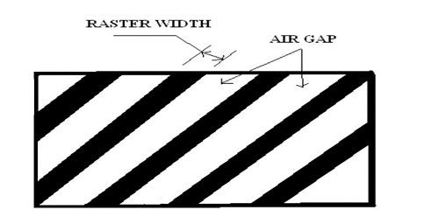
Fig. 3: Raster width and Air gap[4]

Fig. 4: Raster Angle [4]
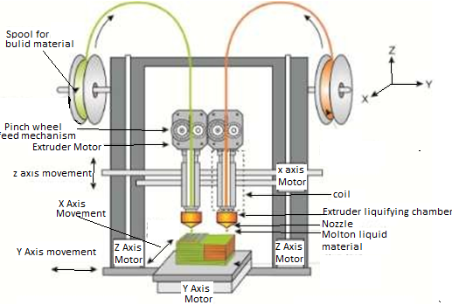
In the material extrusion process the molten material is extrude by the help of a printing head. On this technology the FDM process is based [4]. In FDM technique plastic filament wire is feeds into liquefier chamber, which is heated to a desired temperature to melt the material. In the liquefier the material get soften and get melted. After that the molten material is pushes through a nozzle. The required energy for the melting process is developed by a heater connected with a theremistor to the nozzle. In the melting point area the temperature is maintained low, this is due to avoid material degradation inside the chamber. By use of nozzle the molten material is put down onto a platform or on already placed layer. On the platform or on the layer the material is get cool down to room temperature and get bond with the base material. The extruded layer height depends upon the G- code generated by use of the slicing software. On the diameter of the extrusion nozzle, the width of the extruded layer is depending. Starting of this extrusion process is done by unwind the plastic material from roll. A pinch roller system which is placed in the extrusion head is use to handle the feeding of wire. Extrusion head movement is depending upon the type of printer used. Filament is feed to the print head by using filament feeding equipment. This equipment contains the liquefier chamber for melt the plastic material. A cooler is also use in the head for regulates the printing head temperature. An input for the material and a sink for remove excess heat are containing by extrusion head. Material is melt by heating unit and then extruded by the use of nozzle. After the extrusion, the material get solidifies. The shrinkage due to the cooling is minimized by using a chamber, which is heated. The platform on which material is get extruded is a XY- plane table. This platform is moved by the use of roller screw system. In the current time the popularity of this technology is can be seen in various printers. These printers are now developed in compact shape and in an easy to use manner. Also the prices of the printers are starting to be in a reasonable level.
Fig. 5: Setup of FDM machine [4]

Review on status of research and development in the subject
In the present time FDM process is not only use to produce complex shaped prototypes, visual and conceptual model, but this technology is also use to build drilling grids in the aerospace industry [5] and edentulous mandible trays [6]. This technology decrease assembly cost because this technology can produce complex geometry and flexible function parts from a stereolithography (STL) file by deposition of two-dimensional layers on a build platform. In India, the work on 3D Printing is in a growing stage. By 2021 it is expected that in India the 3D Printing market reach over $79 million by 2021[7]. In the present time researchers are also working on development of new material, also they are working to improve the existing material use in the FDM process to produce different parts in various fields such a automobile, biomedical, aerospace and in many industries. But the in the production of the functional parts the FDM process is limited due to various limitations such as surface irregularity, lack of mechanical properties and low accuracy [8,9,10,11] . Low accuracy is only a relative term and in some application there are not requirement of high accuracy for example in prototype or in display parts. To increase the acceptation of the FDM technology in industry and for mass production of various printing parts, accuracy is the main requirement for that need. To raise the market shares of FDM products and develop good functional parts by FDM machine, it is required to manufacture parts with finer quality to meet specific requirement. There are number of

parameters of FDM process which have a significant impact on the built part. These all parameters affect the bonding between deposited layers. By the optimum combination of parameters desired quality of printing part is gain [12,13,14].

Review of status of Research on Process Parameter Analysis

Number of researches were performed for analysis various effects of process parameter on the mechanical properties, surface roughness of product, dimensional accuracy of product and built time taken by machine. 3D printing is considered as the future of the technology in the world. Most of the world’s research is done in universities and most of them are now focusing on these fields to get ahead of each other. 3D printing is a manufacturing phenomenon that will revolutionize factories and mass production in the coming years. ASTM International Committee F42 on AM has organized the span of AM processes into seven categories, differentiated largely by the means of material deposition [15].

Fig.6: Impact of various process parameters on the part characteristics (Fishbone diagram) [16]
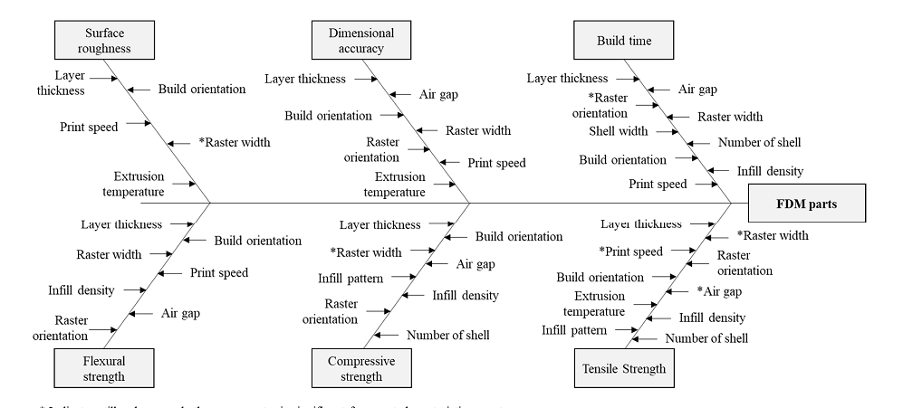
On the basis of various researches on the FDM process, a fishbone diagram is given in the figure 6. In this the impact of various process parameters on different part characteristics are shown. On the basis of various existing researches, this diagram is developed. From this diagram it is noted that some process parameters overlay the part characteristics because a single process parameter can affects number of part characteristics [16].
In various research papers, to obtain maximum information from minimum number of experiments there are number of statistical tools such as full factorial design [17,18,19,20], fractional factorial design [21,22], and face-centred central composite design (FCCCD) [23,24] were used. In some other approaches on the basis of experimental results, optimum levels of process parameters for part characteristics were analysis. In the year 2016 some research papers, such as Mohamed et al. [25] and Chacón et al. [26], developed various mathematical models to give a relationship between process parameters and part quality. Peng et al. [27] and Rayegani et al. [28] worked to find out optimal levels of various process parameters by optimizing mathematical models of part characteristics. There were various heuristic optimization algorithms, such as, quantum-behaved particle swarm optimization (QPSO) [29], non-dominated sorting genetic algorithm II (NSGA-II) [30], differential evolution (DE) [31], and genetic algorithm (GA) [32], were used for simultaneously optimize characteristics of more than one part.

Proposed scope of work in the context of current status
This proposed work is important because FDM is rapidly obtaining popularity in a manufacturing sector due in part to its ability to create unique geometries with unique material compositions across an unprecedented range of length scales from microns to meters. In the large scale manufacturing industry the adoption of the FDM process is mainly depends on developing the FDM technology and it is important to recognize the limitation of current additive manufacturing (AM) techniques for inventing new machine and process designs. Since it is only conception, FDM technology has gradually developed in terms of scale and material capability. The main mechanism of the FDM technique has been developed very little changes from its original design. By using pinch wheel extruder the filament material is still feed into the liquefier chamber. The positioning of nozzle and building platform is still done by use of a series gantry system which is driven by stepping motors. By the result of this the print rate of FDM process has not improved. As future application the FDM process is can be use in the extrusion of nano composite polymer resins material, this process can be use in adoption of large scale additive manufacturing system. Eventually, this research should lead to the setup various rules which can reduce the cost associated with the FDM process and it lead to a feasible large scale manufacturing process.
This will prove to be a next revolution in the manufacturing industries with large scope for technological and economic advancement. Establishment of Experimental Test facility out of this proposed work to investigate the effect of below mentioned controllable parameters will be novelty of the project. The various sub-systems will be optimized to get best print results.
Study will be done on influence of process parameter on the mechanical properties of 3D-printed parts. Samples with five different layer thicknesses (100, 200, 300, 400 and 500µm) and raster angles (00,300and 450) shall be studied. Tensile, compressive, yield strength, flexural strength and hardness will be tested. The optimal mechanical properties of various samples will be found at a particular layer thickness. The various processes will be optimized to get best print results. The post processing methods will be tested to get best print results.

Objectives of this work
- FDM experiment test bench will be use to conduct various experiments for analysis effects of controllable 3D printing parameters such as temperature effects on nozzle and at print bed, layer thickness of building part, extrusion speed, raster angle and raster width, feed rate, viscosity, surface roughness, spacing between path, flow rate and various mechanical properties of 3D printed parts of different material (PLA- ABS) shall be studies in this work.
- For understanding the present technology, FDM machines desktop version will be studies.
- To examine the various effects of controllable parameter on a Cartesian 3D printer (REPRAP 3D printer) will be studies by use of Tinkercad 3D printing software.
- Optimization of process parameters through evolutionary optimization techniques using MATLAB will be carried out to achieve optimum performance of 3D printer.
- The optimization results will be validated with the experiments on the test pieces to justify the objective of this research work

Conclusion
Proposed research investigations will lead to design and develop small scale FDM based 3D printer. It is expected that the understanding of the effect of process parameters of FDM based 3D printer can motivate new 3D printing machine designs that achieve improvised operations. Reduction in dependence on International market and make India self-reliant in the additive manufacturing sector.

References

- uz Zaman, U.K.; Boesch, E.; Siadat, A.; Rivette, M.; Baqai, A.A. Impact of fused deposition modeling (FDM) process parameters on strength of built parts using Taguchi’s design of experiments. Int. J. Adv. Manuf. Technol. 2019, 101, 1215–1226.
- Chen, H.; Yang, X.; Chen, L.; Wang, Y.; Sun, Y. Application of FDM three-dimensional printing technology in the digital manufacture of custom edentulous mandible trays. Sci. Rep. 2016, 6, 19207. [PubMed]
- Letcher, T.; Rankouhi, B.; Javadpour, S. Experimental study of mechanical properties of additively manufactured ABS plastic as a function of layer parameters. In Proceedings of the ASME 2015 International Mechanical Engineering Congress and Exposition (IMECE), Houston, TX, USA, 13–19 November 2015.
- Durgun, I.; Ertan, R. Experimental investigation of FDM process for improvement of mechanical properties and production cost. Rapid Prototyp. J. 2014, 20, 228–235.
- Raney, K.; Lani, E.; Kalla, D.K. Experimental characterization of the tensile strength of ABS parts manufactured by fused deposition modeling process. Mater. Today Proc. 2017, 4, 7956–7961.
- Nancharaiah, T.; Raju, D.R.; Raju, V.R. An experimental investigation on surface quality and dimensional accuracy of FDM components. Int. J. Emerg. Technol. 2010, 1, 106–111.
- Nidagundi, V.B.; Keshavamurthy, R.; Prakash, C. Studies on parametric optimization for fused deposition modelling process. Mater. Today Proc. 2015, 2, 1691–1699.
- Sood, A.K.; Ohdar, R.K.; Mahapatra, S.S. Experimental investigation and empirical modelling of FDM process for compressive strength improvement. J. Adv. Res. 2012, 3, 81–90.
- Nancharaiah, T. Optimization of process parameters in FDM process using design of experiments. Int. J. Emerg. Technol. 2011, 2, 100–102.
- Rayegani, F.; Onwubolu, G.C. Fused deposition modelling (FDM) process parameter prediction and optimization using group method for data handling (GMDH) and differential evolution (DE). Int. J. Adv. Manuf. Technol. 2014, 73, 509–519.
- Chacón, J.; Caminero, M.; García-Plaza, E.; Núñez, P. Additive manufacturing of PLA structures using fused deposition modelling: Effect of process parameters on mechanical properties and their optimal selection. Mater. Des. 2017, 124, 143–157.
- Sood, A.K.; Ohdar, R.K.; Mahapatra, S.S. Parametric appraisal of mechanical property of fused deposition modelling processed parts. Mater. Des. 2010, 31, 287–295.
- Panda, S.K.; Padhee, S.; Anoop Kumar, S.; Mahapatra, S.S. Optimization of fused deposition modelling (FDM) process parameters using bacterial foraging technique. Intell. Inf. Manag. 2009, 1, 89–97.
- Akande, S.O. Dimensional accuracy and surface finish optimization of fused deposition modelling parts using desirability function analysis. Int. J. Eng. Res. Technol 2015, 4, 196–202.
- Gurrala, P.K.; Regalla, S.P. Multi-objective optimisation of strength and volumetric shrinkage of FDM parts: a multi-objective optimization scheme is used to optimize the strength and volumetric shrinkage of FDM parts considering different process parameters. Virtual Phys. Prototyp. 2014, 9, 127–138.
- Rao, R.V.; Rai, D.P. Optimization of fused deposition modeling process using teaching-learning-based optimization algorithm. Eng. Sci. Technol. Int. J. 2016, 19, 587–603.
- Mohamed, O.A.; Masood, S.H.; Bhowmik, J.L. Optimization of fused deposition modeling process parameters: A review of current research and future prospects. Adv. Manuf. 2015, 3, 42–53.
- Popescu, D.; Zapciu, A.; Amza, C.; Baciu, F.; Marinescu, R. FDM process parameters influence over the mechanical properties of polymer specimens: A review. Polym. Test. 2018, 69, 157–166.
- Raju, M.; Gupta, M.K.; Bhanot, N.; Sharma, V.S. A hybrid PSO–BFO evolutionary algorithm for optimization of fused deposition modelling process parameters. J. Intell. Manuf. 2018, 1–16.
- Qattawi, A.; Alrawi, B.; Guzman, A. Experimental optimization of fused deposition modelling processing parameters: a design-for-manufacturing approach. Procedia Manuf. 2017, 10, 791–803.
- Zaldivar, R.; Witkin, D.; McLouth, T.; Patel, D.; Schmitt, K.; Nokes, J. Influence of processing and orientation print effects on the mechanical and thermal behavior of 3D-Printed ULTEM®9085 Material. Addit. Manuf. 2017, 13, 71–80.
- Mohamed, O.A.; Masood, S.H.; Bhowmik, J.L.; Nikzad, M.; Azadmanjiri, J. Effect of process parameters on dynamic mechanical performance of fdm PC/ABS printed parts through design of experiment. J. Mater. Eng. Perform. 2016, 25, 2922–2935.
- Cantrell, J.T.; Rohde, S.; Damiani, D.; Gurnani, R.; DiSandro, L.; Anton, J.; Young, A.; Jerez, A.; Steinbach, D.; Kroese, C. Experimental characterization of the mechanical properties of 3D-printed ABS and polycarbonate parts. Rapid Prototyp. J. 2017, 23, 811–824.
- Kumar, G.P.; Regalla, S.P. Optimization of support material and build time in fused deposition modeling (FDM). Appl. Mech. Mater. 2012, 110–116, 2245–2251.
- Montero, M.; Roundy, S.; Odell, D.; Ahn, S.-H.; Wright, P.K. Material characterization of fused deposition modeling (FDM) ABS by designed experiments. Soc. Manuf. Eng. 2001, 10, 1–21.
- Es-Said, O.; Foyos, J.; Noorani, R.; Mendelson, M.; Marloth, R.; Pregger, B. Effect of layer orientation on mechanical properties of rapid prototyped samples. Mater. Manuf. Process. 2000, 15, 107–122.
- Chin Ang, K.; Fai Leong, K.; Kai Chua, C.; Chandrasekaran, M. Investigation of the mechanical properties and porosity relationships in fused deposition modelling-fabricated porous structures. Rapid Prototyp. J. 2006, 12, 100–105.
- Vasudevarao, B.; Natarajan, D.P.; Henderson, M.; Razdan, A. Sensitivity of RP surface finish to process parameter variation. In Proceedings of the Solid Freeform Fabrication Proceedings, Austin, TX, USA, 7–9 August 2000; pp. 251–258.
- Arivazhagan, A.; Masood, S. Dynamic mechanical properties of ABS material processed by fused deposition modelling. Int. J. Eng. Res. Appl 2012, 2, 2009–2014.
- Jami, H.; Masood, S.H.; Song, W. Dynamic response of FDM made ABS parts in different part orientations. Adv. Mater. Res. 2013, 748, 291–294.
- Fernandes, J.; Deus, A.M.; Reis, L.; Vaz, M.F.; Leite, M. Study of the influence of 3D printing parameters on the mechanical properties of PLA. In Proceedings of the 3rd International Conference on Progress in Additive Manufacturing (Pro-AM 2018), Singapore, 14–17 May 2018.

